Job Profile comprising Job Description and Person Specification
Job Description

Job Title:  Permit Officer - Parking | Grade:  Sc4-S01
Section:  Parking Service | Directorate:  Resources
Responsible to following manager:  Permit Team Leader - Parking | Responsible for following staff:  n/a
Post Number/s: | Last review date:  April 2016

Working for the Richmond/Wandsworth Shared Staffing Arrangement

This role is employed under the Shared Staffing Arrangement between Richmond and Wandsworth Councils. The overall purpose of the Shared Staffing Arrangement is to provide the highest quality of service at the lowest attainable cost.

Staff are expected to deliver high quality and responsive services wherever they are based, as well as having the ability to adapt to sometimes differing processes and expectations.

The Shared Staffing Arrangement aims to be at the forefront of innovation in local government and the organisation will invest in the development of its staff and ensure the opportunities for progression that only a large organisation can provide.

Job Purpose
- To process parking permit applications made by residents and businesses of the borough within agreed turnaround periods and whilst protecting the integrity of scheme.

Specific Duties and Responsibilities
- To ensure that the services for both Councils are dealt with on an equitable basis to deliver the standards required for each, as agreed annually by the Executives of both Councils.

- To advise and support managers on relevant matters affecting the service.

- To contribute as required to performance review and improvement measures on an ongoing basis, helping to ensure that a customer focus is embedded within the function and innovative and creative solutions are evaluated to securing the highest quality and value for money function.

- To contribute as required to change programmes within the service.

Scale 4
- To receive and process applications in respect of the Parking Permit Schemes including contacting service users or other relevant third parties.

- To ensure professional conduct is maintained and adjusted to accommodate the varied needs of the customer base.

- Assist with the compilation of statistics and the production of reports by the team for management as and when required.

- Identify potential areas of non-compliance/abuse in respect of permit applications and ensure preventative systems are in place to prevent losses to the Council, including liaison with other sections.

- To run end of day financial reports for reconciliation.

Additional duties Scale 5
- To undertake project and support work.

- Investigates letters concerning refusals received from members of the public.

- Provide technical advice to members of the public and customer services staff in matters relating to Parking Permit functions.

- Assists in advising junior team members in all procedures relating to Parking Permits.

- Data cleanse permit renewal data to adhere to audit requirements for auto renewal processes.

Additional duties Scale 6
- Maintains stock control, stock orders and stock delivery.

- Processes more complex permit applications and rejected applications.

- To assist with the timely and accurate response to all Freedom of Information requests within prescribed deadlines.

- To be actively involved in project and support work.

Additional duties SO1
- To investigate and prepare answers and responses to all letters to the Parking Service from Members of the Council/Parliament, Chief Executive, Director of Resources, Assistant Director of Resources & Head of Parking Services and other correspondence with political and public relations implications as directed.

- To make recommendations for changes to service practices through the identification of service improvements through the complaints procedure.

- To act as deputy Permits Team Leader as required.

- To provide supervision as required to assigned staff and take responsibility for the allocation and checking of work by staff.

Generic Duties and Responsibilities
- To contribute to the continuous improvement of the services of the Boroughs of Wandsworth and Richmond.

- To comply with relevant Codes of Practice, including the Code of Conduct and policies concerning data protection and health and safety.

- To adhere to security controls and requirements as mandated by the SSA’s policies, procedures and local risk assessments to maintain confidentiality, integrity, availability and legal compliance of information and systems.

- To promote equality, diversity, and inclusion, maintaining an awareness of the equality and diversity protocol/policy and working to create and maintain a safe, supportive and welcoming environment where all people are treated with dignity and their identity and culture are valued and respected.

- To understand both Councils’ duties and responsibilities for safeguarding children, young people and adults as they apply to the role within the council.

- The Shared Staffing Arrangement will keep its structures under continual review and as a result the post holder should expect to carry out any other reasonable duties within the overall function, commensurate with the level of the post.

Additional Information
- This role oversees the assessment and issue of Parking Permit applications for the various parking schemes across both Boroughs. The role will operate differing local policies.

- Administrative support is to be provided to the Head of Parking Services, Permits and Supported Travel Manager and Permits Team Leader to ensure that an efficient, effective and high quality customer service is provided to members of the public and external bodies.

Current team structure

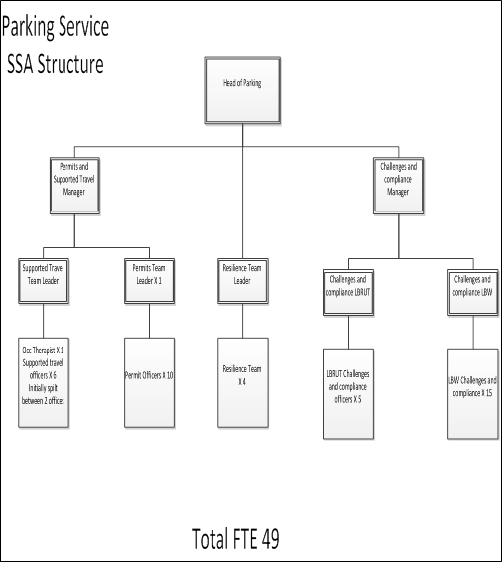

Person Specification

Job Title:  Permit Officer - Parking | Grade:  Sc4-S01
Section:  Parking Service | Directorate:  Resources
Responsible to following manager:  Permit Team Leader - Parking | Responsible for following staff:  n/a
Post Number/s: | Last review date:  April 2016

Our Values and Behaviours

The values and behaviours we seek from our staff draw on the high standards of the two boroughs, and we prize these qualities in particular –

- taking responsibility and being accountable for achieving the best possible outcomes – a ‘can do’ attitude to work
- continuously seeking better value for money and improved outcomes at lower cost
- focussing on residents and service users, and ensuring they receive the highest standards of service provision
- taking a team approach that values collaboration and partnership working.

Person Specification Requirements | Assessed by  A  & I/ T/ C (see below for explanation)
Knowledge
Knowledge of parking permit schemes | A/I
Knowledge of application processes | A/I
Understanding of digital enhancement/improvement | A/I
Experience
Evidence of working in changing circumstances | A/I
Experience of managing workloads with successful outcomes | A/I
Evidence of investigation and resolution | A/I
Experience of working in accordance with internal policies | A/I
Skills
Effective communication skills, both orally and written | A/I
Demonstrate the ability to learn and undertake personal development | A/I
Basic knowledge of and ability to use standard IT packages | A/I
The ability to demonstrate attention to detail | A/I
Ability to organise and prioritise own workload, within defined requirements for the role | A/I
Qualifications

A – Application form
I – Interview
T – Test
C - Certificate

These values and behaviours will be developed further as the SSA becomes established.

