**Job Profile comprising Job Description and Person Specification**

**Job Description**

|  |  |  |
| --- | --- | --- |
| **Job Title:**   |  | | --- | | Civil Engineering Technician Apprentice | | **Grade**:  Apprentice |
| **Section:**   |  | | --- | | Traffic and Engineering | | **Directorate:**   |  | | --- | | Environment and Community Services | |
| **Responsible to following manager:**  Business Manager | **Responsible for following staff:**   |  | | --- | | N/A | |
| **Post Number/s:** | **Last review date:**  November 2019 |

**Working for the Richmond/Wandsworth Shared Staffing Arrangement**

This role is employed under the Shared Staffing Arrangement between Richmond and Wandsworth Councils. The overall purpose of the Shared Staffing Arrangement is to provide the highest quality of service at the lowest attainable cost.

Staff are expected to deliver high quality and responsive services wherever they are based, as well as having the ability to adapt to sometimes differing processes and expectations.

The Shared Staffing Arrangement aims to be at the forefront of innovation in local government and the organisation will invest in the development of its staff and ensure the opportunities for progression that only a large organisation can provide.

**Job Purpose**

Responsible for providing support in the design, management and delivery of engineering services and projects which may include traffic management, highways, highways asset management, street lighting, drainage and flood prevention and cycling.

**Specific Duties and Responsibilities**

* To ensure that the services for both Councils are dealt with on an equitable basis to deliver the standards required for each, as agreed annually by the Executives of both Councils.
* To support senior managers on relevant service and operational matters.
* To assist with feasibility studies, site surveys and site investigations
* To work as required in ways that develop good working relations and collaborative arrangements with internal and external stakeholders.
* Identifies solutions to minor problems and makes recommendations to Senior Engineers.

**Generic Duties and Responsibilities**

* To contribute to the continuous improvement of the services of the Boroughs of Wandsworth and Richmond.
* To comply with relevant Codes of Practice, including the Code of Conduct and policies concerning data protection and health and safety.
* To adhere to security controls and requirements as mandated by the SSA’s policies, procedures and local risk assessments to maintain confidentiality, integrity, availability and legal compliance of information and systems.
* To promote equality, diversity, and inclusion, maintaining an awareness of the equality and diversity protocol/policy and working to create and maintain a safe, supportive and welcoming environment where all people are treated with dignity and their identity and culture are valued and respected.
* To understand both Councils’ duties and responsibilities for safeguarding children, young people and adults as they apply to the role within the council.
* The Shared Staffing Arrangement will keep its structures under continual review and as a result the post holder should expect to carry out any other reasonable duties within the overall function, commensurate with the level of the post.

**Additional Information**

* To ensure that all services are provided in accordance with local and national health and safety requirements.

**Team structure**

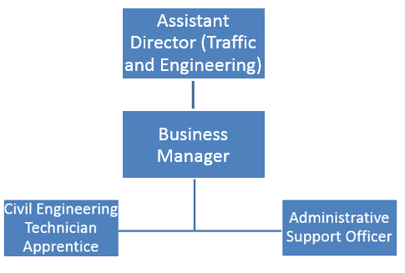

**Person Specification**

|  |  |
| --- | --- |
| **Job Title:**  Civil Engineering Technician Apprentice | **Grade**:  Apprentice |
| **Section:**  Traffic and Engineering | **Directorate:**  Environment and Community Services |
| **Responsible to:**  Business Manager | **Responsible for:**  **N/A** |
| **Post Number/s:** | **Last Review Date:**  **November 2019** |

**Our Values and Behaviours**

The values and behaviours we seek from our staff draw on the high standards of the two boroughs, and we prize these qualities in particular:

**Being open.** This means we share our views openly, honestly and in a thoughtful way. We encourage new ideas and ways of doing things. We appreciate and listen to feedback from each other.

**Being supportive.** This means we drive the success of the organisation by making sure that our colleagues are successful. We encourage others and take account of the challenges they face. We help each other to do our jobs.

**Being positive.** Being positive and helpful means we keep our goals in mind and look for ways to achieve them. We listen constructively and help others see opportunities and the way forward. We have a ‘can do’ attitude and are continuously looking for ways to help each other improve.

|  |  |
| --- | --- |
| **Person Specification Requirements** | **Assessed by**  **A**  **&**  **I/ T/ C (see below for explanation)** |
| **Knowledge** | |
| Appreciation of the role of local government | A/I |
| Understanding the principals of forming good working relationships with colleagues and customers | A/I |
|  |  |
| **Experience** | |
| Experience of dealing effectively with customers | A/I |
| Experience of using a wide range of MS Office packages, including Word, Excel | A/I |
|  |  |
| **Skills** | |
| Ability to analyse and interpret data | A/I |
| Ability to demonstrate attention to detail by producing work that is accurate and on time | A/I |
| Ability to communicate clearly and effectively, both orally and in writing with a wide range of individuals | A/I |
| **Qualifications** | |
| |  | | --- | | Achieved a minimum GCSE grade B in Maths and C in English  Willingness and competence to undertake an Advanced Apprenticeship Level 3 | | C  A/I |

**A – Application form / CV**

**I – Interview**

**T – Test**

**C - Certificate**