Job Profile comprising Job Description and Person Specification
Job Description

Job Title:  Pensions Assistant | Grade:  Scale 4
Section:  Pensions Shared Service | Directorate:  Finance
Responsible to following manager:  Pensions Manager | Responsible for following staff:
Post Number/s: FPL18 & FPW01 | Last review date: January 2018

Working for the Richmond/Wandsworth Shared Staffing Arrangement

This role is employed under the Shared Staffing Arrangement between Richmond and Wandsworth Councils. The overall purpose of the Shared Staffing Arrangement is to provide the highest quality of service at the lowest attainable cost.

Staff are expected to deliver high quality and responsive services wherever they are based, as well as having the ability to adapt to sometimes differing processes and expectations.

The Shared Staffing Arrangement aims to be at the forefront of innovation in local government and the organisation will invest in the development of its staff and ensure the opportunities for progression that only a large organisation can provide.

Job Purpose:

- To be responsible to the Team Leader assisting with the effective and efficient management of the Pensions Shared Service covering all its participating authorities.

- For all participating authorities, to undertake the administration of pension related policies, practices and procedures for the Local Government Pension Scheme (LGPS) with particular reference to the calculation of all benefit entitlements.

- To have knowledge of the LGPS, relevant compensation schemes, HMRC (maximum benefits and social security entitlements) and pensioner payroll.

Job Dimensions:

- Responsible for the accurate calculations of entitlements to benefits and their payments in to and out of the participating authorities’ pension funds and revenue accounts.

- Responsible for checking and recording new entrants to the LGPS for all participating authorities.

Specific Duties and Responsibilities

- In accordance with the provisions of the Local Government Pension Scheme, compensation regulations, employer discretionary policies and overriding HMRC, social security and pensions legislation, calculates entitlements to (and where appropriate the payment of): redundancy or severance, additional contributions, cash equivalent transfer values, refunds of contributions and deferred benefits.

- Assists with Pensioner Payroll input for new entrants and changes for existing Pensioners ensuring the input is accurate and meets the payroll deadlines each month. Liaises with payroll providers, HR, legal, schools, auditors and other relevant officers providing information and assistance when requested.

- Enters payment details on the relevant creditor system, ensuring that payments made to and from the respective pension funds and revenue accounts are correctly allocated and recorded on relevant systems to enable accurate data to be extracted for monitoring and reconciling payments.

- Provides assistance and guidance on pensions generally in writing, on the telephone and in person to all employees answering straight forward enquiries in respect of: additional voluntary contributions, transfers of pension rights, retirement and death benefits, refunds of contributions and permitted maximum benefit accrual.

- Undertakes scanning and indexing and post distribution within the team, entering relevant workflow tasks on Altair as required.

Generic Duties and Responsibilities

- To comply with all the council’s Codes of Practice, including the Code of Conduct, and policies and procedures concerning data protection and health and safety.

- To be committed to the promotion of equality, diversity and inclusion for others, both colleagues and clients and maintain an awareness of the equality and diversity protocol; to work to create and maintain a safe, supportive and welcoming environment where all people are treated with dignity and their identity and culture are valued and respected and to report any instances of inappropriate behaviour or discrimination.

- To be fully aware of and understand the duties and responsibilities arising from the Children’s Act 2004, the London Child Protection Procedures and Working Together in relation to child protection and safeguarding children and young people as this applies to your role within the council. To also be fully aware of the principles of safeguarding as they apply to vulnerable adults in relation to your work role. To ensure that your line manager is made aware and kept fully informed of any concerns which you may have in relation to safeguarding and/or child protection.

- To carry out any other reasonable duties and responsibilities within the overall function, commensurate with the grading and level of responsibilities of the post.

Current team structure

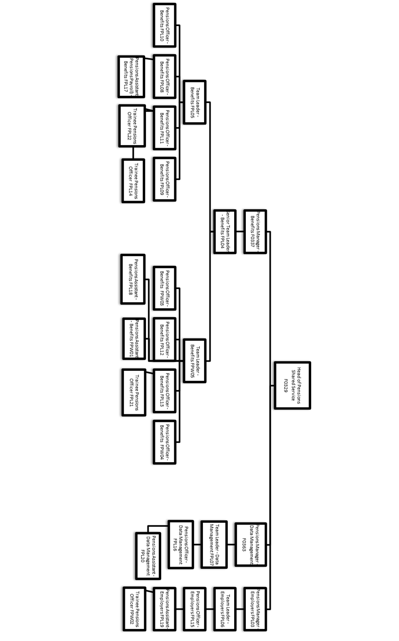

Person Specification

Job Title: Pensions Assistant | Grade: Scale 4
Section: Pensions Shared Service | Directorate: Finance
Responsible to: Pensions Manager | Responsible for:
Post Number/s: FPL18 & FPW01 | Last Review Date: January 2016

Our Values and Behaviours
The values and behaviours we seek from our staff draw on the high standards of the two boroughs, and we prize these qualities in particular:
Being open. This means we share our views openly, honestly and in a thoughtful way. We encourage new ideas and ways of doing things. We appreciate and listen to feedback from each other.
Being supportive. This means we drive the success of the organisation by making sure that our colleagues are successful. We encourage others and take account of the challenges they face. We help each other to do our jobs.
Being positive. Being positive and helpful means we keep our goals in mind and look for ways to achieve them. We listen constructively and help others see opportunities and the way forward. We have a ‘can do’ attitude and are continuously looking for ways to help each other improve.
Person Specification Requirements | Assessed by  A  & I/ T/ C (see below for explanation)
1. Minimum of 3 GCSE’s or equivalent at Grades A-C including Maths and English. | A,C
2. Knowledge of the Local Government Pension scheme (LGPS). | A, I, T
3. Ability to apply and communicate this knowledge to employees, scheme members and colleagues in other service areas (e.g. Human Resources, Payroll, schools and external employers’ representatives). | A, I, T
4. Ability to work flexibly and in response to customer demand and service needs. | A, I,
5. The ability to communicate effectively, both orally and in writing. | A, I
6. Knowledge of relevant ICT packages and the ability to use them effectively. | A, I
7 Ability to develop and promote the service through innovation and creativity. | A, I
8. Good mathematical skills and the ability to incorporate complex rules into calculations. | A, I, T
9. An understanding of the Council’s equal opportunities policy in respect of service delivery and an awareness of the needs of differing cultural and minority groups. | A, I
10. An understanding of the duties and responsibilities in relation to child protection and safeguarding children, young people and vulnerable adults as this applies to this role within the council. | A, I

A – Application form
I – Interview
T – Test
C - Certificate

These values and behaviours will be developed further as the SSA becomes established.

