Job Profile comprising Job Description and Person Specification

Job Description

Job Title:  Income Maximisation Team Leader | Grade:  PO3
Section:  Operations team  Allocations & Provision | Directorate:  Housing and Regeneration
Responsible to following manager:  Housing Income Maximisation and Admin Manager | Responsible for following staff: Income Maximisations Officers (x9)
Post Number/s: | Last review date:  May 2021

Working for the Richmond/Wandsworth Shared Staffing Arrangement

This role is employed under the Shared Staffing Arrangement between Richmond and Wandsworth Councils. The overall purpose of the Shared Staffing Arrangement is to provide the highest quality of service at the lowest attainable cost.

Staff are expected to deliver high quality and responsive services wherever they are based, as well as having the ability to adapt to sometimes differing processes and expectations.

The Shared Staffing Arrangement aims to be at the forefront of innovation in local government and the organisation will invest in the development of its staff and ensure the opportunities for progression that only a large organisation can provide.

Job Purpose

To manage a team responsible for the prompt collection, management and monitoring of all temporary accommodation rents and other income, including minimising arrears for all accounts relating to current and former temporary accommodation.

Specific Duties and Responsibilities

- Responsible to the Housing Income Maximisation and Admin Manager for the collection, management and monitoring of all temporary accommodation rents and charges accounts. Ensuring early interventions to prevent arrears and liaising with agencies so that clients maintain regular payments and are in receipt of welfare benefits. Assisting applicants for claiming housing benefits, as well advising on how to make backdated claims for Housing Benefit.

- Responsible for the line management and development of a team of Income Maximisation Officers, including holding regular, scheduled and structured performance and casework review meetings, supervision and team meetings. Responsible for creating and delivering induction and training action plans and ensuring performance targets are met and/or exceeded.

- Responsible for the monitoring of and dealing with staff sickness, lateness and poor performance within the area of responsibility, and any other matter at the preliminary/informal stage under the SSA’s Human Resources codes in accordance with existing practices and policies.

- Responsible for specifying, producing and analysing statistical and performance monthly reports across all arrears types for senior officers, together with actions plans to maintain performance.

- To be the lead liaison officer for arrears and debt management within housing services other departments in the Council and external agencies such as housing benefits, Citizens Advice, DWP and legal team.

- Recommends cases within an agreed limit to the Housing Income Maximisation and Admin Manager where debt is irrecoverable and which are suitable for submission for write off. Responsible for ensuring that Housing Benefit payments are transferred to the sections computer system(s) resolving any discrepancies arising. Responsible for the checking and authorising of any balances transferred between accounts, sent to other services or refunded to client.

- Responsible for providing detailed information for District Auditor, Internal Auditor and Audit Commission and production of reports/information on all financial duties provided for Homelessness cases.

- Manages the administration of procedures for removal and storage services: including the setting up and closing of accounts, verification of invoices from contractors and liaison with contractors and applicants over unpaid charges and/or disposal of goods.

- Responsible for all correspondence/telephone enquiries from MPs and Councillors in relation to the work of the Housing Income Maximisation Team

- Responsible for the creation and review all the teams processes and procedures are in line with good practice and legislation. Identify service improvements and enhancements to ensure that the team continuously improve.

- Works closely with Operations Team Leader – Admin Support to ensure
appropriate cover across both teams

- Deputises for the Housing Income Maximisation and Admin Manager as required, within the responsibilities of the post

- Undertakes other duties commensurate with the grade as instructed by the Housing Income Maximisation and Admin Manager.

Generic Duties and Responsibilities

- To contribute to the continuous improvement of the services of the Boroughs of Wandsworth and Richmond.

- To comply with relevant Codes of Practice, including the Code of Conduct and policies concerning data protection and health and safety.

- To adhere to security controls and requirements as mandated by the SSA’s policies, procedures and local risk assessments to maintain confidentiality, integrity, availability and legal compliance of information and systems

- To promote equality, diversity, and inclusion, maintaining an awareness of the equality and diversity protocol/policy and working to create and maintain a safe, supportive and welcoming environment where all people are treated with dignity and their identity and culture are valued and respected.

- To understand both Councils’ duties and responsibilities for safeguarding children, young people and adults as they apply to the role within the council.

- The Shared Staffing Arrangement will keep its structures under continual review and as a result the post holder should expect to carry out any other reasonable duties within the overall function, commensurate with the level of the post.

Additional information

- To manage 9x Income Maximisations Officers
- Be prepared to work outside of usual working hours to cover emergencies
- Attend evening meetings
- To attend statutorily convened or otherwise multi-disciplinary meetings/forums
- To do home visits and travel to other sites, and able to use public transport
- As and when directed to meet service needs to assist in the management of Housing Service.

Team structure

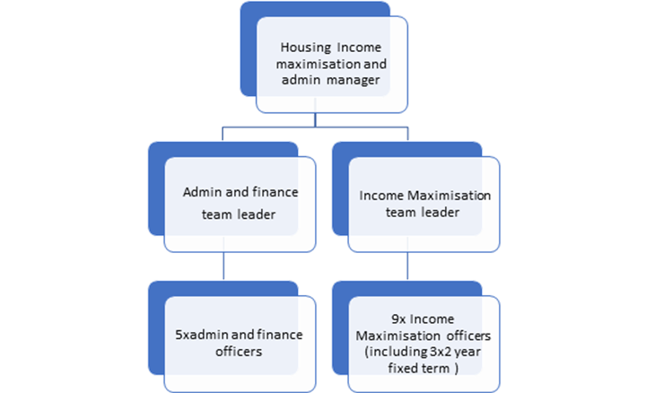

Person Specification

Job Title: Job Title:  Income Maximisation Team leader | Grade:  PO3
Section: Housing Services | Directorate: Housing and Regeneration
Responsible to: Housing Income Maximisation and Admin Manager | Responsible for: Operations Officers – Income Maximisation Officers (x9)
Post Number/s: | Last Review Date:  May 2021

Our Values and Behaviours

The values and behaviours we seek from our staff draw on the high standards of the two boroughs, and we prize these qualities in particular:

Being open. This means we share our views openly, honestly and in a thoughtful way. We encourage new ideas and ways of doing things. We appreciate and listen to feedback from each other.

Being supportive. This means we drive the success of the organisation by making sure that our colleagues are successful. We encourage others and take account of the challenges they face. We help each other to do our jobs.

Being positive. Being positive and helpful means, we keep our goals in mind and look for ways to achieve them. We listen constructively and help others see opportunities and the way forward. We have a ‘can do’ attitude and are continuously looking for ways to help each other improve.

Person specification Requirements | Assessed by A  & I/ T/ C (see below for explanation)
Knowledge
Demonstrate an understanding of good practice on debt and arrears management
An understanding of welfare benefits and ability to provide advice on income maximisation within context of role
Understanding of 1996 Housing Act within context of role
Experience
Experience of working with the public and particularly vulnerable people
Experience working within a team and taking a lead
Experience of good practice around recruiting and interviewing staff
Experience of working in a busy, changing environment and able to effectively manage different priorities
Skills
The ability to use information technology to a high standard.
The ability to undertake a wide range of tasks and manage change.
The ability to create and monitor performance statistics
Proven literacy, numeracy and communication skills .
A calm and empathetic approach when working with the public and dealing with complaints and complex situations
Able to deal with vulnerable clients
Able to work under pressure
Excellent attention to detail
Qualifications
Maths and English GCSE grade C and above or equivalent.

