**Job Profile comprising Job Description and Person Specification**

**Job Description**

|  |  |
| --- | --- |
| **Job Title:**  Senior CIL and S106 Officer | **Grade**:  PO2-PO4 |
| **Section:**  Planning and Transport Strategy Division | **Directorate:**  Environment and Community Services |
| **Responsible to following manager:**  Principal CIL and S106 Officer | **Responsible for following staff:**  Junior Planning staff and CIL and S106 Officers |
| **Post Number/s:** | **Last review date:**  November 2019 |

**Working for the Richmond/Wandsworth Shared Staffing Arrangement**

This role is employed under the Shared Staffing Arrangement between Richmond and Wandsworth Councils. The overall purpose of the Shared Staffing Arrangement is to provide the highest quality of service at the lowest attainable cost.

Staff are expected to deliver high quality and responsive services wherever they are based, as well as having the ability to adapt to sometimes differing processes and expectations.

The Shared Staffing Arrangement aims to be at the forefront of innovation in local government and the organisation will invest in the development of its staff and ensure the opportunities for progression that only a large organisation can provide.

**Job Purpose**

To deliver high quality, robust and transparent decision making within tight time frames on matters relating to S106 legal agreements and the administration of the Community Infrastructure Levy to ensure that the Planning and Transport Strategy Division is recognised as delivering an excellent planning service for its customers. The Senior CIL and S106 Officer will provide day to day management of S106 legal agreements to ensure that the provisions within them are enacted at the correct time and manage incoming funding contributions and its allocation and associated spend; and administer the Community Infrastructure Levy including any related advice requests and correspondence to agreed and identifiable timescales. The Senior CIL and S106 Officer will supervise and coach junior planning and staff and S106 and CIL Officers to help them acquire the skills and knowledge to become self-reliant and independently manage the legal agreements and application of CIL to ensure that the provisions within them are enacted appropriately.

**Specific Duties and Responsibilities**

1. Undertakes a range of duties relating to the management and monitoring of planning obligations from the S106 Agreements and CIL work including responsibility for high profile planning applications, working to identifiable deadlines in a manner that is consistent with meeting corporate targets and objectives.
2. Maintains a good working knowledge of current planning legislation particularly as it relates to planning obligations through S106 Agreements and the CIL.
3. Carries out day to day organisational and administrative tasks to monitor S106 Agreements and determine CIL liabilities, including the application of planning obligations when due, and processing and issuing relevant Notices up to and including Demand Notices.
4. Ensures that funding secured through S106 Agreement is allocated to the necessary person/body, such that the planning obligation can be completed within the agreed timeframe.
5. To process applications for CIL exemption and relief in accordance with the Regulations.
6. Uses Planning Application Systems, Document Management Systems, Council Tax system, non-Domestic Rate Register and Database/Spreadsheets software as necessary to accurately record S106 and CIL information and log Notices.
7. Monitors Commencement Notices and interrogate Building Control, Local Land and Property Gazetteer, Development Monitoring and Council Tax systems to identify commencement and trigger dates.
8. Monitors activity in relation to failure to submit forms, clawback periods etc. and ensures quality control in planning obligation data in relation to the monitoring and S106 Agreements and CIL data.
9. Supplies timely information to facilitate issuing of Demand Notices and collection/recovery action and supplies planning obligation information to Local Land Charges.
10. Liaises with Spatial and Transport Planning Service, Development Management, Finance Department and other Council Officers to establish best practice workflow procedures and identify service improvements.
11. Provides professional advice on S106 Agreement and CIL related matters, including interpretation of Regulations and operation of Planning Obligations as necessary and provide timely response to correspondence and related enquiries.
12. Provides management information and accurate and timely preparation of requested statutory statistical returns to the Information and Planning Obligations Team Manager and Principal Information and Monitoring Officer as required, including projected S106 Agreement and CIL incomes and expenditures.
13. Participates in London and other S106 Agreement and CIL administration best practice forums as required.
14. Contributes to review of procedures and processes related to the monitoring of S106 Agreements and CIL implementation.
15. Provides training on CIL and S106 administrative systems as required.

**CRITERIA FOR PROGRESSION TO PO3 (as for PO2 plus the following)**

1. Works independently on full range of S106 Agreements and CIL work including responsibility for high profile planning applications, working to identifiable deadlines in a manner that is consistent with meeting corporate targets and objectives that required minimal input or correction from the Principal Information and Monitoring Officer and Information and Planning Obligations Team Manager.
2. Maintains an up-to-date knowledge of relevant legislation and takes a proactive approach to relevant changes in legislation, updating colleagues within policy and other teams on those changes and also recommending revised procedures and practices to the Principal Information and Monitoring Officer and Information and Planning Obligations Team Manager.
3. Leads and implements self-contained projects or components of larger projects in order to deliver organisational objectives as well as enabling agreed changes in planning practice and processes to take place.
4. Coaches and facilitates the acquisition of skills and knowledge in others so that they are better equipped to be self-reliant in dealing technical and people issues, particularly for complex and high-profile planning obligation case work.
5. Provides advice and guidance in response to planning best practice, procedure or policy within a legal/organisational policy framework and develops solutions or recommendations to meet service needs.
6. Initiates, participates in and where necessary takes a management role on matters relating to S106 Agreement and CIL specific matters and conflict resolution to ensure high quality innovative outcomes that reflect Council-wide objectives and policies.
7. To process CIL reviews and Appeals in conjuction with the Principal Information and Monitoring Officer and Information and Planning Obligations Team Manager and legal officers.

**CRITERIA FOR PROGRESSION TO PO4 (as for PO3 plus the following)**

1. When necessary, the postholder will be responsible for the direct supervision of at least one member of staff undertaking tasks of a project nature.
2. Maintains an up-to-date knowledge of relevant legislation and takes a proactive approach to relevant changes in legislation and updating all staff on those changes, including making recommendations for implementing revised procedures and practices.
3. Coaches and facilitates the acquisition of skills and knowledge in others so that they are better equipped to be self-reliant in dealing with technical and people issues, particularly focusing on complex, high profile and politically sensitive project specification matters.
4. Takes a lead role in providing advice and guidance in response to S106 Agreement best practice, procedure or policy within a legal/organisational framework and develops and implements solutions or recommendations to meet service needs.
5. Takes responsibility for ensuring the team meets service-wide and corporate performance indicators, targets and customer service standards of the full range of the team’s work. Proactive in identifying issues and proposing improvements and creative solutions within the context of current and future service requirements in order to continually deliver high quality, customer focused planning services to customers and managers.

**Generic Duties and Responsibilities**

* To contribute to the continuous improvement of the services of the Boroughs of Wandsworth and Richmond.
* To comply with relevant Codes of Practice, including the Code of Conduct and policies concerning data protection and health and safety.
* To adhere to security controls and requirements as mandated by the SSA’s policies, procedures and local risk assessments to maintain confidentiality, integrity, availability and legal compliance of information and systems
* To promote equality, diversity, and inclusion, maintaining an awareness of the equality and diversity protocol/policy and working to create and maintain a safe, supportive and welcoming environment where all people are treated with dignity and their identity and culture are valued and respected.
* To understand both Councils’ duties and responsibilities for safeguarding children, young people and adults as they apply to the role within the council.
* The Shared Staffing Arrangement will keep its structures under continual review and as a result the post holder should expect to carry out any other reasonable duties within the overall function, commensurate with the level of the post.

**Additional Information**

Assists as required with management of budgets, including ensuring that all necessary processes and procedures are carried out in a timely and effective manner.

Provides supervision as required to assigned staff and takes responsibility for the allocation and checking of work by staff.

**Team structure**

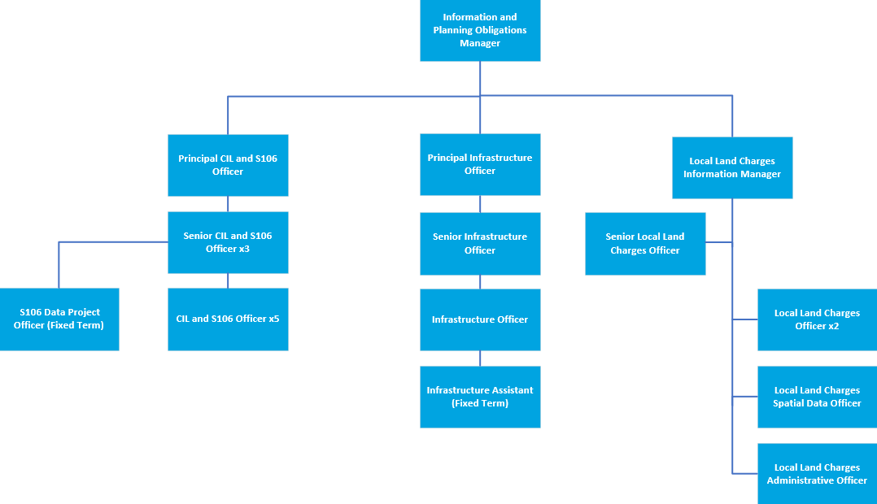

**Person Specification**

|  |  |
| --- | --- |
| **Job Title:**  Senior CIL and S106 Officer | **Grade**:  PO2-PO4 |
| **Section:**  Planning and Transport Strategy Division | **Directorate:**  Environment and Community Services |
| **Responsible to:**  Principal CIL and S106 Officer | **Responsible for:**  Junior Planning staff and CIL and S106 Officers |
| **Post Number/s:** | **Last Review Date:**  November 2019 |

**Our Values and Behaviours**

The values and behaviours we seek from our staff draw on the high standards of the two boroughs, and we prize these qualities in particular:

**Being open.** This means we share our views openly, honestly and in a thoughtful way. We encourage new ideas and ways of doing things. We appreciate and listen to feedback from each other.

**Being supportive.** This means we drive the success of the organisation by making sure that our colleagues are successful. We encourage others and take account of the challenges they face. We help each other to do our jobs.

**Being positive.** Being positive and helpful means we keep our goals in mind and look for ways to achieve them. We listen constructively and help others see opportunities and the way forward. We have a ‘can do’ attitude and are continuously looking for ways to help each other improve.

|  |  |
| --- | --- |
| **Person Specification Requirements** | **Assessed by A**  **&**  **I/ T/ C** |
| **Knowledge** | |
| A good knowledge of planning legislation and more detailed up to date knowledge of that relating to S106 Agreements and CIL administration and their application to development | A/I/T |
| Advanced knowledge of Excel and Access and ability to use a wide range of computer software to collate, query, analyse, interpret and present data. | A/I/T |
| An understanding of planning and building control and related IT systems. | A/I/T |
| **Experience** | |
| Experience of supervising and mentoring staff to deliver workload to required standard, particularly when there are competing deadlines. | A/I |
| Experience of coaching staff to meet work demands. | A/I |
| Experience in working in development management and/or the management of S106 Agreements and CIL Administration. | A/I |
| Experience in working in a high-pressure environment | A/I/T |
| **Skills** | |
| Proven information management and numeracy skills and ability to produce and collate accurate information and data reports | A/I/T |
| Ability to lead on designated projects with minimum supervision | A/I |
| Ability to communicate and liaise effectively, both verbally and in writing, with a range of colleagues and customers. | A/I/T |
| Have a methodical approach to work with high levels of accuracy and ability to pay meticulous attention to detail. | A/I/T |
| A professional approach, with ability to interpret complex Regulations and make reasoned and consistent judgements | A/I |
| A self-starter with the ability to get to grips with work quickly and independently | A/I |
| Ability to work effectively to meet challenging deadlines and manage competing and changing priorities. | A/I |
| Ability to use initiative and identify innovative solutions to everyday challenges, continually striving to improve service delivery. | A/I/T |
| **Qualifications** | |
| Membership or working towards membership of an appropriate professional body. | A/C |

**A – Application form / CV**

**I – Interview**

**T – Test**

**C - Certificate**