Job Profile comprising Job Description and Person Specification

Job Title:  Senior Social Worker | Grade: PO3
Section:  Adult Specialist Community Services | Department:  Education and Social Services
Responsible to following manager:  Service / Locality Manager | Responsible for following staff:  Social Workers, Social Care Assessors
Post Number/s: | Last review date:  November 2016

Working for the Richmond/Wandsworth Shared Staffing Arrangement

This role is employed under the Shared Staffing Arrangement between Richmond and Wandsworth Councils. The overall purpose of the Shared Staffing Arrangement is to provide the highest quality of service at the lowest attainable cost.

Staff are expected to deliver high quality and responsive services wherever they are based, as well as having the ability to adapt to sometimes differing processes and expectations.

The Shared Staffing Arrangement aims to be at the forefront of innovation in local government and the organisation will invest in the development of its staff and ensure the opportunities for progression that only a large organisation can provide.

Job Purpose

The Senior Social Worker supports the Assistant Service / Locality Manager and Service / Locality Manager to ensure the delivery of a person-centred service for adults with social care needs and their carers. This includes the supervision of staff, social workers and social care assessors, within the service and acting a Safeguarding Adult Manager (SAM). The Senior Social Worker will also be responsible for a caseload of more complex cases, maintaining a high level of professional service. They have a lead role in promoting high standards of front line practice, linking with the Principal Social Worker as required.

Specific Duties and Responsibilities

- To provide operational and motivational leadership of staff, promoting a good working environment with the primary aim of delivering high quality services.

- To provide case management, guidance, support and expert advice to social care staff, students and partner staff as and when required, maintaining the highest level of professional service and ensuring that the assessment and provision of social care services is in accordance with the Care Act 2014 guidelines and Council’s policies.

- To provide professional supervision for social care staff, including social workers and social care assessors, in the team, including undertaking regular case file audits, identifying continuing professional development and training needs of the staff working with the Service / Locality Manager to meet these needs.

- To hold a caseload of a high level of complexity and to maintain a high standard of professional practice and competence in keeping with partner agencies' standards, policies and guidance and the relevant national code of conduct (e.g. HCPC) and to contribute to the development of services and good practice in social work management as well as policies and procedures within the Department accordingly.

- To facilitate service user choice and empowerment through promoting independence and the personalisation agenda through all stages of assessment, support planning and review to enable service users to maintain independence for as long as possible.

- To provide advice, information and guidance to service users and carers ensuring that that support plans and other information regarding individual care packages is shared with the service user, carers and other agencies as required in accordance with the Council’s policies and procedures including those on data protection.

- To assist as required with the management of budgets, ensuring that processes and procedures are carried out in a timely and effective way; including authorising assessments, support plans, reviews and to arrange and agree necessary funding to meet the requirements of individual support plans within available resources.

- To monitor implementation of packages of care and support and adjust them as appropriate and to ensure that individual care packages, including funding arrangements for any services, are thoroughly reviewed in accordance with statutory requirements and Council policy to ensure highest quality of service and best value.

- To undertake statutory intervention where service users are deemed to be at risk, including situations where people may be neglected or abused in accordance with the Inter-Agency Policy and Procedures for Safeguarding Adults and to chair protection of vulnerable adults meetings where required.

- To ensure that information is recorded consistently, accurately and meets statutory timescales. To ensure that service user confidentiality is maintained and that information is shared with the service user, carers and other agencies in accordance with the Department’s data protection requirements.

Generic Duties and Responsibilities

- To contribute to the continuous improvement of the services of the Boroughs of Wandsworth and Richmond.

- To comply with relevant Codes of Practice, including the Code of Conduct and policies concerning data protection and health and safety.

- To adhere to security controls and requirements as mandated by the SSA’s policies, procedures and local risk assessments to maintain confidentiality, integrity, availability and legal compliance of information and systems.

- To promote equality, diversity, and inclusion, maintaining an awareness of the equality and diversity protocol/policy and working to create and maintain a safe, supportive and welcoming environment where all people are treated with dignity and their identity and culture are valued and respected.

- To understand both Councils’ duties and responsibilities for safeguarding children, young people and adults as they apply to the role within the council.

- The Shared Staffing Arrangement will keep its structures under continual review and as a result the post holder should expect to carry out any other reasonable duties within the overall function, commensurate with the level of the post.

- To contribute towards the development of good working relations and collaborative arrangements with relevant organisations including private, voluntary and other public organisations.

- To advise and support managers on the relevant matters affecting the service and to contribute as required to change programmes within the service.

- To support ways of working that ensure that residents and stakeholders are actively engaged in the future of the service and are able to influence decision making.

Additional Information

- The Senior Social Worker is responsible for direct and indirect line management of staff, including Social Workers, Social Care Officers and students.

- The Senior Social Worker will take on delegated management responsibilities, including deputising for the Assistant Service / Locality Manager assisting with day-to-day management of the team and its performance.

- The Senior Social Worker will contribute as required by the Service / Locality Manager to the training of other staff locally and through programmes arranged by the Department’s Learning and Development section including leading panels, workshops, projects etc. concerning the development and improvement of services and will participate in research, where required and as authorised by the Directorate.

Current team structure

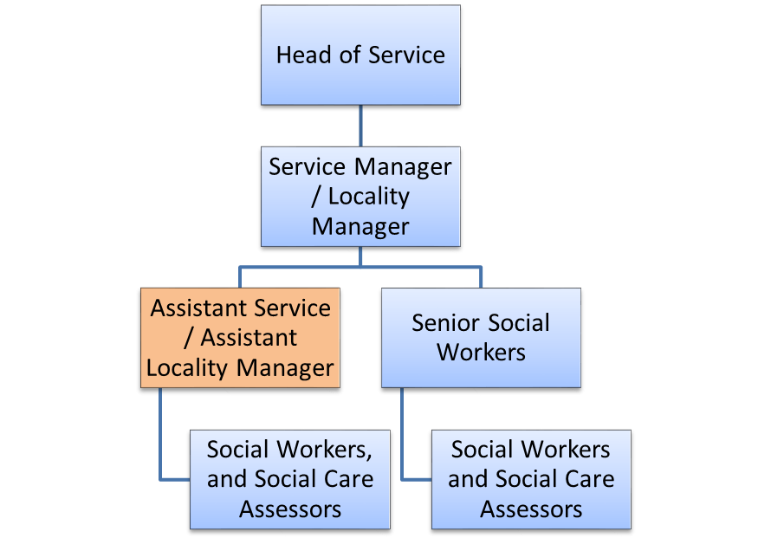

Person Specification

Job Title:  Senior Social Worker | Grade: PO3
Section:  Adult Specialist Community Services | Department:  Education and Social Services
Responsible to following manager:  Service / Locality Manager | Responsible for following staff:  Social Workers, Social Care Assessors
Post Number/s: | Last review date:  November 2016

Our Values and Behaviours

The values and behaviours we seek from our staff draw on the high standards of the two boroughs, and we prize these qualities in particular:

Being open. This means we share our views openly, honestly and in a thoughtful way. We encourage new ideas and ways of doing things. We appreciate and listen to feedback from each other.

Being supportive. This means we drive the success of the organisation by making sure that our colleagues are successful. We encourage others and take account of the challenges they face. We help each other to do our jobs.

Being positive. Being positive and helpful means we keep our goals in mind and look for ways to achieve them. We listen constructively and help others see opportunities and the way forward. We have a ‘can do’ attitude and are continuously looking for ways to help each other improve.

Person Specification Requirements | Assessed by  A  & I/ T/ C (see below for explanation)
Knowledge
- Knowledge of current developments and legislation, national guidance and frameworks in providing a service to (a) older people and/or adults with a physical disability or sensory impairment and/or with adults with acute or chronic health care needs and/or with adults with learning disabilities and (b) to carers with the ability to advise practitioners in their application. | A, I
- A sound knowledge and understanding of the local authority’s responsibilities in the safeguarding of vulnerable adults, and the ability, to lead the team in ensuring that cases related to safeguarding vulnerable adults are handled in accordance with policy and procedures. | A, I
- An awareness of the basic principles of budget management in order to appropriately authorise services within the Council’s resources. | A, I
Experience
- Substantial post-qualification experience of working in a statutory Health or Social Care setting, preferably in a multi-disciplinary team, undertaking assessments, support planning and reviews to improve the well-being and independence of adults and their carers. | A, I
- Experience of identifying and managing risk, planning appropriate interventions, successfully undertaking safeguarding investigations and ability to chair safeguarding meetings and advise practitioners in this process. | A, I
- Experience of achieving positive outcomes for service users and the community through multi-disciplinary and partnership working. | A, I
Skills
- Ability to communicate clearly and effectively both orally and in writing, including use of financial and activity data, report writing, presenting and negotiating. | A, I, T
- The ability to effectively manage time and complex, completing demands in a high pressured environment. | A, I
- Ability to provide high quality professional supervision to qualified and unqualified staff, and to promote their continuous professional development. Ability to use supervision to maximise personal effectiveness and professional development. | A, I
- Ability to manage and motivate staff including performance management and staff development to deliver high quality results. | A, I
- IT skills and keyboard skills in order to be proficient in the use of Outlook, Word and client database systems. | A, I, T
Qualifications
- A relevant professional qualification in social work and current registration with the HCPC. | A

A – Application form
I – Interview
T – Test
C - Certificate

