Job Profile comprising Job Description and Person Specification
Job Description

Job Title: Temporary Accommodation Procurement Officer | Grade: PO1
Section: Temporary Accommodation Team | Directorate: Housing and Regeneration
Responsible to following manager:  Deputy Temporary Accommodation Procurement Manager | Responsible for following staff: None
Post Number/s: | Last review date:

Working for the Richmond/Wandsworth Shared Staffing Arrangement

This role is employed under the Shared Staffing Arrangement between Richmond and Wandsworth Councils. The overall purpose of the Shared Staffing Arrangement is to provide the highest quality of service at the lowest attainable cost.

Staff are expected to deliver high quality and responsive services wherever they are based, as well as having the ability to adapt to sometimes differing processes and expectations.

The Shared Staffing Arrangement aims to be at the forefront of innovation in local government and the organisation will invest in the development of its staff and ensure the opportunities for progression that only a large organisation can provide.

Job Purpose

Responsible for the Allocation, Procurement and Management of Temporary Accommodation

Specific Duties and Responsibilities

- Responsible for the selection and letting of all types of temporary accommodation within statutory guidelines, under each Councils’ sovereign housing duties and Homeless Code of Guidance.
- Responsible for the administrative functions in relation to temporary offers, including the statutory discharge of duty and investigating suitability reviews.
- Responsible for the management of accommodation provided to homeless households occupying various type of temporary accommodation managed by third party landlords through regular inspections. Ensuring occupation by homeless households, compliance proper standards of repair, health and safety and amenities to provide quality accommodation for homeless families. To be on call for out of hours emergencies and participate in duty rotas across the service.
- To attend court where relevant to matters of litigation or other legal proceedings. To draft replies for reports in respect of enquiries from Councillors, members, LGO, solicitors and other agencies.
- Responsible for administering, promoting and developing the Councils’’ various housing procurement initiatives and projects. Responsible for promoting the various options and arranging tenancies for properties under the Councils’ schemes.
- To ensure long term supply of competitively priced suitable accommodation to meet the Councils’ statutory and policy aims
- Responsible for developing links and partnerships with private sector landlords and letting agents and other providers of housing to increase the supply of suitable accommodation to meet various housing duties and powers for households who are homeless or at risk of homelessness, and/or seeking housing mobility.
- Responsible for inspecting potential properties in and outside of the boroughs, assessing physical conditions and verifying various issues relevant to the suitability of such properties for the Councils’ housing purposes. Negotiates, within approved procedures, the terms on which the Council will procure properties including the payment of monies whether by way of lease agreements or as procurement and/or tenancy renewal incentives.
- To provide any ongoing necessary support and advice for the landlords who have accepted referred applicants.
- Ensure that appropriate performance and accurate budgetary information is maintained, Acts as a verification officer, in line with applicable guidance from the Director of Finance and/or Head of Audit, for the purposes of confirming the authenticity of documents provided in support of claims for Local Housing Allowance.

Generic Duties and Responsibilities

- To contribute to the continuous improvement of the services of the Boroughs of Wandsworth and Richmond.

- To comply with relevant Codes of Practice, including the Code of Conduct and policies concerning data protection and health and safety.

- To adhere to security controls and requirements as mandated by the SSA’s policies, procedures and local risk assessments to maintain confidentiality, integrity, availability and legal compliance of information and systems

- To promote equality, diversity, and inclusion, maintaining an awareness of the equality and diversity protocol/policy and working to create and maintain a safe, supportive and welcoming environment where all people are treated with dignity and their identity and culture are valued and respected.

- To understand both Councils’ duties and responsibilities for safeguarding children, young people and adults as they apply to the role within the council.

- The Shared Staffing Arrangement will keep its structures under continual review and as a result the post holder should expect to carry out any other reasonable duties within the overall function, commensurate with the level of the post.
Additional Information
- To be able to carry out property inspections and viewings
- To be part of a duty team
- Must have use of motorised transport and be able to carry out visits and/or be able to carry out visits using public transport
- To work outside of normal working hours to cover emergencies
- To be able to work with vulnerable applicants
- As and when directed in response to service needs and or service needs to undertake the duties of an officer on property management and allocation team.

Team structure

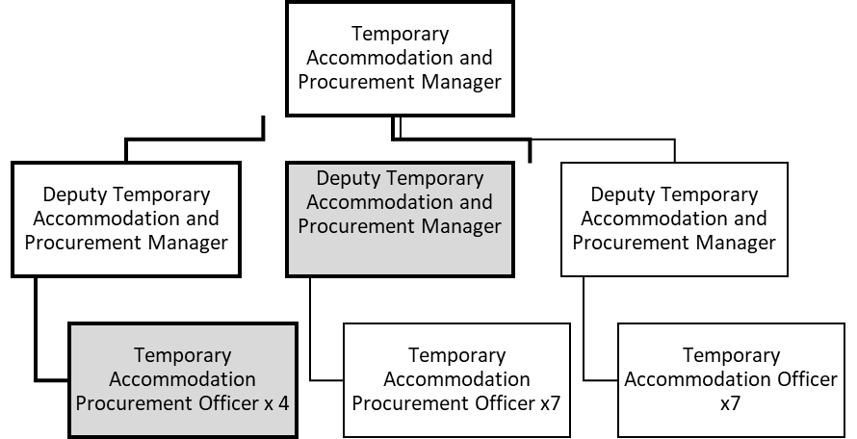

Person Specification

Job Title: Temporary Accommodation Procurement Officer | Grade: PO1
Section: | Directorate: Housing and Regeneration
Responsible to: Deputy Temporary Accommodation Officer | Responsible for: None
Post Number/s: | Last Review Date:

Our Values and Behaviours

The values and behaviours we seek from our staff draw on the high standards of the two boroughs, and we prize these qualities in particular:

Being open. This means we share our views openly, honestly and in a thoughtful way. We encourage new ideas and ways of doing things. We appreciate and listen to feedback from each other.

Being supportive. This means we drive the success of the organisation by making sure that our colleagues are successful. We encourage others and take account of the challenges they face. We help each other to do our jobs.

Being positive. Being positive and helpful means, we keep our goals in mind and look for ways to achieve them. We listen constructively and help others see opportunities and the way forward. We have a ‘can do’ attitude and are continuously looking for ways to help each other improve.

Person Specification Requirements | Assessed by  A  & I/ T/ C (see below for explanation)
Knowledge
Suitability of temporary accommodation and procurement of suitable properties as detailed in the relevant code of guidance | A&I
Welfare reform | A&I
HHSRS | A,I,C
Experience
Working effectively in a busy, pressurised environment within a team and under own initiative. As well as being able to adapt quickly when priorities and targets change. | A&I
Working knowledge of complex legislation applicable to the post in particular, homeless legislation, guidance, case law, practice and landlord and tenant law | A&I
Proven excellent communication skills in dealing with applicants, particularly those with medical/disabilities.
Skills
The ability to work effectively in a busy, pressurised environment within a team in any location. As well as being able to adapt quickly when priorities and targets change. | A&I
The ability to apply working knowledge of complex legislation applicable to the role in particular, homeless legislation, case law, welfare benefits, relevant Codes, as well as landlord and tenant law. | A&I
Qualifications
Maths and English GCSE grade C and above or equivalent | C

A – Application form / CV
I – Interview
T – Test
C - Certificate

