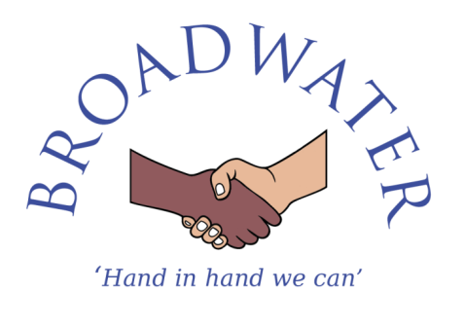

Person Specification – Premises Assistant

Premises Assistant Selection Criteria | Essential or  Desirable
Qualifications
- Hold recognised training/qualifications associated with Health & Safety  - Risk Assessment experience and/or qualification.  - Hold a pool technician qualification.  - Willingness to participate in development and training opportunities.  - Full, clean driving licence | - Desirable  - Desirable  - Desirable  - Desirable  - Desirable
Experience
- Experience or skills in a trade and/or basic repairs and maintenance  - Experience of working in a school environment. | - Essential  - Desirable
Professional knowledge and understanding
- Able to understand and comply with health and safety regulations to ensure that duties are carried out safely.  - Able to operate and understand electrical/mechanical systems.  - Able to use small industrial, electrical and mechanical equipment.  - Able to adhere to the school’s policies and procedures and most importantly the equal opportunities policy, child protection policy and all health & safety related policies.  - Knowledge of safeguarding children and young people | - Essential  - Essential  - Essential  - Essential  - Desirable
Skills
- Able to perform the physical tasks required by the post including lifting, carrying and pushing various equipment to undertake the duties of the post.  - Good level of written and spoken English.  - Good numeracy skills.  - Good ICT skills.  - Able to gather information and problem solve.  - Able to manage own time effectively and demonstrate initiative including establishing priorities.  - Able to prioritise and manage workflow within specific deadlines whilst maintaining a flexible approach to respond to urgent requests.  - Display a conscientious and logical approach to the variety of tasks necessary for the smooth running of the school.  - Able to adapt to changing and conflicting demands.  - Able to model an assertive and respectful way in talking and dealing with children.  - Able to model the idea of respect between all staff and pupils.  - Able to engage with and communicate effectively to a range of audiences  - Able to judge when to make decisions and when to consult with others  - Able to deal sensitively with people and resolve conflicts | - Essential  - Essential  - Essential  - Essential  - Essential  - Essential  - Essential  - Essential  - Essential  - Essential  - Essential  - Essential  - Essential  - Essential

Professional Qualities
- Committed to excellence with high aspirations for all pupils  - Committed to the maintenance of good relationships with staff, parents, pupils, governors, the community and other stakeholders  - Well organised and able to work under pressure and to deadlines  - Able to work as part of a team or individually as required  - Able to self-evaluate learning needs and actively seek professional development opportunities  - Committed to equality, with respect and empathy to all  - Enthusiastic and inspiring to staff, pupils and parents  - Capacity to be flexible and adaptable – willing to take on and develop the best of ideas from within and outside the school  - Able to respond to every day and emergency situations calmly and quickly  - Resilient and has a good sense of humour | - Essential  - Essential  - Essential  - Essential  - Essential  - Essential  - Essential  - Essential  - Essential  - Essential  - Essential

Broadwater Primary School is committed to safeguarding and promoting the welfare of children and young people and expects all staff and volunteers to share this commitment. This post is subject to an enhanced Disclosure & Barring Service (DBS) check.

