**Job Profile comprising Job Description and Person Specification**

**Job Description**

|  |  |
| --- | --- |
| **Job Title:**  Chief Press Officer, News and Reputation Management | **Grade**:  P06 |
| **Section:**  Communications | **Directorate:**  Chief Executive |
| **Responsible to following manager:**  Head of Communications | **Responsible for following staff:**  Senior Media Officer |
| **Post Number/s:**  pending | **Last review date:**  May 2024 |

**Working for the Richmond/Wandsworth Shared Staffing Arrangement**

This role is employed under the Shared Staffing Arrangement between Richmond and Wandsworth Councils. The overall purpose of the Shared Staffing Arrangement is to provide the highest quality of service at the lowest attainable cost.

Staff are expected to deliver high quality and responsive services wherever they are based, as well as having the ability to adapt to sometimes differing processes and expectations.

The Shared Staffing Arrangement aims to be at the forefront of innovation in local government and the organisation will invest in the development of its staff and ensure the opportunities for progression that only a large organisation can provide.

The Communications Team is at the centre of the Council and has a high impact on the services and audiences it serves. It provides strategic leadership on media relations, public relation, event management, community engagement, publications, social media management and monitoring, branding, design and the councils websites. It is also responsible for the operational oversight, delivery and coordination of all communications activity across the wider council.

**Job Purpose**

As the **Chief Press Officer News and Reputation Management**, you will be responsible for protecting and promoting the reputation of Wandsworth Council's and its projects, policies, and services. You will lead, alongside the Head of Communications, on managing reputational risk, developing, maintaining and activating the Council’s crisis communications protocol, media training for cabinet members, maintaining a helicopter view across the organisation of areas of reputational risk and initiatives to enhance the council's reputation.

**Specific Duties and Responsibilities**

* You will be a trusted advisor to the most senior leaders in the organisation, and be able to speak for and on behalf of the Council on high profile external platforms and through the media on a regular basis.
* Communications Account Manager for Directorate Portfolios represented by a councillor, and providing senior level support the account manager for a councillor.
* Developing and implementing media relations strategies to enhance the organisation's reputation and visibility.
* Serving as a spokesperson for the organisation, handling inquiries from journalists and managing media interviews.
* Crafting press releases, statements, and other communications materials to convey key messages and announcements.
* Building and maintaining relationships with members of the media to secure positive coverage and manage potential crises.
* Monitoring media coverage and analysing public sentiment to inform future communication strategies.
* Collaborating with comms SMT including marketing, publication and campaigns to ensure consistency in messaging.
* Providing media training to key members to effectively communicate with the press.
* Managing a senior press officer to execute media relations activities effectively.
* Stay informed about relevant issues, trends, and developments in local government, PR, and communications, and apply insights to enhance our approach.

**Generic Duties and Responsibilities**

* To contribute to the continuous improvement of the services of the Boroughs of Wandsworth and Richmond.
* To comply with relevant Codes of Practice, including the Code of Conduct and policies concerning data protection and health and safety.
* To adhere to security controls and requirements as mandated by the SSA’s policies, procedures and local risk assessments to maintain confidentiality, integrity, availability and legal compliance of information and systems
* To promote equality, diversity, and inclusion, maintaining an awareness of the equality and diversity protocol/policy and working to create and maintain a safe, supportive and welcoming environment where all people are treated with dignity and their identity and culture are valued and respected.
* To understand both Councils’ duties and responsibilities for safeguarding children, young people and adults as they apply to the role within the council.
* The profile is not intended to be an exhaustive list of the duties the post holder will carry out. Other reasonable duties commensurate with the level of the post, including supporting emergency and priority situations, will form part of the role.

**Additional Information**

**Our Values**

**THINK BIGGER**

**EMBRACE DIFFERENCE**

**CONNECT BETTER**

**LEAD BY EXAMPLE**

**PUT PEOPLE FIRST**

Our Values are embedded across the SSA and throughout all roles and responsibilities at all levels of the organisation. Please [familiarise yourself with our values](https://www.richmond.gov.uk/media/afdbdeao/five_values.pdf) as they are an integral part of our recruitment and selection process.

**Team structure**

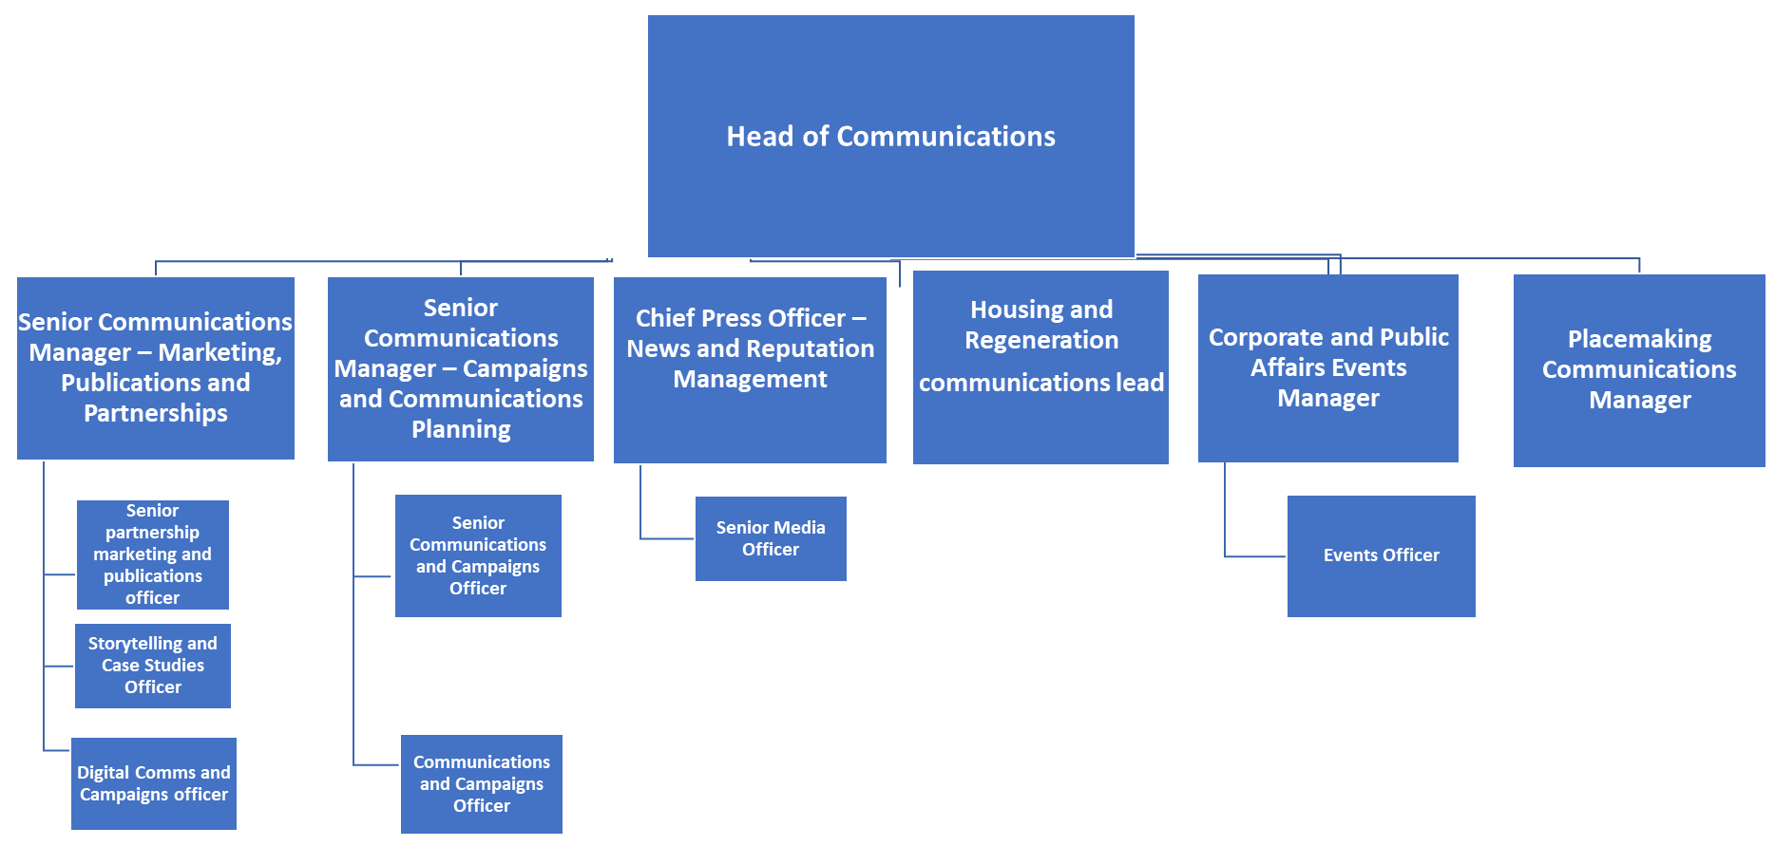

**Person Specification**

|  |  |
| --- | --- |
| **Job Title:** Chief Press Officer, News and Reputation Management | **Grade**: P06 |
| **Section:** Communications | **Directorate:** Chief Executive |
| **Responsible to:** Head of Communications | **Responsible for:** Senior Media Officer |
| **Post Number/s:** | **Last Review Date:** May 2024 |

**Our Values and Behaviours**

The values and behaviours we seek from our staff draw on the high standards of the two boroughs, and we prize these qualities in particular:

**Being open.** This means we share our views openly, honestly and in a thoughtful way. We encourage new ideas and ways of doing things. We appreciate and listen to feedback from each other.

**Being supportive.** This means we drive the success of the organisation by making sure that our colleagues are successful. We encourage others and take account of the challenges they face. We help each other to do our jobs.

**Being positive.** Being positive and helpful means we keep our goals in mind and look for ways to achieve them. We listen constructively and help others see opportunities and the way forward. We have a ‘can do’ attitude and are continuously looking for ways to help each other improve.

|  |  |  |  |  |
| --- | --- | --- | --- | --- |
| **Person Specification Requirements** | | | | **Assessed by**  **A/I/T/C**  **(see below for explanation)** |
| **Knowledge** | **Essential** | **Desirable** | **Assessed** | |
| Outstanding writing, editing, and verbal communication skills | **x** |  | **A&T** | |
| Knowledge of local government policies and issues |  | **x** | **A&I** | |
| Excellent interpersonal skills, with the ability to build relationships and collaborate effectively with diverse stakeholders. | **x** |  | **I** | |
| **Experience** | **Essential** | **Desirable** | **Assessed** | |
| Experience in PR, media relations, or communications, preferably within a public sector or government environment. Previous experience as a journalist would be an advantage. | **x** |  | **A** | |
| Demonstrated ability to develop and execute successful PR campaigns, including crisis communications management. | **x** |  | **A** | |
| Knowledge of Wandsworth borough |  | **x** | **A** | |
| **Skills** | **Essential** | **Desirable** | **Assessed** | |
| Ability to tailor messages for different audiences. | **x** |  | **T** | |
| Strategic thinking and problem-solving abilities, with a results-driven mindset | **x** |  | **I&T** | |
| Clear understanding of how to use and assess the effectiveness of social media and other e-marketing tools. | **x** |  | **A&I** | |
| **Qualifications** | **Essential** | **Desirable** | **Assessed** | |
| Bachelor's degree in communications, public relations, journalism, or a related field |  | **x** | **A** | |
|  |  |  |  | |
|  |  |  |  | |

**A – Application form / CV**

**I – Interview**

**T – Test**

**C - Certificate**