Job Description

Job Title: Director of Public Health | Grade: Hay-3
Section: Public Health | Department: Adults Social Care & Public Health
Responsible to: Director of Adult Social Care & Public Health | Date: December 2019
Post Number(s): RWC0004

Working for the Richmond/Wandsworth Shared Service

This is a senior leadership role working for both Richmond and Wandsworth Councils. The purpose of the shared management arrangement is to provide the best possible professional advice, managerial leadership and provision of service to the two boroughs. The role requires a high level of responsiveness to the needs and expectations of both councils, and the ability to adapt to sometimes differing processes and member expectations. The overall purpose is to provide the highest quality of service at the lowest attainable cost, while meeting the expectations of both councils. In order to succeed at this level, a high level of drive, stamina and political sensitivity are required, along with the ability to foster effective teamwork, help others achieve their maximum contribution and set standards for continuous improvement.

Job Purpose:
The Director of Public Health is the most senior advocate for public health across Richmond and Wandsworth. The post holder is the statutory chief officer responsible for public health duties which include health improvement, health protection and the delivery of public health services.

Specific Duties and Responsibilities relating to this role:

- To be the chief source of leadership, expertise and advice to the borough Councils of Richmond and Wandsworth, their elected members, senior officers and partners including their respective Clinical Commissioning Groups (CCGs), General Practitioners, hospital trusts and other stakeholders in public health.

- To be a proactive partner to the newly formed SWL CCG and its associated local governance.

- To be a member of the Health and Wellbeing Boards in both council areas, to advise and support these boards with relevant data, analysis and strategies.

- To take responsibility for the coordination of the Joint Strategic Needs Assessment (JSNA), Health and Wellbeing strategies and to produce the statutory annual report of the Director of Public Health in both borough councils.

- To work with other council departments, relevant partners and agencies to promote and influence the widest possible participation in the health and wellbeing agenda and to ensure that all relevant public services take responsibility for their part in delivering improved public health, and especially to identify and narrow existing health inequalities for each borough.

- To contribute to borough emergency planning and to ensure that effective and tested plans are in place in the wider health sector to protect the local populations from public health risks.

- To be responsible for the cost effective commissioning of Public Health services by both councils and to provide expert specialist Public Health advice to commissioners on priorities for Health and Social Care spending and the configuration of services in order to maximise opportunities for health.

The above list gives an indication of the full range of responsibilities, but is not intended to be exhaustive.

Generic Duties and Responsibilities

- To ensure that the services for both Councils are dealt with on an equitable basis to deliver the standards required for each, as agreed annually by the Executives of both Councils.

- To provide strategic and motivational leadership of staff, providing a visible presence to the workforce and promoting a good working environment with the primary aim of delivering high quality services.

- To provide effective management of staff, including recruitment, training, development and appropriate application of policies and codes of practice on staffing matters.

- To advise and support Members on all relevant service matters, including advising on legislative developments, making policy proposals, commenting on reports, and attending Member meetings as required.

- To oversee sound business and budget plans and to ensure services and functions are effectively managed within the approved budget.

- To ensure that performance review and improvement and customer focus is embedded within services, as well as seeking innovative and creative solutions to securing highest quality and value for money services.

- To effectively manage programmes and projects to ensure they deliver on time and within agreed budgets.

- To ensure that residents and stakeholders are actively engaged in the future of their communities and services and are able to influence decision making. In Richmond, a key mechanism for this will be the village planning programme.

- To provide effective commissioning, market testing and contract management of services, ensuring delivery to specification and within budget; and to manage processes for the timely re-procurement of relevant contracts in liaison with procurement and legal colleagues.

- To promote and develop good working relations and collaborative arrangements with relevant third party organisations agencies including private, voluntary and other public organisations, to forge effective partnership working.

- To represent the Council and customers, where appropriate, in dealing with external organisations (Government departments, other public authorities etc.)

- To fully comply with the scheme of delegation including all standing orders and financial controls as specified by either Council.

- To comply with all the relevant Codes of Practice, including the Code of Conduct, and policies and procedures concerning data protection and health and safety.

- To be committed to the promotion of equality, diversity and inclusion for others, both colleagues and clients and maintain an awareness of equality and diversity policies. To work to create and maintain a safe, supportive and welcoming environment where all people are treated with dignity and their identity and culture are valued and respected and to report any instances of inappropriate behaviour or discrimination.

- To be fully aware of and understand the duties and responsibilities arising from the Children’s Act 2004, the London Child Protection Procedures and Working Together in relation to child protection and safeguarding children and young people as this applies to your role within the council. To also be fully aware of the duties and responsibilities of the 2014 Care Act in relation to safeguarding vulnerable adults in relation to your work role. To ensure that your line manager is made aware and kept fully informed of any concerns which you may have in relation to safeguarding children and adults.

- The shared staffing arrangement will keep its structures under continual review and as a result the post holder should expect to carry out any other reasonable duties and responsibilities within the overall function, commensurate with the grading and level of responsibilities of the post. This post holder will also be expected to take a leading role in keeping services under review.

Additional information

Key dimensions:
- Responsible for a budget of approximately £36m including Public Health Core Budget of £5m for Richmond and Wandsworth.
- Directly responsible for management of approximately 30FTE staff across both authorities.

Current team structure

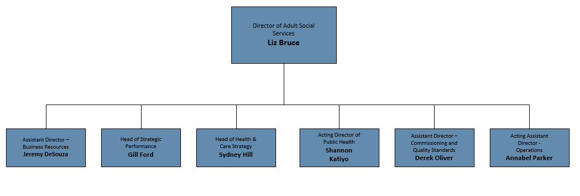

Person Specification

Job Title: Director of Public Health | Grade: TBA
Section: Public Health | Department: Adults Social Care and Public Health
Responsible to: Director of Adult Social Care & Public Health | Date: April 2015
Post Number(s): TBA

Corporate values & behaviours
All managers will be expected to demonstrate exemplary leadership attributes in the example they set in work ethic, integrity and building a climate of trust and respect. The ability to be alert to political expectations is essential, along with a well informed understanding of statutory requirements, resident expectations (and the particular approaches of the Councils in this regard) and innovative approaches to service delivery. Both boroughs place a high value on effective teamwork, staff engagement, openness and productivity. The ability to recognise the needs of diverse communities, and to incorporate the values of aspiration and achievement for everyone, are essential attributes for success at this level.

Requirements | Assessed by A &  I/ C
Notes for Managers
For advertisement purposes the number of selection criteria is limited to 15; all will be essential for the job and should be clear and measurable. Candidates will need to demonstrate how they meet the criteria and you should consider how you will assess this during the selection process:
A – Application form (for shortlisting) I – Interview C – Certificate (original evidence)
Knowledge
High level of understanding of epidemiology and statistics, public health practice, health promotion, health economics and health care evaluation | A
Full understanding of and commitment to addressing relationships and cultures of organisations that impact on the wider determinants of health and delivery of improved health through mainstream NHS and local government activities | A/I
Understanding of NHS and local government cultures, structures and policies, including the complex political environment and the interfaces between health and social care. | A/I
Knowledge of methods of developing clinical quality assurance, quality improvement and evidence based clinical and/or public health practice | A/I
Understanding of the determinants of public safety, and the interventions likely to reduce exposure to risk and becoming a victim of crime and other forms of neglect. | I
Experience
Significant experience of public health practice at a senior level. | A/I
Proven management experience in local government or in a company/organisation delivering equivalent services | A/I
A track record of successfully leading change and delivering positive outcomes in a challenging environment | A/I
Experience of managing conflicting demands and priorities in a large and complex organisation | A/I
Skills
Strong intellect and the ability to think strategically | A/I
Ability to work collaboratively and effectively with partners to deliver key objectives | A/I
Ability to work across complex systems and simplify often complex solutions | I
Visible presence to the workforce and leadership, with an inclusive style | I
Excellent oral, written and presentation skills, including providing clear and concise messages under media and public scrutiny | A/I
Highly developed and persuasive influencing, negotiating and interpersonal skills to influence decision-makers and stakeholders at the highest level | A/I
Ability to foster a climate of determination and creativity, to address challenges, achieve continuous improvement and resolve problems | A/I
Political awareness and sensitivity and the ability to work with elected politicians in varying roles and settings | A/I
Ability to manage contracts for the delivery of significant budgets and schemes | A/I
Qualifications
Appropriately qualified and recognised by the Faculty of Public Health as a suitable person to be employed as a Director of Public Health | C
Other Requirements
Commitment to equality and diversity and an understanding of how this applies within the remit of the role | A/I
Robust standard of stamina and resilience to handle the demands of the post, including numerous and varied evening meetings and other out of hours commitments | A/I

