Job Profile

Provisional Job Title:  Senior Accountant | Provisional Grade:  PO2-5
Section:  Financial Management | Directorate:  Resources
Responsible to:  Principal Accountant | Responsible for:  1.0 Accountancy Officer
Post Number/s:  2posts | Date  September 2022

Working for the Richmond/ Wandsworth Shared Staffing Arrangement

This role is employed under the Shared Staffing Arrangement between Richmond and Wandsworth Borough Councils. The overall purpose of the Shared Staffing Arrangement is to provide the highest quality of service at the lowest attainable cost.

Staff are expected to deliver high quality and responsive services wherever they are based, as well as having the ability to adapt to sometimes differing processes and expectations.

The Shared Staffing Arrangement aims to be at the forefront of innovation in local government and the organisation will invest in the development of its staff and ensure the opportunities for progression that only a large organisation can provide.

Job Purpose

Leads on specific aspects of the Councils’ financial policies and procedure rules, best practice reporting requirements, the Statement of Accounts and the setting of Council Tax.

Specific Duties and Responsibilities

Post holders will be asked to specialise in one or more of the following work areas, with the precise split of responsibilities being determined based on the resources and skill sets available and the relative demands of the work areas:

- Capital specialist for both councils.
- Treasury management, banking and cash flow management for Richmond.
- Treasury management, banking and cash flow management for Wandsworth.
- Asset specialist (with linked projects i.e. IFRS 16 implementation) for both councils.
- Taxation (VAT etc.) also with other projects and financial accounting tasks.
- Financial accounting specialist (including projects and reviews).

Each Senior Accountant will be asked to change the area of specialisation at least every 2 years to promote multiple skill development.

Aspects that each post is responsible for could include elements of the following, for either or both Councils:

- Production of relevant notes to/elements of the Statement of Accounts, ensuring the accuracy and integrity of the accounts.
- Responding to queries from the External Auditors, providing explanations and background working documents when required.
- Ensuring that best practice and the appropriate Codes of Practice are utilised.
- Completing sections of statutory and other returns, producing statistical information and research as required.
- Producing information for the Council Tax setting process including budgets and associated publications.
- Authorising transactions and maintaining accounting records on a daily, weekly and monthly basis throughout the year.
- Providing professional financial advice on all matters relating to the relevant service areas, to a wide range of stakeholders including input into the preparation of strategy documents and future years’ projections

Deputises for the Principal Accountant as and when required and assists on other groups within the Financial Management Division as directed, to provide flexible response to peak workloads.

Ensures that the services for both Councils are dealt with on an equitable basis to deliver the standards required for each, as agreed annually by the Executives of both Councils.

Provides supervision as required to assigned staff and takes responsibility for the allocation of work and quality of outputs.

Progression to PO5

Effectively leads on all work streams within specific areas of responsibility, taking ownership of system and process reviews and managing the process of change with minimum supervision, resulting in more efficient working practices and use of resources within areas of responsibility.

Carries out investigations and prepares reports as required, for instance on the use of resources, appraisals of new developments, new legislation and procedures.

Prepares reports to Committee as and when required including (but not limited to) bids, policy changes, strategy documents etc.

Works with minimal or no supervision.

Line management/mentoring/ supervision of an Accountancy or other Trainee.

Generic Duties and Responsibilities

To contribute to the continuous improvement of the services of the Boroughs of Wandsworth and Richmond.

To comply with relevant Codes of Practice including the Code of Conduct and policies concerning data protection and health and safety.

To promote equality, diversity and inclusion, maintaining an awareness of the equality and diversity protocol/policy and working to create and maintain a safe, supportive and welcoming environment where all people are treated with dignity and their identity and culture are valued and respected.

To understand both Councils’ duties and responsibilities for safeguarding children, young people and adults as they apply to the role.

The Shared Staffing Arrangement will keep its structures under continual review and as a result the post holder should expect to carry out any other reasonable duties within the overall function, commensurate with the level of the post.

Team Structure
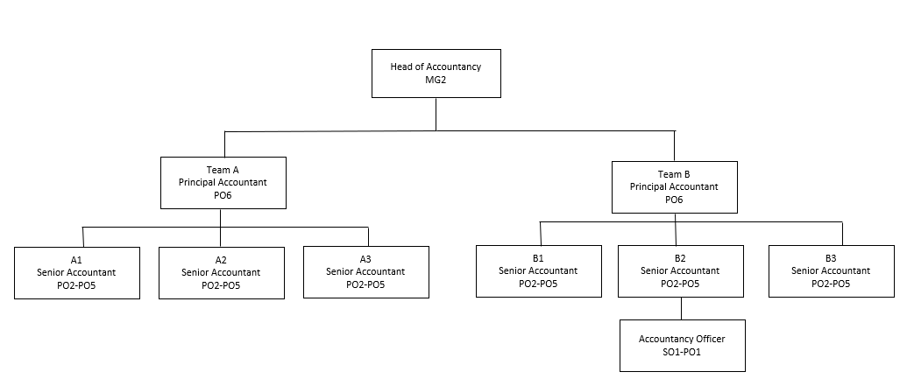
Provisional Job Title:  Senior Accountant | Provisional Grade:  PO2-5
Section:  Financial Management | Directorate:  Resources
Responsible to:  Principal Accountant | Responsible for:  1.0 Accountancy Officer
Post Number/s:  2 posts | Date  September 2022

Our Values and Behaviours

The values and behaviours we seek from our staff draw on the high standards of the two boroughs, and we prize these qualities in particular:

- Taking responsibility and being accountable for achieving the best possible outcomes – a ‘can do’ attitude to work.
- Continuously seeking better value for money and improved outcomes at lower cost.
- Focussing on residents and service users, and ensuring they receive the highest standards of service provision.
- Taking a team approach that values collaboration and partnership working.

Requirements | Assessed by A & I/ T/ C
Knowledge
Good understanding of legislation, accounting standards and accounting codes of practice governing local authority accounts and financial procedures with the ability to interpret complex issues and apply them. | A/I/T
Experience
Experience of a specialism as detailed in the Job Profile or in the closure of local authority Statement of Accounts. | A/I/T
Experience of undertaking complex financial calculations including options appraisals and sensitivity analysis. | A/I/T
Experience of simplifying complex financial issues and presenting them in a manner that the recipient understands. | A/I/T
Experience of designing complex spreadsheets and using them as models for decision making. | A/I/T
Skills
Proficient IT skills to use spreadsheets, financial systems and other relevant packages for analysis and presentation. | A/I/T
Meticulous approach/ working papers for dealing with complex tasks and audit requirements. | A/I/T
Good interpersonal skills to liaise with senior staff and external auditors. | A/I/T
Supervision skills to manage input and quality of output by other staff in the team. | A/I/T
Ability to plan and carry out own workload to meet targets and agreed deadlines. | A/I/T
Qualifications
Part/fully qualified CCAB or equivalent, fully qualified AAT/ACT. | A

These values and behaviours will be developed further as the SSA becomes established.

