Job Profile comprising Job Description and Person Specification
Job Description

Job Title:  Admin Officer | Grade:  Scale 5/6
Section:  Business Resource | Directorate:  Adults Social Services
Responsible to following manager:  Senior Admin Officer | Responsible for following staff:  N/A
Post Number: RWA1111 | Last review date:  April 2017

Working for the Richmond/Wandsworth Shared Staffing Arrangement

This role is employed under the Shared Staffing Arrangement between Richmond and Wandsworth Councils. The overall purpose of the Shared Staffing Arrangement is to provide the highest quality of service at the lowest attainable cost.

Staff are expected to deliver high quality and responsive services wherever they are based, as well as having the ability to adapt to sometimes differing processes and expectations.

The Shared Staffing Arrangement aims to be at the forefront of innovation in local government and the organisation will invest in the development of its staff and ensure the opportunities for progression that only a large organisation can provide.

Job Purpose

To provide comprehensive administrative support to operational teams/training and development team within the Adults Social Services Directorate, helping to ensure efficient and effective admin support systems and processes operate consistently across the Directorate.

Specific Duties and Responsibilities

- To advise and support managers on relevant matters affecting the service.

- To work as required in ways that develop good working relations and collaborative arrangements with partner and other external organisations.
- To support the Senior Admin Officer and work with colleagues in the development and maintenance of administrative processes, procedures and systems.
- To work flexibly across the Directorate to provide support and cover for other administrative staff, as needed.
- To provide effective and efficient office administration support to managers, team leaders and staff as required and using own initiative, including, but not limited to: a. Dealing with internal and external customers, by phone, email and face-to-face, resolving queries at first point of contact, where possible, including dealing with matters of a sensitive and confidential nature.
  - Meeting preparation, including booking rooms, inviting delegates, ordering refreshments, preparing and distributing documentation
  - Producing a variety of high-quality documentation (advanced word-processing), accurately and to deadline.
  - To devise and complete Excel spreadsheets
  - To update and maintain databases accurately, collating statistical information and reports as directed, including social care databases.
  - To undertake daily administrative tasks, such as managing and delegating from a shared electronic mailbox, scanning, photocopying, stationery supplies, as required.

Higher scale:
All the above, plus
- To provide supervision as required to assigned staff and take responsibility for the allocation and checking of work by Admin Assistants.
- To deputise for the Senior Admin Officer when the necessary

Generic Duties and Responsibilities

- To contribute to the continuous improvement of the services of the Boroughs of Wandsworth and Richmond.

- To comply with relevant Codes of Practice, including the Code of Conduct and policies concerning data protection and health and safety.

- To adhere to security controls and requirements as mandated by the SSA’s policies, procedures and local risk assessments to maintain confidentiality, integrity, availability and legal compliance of information and systems

- To promote equality, diversity, and inclusion, maintaining an awareness of the equality and diversity protocol/policy and working to create and maintain a safe, supportive and welcoming environment where all people are treated with dignity and their identity and culture are valued and respected.

- To understand both Councils’ duties and responsibilities for safeguarding children, young people and adults as they apply to the role within the council.

- The Shared Staffing Arrangement will keep its structures under continual review and as a result the post holder should expect to carry out any other reasonable duties within the overall function, commensurate with the level of the post.

Team structure
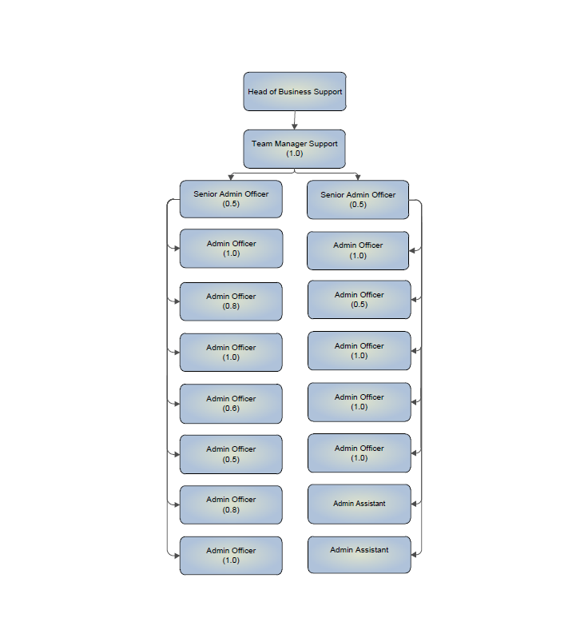

Person Specification

Job Title: Admin Officer | Grade: Scale 5/6
Section: Business Resource | Directorate: Adults Social Services
Responsible to: Senior Admin Officer | Responsible for: N/A
Post Number: | Last Review Date: June 2017

Our Values and Behaviours

The values and behaviours we seek from our staff draw on the high standards of the two boroughs, and we prize these qualities in particular:

Being open. This means we share our views openly, honestly and in a thoughtful way. We encourage new ideas and ways of doing things. We appreciate and listen to feedback from each other.

Being supportive. This means we drive the success of the organisation by making sure that our colleagues are successful. We encourage others and take account of the challenges they face. We help each other to do our jobs.

Being positive. Being positive and helpful means, we keep our goals in mind and look for ways to achieve them. We listen constructively and help others see opportunities and the way forward. We have a ‘can do’ attitude and are continuously looking for ways to help each other improve.

Person Specification Requirements | Assessed by  A  & I/ (see below for explanation)
Knowledge
Good knowledge of office environments and administrative procedures and processes. | A/I
Good knowledge of supporting, coordinating and delivering within a project work-stream. | A/I
Good knowledge of the Data Protection Act 1998. | A/I
Experience
Good experience of managing own workload, under pressure, to meet deadlines. | A/I
Good experience of developing and maintaining record keeping processes and systems. | A/I
Good experience of handling confidential and sensitive information appropriately. | A/I
Proven experience of working successfully in a team and forming relationships with customers and colleagues. | A/I
Skills
Strong knowledge of standard IT packages to an advanced level (MS Office – Outlook and Word) and ability to learn new ones. Good knowledge of Excel to a high-intermediate level. | A/I
Good level of communication skills in English, both written and oral, to provide clear and concise messages in a variety of internal external contexts. | A/I

A – Application form / CV
I – Interview
T – Test
C - Certificate

