Job Profile comprising Job Description and Person Specification
Job Description

Job Title:  Customer Service Advisor | Grade:  Sc 5  Linked grade to Sc6
Section:  Customers and Partnerships | Directorate:  Chief Executive’s Group
Responsible to following manager:  Customer Services Team Manager | Responsible for following staff:  Non Applicable
Post Number/s: | Last review date:  April 2016

Working for the Richmond/Wandsworth Shared Staffing Arrangement

This role is employed under the Shared Staffing Arrangement between Richmond and Wandsworth Councils. The overall purpose of the Shared Staffing Arrangement is to provide the highest quality of service at the lowest attainable cost.

Staff are expected to deliver high quality and responsive services wherever they are based, as well as having the ability to adapt to sometimes differing processes and expectations.

The Shared Staffing Arrangement aims to be at the forefront of innovation in local government and the organisation will invest in the development of its staff and ensure the opportunities for progression that only a large organisation can provide.

Job Purpose

- Deliver an excellent customer experience by providing advice and, wherever possible, resolution at the first point of contact. This includes all customer access channels including telephone, face to face, letter, email, web and SMS

Specific Duties and Responsibilities

- Maintains an up to date knowledge of all services and systems used in the Customer Service receptions to assist customers and resolve their enquiries.
- Handling customer enquiries received by all customer access channels including telephone, face to face, letter, email, website, SMS or other correspondence within agreed target times and to agreed customer service and Council standards

- To ensure a positive image to customers and other individuals and organisations and promote the service by whatever means are appropriate and available

- To professionally deal with any frustrated, angry and abusive customers, providing a resolution to their enquiry and avoiding potential complaints

- To maintain accurate records and information relating to the provision of customer services

- To implement policies and procedures necessary to meet customer care needs and reflect the Councils’ visions and core values

- To contribute to identifying and implementing customer service improvements.

- To actively encourage customers to use the most efficient method to gain access to and information about council services

- To undertake and assist with any training/development activities as directed

- To ensure that the services for both Councils are dealt with on an equitable basis to deliver the standards required for each, as agreed annually by the Executives of both Councils.

- To advise and support managers on relevant matters, including potential problems and complaints, affecting the service

- To contribute as required to change programmes within the service

- To contribute as required to performance review and improvement measures on an ongoing basis, helping to ensure that a customer focus is embedded within the function and innovative and creative solutions are evaluated to securing the highest quality and value for money function

- To support ways of working that ensure residents and stakeholders are actively engaged in the future of the function and are able to influence decision making.

Additional Duties for Scale 6

- To deal effectively with more complex enquiries

- Produce accurate records and reports regarding potential problems and complaints

- Uses Q-Matic and other relevant systems as necessary to monitor queues/waiting times. Ensures any potential wait times above service delivery standards are immediately brought to the attention of the appropriate senior manager

Generic Duties and Responsibilities

- To contribute to the continuous improvement of the services of the Boroughs of Wandsworth and Richmond

- To comply with relevant Codes of Practice, including the Code of Conduct and policies concerning data protection and health and safety

- To adhere to security controls and requirements as mandated by the SSA’s policies, procedures and local risk assessments to maintain confidentiality, integrity, availability and legal compliance of information and systems

- To promote equality, diversity, and inclusion, maintaining an awareness of the equality and diversity protocol/policy and working to create and maintain a safe, supportive and welcoming environment where all people are treated with dignity and their identity and culture are valued and respected

- To understand both Councils’ duties and responsibilities for safeguarding children, young people and adults as they apply to the role within the council

- The Shared Staffing Arrangement will keep its structures under continual review and as a result the post holder should expect to carry out any other reasonable duties within the overall function, commensurate with the level of the post

Current team structure

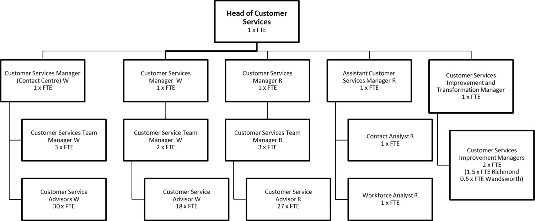

Person Specification

Job Title:  Customer Service Advisor | Grade:  Sc 5 Linked grade to Sc6
Section:  Customers and Partnerships | Directorate:  Chief Executive’s Group
Responsible to following manager:  Customer Services Team Manager | Responsible for following staff:  Non-Applicable
Post Number/s: | Last review date:  April 2016

Our Values and Behaviours

The values and behaviours we seek from our staff draw on the high standards of the two boroughs, and we prize these qualities in particular –
- taking responsibility and being accountable for achieving the best possible outcomes – a ‘can do’ attitude to work
- continuously seeking better value for money and improved outcomes at lower cost
- focussing on residents and service users, and ensuring they receive the highest standards of service provision
- taking a team approach that values collaboration and partnership working

Person Specification Requirements | Assessed by
Experience
Experience of working in a customer services role within the public or private sector | - Application form  - Interview
Experience of working in a pressurised environment where consistently high standards of service delivery are required | - Application form  - Interview
Skills
Ability to communicate clearly to customers in oral & written forms including telephone, e-mail and letter | - Application form  - Interview and Test
Ability to capture data electronically and reasonable level of IT proficiency | - Application form  - Interview and Test
Excellent customer care skills and customer focused attitude | - Application form  - Interview and Test
Ability to demonstrate a flexible and co-operative approach towards changing business needs | - Application form  - Interview and Test
Qualifications
Educated in GCSE or equivalent level in English | - Application form

