Job Profile comprising Job Description and Person Specification
Job Description

Job Title: School Engagement & Project Support Officer | Grade: PO1
Section: South London Careers Hub  South London Partnership | Directorate: Chief Executive
Responsible to following manager: Strategic Lead – South London Careers Hub | Responsible for following staff: N/A
Post Number/s: | Last review date: Feb 2023

Working for the Richmond/Wandsworth Shared Staffing Arrangement

This role is employed under the Shared Staffing Arrangement between Richmond and Wandsworth Councils. The overall purpose of the Shared Staffing Arrangement is to provide the highest quality of service at the lowest attainable cost.

Staff are expected to deliver high quality and responsive services wherever they are based, as well as having the ability to adapt to sometimes differing processes and expectations.

The Shared Staffing Arrangement aims to be at the forefront of innovation in local government and the organisation will invest in the development of its staff and ensure the opportunities for progression that only a large organisation can provide.

Job Purpose

Operating across the five boroughs of Croydon, Sutton, Merton, Kingston and Richmond, the South London Partnership delivers the Mayor’s Career Hub Project which has been set up to improve links between employers and schools and colleges, to create powerful, lasting connections.

As part of the ICP priorities fund the South London Partnership have been awarded funding to deliver a health and care work experience project which will support 100 work experience opportunities for secondary school students within South London.

The South London Careers Hub are looking for an School engagement & Project Support Officer, with extensive experience of employer engagement, event management, marketing and have experience of developing relationships and working in collaboration with internal and external partners to support delivery of their Health and Care work experience project.

The School Engagement & Project Support Officer will take responsibility for the delivery of the health and care work experience project, identifying innovative ways of engaging with employers and business volunteers, working with external and internal stakeholders, organising events and marketing and promoting the project across the local area.

The postholder will be responsible for:

- Raising the profile of the South London Careers Hub health and care project and identify opportunities to promote the project to internal and external stakeholders across the programme area.
- Developing marketing and innovative communication methods to increase the awareness of the South London Careers Hub health and care hub.
- Coordinating South London Career Hub project events to promote opportunities within health and care to local schools and colleges.
- Engaging local employers and business volunteers from within health and care, to work with schools and college, enabling the creation of a homegrown talent pipeline of young people skilled and ready for work in health and care
- Supporting with the development of health and care careers events and work experience opportunities for young people so they are well prepared for the world of work

Specific Duties and Responsibilities

The School Engagement & Project Support Officer will be responsible for:

- Increasing the number of people choosing a career within t Health and care by supporting to develop a careers, education, information, advice, and guidance strategy

- Developing and running careers activities, online and in person, to local young people to increase the number of young people choosing a career in health and care

- Developing a database of local provisions that supports the South London Careers Hub schools and colleges when looking for next steps in training and upskilling of young people in growth sectors.

- Working with the Business and Skills Coordinator, employers, providers and wider partners to identify suitable specific routes, pathways and career progression for young people, training and job opportunities, and helping to link people in training into good quality jobs and apprenticeships in health and care

- Championing and promoting workforce diversity, with specific targets around increasing the representation of business volunteers (Enterprise Coordinators), across a range of careers in the growth sectors

- Developing innovative events and activities which will engage local schools and college and take responsibility for producing effective and creative marketing and promotional materials to raise awareness of the service and the opportunities it offers

- Working with the Operational Lead to meet programme outputs and support in gather data and produce monthly data reports, to fulfil the requirements of the GLA Funding Agreement

- Building strong relationships with key partners and stakeholders across the sub-region such as borough skills officers, schools, colleges, universities, careers leaders, JCPs, community and voluntary sector and job brokerage services, across the programme area, supporting all stakeholders to promote health and care to young people

- Identify and represent the South London Careers Hub Health and care project at relevant pan London and local events, both virtually and in person, as appropriate

- Ensure that the South London Careers Hub integrates with and links to existing South London Partnerships programmes and projects

Generic Duties and Responsibilities

- To contribute to the continuous improvement of the services of the Boroughs of Wandsworth and Richmond.

- To comply with relevant Codes of Practice, including the Code of Conduct and policies concerning data protection and health and safety.

- To adhere to security controls and requirements as mandated by the SSA’s policies, procedures and local risk assessments to maintain confidentiality, integrity, availability and legal compliance of information and systems

- To promote equality, diversity, and inclusion, maintaining an awareness of the equality and diversity protocol/policy and working to create and maintain a safe, supportive and welcoming environment where all people are treated with dignity and their identity and culture are valued and respected.

- To understand both Councils’ duties and responsibilities for safeguarding children, young people and adults as they apply to the role within the council.

- The profile is not intended to be an exhaustive list of the duties the post holder will carry out. Other reasonable duties commensurate with the level of the post, including supporting emergency and priority situations, will form part of the role.

Team structure

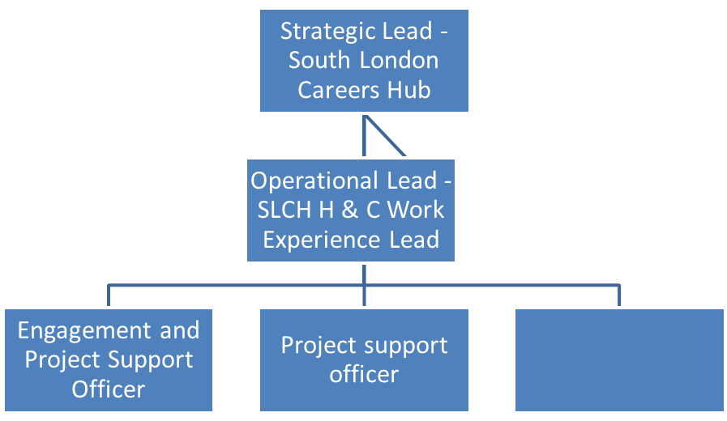

Person Specification

Job Title:School Engagement & Project Support Officer | Grade: SO1 £30,957 - £37,510
Section: South London Careers Hub  South London Partnership | Directorate: Chief Executive
Responsible to following manager: Strategic Lead – South London Careers Hub | Responsible for following staff: N/A
Post Number/s: | Last review date: May 2021

Our Values
THINK BIGGER
EMBRACE DIFFERENCE
CONNECT BETTER
LEAD BY EXAMPLE
PUT PEOPLE FIRST

Our Values are embedded across the SSA and throughout all roles and responsibilities at all levels of the organisation. Please familiarise yourself with our values as they are an integral part of our recruitment and selection process.

Person Specification Requirements |  |  |  |  | Assessed by A/I/T/C  (see below for explanation)
Knowledge |  | Essential |  | Desirable | Assessed
Knowledge of social media, online communication platforms and digital marketing techniques to reach a range of different organisations and people |  | E |  |  | A,I
Knowledge of levels of academic attainment and academic progression pathways for learners |  | E |  |  | A,I
Experience |  | Essential |  | Desirable | Assessed
Successful experience in engaging a wide range of people and organisations across a range of on-line, virtual and face-to-face events, ideally promoting skills, careers and employment opportunities |  | E |  |  | A,I
Experience of developing, implementing and delivering projects that support people to engage with education, skills development and employment opportunities |  | E |  |  | A,I
Experience of leading business development activity, identifying new opportunities with appropriate organisations and developing engagement strategies with stakeholders, preferably health and care employers |  | E |  |  | A,I
Experience of developing sustainable and effective partnerships with stakeholders ideally schools, FE colleges and employers |  | E |  |  | A,I
Experience of using a range of methods to engage with employers and business volunteers s |  | E |  |  | A,I
Experience of developing, maintaining and updating information databases. |  | E |  |  | A,I
Experience of delivering careers related events and activity |  | E
Skills |  |  | Essential | Desirable | Assessed
Effective project management skills |  | E |  |  | A,I
Exceptional interpersonal and relationship management skills, a highly skilled influencer and negotiator, able to achieve outcomes through collaboration. |  | E |  |  | A,I
Ability to develop strong partnership management skills, to ensure positive partnerships across South London |  | E |  |  | A,I
Excellent written and verbal communication skills, in a wide variety of contexts and at different levels, to manage complex and multi-layered stakeholder relationships |  | E |  |  | A,I
A proactive outlook with an ability to prioritise and schedule effectively to manage a dynamic workload and meet internal and external deadlines to balance competing priorities |  | E |  |  | A,I
Creative thinking and problem solving including the ability to improve services, develop new ways of working, and find appropriate solutions to complex issues |  | E |  |  | A,I
Qualifications | Essential |  |  | Desirable | Assessed
Relevant professional qualification or experience which demonstrates the ability to engage a wide range of communities and stakeholders, manage effective partnership and work to targets and deadlines. |  | E |  |  | A,C

A – Application form / CV I – Interview
T – Test C - Certificate

