Job Profile comprising Job Description and Person Specification

Provisional Job Title:  Trainee Project Manager (18-month initial fixed term) | Grade:  SO1
Section:  Corporate IT | Directorate:  Resources
Responsible to:  Projects and Programmes Manager | Responsible for:  n/a
Post Number/s:  RWR0237 / RWR0238 | Date  13 July 2022

Working for the Richmond/ Wandsworth Shared Staffing Arrangement

This role is employed under the Shared Staffing Arrangement between Richmond and Wandsworth Borough Councils. The overall purpose of the Shared Staffing Arrangement is to provide the highest quality of service at the lowest attainable cost.

Staff are expected to deliver high quality and responsive services wherever they are based, as well as having the ability to adapt to sometimes differing processes and expectations.

The Shared Staffing Arrangement aims to be at the forefront innovation in local government and the organisation will invest in your development and ensure the opportunities for progression that only a large organisation can provide.

Job Purpose:

To provide specialist support to the IT Project and Programme Office / Business Partnership functions and selected projects and programmes in accordance with the SSA’s chosen project and programme management methodologies. To assist in control and assurance activities and maintain comprehensive repositories of all project/programme documentation.

Specific Duties and Responsibilities:

- Provide guidance on project and programme management processes, procedures, templates, tools, techniques and software.
- Provide basic advice and guidance on individual project requirements, proposals and plans.
- Produce a range of planned and updated project and programme summary reports.
- Maintain project and programme repositories/libraries and assist in the preparation of documentation for governance boards, assurance activities and quality reviews.
- Maintain project and programme performance metrics and administers change control; risk, issue, action and decision logs.
- Periodically review processes and procedures to assess their ongoing effectiveness and recommend changes where necessary.
- Assist in the monitoring and control of allocated project resources and budgets.
- Provide critical support and contribute to the management of projects and programmes as directed by the designated project / programme manager / IT Business Partner – e.g. through delegated responsibility for the management of one or more work streams.
- Assist the Projects and Programmes Manager and IT Business Partnership Manager in continuous project and programme improvement and organisational development.
- Perform the IT Business Partner and project management role on smaller projects when required or where capacity exists.

Generic Duties and Responsibilities

- To contribute to the continuous improvement of the Borough’s of Wandsworth and Richmond services.

- To comply with relevant Codes of Practice, including the Code of Conduct, and policies concerning data protection and health and safety.

- To adhere to security controls and requirements as mandated by the SSA’s policies, procedures and local risk assessments to maintain confidentiality, integrity, availability and legal compliance of information and systems

- To promote equality, diversity, and inclusion, maintaining an awareness of the equality and diversity protocol/policy and work to create and maintain a safe, supportive and welcoming environment where all people are treated with dignity and their identity and culture are valued and respected.

- To understand the both Council’s duties and responsibilities for safeguarding children, young people and adults as they apply to your role within the council.

- The Shared Staffing Arrangement will keep its structures under continual review and as a result the post holder should expect to carry out any other reasonable duties within the overall function, commensurate with the level of the post.

Additional Information
Posts Managed: n/a

Current team structure

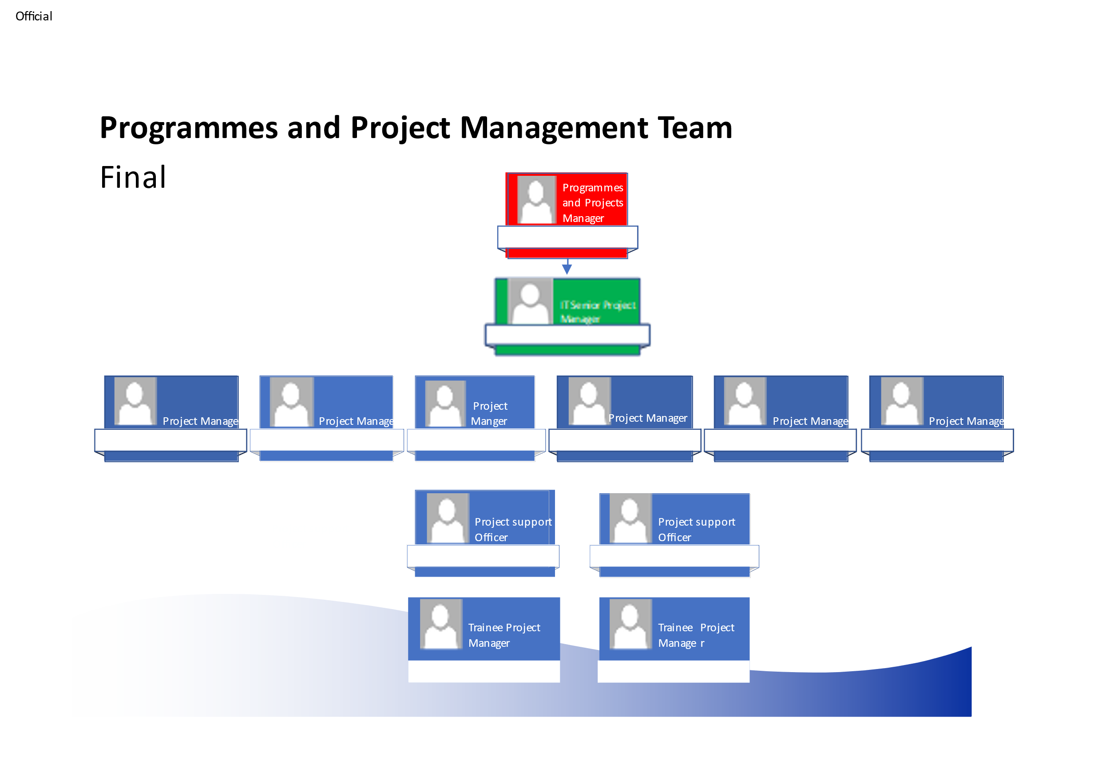
Person Specification
Provisional Job Title:  Trainee Project Manager (18-month initial fixed term) | Grade:  SO1
Section:  Corporate IT | Directorate:  Resources
Responsible to:  Projects and Programmes Manager | Responsible for:  n/a
Post Number/s:  RWR0237 / RWR0238 | Date  13 July 2022

Our Values and Behaviours

The values and behaviours we seek from our staff draw on the high standards of the two boroughs, and we prize these qualities in particular –

- taking responsibility and being accountable for achieving the best possible outcomes – a ‘can do’ attitude to work
- continuously seeking better value for money and improved outcomes at lower cost
- focusing on residents and service users, and ensuring they receive the highest standards of service provision.
- taking a team approach that values collaboration and partnership working

Requirements | Assessed by A & I/ T/ C
Knowledge
Knowledge of project and programme management ‘good-practice’ methodologies. | A/I
Awareness of Corporate, Industry and Professional Standards associated with IT, business change and project practitioner roles. | A/I
Broad appreciation of all key IT service and Council business functions. | A/I
Experience
Demonstrable appreciation of formal project management methodologies. | A/I
Competency in the use of appropriate project / programme management and supporting tools including, but not necessarily limited to, Microsoft Project, Visio, SharePoint and Office. | A/I
Competency in Project Planning and Control Techniques associated with planning and monitoring the progress of projects / programmes and interdependencies between them. | A/I
Demonstrable track-record of supporting successful project delivery or key operational activities across one or more business functions. | A/I
Participation in appropriate project focus and service improvement groups and forums. | A/I
Skills
Managing time, resources and budgets in a structured, effective manner. | A/I
Planning and prioritisation skills. | A/I/C
A demonstrable understanding of the principles, methods, techniques and tools for the effective management of projects through the complete lifecycle from initiation to post-implementation. | A/I
Strong customer service ethos. | A/I
Ability to rapidly absorb and analyse written and verbal information and draw out key messages / conclusions. | A/I
Ability to communicate effectively – both verbally and in writing. | A/I
People management skills for effective liaison with colleagues to support effective project and programme delivery. | A/I
Use of leading project management and other appropriate support tools and repositories at a basic level such as: -  - Microsoft SharePoint  - Microsoft Office 365 | A/I/C
Qualifications
Educated to at least ‘A’ Level standard or equivalent qualifications; and / or demonstrable work experience in a project or operational support role. | C / I
GCSE English and GCSE Maths at Grade C / Grade 4 or above. | C

These values and behaviours will be developed further as the SSA becomes established.

