Job Profile comprising Job Description and Person Specification
Job Description
Job Title:  Digital Content Designer | Grade:  S02 – PO1
Section:  Corporate IT | Directorate:  Resources
Responsible to following manager:  Digital Content Manager | Responsible for following staff:  N/A
Post Number/s: | Last Review Date: October 2021

Working for the Richmond/ Wandsworth Shared Staffing Arrangement

This role is employed under the Shared Staffing Arrangement between Richmond and Wandsworth Borough Councils. The overall purpose of the Shared Staffing Arrangement is to provide the highest quality of service at the lowest attainable cost.

Staff are expected to deliver high quality and responsive services wherever they are based, as well as having the ability to adapt to sometimes differing processes and expectations.

The Shared Staffing Arrangement aims to be at the forefront of innovation in local government and the organisation will invest in the development of its staff and ensure the opportunities for progression that only a large organisation can provide.

Job Purpose:

As part of the Digital Content Team, a Digital Content Designer is responsible for creating and maintaining online material to a consistent standard of excellence that meets the needs of Richmond and Wandsworth residents and staff using the SSA's websites and digital systems.

These systems include the websites: www.richmond.gov.uk, www.wandsworth.gov.uk, the SSA intranet, and other websites or applications where appropriate.

Specific Duties and Responsibilities:

- Plan, design, produce and maintain content that meets agreed corporate digital content standards and best practice guidelines, taking account of house style, layout, accessibility and usability.

- Use data from sources such as web analytics packages and user feedback to make sure the user journeys and the information architecture for both councils’ websites are the best they can be.

- Build and maintain online forms and related web content.

- Follow ongoing quality assurance processes to make sure the quality of information delivered to users is of the highest possible standard (for example correct spelling and grammar, fixing broken links, checking the accuracy and currency of information, and reviewing the consistency of content in terms of style, format and layout).

- Work with stakeholders to understand the issues affecting services in terms of digital information provision, and to ensure that resulting requirements for digital content are met.

- Coordinate and participate in regular website content reviews, and provide constructive feedback to stakeholders so as to ensure the information provided across all areas of both councils’ websites meets the needs of the user.

- Play an active role in suggesting how digital content can be improved to meet user needs in a cost efficient manner.

- Work on ad hoc digital content projects - from the planning and design through to delivery - as directed by the Digital Content Manager.

- Stay up to date with developments and trends affecting websites and digital technologies, especially regarding interface design, usability and accessibility.

- Offer training and advice to users of the councils’ content management systems, as well as responding to customer feedback and assisting users of both councils’ websites.

- Prepare images and multimedia content for use on both councils’ websites.

Progression Criteria

At SO2

Intermediate level of experience and skill when assessed against the requirements listed below.
Can complete digital content tasks as assigned by the Digital Content Manager.
Works with the Digital Content Manager and other Digital Content Designers to gain experience and skills where assigned work requires these and own competencies are not yet developed.
Understanding of user needs in terms of digital content.
Understanding of project management methodologies and customer care.
At PO1
Significant level of experience and skills when assessed against all the requirements listed below.
Can work independently on projects and tasks as set by the Digital Content Manager.
Can design and implement content-based solutions. Can clearly define the needs of residents and staff and clarify requirements with stakeholders.
Thorough understanding of user needs in terms of digital content.
Can document the requirements for interactive solutions for the Digital Development Team and test the effectiveness of these solutions.
Shares skills and knowledge in areas of experience with other Digital Content Designers.
Can deputise for the Digital Content Manager in times of absence.
Sound understanding of project management methodologies and customer care.

Generic Duties and Responsibilities

- To contribute to the continuous improvement of the services of the Boroughs of Wandsworth and Richmond.

- To comply with relevant Codes of Practice, including the Code of Conduct and policies concerning data protection and health and safety.

- To adhere to security controls and requirements as mandated by the SSA’s policies, procedures and local risk assessments to maintain confidentiality, integrity, availability and legal compliance of information and systems

- To promote equality, diversity, and inclusion, maintaining an awareness of the equality and diversity protocol/policy and working to create and maintain a safe, supportive and welcoming environment where all people are treated with dignity and their identity and culture are valued and respected.

- To understand both Councils’ duties and responsibilities for safeguarding children, young people and adults as they apply to the role within the council.

- The Shared Staffing Arrangement will keep its structures under continual review and as a result the post holder should expect to carry out any other reasonable duties within the overall function, commensurate with the level of the post.

Additional Information
This job profile has a scaled grade.

Current team structure

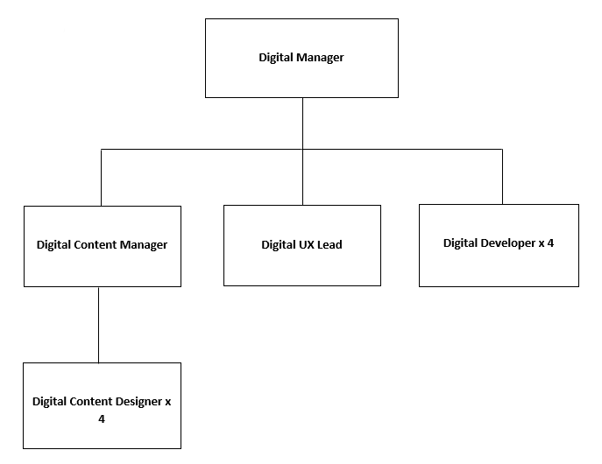

Job Title:  Digital Content Designer | Grade:  S02 – PO1
Section:  Corporate IT | Directorate:  Resources
Responsible to following manager:  Digital Content Manager | Responsible for following staff:  N/A
Post Number/s: | Last Review Date: October 2021

Our Values and Behaviours

The values and behaviours we seek from our staff draw on the high standards of the two boroughs, and we prize these qualities in particular:

Being open. This means we share our views openly, honestly and in a thoughtful way. We encourage new ideas and ways of doing things. We appreciate and listen to feedback from each other.

Being supportive. This means we drive the success of the organisation by making sure that our colleagues are successful. We encourage others and take account of the challenges they face. We help each other to do our jobs.

Being positive. Being positive and helpful means we keep our goals in mind and look for ways to achieve them. We listen constructively and help others see opportunities and the way forward. We have a ‘can do’ attitude and are continuously looking for ways to help each other improve.

Person Specification Requirements | Assessed by A & I/ T/ C (see below for explanation)
Knowledge
User experience techniques (for example: customer journey mapping, card sorting, wire-framing etc.) | A/I
WCAG 2.0 accessibility standards | A/I
Information architecture principles | A/I
Customer care principles and IT Service Standards (for example: ITIL) | A/I
Experience
Experience of writing for the web and producing online content in a public sector or digital media context. | A/I
Experience of creating digital content that is accessible and meets the needs of users. | A/I
Experience of using and administering enterprise Content Management Systems. | A/I
Experience of using website analytics and user feedback to define / shape content. | A/I
Experience of using a user-centric approach to website content design. | A/I
Experience in balancing stakeholder content requirements with the needs of users. | A/I
Experience of sourcing, amending and optimising images and graphics for use on websites. | A/I
Experience of converting and optimising documents for online publication using tools such as Adobe Acrobat. | A/I
Skills
Writing for the web and Plain English | A/I/T
Basic HTML and CSS | A/I
Content Management Systems (for example: LiveLink WCM, Umbraco, Jadu, SharePoint) | A/I
Online forms design | A/I
Website analytics packages and analysis (for example: Google Analytics, SiteImprove, Adobe Digital Analytix) | A/I
Graphics software packages (for example: Fireworks, Photoshop, GIMP) | A/I
Excellent written, communication and interpersonal skills | A/I
Excellent time management and the ability to manage competing deadlines | A/I
Qualifications
Educated to degree level or relevant industry experience | A

A – Application form
I – Interview
T – Test
C - Certificate

