Job Profile comprising Job Description and Person Specification
Job Description

Job Title:  Benefit Officer | Grade:  Sc4-SO1
Section:  Benefit Service, Revenues | Directorate:  Resources
Responsible to following manager:  Team Leader | Responsible for following staff:  n/a
Post Number/s: RWR0367 & RWR0368 | Last review date:  September 2021

Working for the Richmond/Wandsworth Shared Staffing Arrangement

This role is employed under the Shared Staffing Arrangement between Richmond and Wandsworth Councils. The overall purpose of the Shared Staffing Arrangement is to provide the highest quality of service at the lowest attainable cost.

Staff are expected to deliver high quality and responsive services wherever they are based, as well as having the ability to adapt to sometimes differing processes and expectations.

The Shared Staffing Arrangement aims to be at the forefront of innovation in local government and the organisation will invest in the development of its staff and ensure the opportunities for progression that only a large organisation can provide.

Job Purpose
- To assess entitlement to Housing Benefit and Council Tax reduction by maintaining an extensive and up to date knowledge of the IT systems, policy and procedures, benefit regulations, case law and other associated welfare benefits.

Specific Duties and Responsibilities
- Provide a service to customers claiming Housing Benefit or Council Tax reduction by:
  - Accurately assessing entitlement to Housing Benefit and Council Tax reduction
  - Interviewing customers face to face and over the telephone to assess or review entitlement
  - Identifying, creating and correctly classifying overpayments of Benefits in accordance with the regulations and takes appropriate recovery action
  - Liaising with customers, and their representatives, internal and internal stakeholders to effectively resolve enquiries and explanations
  - Checking submitted application forms and where necessary request further evidence in order to determine customers benefit entitlement

Scale 5
  - Assessing the more complex areas of the regulations
  - Providing explanations of complex benefit calculations including overpayments in writing, in person or over the telephone

Scale 6
  - Providing mentoring, coaching and on the job support to less experienced staff
  - Carrying out quality assurance in line with the agreed office procedures

SO1
  - Investigating and responding to complaints, liaising where necessary with other sections
  - Deputising for the Team Leader in the day to day organisation of the section’s work
  - Being responsible for training less experienced staff and all staff on changes to regulations or IT systems

- To ensure that the services for both Councils are dealt with on an equitable basis to deliver the standards required for each, as agreed annually by the Executives of both Councils.

- To advise and support managers on relevant matters affecting the service.

- To contribute as required to performance review and improvement measures on an ongoing basis, helping to ensure that a customer focus is embedded within the function and innovative and creative solutions are evaluated to securing the highest quality and value for money function.

- To contribute as required to change programmes within the service.

- To work as required in ways that develop good working relations and collaborative arrangements with internal and external stakeholders.

Generic Duties and Responsibilities

- To contribute to the continuous improvement of the services of the Boroughs of Wandsworth and Richmond.

- To comply with relevant Codes of Practice, including the Code of Conduct and policies concerning data protection and health and safety.

- To adhere to security controls and requirements as mandated by the SSA’s policies, procedures and local risk assessments to maintain confidentiality, integrity, availability and legal compliance of information and systems

- To promote equality, diversity, and inclusion, maintaining an awareness of the equality and diversity protocol/policy and working to create and maintain a safe, supportive and welcoming environment where all people are treated with dignity and their identity and culture are valued and respected.

- To understand both Councils’ duties and responsibilities for safeguarding children, young people and adults as they apply to the role within the council.

- The Shared Staffing Arrangement will keep its structures under continual review and as a result the post holder should expect to carry out any other reasonable duties within the overall function, commensurate with the level of the post.

Additional Information
n/a

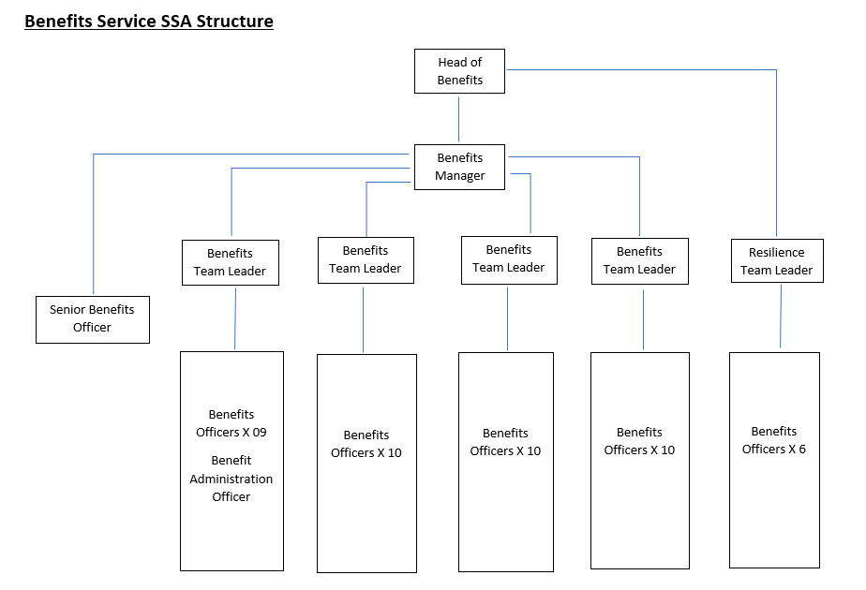

Person Specification

Job Title:  Benefit Officer | Grade:  Sc6 - SO1
Section:  Benefit Service, Revenues | Directorate:  Resources
Responsible to following manager:  Team Leader | Responsible for following staff:  n/a
Post Number/s: RWR0367 & RWR0368 | Last review date:  September 2021

Our Values and Behaviours
The values and behaviours we seek from our staff draw on the high standards of the two boroughs, and we prize these qualities in particular:
Being open. This means we share our views openly, honestly and in a thoughtful way. We encourage new ideas and ways of doing things. We appreciate and listen to feedback from each other.

Being supportive. This means we drive the success of the organisation by making sure that our colleagues are successful. We encourage others and take account of the challenges they face. We help each other to do our jobs.

Being positive. Being positive and helpful means we keep our goals in mind and look for ways to achieve them. We listen constructively and help others see opportunities and the way forward. We have a ‘can do’ attitude and are continuously looking for ways to help each other improve.

Person Specification Requirements | Assessed by  A  & I/ T/ C (see below for explanation)
Knowledge
Scale 6
Knowledge and understanding of welfare benefits and complex Housing Benefit and Council Tax reduction legislation | A/I/T
SO1
Extensive knowledge and understanding of the legislation for Housing Benefit and Council Tax reduction and other welfare benefits | A/I/T
Experience
Scale 6
Experience of dealing with the public within a diverse working environment | A/I
Experience of undertaking the more complex assessments within a Housing & Council Tax reduction environment | A/I
SO1
Experience of responding to formal complaints | A/I
Skills
Scale 6
Ability to be able to provide mentoring, support to other officers including checking of work where appropriate | A/I
Good level of oral and written skills to provide clear and concise messages | A/I/T
Ability to organise and prioritise own workload, | A/I
SO1
Ability to deputise for the Team Leader | A/I
Ability to provide training to others | A/I
Qualifications
n/a

A – Application form
I – Interview
T – Test
C - Certificate

