Job Profile comprising Job Description and Person Specification
Job Description

Job Title:  Social Worker | Grade: PO1-PO2
Section:  Adult Specialist Community Services | Directorate:  Education and Social Services
Responsible to following manager:  Assistant Service Manager/ Assistant Locality Manager/ Senior Social Worker | Responsible for following staff:  N/A
Post Number/s: | Last review date:  April 2016

Working for the Richmond/Wandsworth Shared Staffing Arrangement

This role is employed under the Shared Staffing Arrangement between Richmond and Wandsworth Councils. The overall purpose of the Shared Staffing Arrangement is to provide the highest quality of service at the lowest attainable cost.

Staff are expected to deliver high quality and responsive services wherever they are based, as well as having the ability to adapt to sometimes differing processes and expectations.

The Shared Staffing Arrangement aims to be at the forefront of innovation in local government and the organisation will invest in the development of its staff and ensure the opportunities for progression that only a large organisation can provide.

Job Purpose

In addition to abiding by the standards set down by the Health & Care Professions Council (HCPC) Social Workers are responsible for ensuring the provision of statutory, personalised outcome focussed services for adults and their carers. This incudes the assessment of individual need, the design and review of creative and innovative support plans, and negotiating funding for services with an emphasis on promoting independence. In addition, social workers play a key role in safeguarding adults who are at risk and/or have been harmed.

Specific Duties and Responsibilities

1. To undertake assessments of individual and carers needs and risks to encourage independence, provide support and prevent harm. This includes promoting a multi-agency approach by developing and maintaining effective working relationships

2. To undertake statutory intervention where service users are deemed to be at risk, including situations where people may be neglected or abused in accordance with the Inter-Agency Policy and Procedures for Safeguarding Adults

3. To work in partnership with service users and carers using a person-centred approach, with the aim of maximising independence, wellbeing and choice.

4. To hold a caseload appropriate to the level of expertise and provide support and expert advice to social care assessors, students and partners.

5. To provide advice, information and guidance to service users and carers ensuring that that support plans and other information regarding individual care packages is shared with the service user, carers and other agencies as required in accordance with the Council’s policies and procedures including those on data protection

6. To facilitate service user choice and empowerment through promoting independence and the personalisation agenda through all stages of assessment, support planning and review to enable service users to maintain independence for as long as possible

7. To monitor implementation of packages of care and support and adjust them as appropriate and to ensure that individual care packages, including funding arrangements for any services, are thoroughly reviewed in accordance with statutory requirements and Council policy to ensure highest quality of service and best value.

8. To apply social work ethical principles and values to guide professional practice and respect diversity and apply critical reflection and analysis to inform professional decisions and use supervision to promote continuous professional development

9. To ensure that information is recorded consistently, accurately and meets statutory timescales. To ensure that service user confidentiality is maintained and that information is shared with the service user, care and other agencies in accordance with the Department’s data protection requirements.

Generic Duties and Responsibilities

- To contribute to the continuous improvement of the services of the Boroughs of Wandsworth and Richmond.

- To comply with relevant Codes of Practice, including the Code of Conduct and policies concerning data protection and health and safety.

- To adhere to security controls and requirements as mandated by the SSA’s policies, procedures and local risk assessments to maintain confidentiality, integrity, availability and legal compliance of information and systems

- To promote equality, diversity, and inclusion, maintaining an awareness of the equality and diversity protocol/policy and working to create and maintain a safe, supportive and welcoming environment where all people are treated with dignity and their identity and culture are valued and respected.

- To understand both Councils’ duties and responsibilities for safeguarding children, young people and adults as they apply to the role within the council.

- The Shared Staffing Arrangement will keep its structures under continual review and as a result the post holder should expect to carry out any other reasonable duties within the overall function, commensurate with the level of the post.

- To advise and support managers on the relevant matters affecting the service and to contribute as required to change programmes within the service

- To support ways of working that ensure that residents and stakeholders are actively engaged in the future of the service and are able to influence decision making

- To work in ways that develops good working relations and collaborative arrangements with internal and external stakeholders.

Additional Information
N/A

Team structure

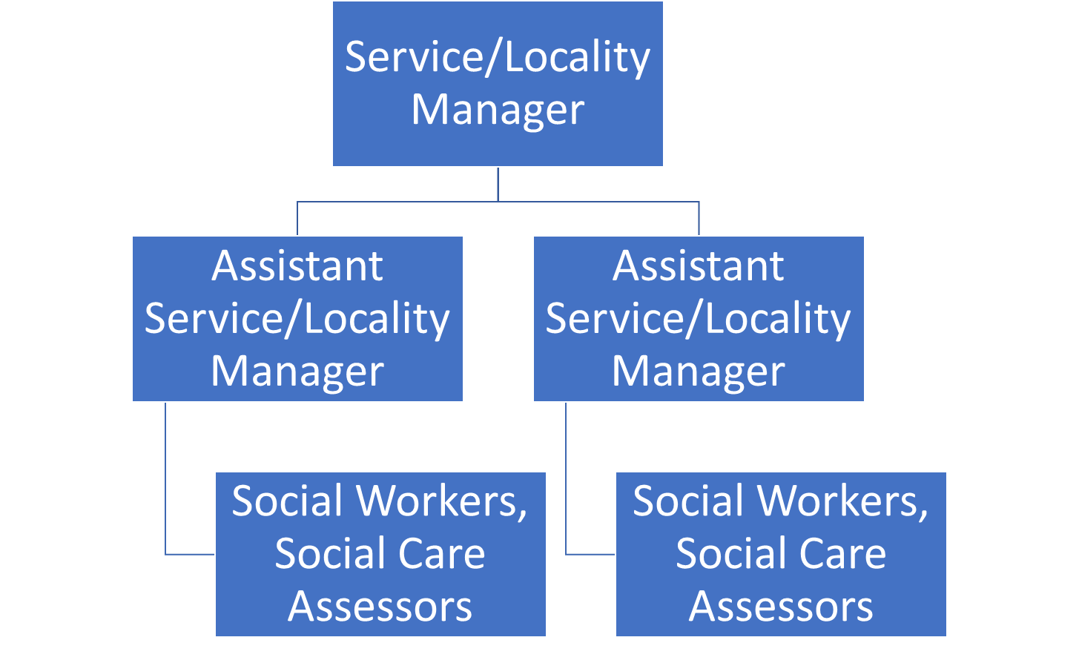
Person Specification

Job Title:  Social Worker | Grade: PO1-PO2
Section:  Adult Specialist Community Services | Directorate:  Education and Social Services
Responsible to:  Assistant Service Manager/ Assistant Locality Manager/ Senior Social Worker | Responsible for:  N/A
Post Number/s: | Last Review Date:  April 2016

Our Values and Behaviours

The values and behaviours we seek from our staff draw on the high standards of the two boroughs, and we prize these qualities in particular:

Being open. This means we share our views openly, honestly and in a thoughtful way. We encourage new ideas and ways of doing things. We appreciate and listen to feedback from each other.

Being supportive. This means we drive the success of the organisation by making sure that our colleagues are successful. We encourage others and take account of the challenges they face. We help each other to do our jobs.

Being positive. Being positive and helpful means we keep our goals in mind and look for ways to achieve them. We listen constructively and help others see opportunities and the way forward. We have a ‘can do’ attitude and are continuously looking for ways to help each other improve.

Person Specification Requirements |  | Assessed by  A  & I/ T/ C (see below for explanation)
Knowledge
1. | Knowledge of current developments and legislation, national guidance and frameworks in providing a service to (a) older people and/or adults with a physical disability or sensory impairment and/or with adults with acute or chronic health care needs and/or with adults with learning disabilities and (b) to carers. | A, I
2. | Knowledge and understanding of the local authority’s responsibilities in the safeguarding of vulnerable adults, and the ability, subject to skills and experience, to act as the Investigating Officer under Safeguarding Vulnerable Adults Policy and Procedures. | A, I
Experience
3. | Experience of working with older people and/or adults with a physical disability or sensory impairment and/or with adults with acute or chronic health care needs and/or with adults with learning disabilities and with carers | A, I
4. | Experience of achieving positive outcomes for service users and carers through support planning and reviews with promote independence, choice and control. | A, I
5. | Ability to use a person-centred approach | I
6. | Ability to demonstrate effective decision making involving all relevant partners in order to achieve best outcomes for service users and their carers. | A, I
Skills
7. | Effective written and verbal communication and recording skills with the ability to demonstrate sound professional development. | A, I, T
8. | The ability to effectively manage time and complex, completing demands in a high pressured environment. | A, I
9. | The ability to effectively use supervision to reflect on practice and contribute towards professional development. | A, I
10. | IT skills and keyboard skills in order to be proficient in the use of Outlook, Word and client database systems | A, T
Qualifications
11. | A relevant professional qualification in social work and current registration with HCPC.  From 2012 Social workers will also need to evidence that they have successfully passed the ASYE programme or be able to demonstrate capabilities and knowledge at that level. Newly qualified Social Workers who meet the eligibility criteria must be willing to undertake the ASYE programme. | 11.

A – Application form / CV
I – Interview
T – Test
C - Certificate

