Job Profile comprising Job Description and Person Specification
Job Description

Job Title:  Administrative Assistant (Temporary) | Grade:  Scale 3
Section:  Pensions Shared Service | Directorate:  Resources
Responsible to following manager:  Pensions Manager | Responsible for following staff:
Post Number/s: FINP02TS, RWRPSA1, F1684 | Last review date: April 2017

Working for the Richmond/Wandsworth Shared Staffing Arrangement

This role is employed under the Shared Staffing Arrangement between Richmond and Wandsworth Councils. The overall purpose of the Shared Staffing Arrangement is to provide the highest quality of service at the lowest attainable cost.

Staff are expected to deliver high quality and responsive services wherever they are based, as well as having the ability to adapt to sometimes differing processes and expectations.

The Shared Staffing Arrangement aims to be at the forefront of innovation in local government and the organisation will invest in the development of its staff and ensure the opportunities for progression that only a large organisation can provide.

Job Purpose

- To be responsible to the Pensions Manager assisting with the effective and efficient administration of the Pensions Shared Service covering all its participating authorities.

- Carries out work set by the Pensions Manager that will comprise of assisting other officers in all areas of work within the section. This will include instruction on and obtaining an understanding of the legislation governing the pensions industry.

Specific Duties and Responsibilities

- Responsible to the Pensions Manager.

- Assists with clerical duties/projects as directed by the Pensions Manager.

- Assists with maintenance of computerised systems relating to employee records.

- Deals with member enquiries of a general nature, referring technical enquiries to the relevant officer.

- Deals with enquiries from HR Sections, Internal and External Audit, Departmental Directorates and Payroll.

- Responsible for amendments to the computerised pensions administration system where a change in personal circumstances has occurred and also assists with other input e.g. service history updates.

- Carries out work set by the Pensions Manager that will comprise of assisting other officers in all areas of work within the section. This will include instruction on and obtaining an understanding of the legislation governing the pensions industry.

- Calculates membership, final pay and pensionable pay for estimates of benefits. Uses the computerised pensions administration system to process these estimates and checks the output for accuracy.

- Enters payment details in to the Integra payment system for all types of payments generated by the Service.

- Undertakes any other duties commensurate with the grade as required by the Pensions Manager

Generic Duties and Responsibilities

- To contribute to the continuous improvement of the services of the Boroughs of Wandsworth and Richmond.

- To comply with relevant Codes of Practice, including the Code of Conduct and policies concerning data protection and health and safety.

- To adhere to security controls and requirements as mandated by the SSA’s policies, procedures and local risk assessments to maintain confidentiality, integrity, availability and legal compliance of information and systems

- To promote equality, diversity, and inclusion, maintaining an awareness of the equality and diversity protocol/policy and working to create and maintain a safe, supportive and welcoming environment where all people are treated with dignity and their identity and culture are valued and respected.

- To understand both Councils’ duties and responsibilities for safeguarding children, young people and adults as they apply to the role within the council.

- The Shared Staffing Arrangement will keep its structures under continual review and as a result the post holder should expect to carry out any other reasonable duties within the overall function, commensurate with the level of the post.

Current team structure
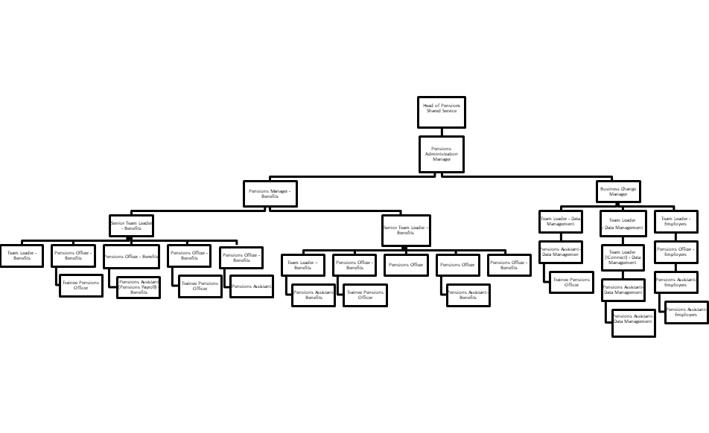

Person Specification
Job Title:  Administrative Assistant (Temporary) | Grade:  Scale 3
Section:  Pensions Shared Service | Directorate:  Resources
Responsible to following manager:  Pensions Manager | Responsible for following staff:
Post Number/s: FINP02TS, RWRPSA1, F1684 | Last review date: April 2017

Our Values and Behaviours
The values and behaviours we seek from our staff draw on the high standards of the two boroughs, and we prize these qualities in particular:

- Being open. This means we share our views openly, honestly and in a thoughtful way. We encourage new ideas and ways of doing things. We appreciate and listen to feedback from each other.
- Being supportive. This means we drive the success of the organisation by making sure that our colleagues are successful. We encourage others and take account of the challenges they face. We help each other to do our jobs.
- Being positive. Being positive and helpful means we keep our goals in mind and look for ways to achieve them. We listen constructively and help others see opportunities and the way forward. We have a ‘can do’ attitude and are continuously looking for ways to help each other improve.

Person Specification Requirements | Assessed by  A  & I/ T/ C (see below for explanation)
Knowledge
Knowledge of relevant ICT packages including Word and Excel and the ability to use them effectively. | A, I
An understanding of the Councils’ equal opportunities policy in respect of service delivery and an awareness of the needs of differing cultural and minority groups. | A, I
An understanding of the duties and responsibilities in relation to child protection and safeguarding children, young people and vulnerable adults as this applies to this role within the Councils. | A, I
Skills
Ability to work as a team to produce high quality work. | A, I
Ability to set own priorities and adapt to changes in working conditions | A, I,
Possess good verbal and written communication skills | A, I, T
Able to learn quickly and apply new concepts | A, I
Excellent mathematical skills and the ability to incorporate complex rules into calculations. | A, I, T
Ability to quickly understand complex rules and explain them clearly and concisely | A, I
Able to demonstrate excellent customer care skills | A, I
Able to suggest quality improvements | A, I
Qualifications
Minimum of Maths and English Language GCSE’s or equivalent at Grades A-C | A, C

A – Application form
I – Interview
T – Test
C - Certificate

