Job Profile comprising Job Description and Person Specification
Job Description

Job Title:  Social Worker | Grade: PO1-PO3
Section:  Adult Social Care Services | Directorate:  Adult Social Care and Public Health
Responsible to following manager:  Assistant Service Manager/ Assistant Locality Manager/ Senior Social Worker | Responsible for following staff:  N/A
Post Number/s: | Last review date:  December 2021

Working for the Richmond/Wandsworth Shared Staffing Arrangement

This role is employed under the Shared Staffing Arrangement between Richmond and Wandsworth Councils. The overall purpose of the Shared Staffing Arrangement is to provide the highest quality of service at the lowest attainable cost.

Staff are expected to deliver high quality and responsive services wherever they are based, as well as having the ability to adapt to sometimes differing processes and expectations.

The Shared Staffing Arrangement aims to be at the forefront of innovation in local government and the organisation will invest in the development of its staff and ensure the opportunities for progression that only a large organisation can provide.

Job Purpose

The purpose of a Social Worker in Adult Social Care is to apply the Care Act 2014 and enhance eligible people’s well-being. In addition to abiding by the practice standards set down by Social Work England (SWE), Social Workers need to apply a wide range of knowledge and skills to understand and build relationships, and work directly with individuals, their families, and carers in a strengths-based way, to enable and empower them to achieve best outcomes. This should include working within statutory frameworks to undertake assessments, plan care and support and make the best use of available resources to enable people to have better lives. In addition, Social Workers play a key role in safeguarding adults who are at risk of harm/or have been harmed.

Specific Duties and Responsibilities

- To work within the Care Act 2014 and other relevant statutory frameworks and take responsibility for maintaining a good standard of professional practice and developing the core skills and knowledge required, in collaboration with your line manager as part of continuous professional development.

- To apply Social Work principles and values to professional practice and to emulate our corporate values in all interactions with residents, colleagues, and partners.

- To engage and fully participate in supervision and to apply critical reflection and analysis to inform professional decisions. To ensure risks are discussed with your line manager to gain direction, advice and support with practice.

- To effectively manage a reasonable caseload appropriate to the level of experience and to maintain adequate throughput of work. To discuss any challenges with caseload management with your line manager in a timely way to access any necessary support with prioritisation.

- To provide support and expert advice on social care to social care assessors, students, and partners.

- To be professionally curious when undertaking effective assessments of individual and carer needs and risks within statutory frameworks, using a strengths-based, person-centred approach to ensure they are focused on outcomes. This includes promoting a holistic, multi-agency approach by developing and maintaining collaborative working relationships.

- To work directly in partnership with residents, their families and carers to enable them to maintain their independence and well-being, cope with change, attain outcomes they want and need, understand and manage risk, and participate in the life of their communities.

- To provide advice and information to residents and carers ensuring that that assessments, care and support plans, information about charging and other information regarding service provision is communicated in a timely way.

- To work in accordance with the Council’s policies and procedures and practice guidance and to remain informed on these using the Loop.

- To complete all mandatory training, including that on data security.

- To make use of staff news and other corporate and Department communications to be up to date and informed.

- To monitor implementation of packages of care and ensure support plans, including funding arrangements for any services, are thoroughly reviewed to meet needs and risks in accordance with statutory requirements and Council policy and deliver highest quality of service and best value.

- To take responsibility for consistent, accurate, clear, and timely case recording. To ensure that confidentiality is maintained, and that information is shared with the resident, service providers and other agencies (health) in accordance with the Department’s data protection and information sharing requirements.

- To be able to understand the impact of poverty, inequality and diversity on social and economic opportunities and how these relate to residents’ health and well-being as well as the functioning of their families, particularly in relation to adult safeguarding and child protection and empowering individuals who may lack capacity.

Progression criteria from PO1 to PO2

- To have a high level of understanding of legislation and to be able to interpret and apply it, alongside national and local policies and procedures underpinning your work specifically where assessment, review and safeguarding elements are applied, use of personal budgets and direct payments (as appropriate) as well as how carers are supported and how the local authority meets its statutory duties.

- To take initiative, form constructive alliances with partners and engage effectively with situations of increasing complexity and challenge including integrated working, complex family dynamics and multiple risk factors. This will be evidenced in their performance and supervision notes.

- To be able to demonstrate an appropriate level of knowledge with evidence of the increasing ability to work independently, to collaborate on equal terms with members of other professions and make sound professional judgments with the ability to explain and justify decisions.

- To be able to manage complex cases and offer skilled opinion to colleagues and partners. To offer expert support to case conferences and produce high quality assessments and reports for a range of functions.

- To demonstrate highly developed interpersonal skills and advanced advocacy skills within the role.

- To show a clear awareness of budgets and the costs of services and their impact on service delivery, where appropriate challenging or identifying creative and proactive options to ensure the best use of resources and preventative work.

- To work towards a Practice Educator qualification
Additional duties at PO3

- To act as a Safeguarding Adult Manager (SAM).

- To understand performance and budget management and forecasting at a more strategic level and to be able to support and champion the improvement of performance against key indicators with team colleagues.

- To lead on promoting high standards of practice with team colleagues and to develop resilience, linking with Professional Standards colleagues as required. To model high standards and a high level of competence adhering to practice guidance, statutory frameworks, and best practice across the UK.

- To hold a caseload of higher-level complexity and to be able to conduct legally compliant assessments in a wide range of challenging contexts, cope with difficult conversations and be highly resilient.

- To chair meetings with professionals from multiple agencies.

- To support transformation and innovation within the service.

- To mentor Social Work Apprentices

- To act as a Practice Educator

Generic Duties and Responsibilities

- To contribute to the continuous improvement of the services of the Boroughs of Wandsworth and Richmond.

- To comply with relevant Codes of Practice, including the Code of Conduct and policies concerning data protection and health and safety.

- To adhere to security controls and requirements as mandated by the SSA’s policies, procedures and local risk assessments to maintain confidentiality, integrity, availability and legal compliance of information and systems.

- To promote equality, diversity, and inclusion, maintaining an awareness of the equality and diversity protocol/policy and working to create and maintain a safe, supportive and welcoming environment where all people are treated with dignity and their identity and culture are valued and respected.

- To understand both Councils’ duties and responsibilities for safeguarding children, young people and adults as they apply to the role within the council.

- The Shared Staffing Arrangement will keep its structures under continual review and as a result the post holder should expect to carry out any other reasonable duties within the overall function, commensurate with the level of the post.

- To advise and support managers on the relevant matters affecting the service and to contribute as required to change programmes within the service.

- To support ways of working that ensure that residents and stakeholders are actively engaged in the future of the service and are able to influence decision making.

- To work in ways that develops good working relations and collaborative arrangements with internal and external stakeholders.

Additional Information

- To contribute as required by the Service Manager to the learning of other staff within the team, and through wider programmes arranged by the Department Learning and Development section including leading panels, workshops or projects and will participate in research, where required.

Team structure

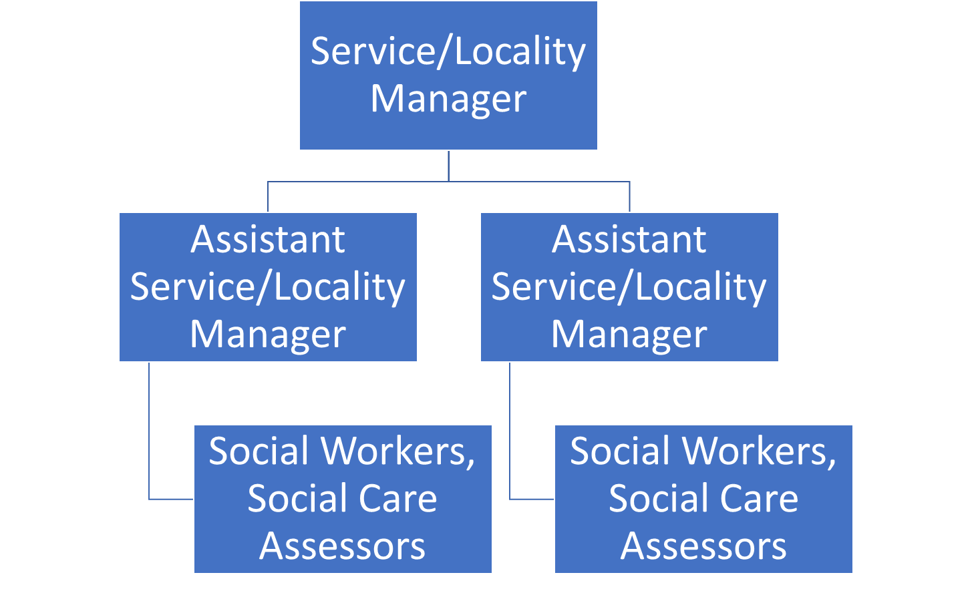
Person Specification

Job Title:  Social Worker | Grade: PO1-PO3
Section:  Adult Social Care Services | Directorate:  Adult Social Care and Public Health
Responsible to:  Assistant Service Manager/ Assistant Locality Manager/ Senior Social Worker | Responsible for:  N/A
Post Number/s: | Last Review Date:  September 2021

Our Values and Behaviours

The values and behaviours we seek from our staff draw on the high standards of the two boroughs, and we prize these qualities in particular:

Being open. This means we share our views openly, honestly and in a thoughtful way. We encourage new ideas and ways of doing things. We appreciate and listen to feedback from each other.

Being supportive. This means we drive the success of the organisation by making sure that our colleagues are successful. We encourage others and take account of the challenges they face. We help each other to do our jobs.

Being positive. Being positive and helpful means we keep our goals in mind and look for ways to achieve them. We listen constructively and help others see opportunities and the way forward. We have a ‘can do’ attitude and are continuously looking for ways to help each other improve.

Person Specification Requirements |  | Assessed by  A  & I/ T/ C (see below for explanation)
Knowledge
1. | Knowledge of Social Work Professional Standards. | A I
2. | Knowledge and practical understanding of relevant adult social care and health legislation, practice guidance and policies, including that relating to safeguarding adults. | A, I
3. | Understanding of the strengths-based approach. | A, I
Experience
4. | Experience of working with people with disabilities. | A, I
5. | Experience of conducting effective assessments including of risk. | A, I
6. | Experience of developing care and support plans that deliver personalised, integrated care and support that helps people to maintain their independence and attain the outcomes they want. | I
7. | Experience of working collaboratively with residents, their families and other professionals. | A, I
8. | Experience of making effective decisions that make best use of available resources to meet eligible needs and achieve outcomes. | A I
Skills
9. | Ability to maintain Social Work Professional Standards | A I
10. | Ability to model and encourage our Corporate values and behaviours and to be positive, open-minded, supportive and respectful to colleagues, partners and residents. | A I
11. | Ability to communicate effectively with others and ability to write a clear, accurate, consistent and timely and case record and reports as per the Recording Guidance. | A, I, T
8. | The ability to effectively manage time effectively, including adequate throughput of casework, learning and other team requirements. | A, I
9. | The ability to effectively use supervision to support caseload management, raise risks and ask advice, reflect on practice and contribute towards development of core skills and competence. | A, I
10. | To be technically proficient and able to use IT equipment, able to demonstrate digital solutions for residents and carers and understand pertinent data. | A, T
Qualifications
11. | A relevant professional qualification in social work and current registration with Social Work England.  Evidence of successfully passing the ASYE programme or be able to demonstrate capabilities and knowledge at that level. Newly qualified Social Workers who meet the eligibility criteria must be willing to undertake the ASYE programme. | A/I/C

A – Application form / CV
I – Interview
T – Test
C - Certificate

