Job Profile comprising Job Description and Person Specification
Job Description

Job Title:  Health and Wellbeing Board Partnerships Manager | Grade:  PO4
Section:  Health and Care Integration | Directorate:  Adult Social Care and Public Health
Responsible to following manager:  Head of Health and Care Integration | Responsible for following staff:  None
Post Number/s:  RWAHCS2 | Last review date:  May 2022

Working for the Richmond/Wandsworth Shared Staffing Arrangement

This role is employed under the Shared Staffing Arrangement between Richmond and Wandsworth Councils. The overall purpose of the Shared Staffing Arrangement is to provide the highest quality of service at the lowest attainable cost.

Staff are expected to deliver high quality and responsive services wherever they are based, as well as having the ability to adapt to sometimes differing processes and expectations.

The Shared Staffing Arrangement aims to be at the forefront of innovation in local government and the organisation will invest in the development of its staff and ensure the opportunities for progression that only a large organisation can provide.

Job Purpose
To ensure the effective support and management of the sovereign Richmond and Wandsworth Health and Wellbeing Boards (HWBs) in fulfilling their statutory responsibilities. This will include managing and supporting the delivery of each Board’s agenda and work programmes (including the planning and delivery of key products, Board development sessions, projects, and action plans).
A key function of the role is to ensure a clear, coherent, and effective approach to planning and delivering the business of the Health and Wellbeing Boards. This includes ensuring that both Health and Wellbeing Boards maintain close links with all member organisations and other relevant bodies, (e.g., other local strategic partnership bodies/boards, other regional and national organisations) and ensuring that the statutory reports and submissions are developed and delivered. It encompasses overall responsibility for managing and developing the functions delivered by the Health and Wellbeing Boards, in support of both Chairs.

Specific Duties and Responsibilities

- To take a lead role in ensuring the Boards develop as the driving force and key partnership for improving health and wellbeing, encourage integrated service delivery and address health inequalities by supporting and advising senior leaders across the partnership to transform health and care in both Boroughs. This will be done through ;
- Coordination of the Board’s work programme and associated activities and knowledgeably supporting the Boards in developing and agreeing key reports and plans (supported administratively by democratic services);
- Planning and supporting delivery of both Boards development sessions;
- Provision of regular and ad hoc briefings to both Chairs;
- Quality assuring and co-ordinating the oversight of key statutory documents for the Boards (e.g., Joint Health and Wellbeing Strategy, JHWB Delivery Plan, HWB Board Annual Report, Pharmaceutical Needs Assessment and Health and Care Plan);
- Formulation, delivery, monitoring, and evaluation of project/action plans related to the work of the Boards;
- Management of specific task groups, projects, or other actions on behalf of both the Health and Wellbeing Boards, Director of Public Health, Director of Adult social Care and/or Board Chairs, as required.

- To work jointly with each of the Board Chairs, Director of Adult Social Care and Public Health, the Director of Public Health, and senior NHS leaders and community partners to ensure continuous improvement within the delivery of both Board’s work programmes.

- To drive developments led by each Health and Wellbeing Board across partner organisations.

- To work in partnership with partners and provide administrative, technical and management support to produce key publications required from each Board including Joint Strategic Needs Assessment (JSNA), Health and Wellbeing Board Strategy, Health and Care plan and Health, Pharmaceutical Needs Assessment and Wellbeing Board Annual report.

- To provide relationship management with members of the Board and the respective wider management teams of member organisations, and attend/present as needed at other partnership boards/governance meetings in support of the delivery of the work of the Health and Wellbeing Board.

- To work with performance management leads across the partnership to develop and maintain a Place Based Performance/Outcomes dashboard which reflects the Board’s priorities and work programme and that the Board oversees remedial plans to address any gaps in performance or outcomes at Place.

- To promote the profile of the Health and Wellbeing Board and the importance of health and wellbeing outcomes across organisations and the wider community, including taking responsibility for published materials and the web site content ,in partnership and with support from the Councils Communication Department.

- To provide knowledgeable updates on legal, policy and statutory guidance changes which impact on the functioning of the Health and Wellbeing Boards and support and guide the relationship between the Board and Place Based committees as part of the development of the Integrated Care System.

- Participate in regional and national networks, and undertake knowledge sharing and horizon scanning etc., advising the Chair, senior Council officers and wider members of the Board as needed.
- To work jointly with democratic services to ensure efficient management of Health and Wellbeing Board reporting cycles, processes and governance.

- To participate as required in corporate activities commensurate with role and grade, and conduct the role and the boards business in line with the Councils corporate policies and procedures

Generic Duties and Responsibilities

- To contribute to the continuous improvement of the services of the Boroughs of Wandsworth and Richmond.

- To comply with relevant Codes of Practice, including the Code of Conduct and policies concerning data protection and health and safety.

- To adhere to security controls and requirements as mandated by the SSA’s policies, procedures, and local risk assessments to maintain confidentiality, integrity, availability and legal compliance of information and systems

- To promote equality, diversity, and inclusion, maintaining an awareness of the equality and diversity protocol/policy and working to create and maintain a safe, supportive, and welcoming environment where all people are treated with dignity and their identity and culture are valued and respected.

- To understand both Councils’ duties and responsibilities for safeguarding children, young people, and adults as they apply to the role within the council

- The Shared Staffing Arrangement will keep its structures under continual review and as a result the post holder should expect to carry out any other reasonable duties within the overall function, commensurate with the level of the post.
Additional Information
This role will require occasional evening working and frequent contact with senior representatives from partners and within the council.

Team structure

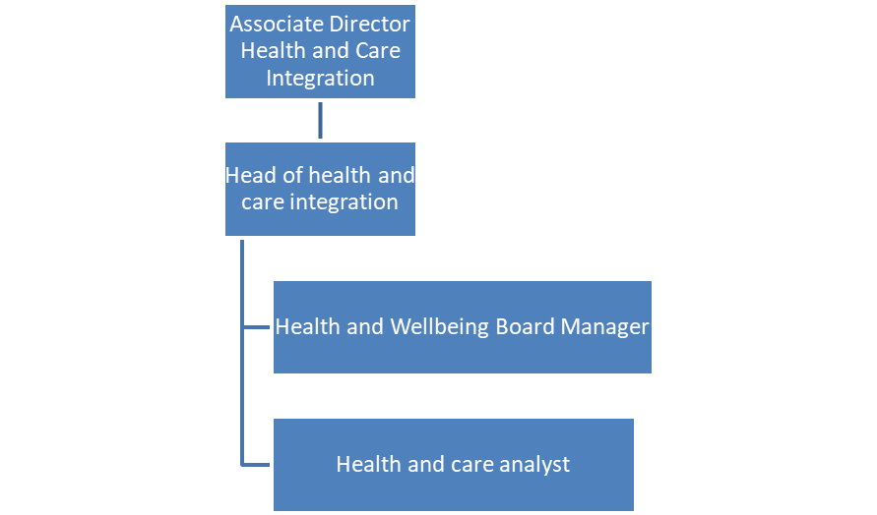
.
Person Specification

Job Title: Health and Wellbeing Board Partnerships Manager | Grade:  PO4
Section:  Health and Care Integration | Directorate: Adult Social Care and Public Health
Responsible to:  Head of Health and Care Integration | Responsible for:
Post Number/s: RWAHCS2 | Last Review Date: May 2022

Our Values and Behaviours

The values and behaviours we seek from our staff draw on the high standards of the two boroughs, and we prize these qualities in particular:

Being open. This means we share our views openly, honestly and in a thoughtful way. We encourage new ideas and ways of doing things. We appreciate and listen to feedback from each other.

Being supportive. This means we drive the success of the organisation by making sure that our colleagues are successful. We encourage others and take account of the challenges they face. We help each other to do our jobs.

Being positive. Being positive and helpful means, we keep our goals in mind and look for ways to achieve them. We listen constructively and help others see opportunities and the way forward. We have a ‘can do’ attitude and are continuously looking for ways to help each other improve.

Person Specification Requirements | Assessed by  (A / I/ T/ C)  see below for explanation
Knowledge
- In depth knowledge and understanding of the role, responsibilities and functions of a Health and Wellbeing Board and able to support the delivery integrated system changes | A/I
- A sound knowledge of existing, and pending health and care policy and relevant guidance and the ability to advise on these to support, advise and influence senior managers in their decision making as members of the Board | A/I
- Knowledge of the theory and practice of service improvement and performance management and able to apply this to continuous improvement and development of the partnership board. | A/I
Experience
- Experience of building effective partnerships/working relationships and ability to influence and persuade senior leaders, Elected Members and wider community organisations to work collaboratively in discharging the duties of the Board | A/I
- Effective problem solving using an evidence-based approach, negotiation and influencing shared programmes of work across multiple organisations and community stakeholders. | A/I
- Experience of chairing and supporting and servicing professional meetings attended by senor leaders and elected members. | A/I
Skills
- Excellent interpersonal skills including the ability to communicate effectively at all levels, including with Senior Executives, with partner organisations, Elected Members, and service users. | A/I
- Proven relationship management skills which demonstrate the ability to develop and maintain effective working partnerships with local statutory and voluntary sector agencies, other organisations as well as users and carers in order to support the board in the discharge of its duties. | A/I
- Ability to analyse complex information and provide professional advice to staff and managers at all levels in a range of organisation. | A/I
- Excellent written communication skills, with the ability to prepare reports, briefings, and policy to suit of variety of audiences. This will be combined with excellent skills using all Microsoft office packages to analyse and present complex data and concepts. | A/I
- Proven ability to think, plan and problem solve complex information in developing policies and approaches focused on performance management and improvement. | A/I
- Demonstrable skills in programme or project management skills. | A/I
- Ability to work under pressure and to deadlines. | I
- Expertise in dealing with confidential and sensitive information across organisations/ partnership boundaries. | I
- An understanding of, and commitment to Equality, Diversity and inclusion and the ability to apply this to all situations. | I
Qualifications
- Relevant professional qualification which demonstrates ability to function at a strategic level within organisations and between organisations. | A/C

A – Application form / CV
I – Interview
T – Test
C – Certificate

