Job Profile comprising Job Description and Person Specification
Job Description

Job Title:  Admin & Finance Team leader | Grade:  PO2
Section:  Operations team  Allocations & Provision | Directorate:  Housing and Regeneration
Responsible to following manager:  Housing Income Maximisation and Admin Manager | Responsible for following staff:  Admin & Finance Officers (x5)
Post Number/s: | Last review date:  New post

Working for the Richmond/Wandsworth Shared Staffing Arrangement

This role is employed under the Shared Staffing Arrangement between Richmond and Wandsworth Councils. The overall purpose of the Shared Staffing Arrangement is to provide the highest quality of service at the lowest attainable cost.

Staff are expected to deliver high quality and responsive services wherever they are based, as well as having the ability to adapt to sometimes differing processes and expectations.

The Shared Staffing Arrangement aims to be at the forefront of innovation in local government and the organisation will invest in the development of its staff and ensure the opportunities for progression that only a large organisation can provide.

Job Purpose

To manage and lead a team of staff providing comprehensive support around finance and administrative functions to the Housing Services division as directed

Specific Duties and Responsibilities

- Responsible to the Housing Income Maximisation and Admin Manager for the provision of administrative and financial functions within Housing Services

- Responsible for the line management and development of a team of Admin & Finance Officers, including regular, scheduled and structured performance and casework review meetings, supervision and team meetings. Responsible for creating training action plans and ensuring performance targets are exceeded.

- Responsible for the monitoring of and dealing with staff sickness, lateness, and poor performance within the area of responsibility, and any other matter at the preliminary/informal stage under the SSA’s Human Resources codes in accordance with existing practices and policies

- Responsible for monthly reconciliation of payments to accommodation providers across all types. Responsible for reconciliation of Housing benefit payments received against housing financial system. Responsible for the management and timely payment of Temporary Accommodation Providers invoices. Responsible for the checking and authorising of all payments in the NPS system.

- Promotes good working relationships and the effective exchange of information across Housing Services and around the Council including with creditors/Debtors Sections, Accountancy, Lettings, Housing Benefits, Legal Dept. etc, attending meetings as appropriate. Acts as lead liaison officer with these sections. Promotes good working relationships with accommodation providers, other local authorities, utility companies through effective communication and liaison.

- Responsible for the creation and review of all the team’s processes, ensuring that procedures are in line with good practice and legislation. Identify service improvements and enhancements to ensure that the team continuously improve.

- Responsible for the management of all Part VI Housing applications received both online and in paper format including management transfers. Maintain performance reports to ensure that applications are managed within prescribed timescales.

- Responsible for authorising and checking of all payments for housing mobility schemes and certifying journals as required.

- Responsible for ensuring the accurate and prompt response to all DPA, FOI and police requests for information.

- Responsible for providing detailed information for District Auditor, Internal Auditor and Audit Commission and production of reports/information on all financial duties.

- Responsible for responding to correspondence enquiries from MPs and Councillors, ombudsman and complaints in relation to the work of the Operations Team

- Ensures the Councils Equal Opportunities Policy is adhered to in respect of all aspects of the post.

- Works closely with Operations Team Leader – Income & Support to ensure
appropriate cover across both teams

- Deputises for the Housing Income Maximisation and Admin Manager as required, within the responsibilities of the post

Generic Duties and Responsibilities

- To contribute to the continuous improvement of the services of the Boroughs of Wandsworth and Richmond.

- To comply with relevant Codes of Practice, including the Code of Conduct and policies concerning data protection and health and safety.

- To adhere to security controls and requirements as mandated by the SSA’s policies, procedures and local risk assessments to maintain confidentiality, integrity, availability and legal compliance of information and systems

- To promote equality, diversity, and inclusion, maintaining an awareness of the equality and diversity protocol/policy and working to create and maintain a safe, supportive and welcoming environment where all people are treated with dignity and their identity and culture are valued and respected.

- To understand both Councils’ duties and responsibilities for safeguarding children, young people and adults as they apply to the role within the council.

- The Shared Staffing Arrangement will keep its structures under continual review and as a result the post holder should expect to carry out any other reasonable duties within the overall function, commensurate with the level of the post.

Additional information
- To manage 5 x Admin & Finance Officers
- Be prepared to work outside of usual working hours to cover emergencies
- Attend evening meetings where required
- To attend statutorily convened or otherwise multi-disciplinary meetings/forums
- To do home visits and travel to other sites, and able to use public transport
- As and when directed to meet service needs to assist in the management of Housing Service.

Team structure

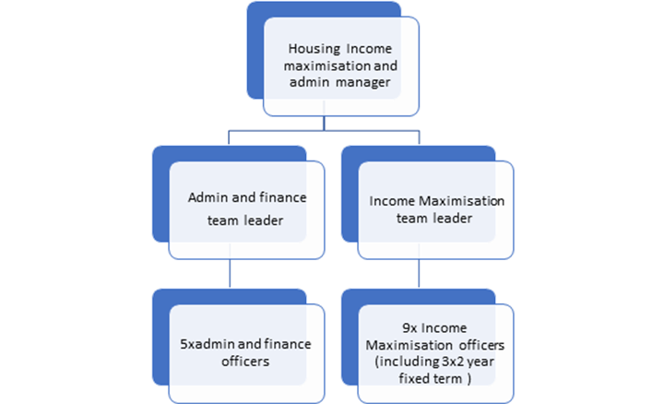

Person Specification

Job Title: Job Title:  Admin and Finance Team Leader | Grade:
Section: Housing Services | Directorate: Housing and Regeneration
Responsible to: Housing Income Maximisation and Admin Manager | Responsible for: Operations Officers – Admin and Finance Officers
Post Number/s: | Last Review Date:

Our Values and Behaviours

The values and behaviours we seek from our staff draw on the high standards of the two boroughs, and we prize these qualities in particular:

Being open. This means we share our views openly, honestly and in a thoughtful way. We encourage new ideas and ways of doing things. We appreciate and listen to feedback from each other.

Being supportive. This means we drive the success of the organisation by making sure that our colleagues are successful. We encourage others and take account of the challenges they face. We help each other to do our jobs.

Being positive. Being positive and helpful means we keep our goals in mind and look for ways to achieve them. We listen constructively and help others see opportunities and the way forward. We have a ‘can do’ attitude and are continuously looking for ways to help each other improve.

Person specification Requirements | Assessed by A  & I/ T/ C (see below for explanation)
Knowledge
Demonstrate an understanding of good practice around invoicing and administration within housing
Demonstrating and understanding of how financial IT systems operate
Understanding 1996 Housing Act within the context of the role
Experience
Experience of working in a financial environment particularly invoice management.
Experience of working within a team and taking the lead
Experience of good practice around recruiting and interviewing staff
Experience of working in a busy, changing environment and able to effectively manage different priorities
Skills
The ability to use information technology to a high standard.
The ability to undertake a wide range of financial and administrative tasks.
The ability to adapt to both varying tasks and those of a routine nature.
The ability to respond effectively to staff, outside agencies, suppliers and
the public, both in person, in writing and over the telephone.
Proven literacy, numeracy and communication skills.
A calm and empathetic approach when working with the public and dealing with complaints and complex situations
Excellent attention to detail
Able to work under pressure
Qualifications
Maths and English GCSE grade C and above or equivalent.

