Job Profile comprising Job Description and Person Specification

Job Description

Job Title:  Community Health and Wellbeing Development Officer | Grade & Starting Salary: Scale 4-6 with annual progression (Subject to successful yearly completion of study of BSc Public Health Apprenticeship)
Section:  Public Health | Directorate:  Adult Social Care and Public Health
Responsible to following manager:  Senior Public Health Lead  Reports to:  Senior Public Health Lead  working in matrix approach (dotted line to Partnership Manager/ Community Engagement Manager, Community and Partnerships team | Responsible for following staff:  N/A
Post Number/s: | Last review date: July 2021
Contract type: Fixed term 3 and a half years F/T (36 hours/week, including 20 percent study time for Public Health Practitioner apprenticeship qualification) | Start date: October 2021  End date: March 2025
Area covered: Richmond and Wandsworth  Base: Wandsworth | Special conditions:  Possible evening / weekend work- Flex working, take time back

Working for the Richmond/Wandsworth Shared Staffing Arrangement

This role is employed under the Shared Staffing Arrangement between Richmond and Wandsworth Councils. The overall purpose of the Shared Staffing Arrangement is to provide the highest quality of service at the lowest attainable cost.

Staff are expected to deliver high quality and responsive services wherever they are based, as well as having the ability to adapt to sometimes differing processes and expectations.

The Shared Staffing Arrangement aims to be at the forefront of innovation in local government and the organisation will invest in the development of its staff and ensure the opportunities for progression that only a large organisation can provide.

You will have a passion for working with people and empowering them to achieve their goals. You will be able to build strong, positive, and long-lasting relationships that lead towards better well-being for all. You will be motivated, organised, proactive and a confident communicator. You will be comfortable working independently and alongside the team to achieve our programme objectives.
Key PH Competencies
Begin a training programme to develop the public health standard’s knowledge, skills and behaviours
See standards here: Public health practitioner (integrated degree) / Institute for Apprenticeships and Technical Education.
Job Purpose:
The Community Health and Wellbeing Development Officer will support the development and delivery of community action prevention and wellbeing projects and activity. They will work with the local community to develop and deliver a range of health and wellbeing activities and prevention programmes based on evidence and community need. They will reach out to those who are not engaged, helping them to overcome the barriers which are stopping them. They will work closely with our partners in the Council’s Health Protection, Community and Partnerships Team and support the Community Public Health Leads.
Specific Duties and Responsibilities
- To support the faith and community leaders work using a community led and community development approach with sustainable ways of working to improve local outcomes.
- To develop and deliver a range of health and wellbeing and Local Outbreak Management Plan programmes/events to increase opportunities for the local communities to improve their health and wellbeing.
- To work with partners to identify and deliver training for community members to enhance local capacity, knowledge, and skills.
- To work with the Healthy Communities lead, Public Health Policy Officer, and Community Engagement team and partners to develop and deliver a wide range of information, tools, and resources.
- To be an active member of the Community Health Action Group.
- To support the PH Policy Officer (chair of CAG) in the development and delivery of health and wellbeing projects and programmes delivered by the PH Community Action Group.
- To monitor, record and report on the project’s impact, collating quantitative and qualitative data, and reporting back on the outcomes achieved.
- To liaise with the wider community in the 20% most deprived geographies/areas of Wandsworth to share knowledge, expertise, and resources and relevant communities in Richmond.
- To learn and develop practical experience, drawing on knowledge acquired through vocational study and on the job training.
- To learn about community action, health promotion and evidence based healthcare.
- To work with the Public Health colleagues on work programmes to ensure that interventions are based on evidence of need through Public Health intelligence and professional expertise and aimed at improving Public Health outcomes, especially through the lens of community development
- To contribute to the gathering and analysis of relevant demographic information, service trends, user consultation and feedback.
- To deliver training for community members to enhance local capacity, knowledge, and skills
- To contribute to briefings to Members, senior management, programme boards and other briefings. This will be fully supervised by the line manage (Senior Public Health Lead).

SCALE 5 - Key PH Competencies
Successful Apprentice will be able to demonstrate at the end of their course:
• a systematic understanding of key aspects of their field of study, including acquisition of coherent and detailed knowledge, at least some of which is at, or informed by, the forefront of defined aspects of a discipline
• an ability to deploy accurately established techniques of analysis and enquiry within a discipline
• conceptual understanding that enables them:
- to devise and sustain arguments, and/or to solve problems, using ideas and techniques, some of which are at the forefront of a discipline
- to describe and comment upon particular aspects of current research, or equivalent advanced scholarship, in the discipline
• an appreciation of the uncertainty, ambiguity and limits of knowledge
• the ability to manage their own learning, and to make use of scholarly reviews and primary sources (for example, refereed research articles and/or original materials appropriate to the discipline)
SCALE 5 -Gateway requirements:
The apprentice has completed 330 credits of the degree programme (The final 30 credits of the degree will be attributed to end-point assessment)
The apprentice has prepared a portfolio of evidence that underpins the first assessment method mapped to all of the knowledge, skills, behaviours (KSBs) (Public health practitioner (integrated degree) / Institute for Apprenticeships and Technical Education)

Apprentice must submit a portfolio of evidence to the EPAO (end-point assessment organisations)

End point assessment (EPA): After completion of degree all apprentices must take an independent assessment at the end of their training to confirm that they have achieved occupational competence based on apprenticeship standards relating to Public Health
Please note:
- The EPA period should only start, and the EPA be arranged, once we are satisfied that the apprentice is consistently working at or above the level set out in the occupational standard
- The EPA must be completed within a period lasting a maximum of 3 month(s), beginning when the apprentice has passed the EPA Gateway (as evidenced to an EPAO)
The EPA consists of 2 discrete assessment methods. The individual assessment methods will have the following grades:
- Assessment method 1: Presentation of practice with question and answer session Graded: fail/pass/distinction
- Assessment method 2: Scenario-based situational judgement test Graded: fail/pass. (must be overseen by an external assessor and be a total assessment time of 150 minutes)

Performance in the EPA will determine the overall apprenticeship grades of fail/pass/distinction.
LINKED GRADE PROGRESSION (AFTER MEETING GATEWAY REQUIREMENTS AND PH COMPETENCIES) - SCALE 5

- to write reports/briefings (with senior support) to inform stakeholders of public health information and evidence
- To ensure maintenance and development of a strong Public Health knowledge base around community action
- To ensure the effective delivery of a range of appropriate community interventions; insight, engagement and effective partnerships, to aid and influence delivery, across a range of stakeholders.

SCALE 6 - Gateway requirements:
Completion of end point assessment. Move to Scale 6 only once candidate has completed this and demonstrated competencies within work appraisal process.

SCALE 6 - Key PH Competencies

Typically, holders of the newly acquired qualification will be able to:
• apply the methods and techniques that they have learned to review, consolidate, extend and apply their knowledge and understanding, and to initiate and carry out projects
• critically evaluate arguments, assumptions, abstract concepts and data (that may be incomplete), to make judgements, and to frame appropriate questions to achieve a solution - or identify a range of solutions - to a problem
• communicate information, ideas, problems and solutions to both specialist and non - specialist audiences
And holders will have: Qualities and transferable skills necessary for employment requiring:
- the exercise of initiative and personal responsibility
- decision-making in complex and unpredictable contexts

- The learning ability needed to undertake appropriate further training of a professional or equivalent nature
Completion of training to develop the occupation standard’s knowledge, skills and behaviours – demonstrating a broad knowledge and experience of the breadth of public health practice including health improvement, public health knowledge and intelligence, aspects of healthcare public health and health protection.
See details here: Public health practitioner (integrated degree) / Institute for Apprenticeships and Technical Education

LINKED GRADE PROGRESSION (AFTER MEETING GATEWAY REQUIREMENTS AND PH COMPETENCIES) - SCALE 6

As above with more autonomy and delivery of community action and community engagement with the Health Protection and working with wider Council team with senior Public Health Lead support.

Generic Duties and Responsibilities

- A commitment to undertake learning and development opportunities as agreed with line manager.
- To attend supervision and other meetings as requested by your line manager.
- To complete other tasks and assume other duties as required and appropriate.
- To co
- mply with relevant Codes of Practice, including the Code of Conduct and policies concerning data protection and health and safety.
- To adhere to security controls and requirements as mandated by the SSA’s policies, procedures, and local risk assessments to maintain confidentiality, integrity, availability and legal compliance of information and systems.
- To promote equality, diversity, and inclusion, maintaining an awareness of the equality and diversity protocol/policy and working to create and maintain a safe, supportive, and welcoming environment where all people are treated with dignity and their identity and culture are valued and respected.
- To understand both Councils’ duties and responsibilities for safeguarding children, young people and adults as they apply to the role within the council.

Additional Information

- This job description is intended to outline the post at this stage of development. It is not an exhaustive list, and it is recognised that jobs change and evolve over time as the Apprentice develops.
- Post holders will be required to carry out any other duties associated with the project only to the equivalent level that are necessary to fulfil the purpose of the job, and to respond positively and flexibly to changing organisational needs and as their skills develop on the Apprenticeship.
- Post holder may be expected to work flexibly across two locations (Wandsworth Town Hall and Richmond Civic Centre).
The cost of undertaking this qualification will be met by the Council. The post holder will be supported to obtain successful admission onto the BSc Public Health Practitioner Apprenticeship programme, offered by suitable training provider, which is likely to be a University, on a part-time basis commencing either September 2021 or January 2022. 20% off the job time is awarded to support completion of the degree.
- The post is subject to the usual employment checks.
- This post has an apprenticeship agreement.
- All travel expenses and accommodation in relation to the post will be paid for through normal expenses processes.
- The post holder is expected to participate in the organisation’s staff appraisal scheme and departmental audit and ensure appraisal and development of any staff for which s/he/they is/are responsible.

Current Team Structure

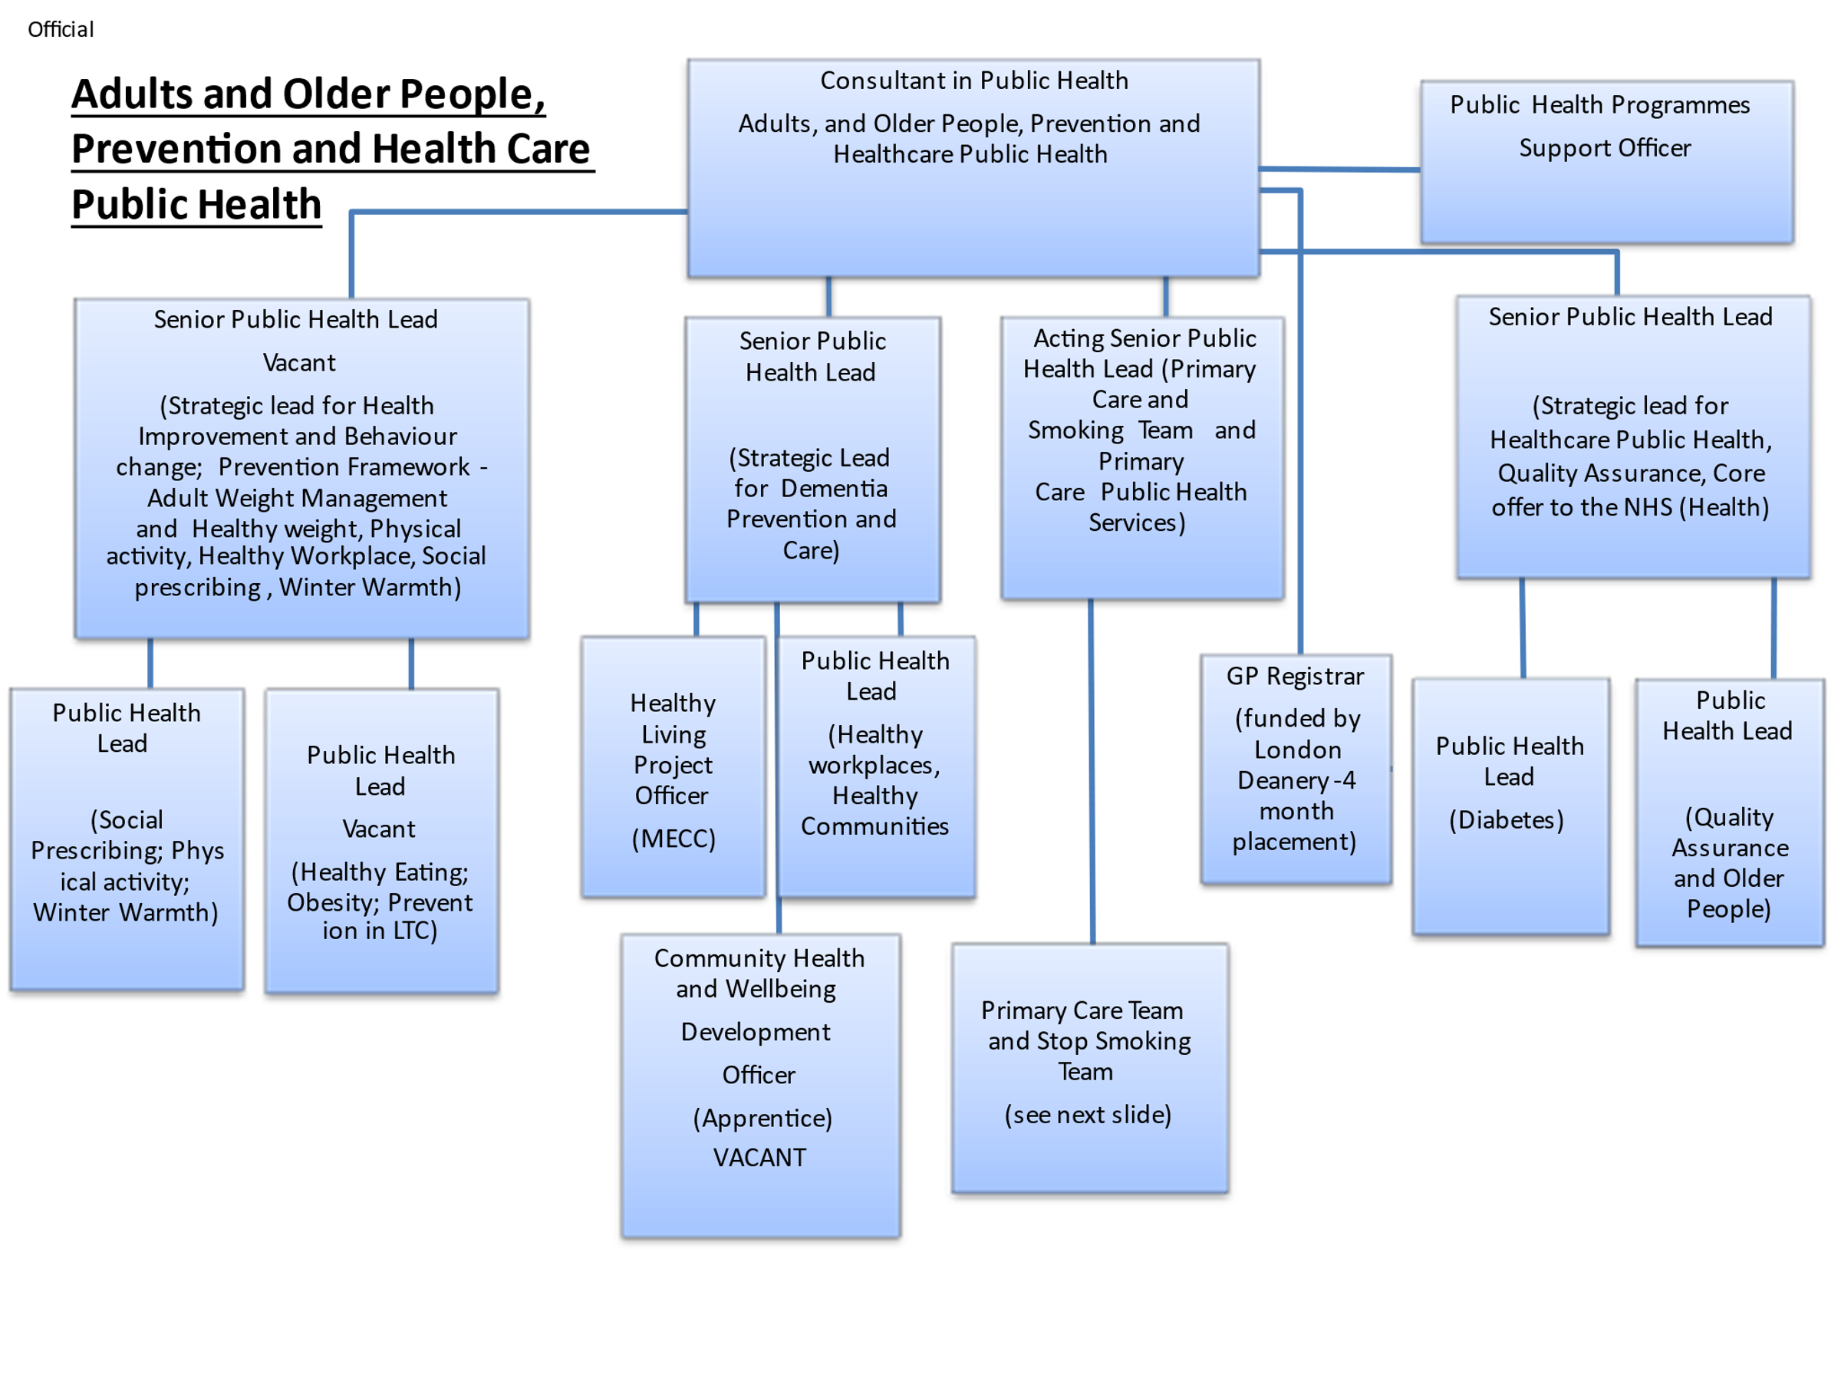
Professional obligations
The post holder will be expected to:
- To successfully pursue a course of study with the assigned learning provider, college, or University, participating in lessons and undertaking required assignments, projects, tests, and end point assessment within the required timescales.
- To complete the BSc Public Health Practitioner Apprenticeship and following this, to undertake CPD as required.

Person Specification Requirements based on PHP Apprenticeship Entry Criteria
Job Title:  Community Health and Wellbeing Development Officer | Grade & Starting Salary: Scale 4-6
Section:  Public Health | Directorate:  Adult Social Care and Public Health
Responsible to following manager:  Senior Public Health Lead  Reports to:  Senior Public Health Lead  working in matrix approach (dotted line to Partnership Manager/ Community Engagement Manager, Community and Partnerships team) | Responsible for following staff:  N/A
Post Number/s: | Last review date: July 2021
Contract type: Permanent F/T (36 hours/week, including 20 percent study time for Apprenticeship | Start date: October 2021  End date: December 2024
Area covered: Richmond and Wandsworth  Base: Wandsworth | Special conditions:  Possible evening / weekend work- Flexi working, take time back

Our Values and Behaviours
The values and behaviours we seek from our staff draw on the high standards of the two boroughs, and we prize these qualities in particular:
Being open. This means we share our views openly, honestly and in a thoughtful way. We encourage new ideas and ways of doing things. We appreciate and listen to feedback from each other.

Being supportive. This means we drive the success of the organisation by making sure that our colleagues are successful. We encourage others and take account of the challenges they face. We help each other to do our jobs.

Being positive. Being positive and helpful means, we keep our goals in mind and look for ways to achieve them. We listen constructively and help others see opportunities and the way forward. We have a ‘can do’ attitude and are continuously looking for ways to help each other improve.
Person Specification Requirements based on PHP apprenticeship Entry Criteria | Assessed by A & I/ T/ C (see below for explanation)
Knowledge
Knowledge of public health practice, health promotion, and health care evaluation | A / I / T
Experience
Prior learning and experience in a public health context | A/I
Skills
Excellent communicator in oral, written and presentation skills (verbal and written) | A / I
Able to adapt communication techniques used according to audiences | A /I
Community engagement, motivation skills | A / I
Excellent personal and professional values
Effective team member with good interpersonal skills | A / I
Flexible, pro-active, uses initiative, prioritises, manages own workload | A / I
Ability to carry out research and evaluate research carried out by others | A / I
Computer literate to enable reports, presentations, spreadsheets, databases to be produced | A / I / T
Qualifications
Level 2 or equivalent English and Maths qualification, grade C or above | A/C
Demonstration of successful study at Level 3 (A level, Access, BTEC) or equivalent experience, providing evidence of working at a level 3 study | A/C
* For applicants without the above level 3 qualifications: at least 2 years’ experience in a public health related role, providing evidence of the following via personal statement:  - Team working ability  - professional engagement / motivation  - communication skills (verbal and written)  - personal and professional values  - prior learning and experience in a public health context | A

