Job Profile comprising Job Description and Person Specification
Job Description

Job Title:  Community Ambassador Project Officer (Housing)  (Fixed term until 31st June 2024) | Grade:  SO1
Section:  Community and Partnerships, Customers and Partnerships | Directorate:  Chief Executive’s Directorate
Responsible to following manager:  Community Engagement Manager | Responsible for following staff:  Community Ambassadors (volunteers)
Post Number/s: | Last review date:  April 2023

Working for the Richmond/Wandsworth Shared Staffing Arrangement

This role is employed under the Shared Staffing Arrangement between Richmond and Wandsworth Councils. The overall purpose of the Shared Staffing Arrangement is to provide the highest quality of service at the lowest attainable cost.

Staff are expected to deliver high quality and responsive services wherever they are based, as well as having the ability to adapt to sometimes differing processes and expectations.

The Shared Staffing Arrangement aims to be at the forefront of innovation in local government and the organisation will invest in the development of its staff and ensure the opportunities for progression that only a large organisation can provide.

Job Purpose
The post reports to the Community Engagement Manager. The main purpose of this post is to engage with residents of social housing to enlist and develop volunteer Community Ambassadors by providing professional support to improve the capacity and effectiveness to the volunteers. Support includes volunteer management, recruitment, inducting and ensuring training is delivered to all Community Ambassadors. This role focuses on work in the borough of Richmond. The post is within the Community Engagement team which also includes support for initiatives in Wandsworth. This role will work closely with Richmond based Community Engagement Officers and will involve direct support for events and work done by the team as required.

This role will act as a bridge between the Council and housing associations. All of the borough’s social housing is owned and managed by housing associations, there is no Council managed housing stock in Richmond. This role will support and inform the housing associations in working to improve housing and environmental standards and in responding and dealing with complaints from the residents. Its aim is to give a voice to the residents of social housing with their landlords and the Council. Additionally, the role will support the Community Engagement team in helping to reach seldom heard groups.

The Community Ambassador Project Officer is a new post. The officer will need to be a self-starter, confident at introducing new initiatives and approaching communities who may not have a current relationship with the Council or their landlord.

Specific Duties and Responsibilities

- Recruit Community Ambassadors and provide any training (overview of Community Ambassadors objectives and activities).

- To lead the activities carried out by the Community Ambassadors and coach them in best practice community engagement. At times, this will also include challenging the Community Ambassadors and guiding them.

- Ensure Community Ambassadors are sufficiently resourced (e.g. posters, leaflets, etc.) to be effective.

- To facilitate, steer and resolve issues raised by the Community Ambassadors.

- To maintain a positive engagement with existing Community Ambassadors and ensure high levels of engagement in communities.

- To plan and organise Community Ambassadors quarterly forums.

- Consistently update the Community Ambassador webpage and social media on the progress/ promotion of the programme.

- To gather case studies on the programme on an ongoing basis.

- To lead in the production of reports and monitoring of the Community Ambassador Programme.

- Develop asset maps and ward profiles of the areas covered by the Community Ambassadors, as well as gathering insightful data that informs our engagement on an ongoing basis.

- Work with the Community Engagement Team, Project Officer, wider Community and Partnerships Team, Housing Department and other departments, to coordinate the targeted aims of the Community Ambassador Programme.

- Keep a running brief with the Spokesperson for Housing on the direction of the programme and their preferences, ensuring these resonate with the targeted aims. Also keeping close contact with the Council’s Tenants’ Champion.

- To respond to all enquiries about the Community Ambassador programme, from the public, senior officers and elected Members. This is to include by email, social media, letter, telephone and in-person meetings.

- To represent the Community Ambassador programme, which may include making presentations to groups.

- To maintain relationships with housing associations, working in close conjunction with the Housing Department.

- To contribute to the engagement work to reach and enable underrepresented groups and individuals along with protected characteristic groups.

- Ability to create and implement Volunteer Reward and Recognition Ensure that the Project is following national best practice guidelines in volunteer management.

Generic Duties and Responsibilities

- To contribute to the continuous improvement of the services of the Boroughs of Wandsworth and Richmond.

- To comply with relevant Codes of Practice, including the Code of Conduct and policies concerning data protection and health and safety.

- To adhere to security controls and requirements as mandated by the SSA’s policies, procedures and local risk assessments to maintain confidentiality, integrity, availability and legal compliance of information and systems

- To promote equality, diversity, and inclusion, maintaining an awareness of the equality and diversity protocol/policy and working to create and maintain a safe, supportive and welcoming environment where all people are treated with dignity and their identity and culture are valued and respected.

- To understand both Councils’ duties and responsibilities for safeguarding children, young people and adults as they apply to the role within the council.

- The Shared Staffing Arrangement will keep its structures under continual review and as a result the post holder should expect to carry out any other reasonable duties within the overall function, commensurate with the level of the post.
Additional Information
- The post holder is expected to have volunteer management experience, they will need to demonstrate levels of experience in all areas of the volunteer management cycle; Recognition - Planning – Recruitment – Induction and Training – Supervision and Evaluation – Review.
- The post holder will be expected to supervise 15-20 volunteers as a maximum through the project.
- The Shared Staffing Arrangement will keep its structures under continual review and as a result the post holder should expect to carry out any other reasonable duties within the overall function, commensurate with the level of the post.
- The post(holder) will be part time (2.5 days) which means that the work of the post needs to be proportionate to time worked and the duties that are prioritised
- To ensure that the services for both Councils are dealt with on an equitable basis to deliver the standards required for each, as agreed annually by the Executives of both Councils
- No staff are supervised by this post, only volunteers.
- This post will be a mixture of desk work and work directly in the field with Community Ambassadors, including on social housing estates. This will include lone working on estates.

Our Values and Behaviours

The values and behaviours we seek from our staff draw on the high standards of the two boroughs, and we prize these qualities in particular:

Being open. This means we share our views openly, honestly and in a thoughtful way. We encourage new ideas and ways of doing things. We appreciate and listen to feedback from each other.

Being supportive. This means we drive the success of the organisation by making sure that our colleagues are successful. We encourage others and take account of the challenges they face. We help each other to do our jobs.

Being positive. Being positive and helpful means we keep our goals in mind and look for ways to achieve them. We listen constructively and help others see opportunities and the way forward. We have a ‘can do’ attitude and are continuously looking for ways to help each other improve.

Person Specification Requirements |  |  |  | Assessed by  A/I/T/C  (See below for explanation)
 | Knowledge | Essential | Desirable | Assessed
 | - Knowledge of current issues facing social housing | x
 | - Good working knowledge of service user involvement in major decisions | x
 | - Experience of working with multi-agency groups | x
 | - Ability to independently manage projects with different deadlines |  | x
 | - Good working knowledge of customer care principles and techniques |  | x
 | Experience | Essential | Desirable | Assessed
 | - Demonstrable experience of working in a customer focused environment | x
 | - Experience of resident involvement or a similar field (e.g. community engagement) | x
 | Skills | Essential | Desirable | Assessed
 | - Ability to form and develop effective working relationships with a wide range of people and organisations | x
 | - Excellent communication and presentational skills | x
 | - Skilled use of a wide range of computer applications and databases | x
 | - Ability to deliver training to residents |  | x
 | - Ability to collate and analyse data |  | x
 | Qualifications | Essential | Desirable | Assessed
 | Relevant professional qualification |  | x
 | Ability to deal confidently with difficult situations and people |  | x

Team Structure

*** Denotes team currently sited within Stronger and Safer Communities Department

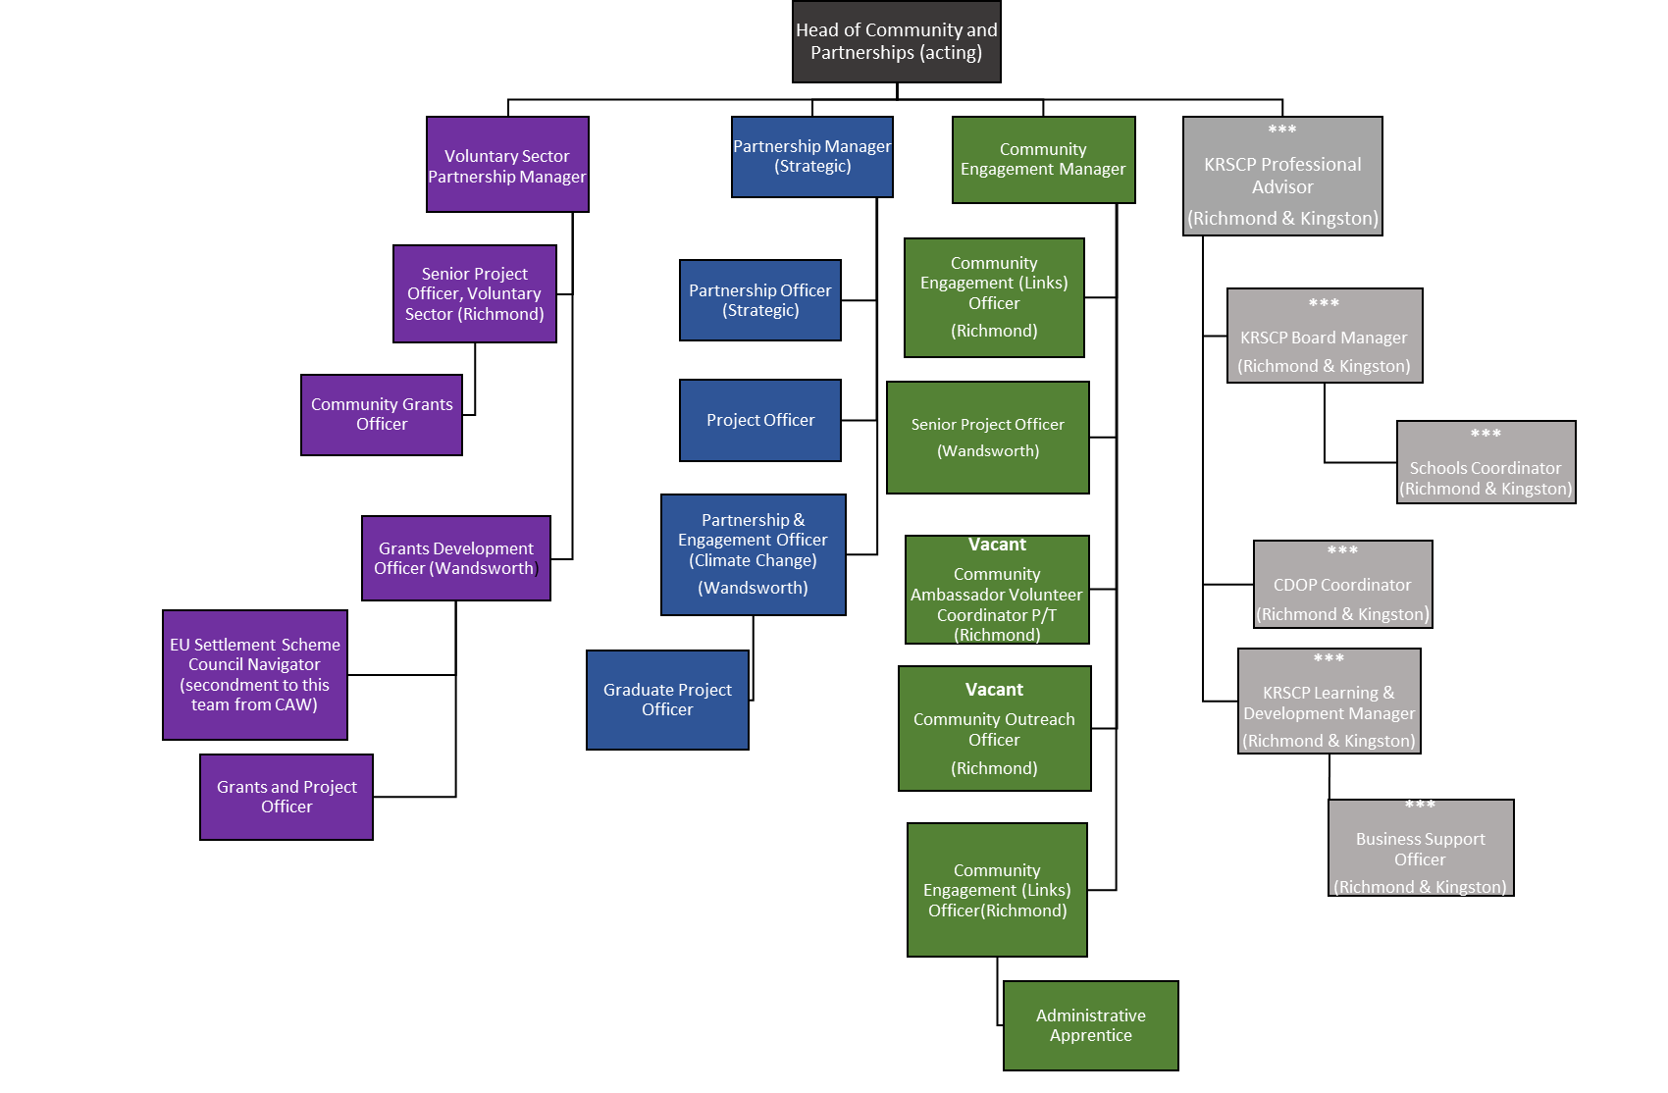

Person Specification

Job Title:  Community Ambassador Project officer | Grade:  SO1
Section:  Community and Partnerships, Customers and Partnerships | Directorate:  Chief Executive Directorate
Responsible to:  Community Engagement Manager | Responsible for:  Community Ambassadors (volunteers)
Post Number/s: | Last Review Date:  September 2021

Our Values and Behaviours

The values and behaviours we seek from our staff draw on the high standards of the two boroughs, and we prize these qualities in particular:

Being open. This means we share our views openly, honestly and in a thoughtful way. We encourage new ideas and ways of doing things. We appreciate and listen to feedback from each other.

Being supportive. This means we drive the success of the organisation by making sure that our colleagues are successful. We encourage others and take account of the challenges they face. We help each other to do our jobs.

Being positive. Being positive and helpful means, we keep our goals in mind and look for ways to achieve them. We listen constructively and help others see opportunities and the way forward. We have a ‘can do’ attitude and are continuously looking for ways to help each other improve.

Person Specification Requirements | Assessed by  A  & I/ T/ C (see below for explanation)
Knowledge
A knowledge of the social housing sector and the services provided by social housing landlords in particular. | A/I
Clear understanding of the role of volunteers and their impact within an organisation. | A/I
Knowledge of local government structures and role of local ward Councilors. | A/I
Understanding of consumer-focused service delivery and customer care standards. | A/I
Experience
Managing and coordinating volunteers. | A/I
Managing and building strong relationships with volunteers, service users and external agencies. | A/I
Experience of working in an administrative and project support role in a local authority or similar organisation. | A/I
Experience in communicating effectively and sensitively in oral and written form to a wide range of individuals and organisations. | A/I/T
Some experience in producing information/publicity material including web editing and providing text for social media. | A/I
Support and advise volunteers to develop good practice and to ensure all volunteers work within correct frameworks. | A/I
Experienced in all areas of the volunteer management cycle | A/I/T
Skills
Proven organisational and time management skills. | A/I
Ability to organise and prioritise own workload, to work under pressure and meet deadlines. | A/I
Ability to handle confidential or sensitive information, together with an understanding of data protection requirements. | A/I
Ability to critically investigate issues and prepare briefings/assessments as required. | A/I
Support and advise volunteers to develop good practice and to ensure all volunteers work within correct frameworks. | A/I
To develop and maintain the volunteers’ understandings of the organisation’s work. | A/I
Ability to carry out risk assessments in line with local and national standards | A/I
Ability to organise and facilitate groups where volunteers can share feedback on their experiences. | A/I
Ability to manage volunteers including their personal development. | A/I
Ability to develop and maintain policy and procedure for volunteers | A/I
Good working knowledge of using standard IT packages including Microsoft packages. | A/I
Able to maintain a range of different record keeping systems. | A/I
Ability to facilitate and maintain positive communications locally. | A/I
Ability to deliver high impact verbal and written presentations to a range of stakeholders including Councilors, senior members of staff, residents and volunteers. | A/I/T
Qualifications
Qualifications or qualified by experience proving a good standard of both written and spoken English and capability in maths. | A/C/I
Qualified by experience in working with volunteers. | A/C/I

A – Application form / CV
I – Interview
T – Test
C - Certificate

