Job Profile comprising Job Description and Person Specification
Job Description

Job Title:  Information and Transparency Manager | Grade:  PO6
Section:  Resident Engagement Team | Directorate:  Chief Executive’s Group
Responsible to following manager:  Statutory and Corporate Complaints and FOI Manager | Responsible for following staff:  FOI and DPA Officers (x4)
Post Number/s:  RWC0223 | Last review date:  October 2018

Working for the Richmond/Wandsworth Shared Staffing Arrangement

This role is employed under the Shared Staffing Arrangement between Richmond and Wandsworth Councils. The overall purpose of the Shared Staffing Arrangement is to provide the highest quality of service at the lowest attainable cost.

Staff are expected to deliver high quality and responsive services wherever they are based, as well as having the ability to adapt to sometimes differing processes and expectations.

The Shared Staffing Arrangement aims to be at the forefront of innovation in local government and the organisation will invest in the development of its staff and ensure the opportunities for progression that only a large organisation can provide.

Job Purpose

- Accountable for the Councils’ responsibilities for Freedom of Information (FOI) and Environmental Information Regulations (EIR) and meeting the councils’ objectives for openness and transparency

- Support the development and implementation of the SSA’s approach to the provision of information to the public, ensuring transparency and promoting accountability

- Provide support across the SSA on the development, implementation and promotion of policies and procedures in relation to compliance

Specific Duties and Responsibilities:

- To lead the development and implementation of a systematic approach to making information about both Councils available to the public to encourage transparency and accountability

- To develop, implement and keep under review arrangements across the SSA for ensuring compliance with the FOI Act 2000, EIR 2004 and General Data Protection Regulation (GDPR) and Data Protection Act (DPA) 2018 and associated legislation, ensuring consistency and robustness in terms of policies, processes and procedures

- To lead on the provision of training and advice to officers and members from both Councils on public information matters including FOI/EIR and DPA and to provide advice to senior officers, Members and the public on more complex cases

- To contribute to the development, implementation and review of information governance policies, procedure and practice across the organisation and support the Complaints and FOI Manager and GDPR and Information Governance Manager in their lead roles in relation to information governance

- To provide expertise and advice on how data protection, FOI and EIR issues should be appropriately considered and reflected in the Councils’ other policies and procedures such as contracts, publications etc

- To be the key point of contact with the Information Commissioner’s Office and maintain the Councils’ registrations in accordance with ICO and data protection requirements for both Councils

- To provide effective management of 4 FOI and DPA Officers, including recruitment, training, development and appropriate application of policies and codes of practice on staffing matters

- To ensure there is strategic oversight and that caseloads relating to FOI/EIR/DPA and Subject Access Requests (SAR) are effectively allocated and managed to meet statutory deadlines and quality standards, and to monitor and report on compliance and other performance measures as required

- To deal with individual FOI/EIR/DPA/ SAR casework as required but particularly more complex or non-standard cases, and to ensure effective systems exist for recording, reporting, and quality assurance in cases where requests for information have not been granted

- To carry out internal reviews on responses to FOI and EIR requests as required

Generic Duties and Responsibilities

- To contribute to the continuous improvement of the services of the Boroughs of Wandsworth and Richmond

- To comply with relevant Codes of Practice, including the Code of Conduct and policies concerning data protection and health and safety

- To adhere to security controls and requirements as mandated by the SSA’s policies, procedures and local risk assessments to maintain confidentiality, integrity, availability and legal compliance of information and systems

- To promote equality, diversity, and inclusion, maintaining an awareness of the equality and diversity protocol/policy and working to create and maintain a safe, supportive and welcoming environment where all people are treated with dignity and their identity and culture are valued and respected

- To understand both Councils’ duties and responsibilities for safeguarding children, young people and adults as they apply to the role within the council

- The Shared Staffing Arrangement will keep its structures under continual review and as a result the post holder should expect to carry out any other reasonable duties within the overall function, commensurate with the level of the post.

Additional Information

- Management of 4 FOI and DPA Officers

- Post holder will be expected to work flexibly across two locations (Wandsworth Town Hall and Richmond Civic Centre) in order to manage staffing teams across both sites.

Current team structure

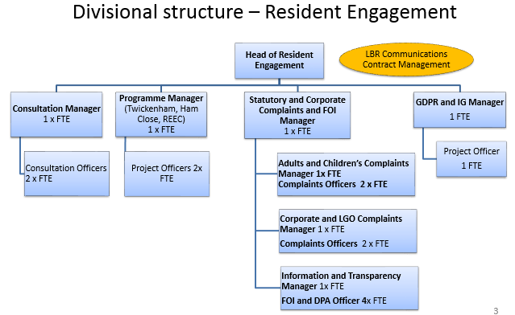
Person Specification

Job Title:  Information and Transparency Manager | Grade:  PO6
Section:  Resident Engagement | Directorate:  Chief Executive’s Group
Responsible to following manager:  Statutory and Corporate Complaints and FOI Manager | Responsible for following staff:  FOI and DPA Officers (x4)
Post Number/s:  RWC0223 | Last review date:  October 2018

Our Values and Behaviours

The values and behaviours we seek from our staff draw on the high standards of the two boroughs, and we prize these qualities in particular –

- Being Open - means we share views openly, honestly and in a thoughtful way. We encourage new ideas and ways of doing things. We appreciate and listen to feedback from each other.

- Being supportive - means we drive the success of the organisation by making sure that our colleagues are successful. We encourage others and take account of the challenges they face. We help each other to do our jobs.

- Being positive and helpful - means we keep our goals in mind and look for ways to achieve them. We listen constructively and help others see opportunities and the way forward. We have a ‘can do’ attitude and are continuously looking for ways to help each other improve.

Person Specification Requirements | Assessed by  A & I/ T/ C (see below for explanation)
Knowledge
Detailed knowledge of the Freedom of Information Act 2000, Environmental Information Regulations 2004, the Data Protection Act 2018, and their application to local authorities | A, I, T
Good understanding of the transparency and information agendas | A, I, T
Detailed understanding of the principles of good information governance as they apply to a local authority | A, I, T
Experience
Experience of successfully developing, implementing and maintaining corporate processes across complex organisations | A, I, T
Experience of successfully managing FOI/EIR/DPA/SAR processes in compliance with statutory requirements and minimising risk to the Council | A, I, T
Experience of managing staff and/or the allocation of caseload to others and monitoring delivery, with positive outcomes | A,I
Skills
Good oral and written communication skills in order to convey both information and complex legal reasoning effectively to members of the public and to convince officers and Members of the merits of complying with procedures | A, I, T
Good interpersonal skills including the ability to build good relationships and establish credibility with senior officers and elected members in order to secure their buy-in to compliance with corporate processes | A, I
Ability to successfully manage own workload and that of others in an environment where deadlines and priorities frequently change and are sometimes conflicting | A, I
Qualifications
Qualification in Information Law desirable but not essential | C

A – Application form
I – Interview
T – Test
C - Certificate

