Job Profile comprising Job Description and Person Specification
Job Description

Job Title: Electoral Services & Elections Officer | Grade: SO1/SO2 linked grade
Section: Electoral Services (Wandsworth) | Directorate: Resources
Responsible to following manager:  Deputy Electoral Services & Elections Manager PO4/5 | Responsible for following staff: See Job Dimensions and current Team Structure
Post Number: A0901 A0907 A0908 | Last Review date: 2 July 2018

Working for the Richmond/Wandsworth Shared Staffing Arrangement

This role is employed under the Shared Staffing Arrangement [SSA] between Richmond and Wandsworth Councils. The overall purpose of the Shared Staffing Arrangement is to provide the highest quality of service at the lowest attainable cost.

Staff are expected to deliver high quality and responsive services wherever they are based, as well as having the ability to adapt to sometimes differing processes and expectations.

The Shared Staffing Arrangement aims to be at the forefront of innovation in local government and the organisation will invest in the development of its staff and ensure the opportunities for progression that only a large organisation can provide.

Please note that within the context of the SSA Electoral Services at Richmond and Wandsworth Councils operate as two separate Services.

Job Purpose

To assist with the management and discharge the duties, and support the Chief Executive Officer (CEO) as Electoral Registration Officer and Returning Officer and the Council, CEO and the Assistant Director of Resources – Corporate Services – (ADRCS) for the development, management and administration of electoral registration and election management matters.

To assist with all electoral registration and election arrangements in accordance with legislation and referenda including: Parliamentary, European Parliamentary, Local Council, Referendums, and GLA Mayoral and Assembly for London (with Wandsworth being the lead borough for the Merton and Wandsworth Constituency). This also includes all Neighbourhood Planning (residential and/or business) or Council Tax Referendums.

Assists with administering on behalf of the Ballot Holder, all Business Improvement District (BID) ballots and renewal ballots working in liaison with Revenue Services and the Economic Development Office.

Job Dimensions

Assists with the supervision and training of temporary, agency administrative support staff and seasonal canvass staff.

Prior to and during elections and the annual canvass the post holder will be required to work additional hours at evenings and weekends and unsocial hours at short notice to ensure that statutory deadlines are met, and when participating in community outreach work.

Agreement to restrict leave during the main electoral canvass period (September to December) and at election times.

Specific Duties and Responsibilities

SO1

- Assist the Head of Electoral Services & Elections (HESE) with the effective and efficient delivery of the electoral registration process, annual canvass, all elections, referenda, statutory ballots and periodic reviews.

2. To assist with the day to day preparation, compilation, publication and distribution of the register of electors and other published lists in accordance with statutory provisions referring any complex queries to the Deputy Electoral Services & Elections Manager (DESEM).

3. To undertake the day to day administrative tasks relating to maintaining an accurate register of electors, including processing the addition and removal of electors (via both online and hard copy applications as received,) under Individual Electoral Registration (IER). Process applications that have failed verification or are otherwise incomplete. Assist with all procedures and administration connected with the daily checking of applications for registration and absent voting.

4. To undertake assigned duties in the preparation of Elections and Referenda as part of a dedicated team dealing with a full range of statutory activities which include the planning and conduct of all elections and referenda.

5. Awareness of the law and regulations in relation to electoral services including the regulations covering Individual Electoral Registration (IER).

6. Undertake duties associated with the preparation and organizing of the annual canvass and election training materials and maintain and update staffing lists as required.

7. To deal effectively with internal and external parties, including routine enquiries from members of the public, which could be face to face or receiving and responding to incoming communication e.g. general telephone calls and emails. Resolving general enquiries at first point of contact, wherever possible.

8. Liaise with electoral software company with regard to reporting system problems.

9. Assist with electoral awareness campaigns including the design of registration forms, canvassing materials and support publicity and other campaigns to encourage public awareness and voter participation.

10. Participate in, and contribute to the development and implementation of procedures to improve involvement in the democratic process, including promotional / educational visits to local community groups and to schools and colleges.

11. To assist in maintaining absent voters lists including processing, checking and filing. Undertake other electoral services work in relation to the processing and checking of absent voting applications.

12. To assist with the registration of special category electors such as service and overseas electors, crown servants and local connection, including the acknowledgement and authorisation of all relevant documentation referring any complex queries to the DESEM.

13. Assist in arranging the sale of published documents, public access to the register and replies given to enquiries from personal visitors & telephone callers in accordance with Electoral Commission Guidance and Council policy.

14. Undertake the main duties of the post with limited supervision, and able to work on own initiative.

15. Assist the DESEM with their duties as and when required and any other duties which are in line with the grade and general level of responsibility of the post.

Specific details above are given to provide additional clarity on the responsibilities of this particular job, but does not count towards the evaluation. In addition key objectives, performance indicators and targets for the next 12 months are regularly set as part of the appraisal process.

Scale S02 – All of the above

- To support the Deputy Electoral Services & Elections Manager (DESEM) with the preparation of training materials and the delivery of training to all Polling Station and Annual Canvass staff.

- Assists with all procedures and administration connected with the daily processing of applications for registration and absent voting. Assists with the initial checking of the printed register to ensure accuracy and incorporates additional information, correcting data as necessary. Responsible for collating and distributing registers and absent voters lists to internal and external agencies.

- Assists with all special canvass accommodation of residential homes, sheltered housing, Hospitals and Student Halls of Residence. Responsible for all other category electors, European Union Citizens, Overseas Electors, Lords, Service Voters, Crown Servants, Mental Health Patients, Homeless and Anonymous electors.

- Liaises with Local Land and Property Gazetteer Services, Street Naming and Numbering Officer and Royal Mail and imports data updating the Express computer system property data base. Carries out site visits as and when necessary on property related issues.

- Assists with certain financial aspects of the Service dealing with income received for electoral register sales and search fees, maintaining detailed financial records and checks accuracy of invoices received for services purchased. Assists with the calculation of payments due to all canvass staff. Assists with monitoring and ordering office stationery and equipment for the Service.

- Assists with the prevention and detection of electoral malpractice to ensure electoral integrity. Works closely with other Council Departments for the prevention of fraud aimed at the Council by providing the relevant information, subject to the appropriate legal requirements being met, and applies same principle to external bodies that are covered by statutory regulations.

- Deals with enquiries (written, e-mail, faxes, telephone or in person) on a regular basis with public representatives and agencies including Members of Parliament, Council Members, GLA Members, other Council Services, officers of other local authorities, private companies, political parties, candidates, Electoral Commission, Cabinet Office, Office for National Statistics, Association of Electoral Administrators, and local community groups. Deals with own correspondence and refers only very complex cases to DESEM.

- Assists with electoral and boundary reviews, including, polling district, polling place, ward, borough, and parliamentary constituencies.

- Assists with the statutory returns ensuring statistical returns are provided to government departments, and performance standards for both electoral registration and Returning Officer election returns are provided to the Electoral Commission and external auditors as required.

- Manage specific projects, provide statistical, verbal and written reports relating to the electoral register and election results, including collating information required to meet local and national performance indicators.

- Assists with developing, monitoring and reviewing the performance and quality standards, ensuring that service requirements are met in relation to the Council’s Corporate Performance and Business Continuity Plans. Assists with the monitoring and logging of complaints, comments and suggestions received under the Council’s integrated procedure and that they are logged, monitored and proposals are outlined for the improvement to service and election delivery once investigated and responded to.

These are the key responsibilities as currently defined. Although there is an attempt to list them in priority order, priorities are subject to change and post holders should not place permanent emphasis on the location of the task within this job description.

Generic Duties and Responsibilities

- To contribute to the continuous improvement of the services of the Boroughs of Wandsworth and Richmond.

- To comply with relevant Codes of Practice, including the Code of Conduct and policies concerning data protection and health and safety.

- To adhere to security controls and requirements as mandated by the SSA’s policies, procedures and local risk assessments to maintain confidentiality, integrity, availability and legal compliance of information and systems.

- To promote equality, diversity, and inclusion, maintaining an awareness of the equality and diversity protocol/policy and working to create and maintain a safe, supportive and welcoming environment where all people are treated with dignity and their identity and culture are valued and respected.

- To carry out any other reasonable duties and responsibilities within the overall function, commensurate with the grading and level of responsibilities of the post.

- The Shared Staffing Arrangement will keep its structures under continual review and as a result the post holder should expect to carry out any other reasonable duties within the overall function, commensurate with the level of the post.

Current team structure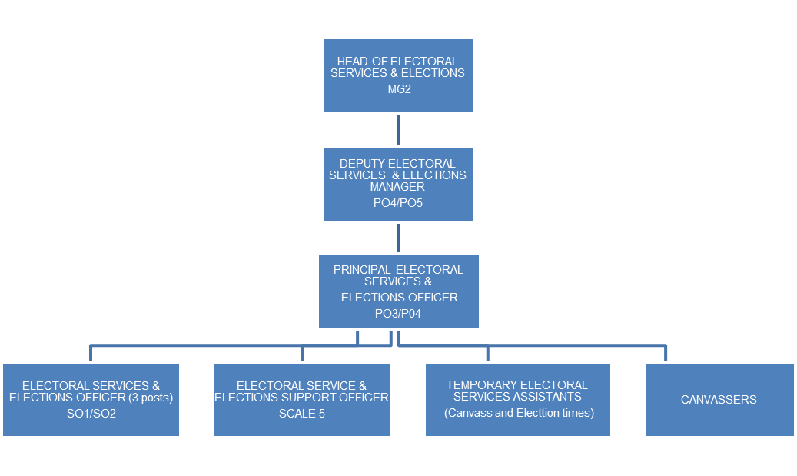
Person Specification

Job Title: Electoral Services & Elections Officer | Grade: SO1/SO2 linked grade
Section: Electoral Services (Wandsworth) | Directorate: Resources
Responsible to following manager:  Deputy Electoral Services & Elections Manager PO4/5 | Responsible for following staff: See Job Dimensions and current Team Structure
Post Number/s: A0901 A0907 A0908 | Last review date: 2 July 2018

Our Values and Behaviours

The values and behaviours we seek from our staff draw on the high standards of the two boroughs, and we prize these qualities in particular:

Being open. This means we share our views openly, honestly and in a thoughtful way. We encourage new ideas and ways of doing things. We appreciate and listen to feedback from each other.

Being supportive. This means we drive the success of the organisation by making sure that our colleagues are successful. We encourage others and take account of the challenges they face. We help each other to do our jobs.

Being positive. Being positive and helpful means we keep our goals in mind and look for ways to achieve them. We listen constructively and help others see opportunities and the way forward. We have a ‘can do’ attitude and are continuously looking for ways to help each other improve.

Person Specification Requirements – SO1/SO2 linked grade | Assessed by  A  & I/ T/ C (see below for explanation)
Knowledge
1. Good working knowledge of electoral law and electoral procedures | A & I
Experience
2. Experience of working in electoral administration or an elections environment. | A & I
3. Experience of organising, prioritising and managing own work load. | A & I
4. Experience of using a bespoke electoral software system. | A & I
Skills
5. Ability to work accurately under pressure to meet statutory deadlines |  | A & I
6. Good verbal and written communication skills |  | A & I
7. A team player working with a variety of internal and external clients. |  | A & I
8. To be able to use MS Office packages, including Word, Excel and Outlook. |  | A & I
Qualifications
9. Qualification or foundation in Electoral Administration or a willingness to work towards them. |  | A & I
Other
10. Able to work unsociable and extended hours at election and canvass time |  | A & I

A – Application form
I – Interview
C – Certificate

