Job Profile comprising Job Description and Person Specification
Job Description

Job Title:  VCS Partnerships & Co-ordination Officer | Grade:  PO3
Section:  Stronger and Safer Communities | Directorate:  Chief Executive’s Group
Responsible to following manager:  Voluntary Sector Strategy and Partnerships Manager, Wandsworth | Responsible for following staff:  None
Post Number/s: | Last review date:  October 2025

Working for the Richmond & Wandsworth Better Service Partnership

This role is employed under the Richmond & Wandsworth Better Service Partnership. The overall purpose of Richmond & Wandsworth is to provide the highest quality of service at the lowest attainable cost.

Staff are expected to deliver high quality and responsive services wherever they are based, as well as having the ability to adapt to sometimes differing processes and expectations.
Richmond & Wandsworth Better Service Partnership aims to be at the forefront of innovation in local government, and the organisation will invest in the development of its staff and ensure the opportunities for progression that only a large organisation can provide.

A crucial part of this role is about building meaningful relationships and trust with local communities and organisations – particularly building on strengths and skills. This role therefore needs excellent interpersonal skills, requires someone who is empathetic, but able to collaborate and bring together different voices.

Job Purpose

- To work closely with local VCS networks, alliances and other groups delivering in Wandsworth, with a particular focus on Roehampton and the Winstanley estate area, with community engagement and development capacity, to ensure that work programmes complement and strengthen each other.
- To work closely with Neighbourhood Regeneration and other relevant teams to coordinate community activities and engagement, as well as strengthen and align partnership working with a broad range of voluntary and community sector organisations.
- To create and maintain a documented overview of the various strategic community development interventions and partnerships in the Roehampton and Winstanley & York Road areas.
- To work with the community and partners to develop a good understanding of potential service gaps (including voluntary and community sector led activities) and opportunities for the local areas, and connecting communities together with partners, to problem solve these and strengthen local capacity.
- To build relationships with small, medium and large Voluntary and Community Sector organisations and other statutory / non-statutory partners across Roehampton and Winstanley & York Road, strengthening the Council’s knowledge and connections with a diverse range of local organisations.
- Engage, connect and facilitate effective dialogue and communication between the different Council departments and the local community, breaking down barriers and championing collaboration and partnership working.

Specific Duties and Responsibilities

- Relationship Building: You will build trusted and meaningful relationships with residents, local councillors and a range of voluntary and community sector (VCS) organisations, and wider partners, to develop a thorough understanding of local needs, capacity, experiences and aspirations.
- Connecting and convening: You will act as a strategic connector and convenor, supporting collaborative working and partnerships to ensure the effective delivery of projects.
- Community Development: You will use a strength-based community development model to really understand the local landscape: the residents, organisations and groups, projects, resources and assets.
- Community Capacity Building: You will use your skills and experience in building the capacity of the local voluntary sector.
- You will develop in-depth local knowledge with a particular focus on Roehampton (particularly on the Alton, Lennox, Ashburton and Putney Vale estates) and Winstanley and York Road estate, collaborating with the community to build on and develop existing partnerships, networks and projects. This may be extended to other geographical areas in Wandsworth as required.
- Testing and piloting: You will work autonomously to pilot and test innovative local approaches, enabling new ideas and solutions that contribute to service improvement emerge and inform other place-based models.
- Place-based working: you will be responsible for strengthening community capacity within identified priority areas including Roehampton, Putney and Winstanley, so you will be out and about on the ground (at least 60% of the time) as a present, open and active member of the community. You will work regularly from community spaces across the borough and Wandsworth Town Hall.
- Community insight reporting: you will work with a wide range of community groups, councillors, council services, and key partners to produce quarterly reports – demonstrating local knowledge and progress on how we are working together to utilise and build upon local resources and assets.
- Area Forums, area action plans, and community events: you will seek to maximise community development and attendance, ensuring the events are meaningful, relevant, and inclusive. You will also be expected to support communities to run events of their own, connecting them with local resources and partners.
- Community organising and funding: you will work with community groups to identify and then deliver on the local priorities, needs and aspirations. You will support groups to identify and access funding and/or Council and community assets to enhance local projects. You will work closely with Councillors, supporting them in their role as Community Leaders so they can champion local projects and programmes.
- Community Engagement: Outreach work with communities to better understand how they work and what they need, part of this will be to connect them with the right partners to collaborate on potential projects including supporting a funding proposal.

- Creating channels of engagement and collaboration for communities, ensuring that resident and VCS views are coordinated in the Council, reported back, and opportunities to work together are developed and supported.

- Provision of Information and Publicity: Assist in the provision of information and publicity co-ordination on all services provided by the Council and other agencies at the local level.
- Partnership Working: Collaborate with all partners for the mutual benefit of participants and programme performance. Liaise with external, strategic partners and stakeholders to ensure Wandsworth Council programme delivery adds value to existing provision across the borough.

Other Duties:

- Establish strong visibility and rapport across the local community and with relevant Council departments and wider partners.
- To particularly engage and consult with marginalised communities and break down any barriers to accessing services or support.
- To map, support and champion community led programmes and projects across Roehampton and Winstanley & York Road, building on existing networks and identifying gaps, and other geographical areas in Wandsworth as required
- To collaborate with communities on co-producing solutions to meet potential gaps and utilise local skills and resources for this.
- To better connect existing provisions with local people, groups and partners, improving communications and connections across the local area.
- Support members of the community in articulating their views and projects, particularly to support people’s participation in local decision making and policies.
- To build up sound knowledge on all available support, funding and resources (training, accessing data tools, venues etc.) which could help local communities thrive and sustain themselves.
- Work closely with the VCS team and new VCS infrastructure and capacity building support service, to link in with wider VCS support across the borough and champion the new VCS strategy.

Additional responsibilities:

Integrate with wider teams and share knowledge and learnings to benefit the holistic development of relevant council programmes.

To operate in a pro-active and innovative manner, to generate co-produced solutions which support a diverse range of experiences and perspectives.

Comply with all organisational policy, procedures and systems.

To be aware of and assume the appropriate level of responsibility for safeguarding and promoting the welfare of children, young people and vulnerable adults and to report any concerns in accordance with the organisation’s safeguarding policies.

Ability to work outside of normal office hours.

Generic Duties and Responsibilities

- To contribute to the continuous improvement of the services of Richmond & Wandsworth Better Service Partnerships.

- To comply with relevant Codes of Practice, including the Code of Conduct and policies concerning data protection and health and safety.

- To adhere to security controls and requirements as mandated by Richmond and Wandsworth procedures and local risk assessments to maintain confidentiality, integrity, availability and legal compliance of information and systems

- To promote equality, diversity, and inclusion, maintaining an awareness of the equality and diversity protocol/policy and working to create and maintain a safe, supportive and welcoming environment where all people are treated with dignity and their identity and culture are valued and respected.

- To understand both Councils’ duties and responsibilities for safeguarding children, young people and adults as they apply to the roles within the Councils.

- To complete all training assigned to you and cooperate in all matters relating to Health and Safety and implement all procedures for your job role. The identification of Health and Safety related risks within the working environment must be highlighted to your manager.

- Any other duties appropriate to the post: These other duties must be equivalent to or below the salary and status of the role and, where appropriate, under the Equality Act 2010, due consideration must be given to any employees with a “protected characteristic” group.

- The profile is not intended to be an exhaustive list of the duties the post holder will carry out. Other reasonable duties commensurate with the level of the post, including supporting emergency and priority situations, will form part of the role.

Team Structure

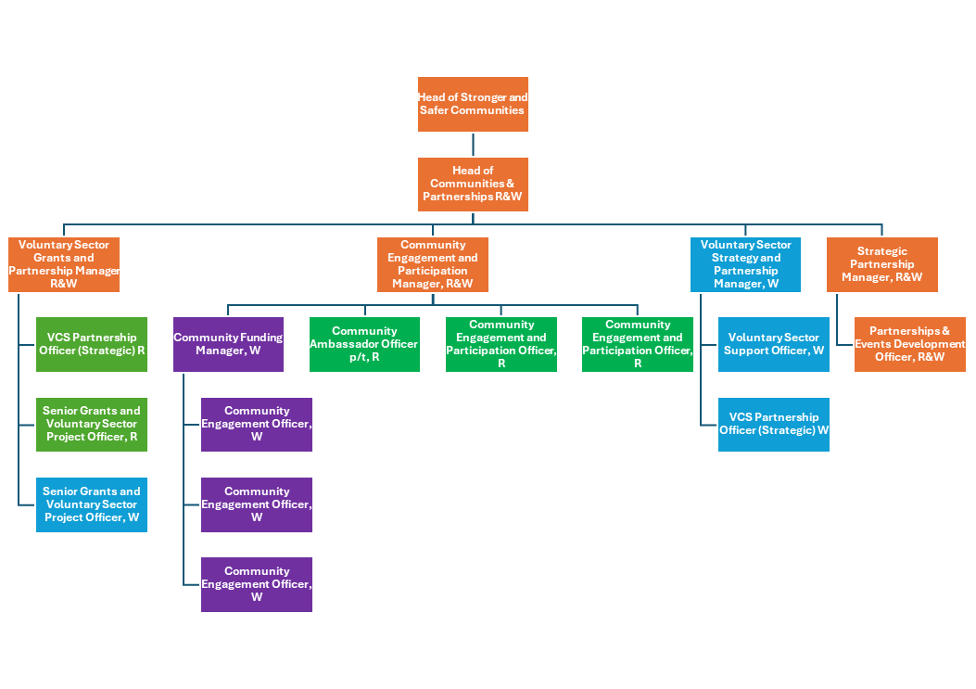

Person Specification

Job Title:  VCS Partnerships & Coordination Officer | Grade:  PO3
Section:  Stronger and Safer Communities | Directorate:  Chief Executive’s Group
Responsible to:  Voluntary Sector Strategy and Partnership Manager, Wandsworth | Responsible for:  None
Post Number/s: | Last Review Date:  October 2025

Our Values
THINK BIGGER
EMBRACE DIFFERENCE
CONNECT BETTER
LEAD BY EXAMPLE
PUT PEOPLE FIRST

Our Values are embedded across Richmond & Wandsworth Better Service Partnership and throughout all roles and responsibilities at all levels of the organisation. Please familiarise yourself with our values as they are an integral part of our recruitment and selection process.

Person Specification Requirements |  |  |  | Assessed by  A/I/T/C  (see below for explanation)
 | Knowledge | Essential | Desirable | Assessed
 | Knowledge of a range of community activities, assets, projects and issues that can affect residents and voluntary and community sector organisations. | X |  | AF/I
 | Knowledge of how to effectively engage and communicate with a broad range of communities, organisations and partners. | X |  | AF/I
 | Knowledge of Asset Based Community Development (ABCD) |  | X | AF/I
 | Experience | Essential | Desirable | Assessed
 | Experience working in partnerships, community development or engagement type roles | X |  | AF/I
 | Experience of working with and advocating for underrepresented groups | X |  | AF/I
 | Experience of coordinating and connecting different projects, activities or partners to strengthen the impact for communities | X
 | Experience of building and sustaining relationships with a wide range of communities, VCS organisations and partners | X |  | AF/I
 | Skills | Essential | Desirable | Assessed
 | Active listening and empathetic – recognising the importance of a range of individual perspectives, experiences and insight. | X |  | AF/I
 | Self motivated, with the ability to work autonomously and prioritise competing demands while recognising when to seek guidance or escalate issues. | X
 | Proactive – ability to engage and connect with a diverse range of communities, organisations and stakeholders. | X |  | AF/I
 | Effective communicator and collaborator with an ability to work with a wide range of teams, communities, organisations and stakeholders. | X |  | AF/I
 | Qualifications | Essential | Desirable | Assessed
 | Degree level or equivalent qualification through experience |  | X | AF/I

AF – Application form / CV
I – Interview
T – Test
C - Certificate

