Job Profile comprising Job Description and Person Specification
Job Description

Job Title:  Admin Officer | Grade:  Scale 5/6
Section:  Business Resource | Directorate:  Adult Social Care and Public Health
Responsible to following manager:  Senior Admin Officer | Responsible for following staff:
Post Number/s: | Last review date:  April 2017

Working for the Richmond & Wandsworth Better Service Partnership

We’re Richmond & Wandsworth Better Service Partnership, the shared public service team for Richmond and Wandsworth Councils. Like any local authority, our role is to deliver the agenda of our elected members on behalf of the people who live and work in our part of the world. We deliver key services to our communities including social care, public health, children’s services, housing and regeneration and environmental and community services.

Our joint workforce creates efficiency and resilience by bringing more creativity to the way we work, more objectivity and adaptability too, helping us deliver better services for all our residents.

We’re here to help our communities thrive in a changing world, and to be there for the people who need us most we believe we need to keep adapting. That’s why, at Richmond & Wandsworth Better Service Partnership, you’ll be at the forefront of innovation in local government, and we’ll invest in you and offer you opportunities to grow in a way only our unique organisation can.

Job Purpose

To provide comprehensive administrative support to operational teams/training and development team within the Adults Social Services Directorate, helping to ensure efficient and effective admin support systems and processes operate consistently across the Directorate.

Specific Duties and Responsibilities

- To advise and support managers on relevant matters affecting the service.

- To work as required in ways that develop good working relations and collaborative arrangements with partner and other external organisations.

- To support the Senior Admin Officer and work with colleagues in the development and maintenance of administrative processes, procedures and systems.

- To work flexibly across the Directorate to provide support and cover for other administrative staff, as needed.

- To provide effective and efficient office administration support to managers, team leaders and staff as required and using own initiative, including, but not limited to:

a. Dealing with internal and external customers, by phone, email and face-to-face, resolving queries at first point of contact, where possible, including dealing with matters of a sensitive and confidential nature.
b. Meeting preparation, including booking rooms, inviting delegates, ordering refreshments, preparing and distributing documentation
c. Producing a variety of high-quality documentation (advanced word-processing), accurately and to deadline.
d. To devise and complete Excel spreadsheets
e. To update and maintain databases accurately, collating statistical information and reports as directed, including social care databases.
f. To undertake daily administrative tasks, such as managing and delegating from a shared electronic mailbox, scanning, photocopying, stationery supplies, as required.

Higher scale:

All the above, plus
- To provide supervision as required to assigned staff and take responsibility for the allocation and checking of work by Admin Assistants.

2. To deputise for the Senior Admin Officer when the necessary

Generic Duties and Responsibilities

- To contribute to the continuous improvement of the services of Richmond & Wandsworth Better Service Partnerships.

- To comply with relevant Codes of Practice, including the Code of Conduct and policies concerning data protection, handling complaints and health and safety.

- To adhere to security controls and requirements as mandated by Richmond and Wandsworth procedures and local risk assessments to maintain confidentiality, integrity, availability and legal compliance of information and systems

- To promote equality, diversity, and inclusion, maintaining an awareness of the equality and diversity protocol/policy and working to create and maintain a safe, supportive and welcoming environment where all people are treated with dignity and their identity and culture are valued and respected.

- To understand both Councils’ duties and responsibilities for safeguarding children, young people and adults as they apply to the roles within the Councils.

- The profile is not intended to be an exhaustive list of the duties the post holder will carry out. Other reasonable duties commensurate with the level of the post, including supporting emergency and priority situations, will form part of the role.
Additional Information

Team structure

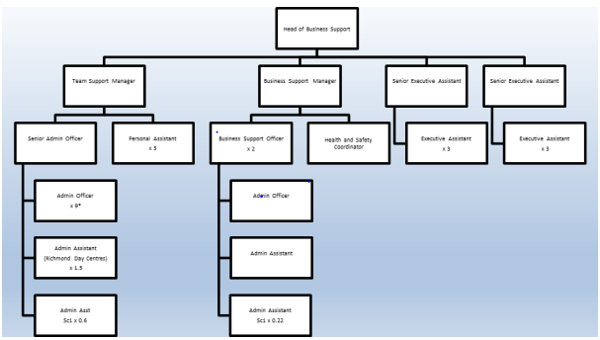
Person Specification

Job Title:  Admin Officer | Grade:  Scale 5/6
Section:  Business Resource | Directorate:  Adult Social Care and Public Health
Responsible to:  Senior Admin Officer | Responsible for:
Post Number/s: | Last Review Date:  April 2017

Our Values
THINK BIGGER
EMBRACE DIFFERENCE
CONNECT BETTER
LEAD BY EXAMPLE
PUT PEOPLE FIRST

Our Values are embedded across Richmond & Wandsworth Better Service Partnership and throughout all roles and responsibilities at all levels of the organisation. Please familiarise yourself with our values as they are an integral part of our recruitment and selection process.

Person Specification Requirements |  |  |  | Assessed by  A/I/T/C  (see below for explanation)
 | Knowledge | Essential | Desirable | Assessed
 | Good knowledge of office environments and administrative procedures and processes. | x |  | A/I
 | Good knowledge of supporting, coordinating and delivering within a project work-stream. | x |  | A/I
 | Good understanding of the General Data Protection Regulation (GDPR) | x |  | A/I
 | Good knowledge of the Data Protection Act 1998. | x |  | A/I
 | Experience | Essential | Desirable | Assessed
 | Good experience of managing own workload, under pressure, to meet deadlines. | x |  | A/I
 | Good experience of developing and maintaining record keeping processes and systems. | x |  | A/I
 | Good experience of handling confidential and sensitive information appropriately. | x |  | A/I
 | Proven experience of working successfully in a team and forming relationships with customers and colleagues. | x |  | A/I
 | Skills | Essential | Desirable | Assessed
 | Strong knowledge of standard IT packages to an advanced level (MS Office – Outlook, Excel and Word) and ability to learn new ones. Good knowledge of Excel to a high-intermediate level. | x |  | A/I
 | Highly organised and able to prioritise work and meet deadlines. | x |  | A/I
 | Ability to work effectively as part of a team and with other professional groups, providing effective administration to support the operation of the service | x |  | A/I
 | Ability to develop appropriate administrative systems and procedures and train others in their use e.g. creation of a new filing system, IT database or spreadsheet | x |  | A/I
 | Good knowledge of standard IT packages to an advanced level (MS Office 2010– Outlook, Word) and ability to learn new ones. Good knowledge of Excel to an intermediate level. | x |  | A/I
 | Good level of communication skills in English, both written and oral, to provide clear and concise messages in a variety of internal external contexts. | x |  | A/I
 | Qualifications | Essential | Desirable | Assessed

A – Application form / CV
I – Interview
T – Test
C - Certificate

