FULL TIME CLASS TEACHER
RECRUITMENT PACK
2026
A community that cares about excellence, wonder and learning for life

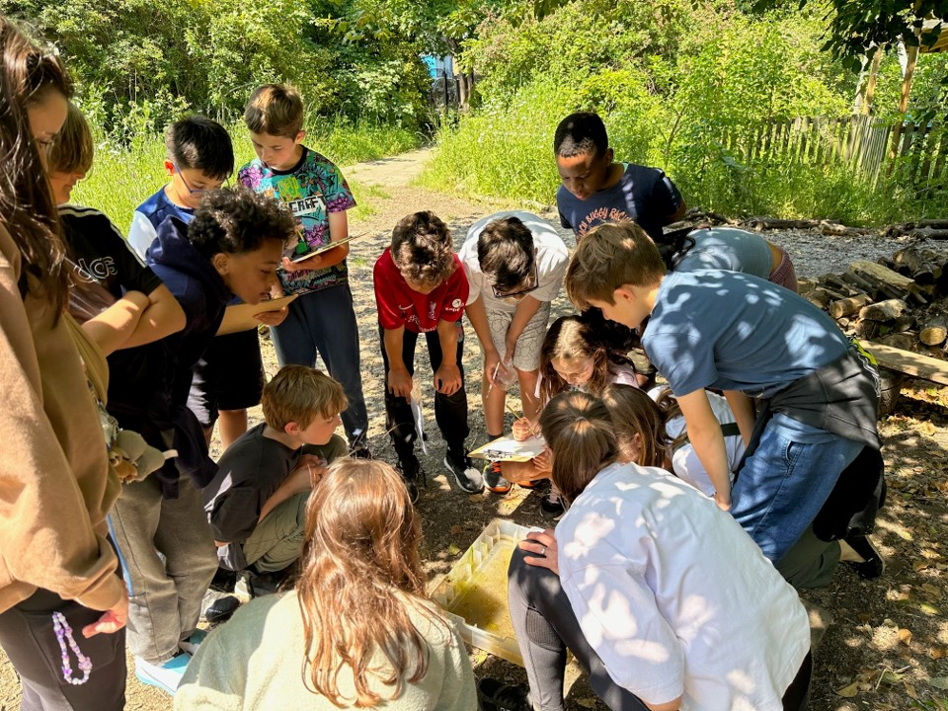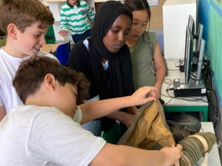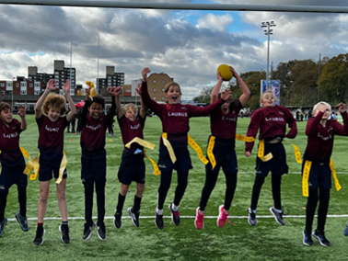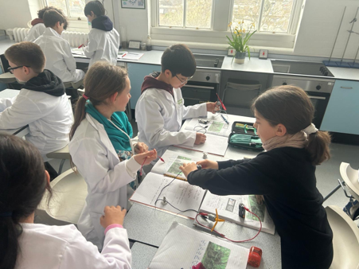

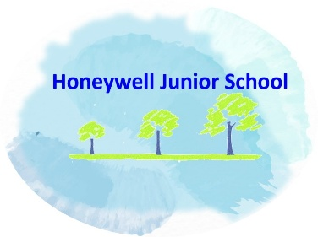


Welcome to Honeywell Junior School

Thank you for your interest in this vacancy at our school.

Honeywell Junior School is situated south of the river in Central London, housed in a Victorian building which it shares with Honeywell Infant School. There are approximately 330 pupils on roll, aged 7 to 11 years and many of them come from somewhere else!! The majority of pupils are White English with sizeable groups from White Western and White European families. About 47% speak, read or write a language other than English and 20% have special educational needs that require extra support from the school or other agencies. As an indicator of the local intake to the school, 12% of pupils are entitled to free school meals provided for them because of the low income of the family.
The Honeywell Junior Curriculum is engaging, stimulating and responsive, enabling our pupils with a breadth of study and with a wealth of positive learning opportunities for all. We use research and all of our particular pupils to mould our curriculum offer so they make links between areas of learning and travel beyond the classroom to extend their experience, perspectives and understanding. We aim for them to acquire an intellectual curiosity that supports their journey into becoming lifelong learners. We celebrate neurodiversity and believe “rising tides raise all ships”, and have high expectations of all.
By becoming part of our staff team, you will be joining a compassionate and committed community, who put our pupils at the heart of everything we do.
Please explore our website and make a time to come and meet us and see us in action. I am happy to answer any queries you may have, just email the school office at people.operations@honeywell.wandsworth.sch.uk and I will get back to you.

Very best wishes

Ms Jo Clarke
Head Teacher



A community that cares about excellence, wonder and learning for life
https://www.honeywellschools.org/

Full Time KS2 Class Teacher
Grade: M1 to M6 dependent on experience
Reporting to: Head Teacher and Governing Body
Required for September 2026
We are looking for someone to support our pupils in providing outstanding teaching and learning to our pupils, based on quality research and bespoke learning for our staff.
We encourage and welcome a visit.

We can offer:
- Wonderful pupils who remain at the heart of everything we do
- A committed and experienced staff team
- Opportunities for developing pedagogy and practice in innovative ways
- A school committed to the enjoyment, achievement and well-being of all
- An opportunity to further support the strategic direction of the school

The successful candidate should be:
- An excellent teacher with high expectations for all
- Familiar with the uniqueness of a junior school
- Inspirational and creative to make learning challenging and fun
- Dedicated to raising achievement, attainment and aspirations for all
- Effective and efficient with organisational skills and work life balance
- Able to work as a part of a team but also be self-motivated to work independently
- Good humoured




Honeywell Schools Federation is committed to safer recruitment practices and to safeguarding and promoting the welfare of all children. All candidates should be aware that we follow safer recruitment policies and procedures so references will be taken up prior to interview. We are committed to equality of opportunity and we are an equal opportunities employer.

For further details and to register interest, please contact the school to arrange a visit, answer any queries and arrange for an application pack.

Closing Date: midday 12pm Monday 20th April 2026
Interviews: Week commencing 27th April 2026
Contract: from September 2026

https://honeywell-infant-school.primarysite.media/media/honeywell-school-video

JOB DESCRIPTION

PERMANENT KS2 CLASS TEACHER
Reporting to: Phase Leader/ Deputy Head Teacher / Head Teacher

Job Title: Full Time KS2 Class Teacher

Pay scale: Main Pay Scale

From: September 2026

This Job Description may be amended at any time after consultation with the member of staff and should be read alongside the range of duties set out in the Teachers Pay and Conditions Document. All teachers are expected to meet the requirements of the current Teacher Standards.

Main Purpose
This job description should be read alongside the range of duties set out in the Teachers Pay and Conditions Document, a copy of which is kept in the Schools’ Office. All teachers are expected to meet the requirements of the current Teacher Standards.

Specific Purpose
- To promote the aims and values of the school
- Maintain good order among pupils and safeguard their health and safety
- Actively promote equality of opportunity and the Rights Respecting Agenda
- Lead a curriculum subject or aspect of learning across the whole school (except ECTs)
- Ensure all local and national assessment arrangements are effectively managed for your class under the direction of the Deputy Head Teacher
- Work in partnership with all constituents of the school community, including communicating and consulting with colleagues, governors, parents and carers and outside agencies as necessary
- Maintain professional behaviour at all times, acting as a good role model, including punctuality and attendance
- Fulfil the “Professional Standards” for Teachers in England - September 2012, in relation to your current position on the pay spine (QTS, Core or Post-Threshold)

Qualities
The Class Teacher will:
- Uphold public trust in school and maintain high standards of ethics, behaviour and professional conduct
- Build positive and respectful relationships across the school community
- Serve in the best interests of the school’s pupils

Main Duties and Responsibilities
This job description should be read alongside the range of duties set out in the Teachers Pay and Conditions Document, a copy of which is kept in the Schools’ Office. All teachers are expected to meet the requirements of the current Teacher Standards.
In addition to these responsibilities teachers at Honeywell Junior School will be expected to:
- Plan, deliver and monitor a quality curriculum that enables access for the range of needs of all pupils
- Have a thorough and detailed understanding of the Primary Curriculum
- Be up to date or willing to learn about current quality pedagogy, research and practice
- Assess, record and report on the progress and attainment of pupils
- Have regard to the curriculum and policies for the school, and with a view to promoting the development of the abilities and aptitudes of the pupils in any class
- Create and maintain a stimulating and attractive learning environment for pupils within the classroom that is well organised and managed, is conducive to learning and promotes the Honeywell Curriculum
- Liaise with parents and carers including parents’ evenings, currently three times a year, and complete a written end of year report for each pupil
- Support and promote all school policies and agreed practices
- Attend staff meetings and INSET days as required
- Attend year group and planning meetings as required, to ensure common curriculum provision and practices across the school
- Share responsibility for development and initiatives as required by the School Improvement Plan or other initiatives which arise from local or national initiatives
- Where appropriate, be responsible for the management of LSAs and/or teaching assistants after consultation with the SENDCo or Deputy
- Participate in arrangements for further training and professional development as a teacher, including undertaking training and professional development which aim to meet needs identified in appraisal objectives or in appraisal statements
- In the case of a teacher serving an induction period pursuant to the Induction Regulations, participating in arrangements for supervision and training
- To be aware of and show commitment to the schools’ policy on Equality and Inclusion and the promoting and safeguarding of all pupils and to encourage positive behaviour in accordance with the schools’ Behaviour Policy
- Carry out an equal amount of playground or class duties as required by school rotas
- Ensure that the school’s Safeguarding Policy and child protection practices are implemented fully

Specific Requirements
- To promote the aims and values of the school with particular reference to it being a junior school
- Maintain good order among pupils and safeguard their health and safety
- Actively promote equality of opportunity and the Rights Respecting Agenda
- Lead a curriculum area across the whole school (except ECTs)
- Effectively use Seesaw or comparable platform to enhance learning
- Ensure all local and national assessment arrangements are effectively managed for your class under the direction of the Deputy Head Teacher
- Work in partnership with all constituents of the school community, including communicating and consulting with colleagues, governors, parents and carers and outside agencies as necessary
- Maintain professional behaviour at all times, acting as a good role model, including punctuality and attendance
- Fulfil the “Professional Standards” for Teachers in England, in relation to your current position on the pay spine (QTS, Core or Post-Threshold)

This job description may be amended at any time following discussion between the Head Teacher and staff member.
This job description may be amended at any time in consultation with the postholder.

Person Specification
This person specification relates to the requirements of the post as determined by the job description. Please write a personal statement detailing how you meet the criteria below and how your examples demonstrate impact.
Key: E – Essential
D – Desirable
S – Demonstrated at Shortlisting
I – Demonstrated at Interview
Qualifications
 |  |  | S | I
1 | Qualified teacher status | E | √
2 | Evidence of successful teaching in KS2 | D | √
3 | An excellent understanding of current theory and best practice in teaching and learning | E | √
Skills and Knowledge
4 | An excellent classroom practitioner | E |  | √
5 | Good interpersonal skills | E |  | √
6 | Ability to work as part of a team | E | √
7 | Ability to plan lessons effectively for all pupils in a class, setting clear learning intentions and challenging, accessible tasks | E |  | √
8 | Make effective use of the range of assessment strategies as a basis for setting challenging learning objectives and cohesive planning | E |  | √
9 | Managing behaviour constructively by establishing and maintaining a clear and positive framework for classroom discipline | E |  | √
10 | Good communication skills in working with parents and carers, staff and other agencies | E | √
11 | Knowledge and understanding of current issues in educational thinking | E | √
Commitment to:
12 | Equalities and Inclusion | E |  | √
13 | Child Protection and Safeguarding procedures | E |  | √
14 | The school’s vision and ethos | E |  | √
15 | High quality stimulating learning environment | E |  | √
16 | Professional development for self and others | E |  | √
Special Requirements
17 | Expertise in using Seesaw or comparable platform to enhance learning and engagement | E |  | √
18 | Experience of leading a curriculum area across the age range | E |  | √
19 | Satisfactory enhanced DBS check | E |  | √
20 | Excellent attendance and punctuality record | E |  | √

