Job Profile comprising Job Description and Person Specification
Job Description

Job Title:  Public Health Programmes Support Officer | Grade:  SO1
Section:  Public Health | Directorate:  Adult Social Care and Public Health
Responsible to following manager:  Consultant in Public Health - Children and Targeted Interventions | Responsible for following staff:  N/A
Post Number/s: | Last review date: April 2016

Working for the Richmond & Wandsworth Better Service Partnership

We’re Richmond & Wandsworth Better Service Partnership, the shared public service team for Richmond and Wandsworth Councils. Like any local authority, our role is to deliver the agenda of our elected members on behalf of the people who live and work in our part of the world. We deliver key services to our communities including social care, public health, children’s services, housing and regeneration and environmental and community services.

Our joint workforce creates efficiency and resilience by bringing more creativity to the way we work, more objectivity and adaptability too, helping us deliver better services for all our residents.

We’re here to help our communities thrive in a changing world, and to be there for the people who need us most we believe we need to keep adapting. That’s why, at Richmond & Wandsworth Better Service Partnership, you’ll be at the forefront of innovation in local government, and we’ll invest in you and offer you opportunities to grow in a way only our unique organisation can.

Job Purpose
Responsible for providing project management support and coordination to the Consultant in Public Health and their team. To assist with the management of projects, contracts and initiatives, and provide generic support.

Specific Duties and Responsibilities

- Be responsible for the day-to-day administration of designated project activities, working closely with all members of the project to provide administrative research and logistical support.
- Under the supervision of the Consultant in Public Health facilitates, engages and finalises action plans and follows up as appropriate.
- Develop and roll out a standardised approach to project management across their team.
- Handle confidential information/processes, for example those relating to Independent Funding Reviews, adult safeguarding and child safeguarding, child death overview panel issues, and all aspects of clinical and quality governance.
- Draft, produce and quality assure documentation, including complex planning documents, reports, letters, memorandums, minutes and agendas.
- Maintain a plan of reports and actions and ensure that all corporate documents are in line with business planning processes/schedules and committee report guidelines.
- Assist in providing office support to the Consultants in Public Health and the teams, to ensure the smooth running of the department, including dealing with enquiries and any other activities required within the service.
- Work in partnership with other officers within Public Health, other Wandsworth and Richmond services and outside organisations as required.
- Arrange high level meetings including cross-borough/agency meetings, including booking venues etc.
- Deal with urgent diary issues for the Consultant in Public Health and provide initial response in their specialist areas.
- Provide cover for the Director of Public Health’s assistant when absent, including telephone and other cover as required.
- Support the delivery and development of key public health projects.

Generic Duties and Responsibilities

- To contribute to the continuous improvement of the services of Richmond & Wandsworth Better Service Partnerships.

- To comply with relevant Codes of Practice, including the Code of Conduct and policies concerning data protection, handling complaints and health and safety.

- To adhere to security controls and requirements as mandated by Richmond and Wandsworth procedures and local risk assessments to maintain confidentiality, integrity, availability and legal compliance of information and systems

- To promote equality, diversity, and inclusion, maintaining an awareness of the equality and diversity protocol/policy and working to create and maintain a safe, supportive and welcoming environment where all people are treated with dignity and their identity and culture are valued and respected.

- To understand both Councils’ duties and responsibilities for safeguarding children, young people and adults as they apply to the roles within the Councils.

- The profile is not intended to be an exhaustive list of the duties the post holder will carry out. Other reasonable duties commensurate with the level of the post, including supporting emergency and priority situations, will form part of the role.
Additional Information
- The post holder will have the opportunity to combine home and on-site working as the Better Service Partnership moves towards agile working.
- When on-site the post holder will be expected to work flexibly across two locations (Wandsworth Town Hall and Richmond Civic Centre).

Team structure
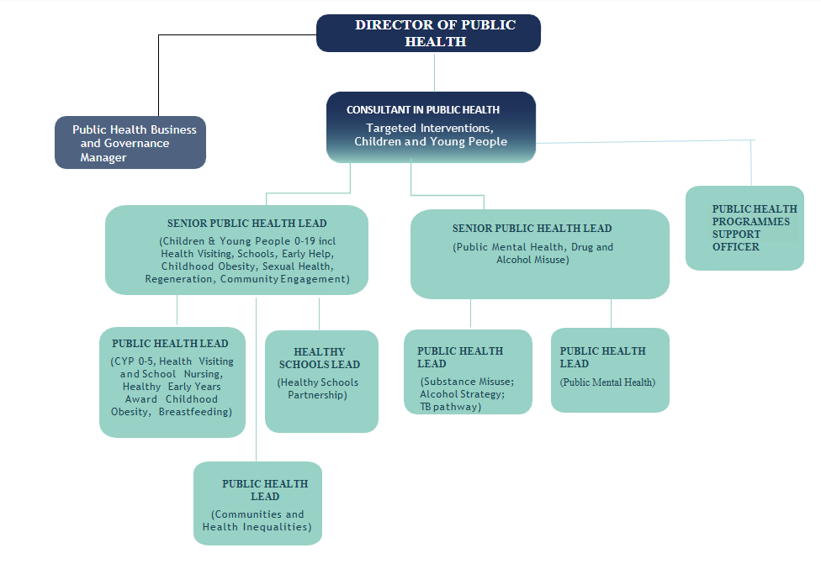

Person Specification

Job Title:  Public Health Programmes Support Officer | Grade:  SO1
Section:  Public Health | Directorate:  Adult Social Care and Public Health
Responsible to:  Consultant in Public Health | Responsible for:  N/A
Post Number/s: | Last Review Date: April 2016

Our Values
THINK BIGGER
EMBRACE DIFFERENCE
CONNECT BETTER
LEAD BY EXAMPLE
PUT PEOPLE FIRST

Our Values are embedded across Richmond & Wandsworth Better Service Partnership and throughout all roles and responsibilities at all levels of the organisation. Please familiarise yourself with our values as they are an integral part of our recruitment and selection process.

Person Specification Requirements |  |  |  | Assessed by  A/I/T/C  (see below for explanation)
 | Knowledge | Essential | Desirable | Assessed
 | Proficient in use of Microsoft Office, including Outlook, Word, Excel and PowerPoint. | Y |  | A/I/T
 | Experience | Essential | Desirable | Assessed
 | Experience of working as an administrator and project officer at a senior level. |  | Y | A/I/T
 | Skills | Essential | Desirable | Assessed
 | Demonstrable project management skills. | Y |  | A/I
 | The ability to work effectively and accurately to tight deadlines in a sometimes, challenging environment and to manage multiple project deadlines. | Y |  | A/I
 | Ability to organise and prioritise own work in an efficient and effective way, and to work with minimum supervision. | Y |  | A/I
 | A high level of office and business management skills, diary management and the ability to organise meetings. | Y |  | A/I/T
 | Be able to demonstrate a meticulous approach and an eye for detail. | Y |  | A/I
 | The ability to communicate effectively and sensitively, orally and in writing on a wide range of detailed issues. | Y |  | A/I/T
 | The ability to take and transcribe action points/minutes of meetings and draft non-standard correspondence. | Y |  | A/I/T
 | Be able to collate information and maintain files and records accurately on computerised and manual recording systems. | Y |  | A/I
 | Be able to work as part of a team and be able to deal confidently, tactfully, calmly and sensitively with a wide range of Officers and professionals at all levels inside and outside of the organisation. | Y |  | A/I
 | Qualifications | Essential | Desirable | Assessed
 | Project management qualification or evidence of an equivalent qualification and/or experience. | Y |  | A/C

A – Application form / CV
I – Interview
T – Test
C - Certificate

