Job Profile comprising Job Description and Person Specification
Job Description

Job Title:  Combatting Drugs Partnership coordinator | Grade:  PO4
Section:  Public Health | Directorate:  Adult Social Care and Public Health
Responsible to following manager:  Consultant in Public Health for Children and Young People and Targeted Interventions | Responsible for following staff:  N/A
Post Number/s: | Last review date:  March 2026

Working for the Richmond & Wandsworth Better Service Partnership

We’re Richmond & Wandsworth Better Service Partnership, the shared public service team for Richmond and Wandsworth Councils. Like any local authority, our role is to deliver the agenda of our elected members on behalf of the people who live and work in our part of the world. We deliver key services to our communities including social care, public health, children’s services, housing and regeneration and environmental and community services.

Our joint workforce creates efficiency and resilience by bringing more creativity to the way we work, more objectivity and adaptability too, helping us deliver better services for all our residents.

We’re here to help our communities thrive in a changing world, and to be there for the people who need us most we believe we need to keep adapting. That’s why, at Richmond & Wandsworth Better Service Partnership, you’ll be at the forefront of innovation in local government, and we’ll invest in you and offer you opportunities to grow in a way only our unique organisation can.

Job Purpose
Working in partnership, this role will provide programme management support to enable the delivery of the Richmond and Wandsworth Combatting Drugs Partnership (CDP) and its corresponding strategic delivery plan.

This post will sit within the Public Health Team, and work collaboratively with colleagues across the council, notably Commissioning, Community Safety, Adult and Children’s Social Care as well as wider system partners including the Police, Treatment Providers, Voluntary and Community Sector Organisations and those with Lived Experience.

Specific Duties and Responsibilities

- Governance and administration
  - Oversee the development and delivery of a shared Richmond and Wandsworth Combatting Drugs Partnership plan
  - Convene and manage the administration of the multi-agency CDP meetings including arranging meetings, developing agendas, taking minutes, taking ownership of delivery of specified actions within the plan.
  - Encourage full involvement of appropriate system-wide leaders and put in place the governance structure and culture to drive joint and system wide decision making.
  - Support the set up and delivery of CDP subgroups required to deliver specific actions within the delivery plan
  - Support administration of the Richmond and Wandsworth Drug and Alcohol Related Death Panel (DARD).

- Monitoring and evaluation
  - Liaise with relevant stakeholders including local authority, health, and police to ensure appropriate performance data is available to measure progress against the CDP strategic delivery plan.
  - Work with the Public Health Lead for Alcohol and Substance MisUse prevention to advise on the analysis and interpretation of data, identify trends and present results
  - Prepare regular reports on the partnership’s performance and delivery as required by the Office for Health Improvement and Disparities.
- Communication
  - Work with communications teams, to ensure up to date, relevant information is easily accessible and there is appropriate communication and engagement across the system to deliver the strategic delivery plan objectives.

Generic Duties and Responsibilities

- To contribute to the continuous improvement of the services of Richmond & Wandsworth Better Service Partnerships.

- To comply with relevant Codes of Practice, including the Code of Conduct and policies concerning data protection, handling complaints and health and safety.

- To adhere to security controls and requirements as mandated by Richmond and Wandsworth procedures and local risk assessments to maintain confidentiality, integrity, availability and legal compliance of information and systems

- To promote equality, diversity, and inclusion, maintaining an awareness of the equality and diversity protocol/policy and working to create and maintain a safe, supportive and welcoming environment where all people are treated with dignity and their identity and culture are valued and respected.

- To understand both Councils’ duties and responsibilities for safeguarding children, young people and adults as they apply to the roles within the Councils.

- The profile is not intended to be an exhaustive list of the duties the post holder will carry out. Other reasonable duties commensurate with the level of the post, including supporting emergency and priority situations, will form part of the role.

Additional Information
- The post holder will have the opportunity to combine home and on-site working as the Better Service Partnership moves towards agile working.
- When on-site the post holder will be expected to work flexibly across two locations (Wandsworth Town Hall and Richmond Civic Centre).

Team structure
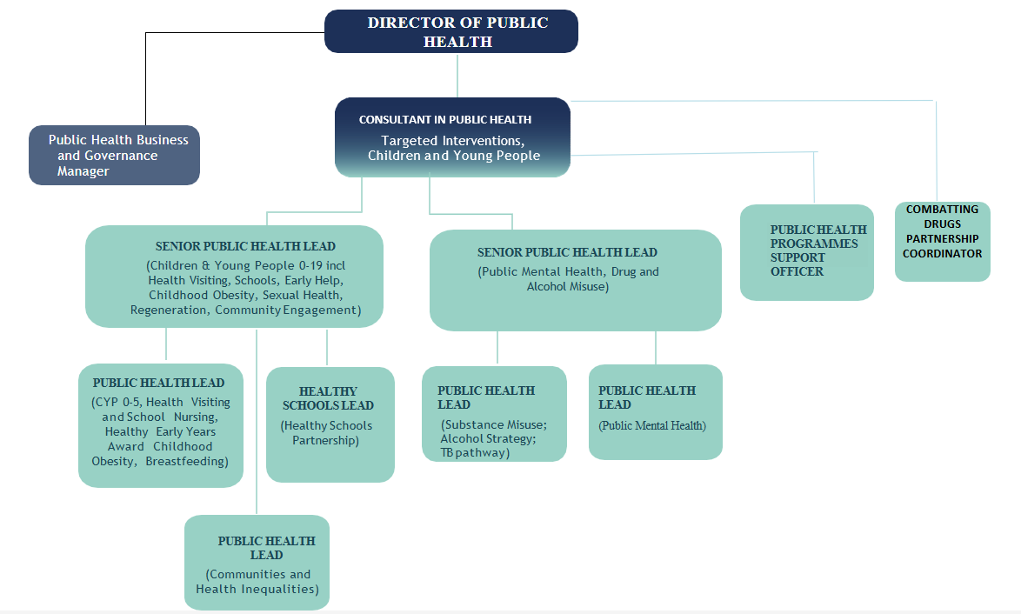

Person Specification

Job Title: Combatting Drugs Partnership coordinator | Grade: PO4
Section: Public Health | Directorate: Adult Social Care and Public Health
Responsible to: Consultant in Public Health for Children and Young People and Targeted Interventions | Responsible for: NA
Post Number/s: | Last Review Date:  March 2026

Our Values
THINK BIGGER
EMBRACE DIFFERENCE
CONNECT BETTER
LEAD BY EXAMPLE
PUT PEOPLE FIRST

Our Values are embedded across Richmond & Wandsworth Better Service Partnership and throughout all roles and responsibilities at all levels of the organisation. Please familiarise yourself with our values as they are an integral part of our recruitment and selection process.

Person Specification Requirements |  |  |  | Assessed by  A/I/T/C  (see below for explanation)
 | Knowledge | Essential | Desirable |  | Assessed
 | Proficient in use of Microsoft Office, including Outlook, Word, Excel and PowerPoint. | Y |  |  | A/I
 | Knowledge of key relevant policies and strategies and best practice evidence around alcohol and substance misUse, violence and harm reduction | Y |  |  | A/I
 | Experience | Essential | Desirable |  | Assessed
 | Experience of project managing multiagency or complex strategy development and delivery | Y |  |  | A/I
 | Experience of working in partnership across organisational boundaries to improve outcomes | Y |  |  | A/I
 | Experience of developing and monitoring against performance management frameworks |  | Y |  | A/I
 | Experience of conducting service reviews and health needs assessments. |  | Y |  | A/I
 | Skills | Essential | Desirable |  | Assessed
 | The ability to work effectively and accurately to tight deadlines in a sometimes, challenging environment and to manage multiple project deadlines. | Y |  |  | A/I
 | Ability to organise and prioritise own work in an efficient and effective way, and to work with minimum supervision. | Y |  |  | A/I
 | The ability to communicate effectively and sensitively, orally and in writing on a wide range of detailed issues. | Y |  |  | A/I
 | Be able to collate information and maintain files and records accurately on computerised and manual recording systems. | Y |  |  | A/I
 | Be able to work as part of a team and be able to deal confidently, tactfully, calmly and sensitively with a wide range of colleagues at all levels inside and outside of the organisation. | Y |  |  | A/I
 | Able to analyse and manipulate complex data to produce defined information products and reports in order to inform and present strategies and plans |  | Y |  | A/I
 | Ability to plan and deliver a broad range of activities, formulate and adjust strategies and plans and overcome barriers to progressing work. | Y |  |  | A/I
 | Managing a wide range of relationships through collaboration with partners, including elected members and service users. |  | Y |  | A/I
 | Able to deal with the changing political and policy context and the needs of multiple different stakeholders. |  | Y |  | A/I
 | Qualifications | Essential | Desirable |  | Assessed
 | A relevant degree or significant equivalent work experience | Y |  |  | A/C

A – Application form / CV
I – Interview
T – Test
C - Certificate

