

Director of the Wandsworth Primary Schools’ Consortium (WPSC)
School Centred Initial Teacher Training (SCITT)
Full Time
Salary: Leadership Scale (Points 4-10)
Start date: January 2027
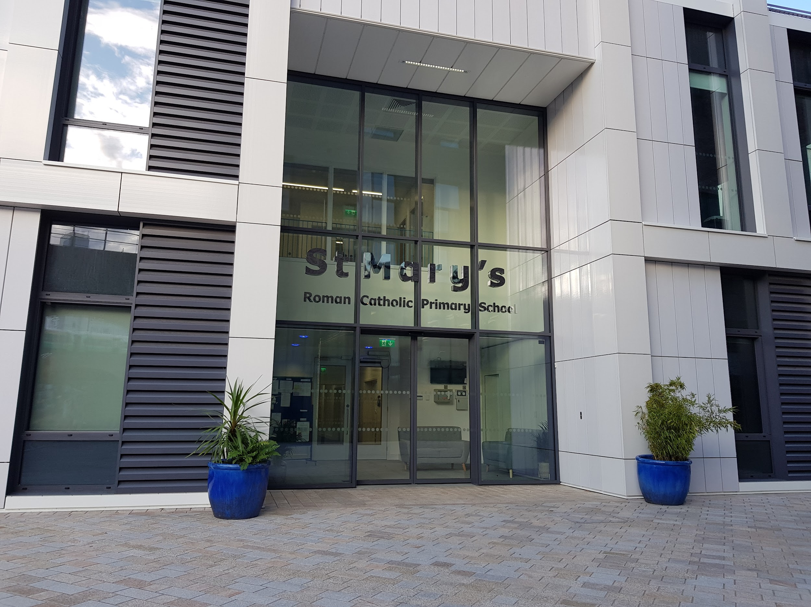

About our SCITT
The Wandsworth Primary Schools’ Consortium was established in 1996 to offer high-quality School-Centred Initial Teacher Training (SCITT) to our local schools. We are based at St Mary’s RC Primary School, Battersea, and work with over twenty local schools across the London Borough of Wandsworth. We have trained hundreds of primary school teachers, many of whom have obtained employment in our local schools; as such, the Consortium is an important source of ECTs within the borough. We maintain a very close working relationship with our schools and successfully collaborate to secure quality training placements for our trainee teachers.
The Course Director is accountable to, and works collaboratively with, the WPSC Senior Management Group, which provides strategic direction and support. This group consists of the Headteacher of the Lead School (Brandlehow Primary), the Headteachers of St Michael's CE Primary School and Ronald Ross Primary School, the SCITT Quality Assurance Officer and SCITT Lead Mentor, and the Deputy Director of the Wandle Teaching School Hub.
As an independent SCITT working with schools across our borough, we ensure trainees understand the underpinning principles of effective, inclusive practice shared by a range of teaching approaches. Our ambition is to prepare trainees for the challenges they will face as ECTs working in a diverse range of London schools. To secure this rich, robust ITT curriculum, we maintain strong relationships with a range of partners, drawing upon expertise from experienced tutors, specialists in our partner schools, and teams in local hubs and networks across Wandsworth, London, and the South East.
We work with Kingston University, who validate the PGCE component of our centre-based training. While all lectures, workshops, and academic tutoring are delivered by the SCITT at our training base, we work closely with the Kingston University team to moderate academic work. We also support their review and adaptation of the Master’s Level programme to ensure it develops trainees’ critical thinking and makes a real impact on their classroom practice.
Currently, the WPSC offers two routes to Qualified Teacher Status (QTS). In addition to the Primary PGCE, it offers an Assessment Only route to QTS for experienced, as-yet unqualified teachers. While our PGCE placements are focused in Wandsworth, our Assessment Only route is offered across London and Greater London.
PGCE trainees are placed at partnership schools and attend blocks of professional training sessions during the first half of the autumn and spring terms at our base in St Mary’s RC Primary School, Battersea. Some professional training sessions are held at partnership schools, and there are additional contact points for trainees after the spring break and at the end of the programme. The programme runs from 1st September until 30th June. Our placements are arranged on a BAA model, with an Alternate Key Stage placement in the autumn term and the Main Key Stage placement across the spring and summer. This ensures minimum disruption to each trainee’s progress towards their six weeks at 80% teaching practice prior to final assessment.
Trainees work with class-based mentors and follow an in-school SCITT curriculum, where they are supported with activities to further their understanding within the school’s context. The curriculum is themed and carefully sequenced to ensure that trainees build on their learning and are supported to implement this into their school-based practice. Assessment is varied, focusing on what trainees have covered in the SCITT curriculum and requiring them to link this to the research base. Trainees should, therefore, develop a clear knowledge and understanding of what constitutes effective teaching and how this relates to cognitive science. Link Tutors and a Lead Mentor provide objective oversight and support of both the trainees and the mentors during placements. The Lead Mentor delivers a carefully constructed suite of mentor training to ensure that they are confident in their role and work effectively with trainees to ensure steady and consistent progress.
We have been successfully reaccredited by the DfE following the ITT Market Review and have reflected carefully on the development of our robust, inclusive, and carefully scaffolded curriculum, which is fully in line with the ITTECF. The strengths of the curriculum, the highly personalised pastoral support, and the strength of our partnerships have been noted by Ofsted (Outstanding, April 2023), including in their most recent inspection (February 2026).
The post will start in January 2027 to ensure that the current Course Director can onboard the new cohort of trainees, commence the training programme, and identify placement matches. This means the new Course Director will enter a well-established, thriving ITT provision and have the opportunity to manage the transition into their role thoughtfully, with the full support of the WPSC Senior Management Group and other experienced SCITT colleagues.
Closing date: Thursday 16th April 2026
Interviews: week beginning 20th April 2026
For further information please contact
Nela Law (SCITT Administrator)
email: nelalaw@scitt.org

