Job Profile comprising Job Description and Person Specification
Job Description

Job Title:  Revenue Services Collection Officer | Grade: S01
Section: Rent Collection Service | Directorate: Resources
Responsible to following manager:  Revenue Services Performance Manager | Responsible for following staff:  N/A
Post Number: | Last review date: May 2019

Working for the Richmond/Wandsworth Shared Staffing Arrangement

This role is employed under the Shared Staffing Arrangement between Richmond and Wandsworth Councils. The overall purpose of the Shared Staffing Arrangement is to provide the highest quality of service at the lowest attainable cost.

Staff are expected to deliver high quality and responsive services wherever they are based, as well as having the ability to adapt to sometimes differing processes and expectations.

The Shared Staffing Arrangement aims to be at the forefront of innovation in local government and the organisation will invest in the development of its staff and ensure the opportunities for progression that only a large organisation can provide.

Job Purpose

- Responsible for collection of rent arrears on a given patch including co-operatives, equity shares and leasehold accounts. Provide cover and assist on other patches within the Rent Collection Service as and when required.

- Liaise with other internal and external departments e.g Housing, Social Services, HPU, CAB, DWP and CMHT to ensure a speedy resolution where tenancy management, vulnerability and rent arrears are inter-related to jointly resolve the problems and help the tenant sustain their tenancies.

- Prepares and hand deliver Notice of Seeking Possession and Notice to Quit on arrears cases

- Work in a pressurised environment dealing with tenants who are vulnerable and with challenging behaviour.

Specific Duties and Responsibilities

- Generates appropriate letters via PC, word processing and inputs and extracts information from the Housing Management System. Ensure information is up-dated on computer held records.

- Remain conversant with information technology sufficient to allow full use of the Housing Management System and the Council’s various IT/ PC based systems including taking telephone payments.

- Maintains up-to-date computerised records of all phone calls made and received and their outcome ensuring compliance with the Data Protection Act.

- Provides tenants with welfare benefits information and gives basic debt advice and counselling as necessary in Council Offices or in tenant’s home as required. Advise tenants as to the implications of further arrears action such as arrears possession proceedings and eviction. Prepares reports detailing the outcome of such interviews.

- Prepares court and eviction reports ensuring that all appropriate and up-to-date information is included and that all appropriate and recent action has been taken prior to submission to the Deputy Rent Collection Manager and to ensure a satisfactory standard of reporting is met.

- Monitors unauthorised occupation cases and liaises with Housing for quicker vacation or re-housing to avoid arrears build up. Attends arrears evictions and signs the warrants in the absence of the Estate Manager

- Assists in the training of new Revenue Services Collection Officers in all aspects of rent arrears recovery procedures and computer usage.

- Identify cases where breaches of Court Orders have occurred and send the notice of default to tenant. Discuss the letter and repercussions as a result of the default. Maintains sufficient and up to date knowledge of the legal framework for debt recovery in order to provide appropriate advice

- Attends and presents cases at Introductory Tenancy Review Boards as required

Generic Duties and Responsibilities

- To contribute to the continuous improvement of the services of the Boroughs of Wandsworth and Richmond.

- To comply with relevant Codes of Practice, including the Code of Conduct and policies concerning data protection and health and safety.

- To adhere to security controls and requirements as mandated by the SSA’s policies, procedures and local risk assessments to maintain confidentiality, integrity, availability and legal compliance of information and systems

- To promote equality, diversity, and inclusion, maintaining an awareness of the equality and diversity protocol/policy and working to create and maintain a safe, supportive and welcoming environment where all people are treated with dignity and their identity and culture are valued and respected.

- To understand both Councils’ duties and responsibilities for safeguarding children, young people and adults as they apply to the role within the council.

- The Shared Staffing Arrangement will keep its structures under continual review and as a result the post holder should expect to carry out any other reasonable duties within the overall function, commensurate with the level of the post.

Team structure

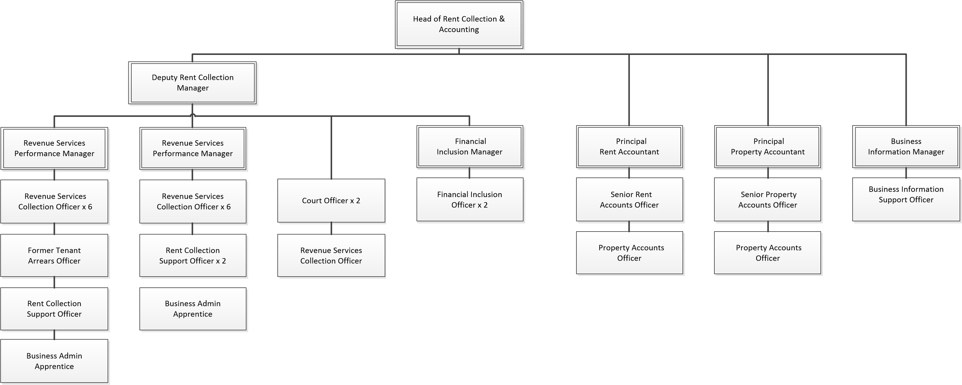

Person Specification

Job Title:  Revenue Services Collection Officer | Grade: S01
Section: Rent Collection Service | Directorate: Resources
Responsible to:  Revenue Services Performance Manager | Responsible for:  N/A
Post Number: RWR0415 | Last Review Date: May 2019

Our Values and Behaviours

The values and behaviours we seek from our staff draw on the high standards of the two boroughs, and we prize these qualities in particular:

Being open. This means we share our views openly, honestly and in a thoughtful way. We encourage new ideas and ways of doing things. We appreciate and listen to feedback from each other.

Being supportive. This means we drive the success of the organisation by making sure that our colleagues are successful. We encourage others and take account of the challenges they face. We help each other to do our jobs.

Being positive. Being positive and helpful means we keep our goals in mind and look for ways to achieve them. We listen constructively and help others see opportunities and the way forward. We have a ‘can do’ attitude and are continuously looking for ways to help each other improve.

Person Specification Requirements | Assessed by  A  & I/ T/ C (see below for explanation)
Knowledge
Experience of providing welfare benefits and debt advice to customers face to face and over the telephone | A & I
Must be fully aware of the principles of safeguarding vulnerable adults and children | A & I
Must be fully aware of Council’s duties and responsibilities arising from the Data Protection Act, Health and Safety, Information Technology and Equal Opportunities | A & I
Experience
A thorough working knowledge of debt recovery procedures in a Local Authority or Housing Association environment | A, I & T
Experience of negotiating repayment agreements with customers | A & I
Ability to work in a pressurised environment and consistently meet performance targets and to make contributions to service improvements | A & I
Experience of organising and managing a varied workload in order to meet deadlines and set targets | A & I
Skills
Ability to work under pressure with minimum supervision | A & I
Proven writing skills displaying attention to detail when producing reports with supporting recommendations in a work place environment | A & I
Must be IT literate with experience of using housing management databases and possess good keyboard skills | A & I
Must have good oral and written communication skills to communicate with stake holders both internally and externally | A, I & T
Qualifications
GCSE pass A to C or equivalent in Maths and English or experience demonstrating competency in the everyday use of Maths and English | I & T

A – Application form / CV
I – Interview
T – Test
C - Certificate

