Job Profile comprising Job Description and Person Specification
Job Description

Job Title: Arts Officer (Commercial) | Grade: SO2
Section: Arts | Directorate: Resident Services
Responsible to following manager:  Business Coordinator | Responsible for following staff:  Casual event staff
Post Number/s: | Last review date:  July 2026

Working for the Richmond & Wandsworth Better Service Partnership

We’re Richmond & Wandsworth Better Service Partnership, the shared public service team for Richmond and Wandsworth Councils. Like any local authority, our role is to deliver the agenda of our elected members on behalf of the people who live and work in our part of the world. We deliver key services to our communities including social care, public health, children’s services, housing and regeneration and environmental and community services.

Our joint workforce creates efficiency and resilience by bringing more creativity to the way we work, more objectivity and adaptability too, helping us deliver better services for all our residents.

We’re here to help our communities thrive in a changing world, and to be there for the people who need us most we believe we need to keep adapting. That’s why, at Richmond & Wandsworth Better Service Partnership, you’ll be at the forefront of innovation in local government, and we’ll invest in you and offer you opportunities to grow in a way only our unique organisation can.

Job Purpose

This post will play a key role in the delivery and implementation of commercial activity at Orleans House Gallery and across the borough, contributing to the financial sustainability of the Arts Service and increasing engagement opportunities for our audiences through revenue streams such as venue hire, retail and individual giving.
The ideal candidate has excellent administrative and project management skills, is able to think in a flexible and entrepreneurial way to maximise income potential and has some experience of working in an income generating environment, ideally within an arts venue or organisation.
Richmond Arts Service’s mission is to build community through creativity. We foster creativity and enjoyment of the arts, enable people to reflect on their lives and develop new ways of seeing the world. We bring thought-provoking art to the borough and cultivate a network of individuals, organisations and programmes that nourishes the arts, local organisations and communities.

The council released Culture Richmond, in 2021 a vision for culture in Richmond Upon Thames. The council is committed to developing a thriving, resilient and innovative cultural sector which contributes to the growth and success of our borough, communities and people.

Richmond Arts Service produces and delivers a range of ongoing creative programmes, for audiences and wider communities, including artist led exhibitions, an emerging artist's programme, learning programmes for schools, engagement activities with and for families. The commercial work of the service sits within this framework, providing experience enriching private hires for important life moments such as weddings and memorials, retail opportunities to support the local arts ecology and spaces for our communities. The post holder will deliver commercial activity which upholds the values of the Arts Service, whilst continuing to develop opportunity for good growth and increased income potential.

The post holder will work closely with hirers, artists, communities and audiences, partners and organisations, as well as staff from across the council and elected Members.

The post holder will report to the Business Coordinator, working closely with the Front of House team and Events Officers (casual).

Specific Duties and Responsibilities

- Demonstrating excellent project management skills to lead on delivery of the objectives of the commercial plan across its three primary income streams: venue hire, retail and individual giving

- Leading on administration relating to private hires including liaising with hirers and vendors; creating event schedules; overseeing robust terms of letting; making payment requests and generating invoices

- Providing both administrative and strategic support to the retail offer, including buying for the physical Orleans House Gallery and online shops; overseeing the project management of retail events; undertaking stock takes and good housekeeping and maintaining excellent working relationships with artists, makers and trade suppliers

- Supporting the implementation of the newly introduced individual giving revenue stream by tracking donations; helping to develop fundraising campaigns and liaising with front line staff to identify where training or support may be required to drive donations

- Create public facing content from hire documentation, to website copy and social media content which drives sales whilst adhering to the tone of voice and ethos of wider Arts Service content

- Maintaining excellent customer relationships and acting as a channel of communication between hirers, the Arts Service team and the Business co-ordinator. Escalating potential conflicts or concerns in a timely manner

- Collating feedback and developing evaluation tools to contribute to service KPI’s and support best practice

- Working closely with the operations and programming teams to ensure accessibility and inclusivity, to manage financial processes and budgets as well as financial targets

- To contribute to strategic initiatives and policies which increase the effectiveness of our services. To work with other council services and the wider Culture and Leisure team to increase the public benefit on shared priorities.

- To take on the role of Assistant Duty Manager as and when required

- To work flexibly across the service and provide support and cover for colleagues and senior staff as required.

The Arts Officer (Commercial) will report to the Business Co-ordinator, but work closely with the Operations Team and Arts Officers. This is to ensure a streamlined approach to commercial activity across programmes and projects.

Generic Duties and Responsibilities

- To contribute to the continuous improvement of the services of Richmond & Wandsworth Better Service Partnerships.

- To comply with relevant Codes of Practice, including the Code of Conduct and policies concerning data protection, handling complaints and health and safety.

- To adhere to security controls and requirements as mandated by Richmond and Wandsworth procedures and local risk assessments to maintain confidentiality, integrity, availability and legal compliance of information and systems

- To promote equality, diversity, and inclusion, maintaining an awareness of the equality and diversity protocol/policy and working to create and maintain a safe, supportive and welcoming environment where all people are treated with dignity and their identity and culture are valued and respected.

- To understand both Councils’ duties and responsibilities for safeguarding children, young people and adults as they apply to the roles within the Councils.

- The profile is not intended to be an exhaustive list of the duties the post holder will carry out. Other reasonable duties commensurate with the level of the post, including supporting emergency and priority situations, will form part of the role.
Additional Information
The post includes some flexible working, including weekends and evenings. The venue is open six days a week, and events may take place on evenings and weekends.

Richmond Arts Service follows a set of agile working principles. Staff work at locations across the borough, at Orleans House Gallery, and from home. This role would require a minimum of 2 days a week at the gallery.

Team structure

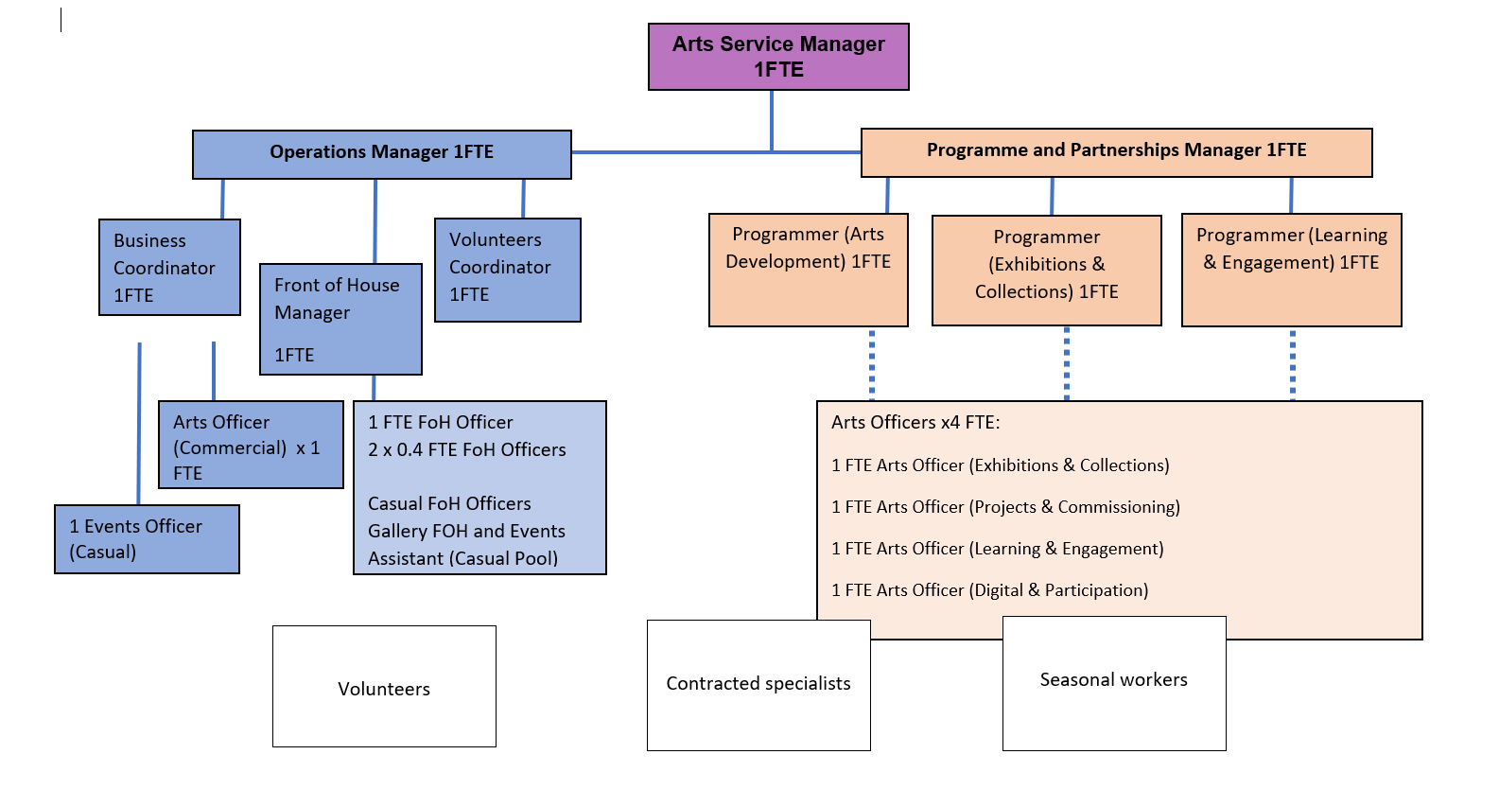
Person Specification

Job Title: Arts Officer (Commercial) | Grade: SO2
Section: Arts | Directorate: Resident Services
Responsible to: Business Coordinator | Responsible for: Casual event staff
Post Number/s: | Last Review Date:  July 2026

Our Values
THINK BIGGER
EMBRACE DIFFERENCE
CONNECT BETTER
LEAD BY EXAMPLE
PUT PEOPLE FIRST

Our Values are embedded across Richmond & Wandsworth Better Service Partnership and throughout all roles and responsibilities at all levels of the organisation. Please familiarise yourself with our values as they are an integral part of our recruitment and selection process.

Person Specification Requirements |  |  |  | Assessed by  A/I/T/C  (see below for explanation)
 | Knowledge | Essential | Desirable | Assessed
 | Knowledge of operational systems that enable the smooth delivery of services | x |  | A/I
 | Knowledge of the importance of income generation within arts and cultural organisations, with an understanding of common income streams and revenue initiatives | x |  | A/I/T
 | Knowledge of budget management and income tracking methods (P&L, forecasting, income targets, VAT liabilities etc) | x |  | A/I/
 | Experience | Essential | Desirable | Assessed
 | Experience of working in a public facing role in a busy environment | x |  | A/I
 | Administrative experience which requires good attention to detail and includes use of Microsoft IT applications | x |  | A/I/T
 | Experience of event management in listed buildings or buildings with unique usage considerations |  | x | A/I
 | Experience of working in an income generating role | x |  | A/I
 | Experience of working in retail |  | x | A/I
 | Experience of working with artists and/or makers |  | x | A/I
 | Experience of overseeing budgets and working towards financial targets | x |  | A/I
 | Experience of creating content for and using social media platforms (Instagram and Facebook) |  | x | A/I
 | Managing and leading projects in a fast paced dynamic environments | x |  | A/I
 | Skills | Essential | Desirable | Assessed
 | Ability to communicate clearly and effectively with a wide range of customers, suppliers and partners both orally and in writing. | x |  | A/I/T
 | Ability to forward plan and manage risk and security issues e.g. safeguarding, risk assessments, contracts |  | x | A/I
 | Ability to work independently and as an effective team member using own initiative. | x |  | A/I
 | Ability to adapt to changing priorities, contexts and deadlines. | x |  | A/I
 | Qualifications | Essential | Desirable | Assessed
 | First Aid at work qualification (could be secured post appointment) |  | x | c

A – Application form / CV
I – Interview
T – Test
C - Certificate

