Job Profile comprising Job Description and Person Specification
Job Description

Job Title:  Senior CIL and S106 Officer | Grade:  PO2-PO4
Section:  Spatial Planning | Directorate:  Growth and Place
Responsible to following manager:  Principal CIL and S106 Officer | Responsible for following staff:  CIL and S106 Officers
Post Number/s: | Last review date:  November 2019

Working for the Richmond & Wandsworth Better Service Partnership

We’re Richmond & Wandsworth Better Service Partnership, the shared public service team for Richmond and Wandsworth Councils. Like any local authority, our role is to deliver the agenda of our elected members on behalf of the people who live and work in our part of the world. We deliver key services to our communities including social care, public health, children’s services, housing and regeneration and environmental and community services.

Our joint workforce creates efficiency and resilience by bringing more creativity to the way we work, more objectivity and adaptability too, helping us deliver better services for all our residents.

We’re here to help our communities thrive in a changing world, and to be there for the people who need us most we believe we need to keep adapting. That’s why, at Richmond & Wandsworth Better Service Partnership, you’ll be at the forefront of innovation in local government, and we’ll invest in you and offer you opportunities to grow in a way only our unique organisation can.

Job Purpose

To deliver high quality, robust and transparent decision making within tight time frames on matters relating to S106 legal agreements and the administration of the Community Infrastructure Levy to ensure that the Spatial Planning Service is recognised as delivering an excellent planning service for its customers. The Senior CIL and S106 Officer will provide day to day management of S106 legal agreements to ensure that the provisions within them are enacted at the correct time and manage incoming funding contributions and its allocation and associated spend; and administer the Community Infrastructure Levy including any related advice requests and correspondence to agreed and identifiable timescales. The Senior CIL and S106 Officer will supervise and coach S106 and CIL Officers to help them acquire the skills and knowledge to become self-reliant and independently manage the legal agreements and the application of CIL to ensure that the provisions within them are enacted appropriately.

Specific Duties and Responsibilities

- Undertakes a range of duties relating to the management and monitoring of planning obligations from the S106 Agreements and CIL work including responsibility for high profile planning applications, working to identifiable deadlines in a manner that is consistent with meeting corporate targets and objectives.

- Maintains a good working knowledge of current planning legislation particularly as it relates to planning obligations through S106 Agreements and the CIL.

- Carries out day to day organisational and administrative tasks to monitor S106 Agreements and determine CIL liabilities, including the application of planning obligations when due, and processing and issuing relevant Notices up to and including Demand Notices.

- Ensures that funding secured through S106 Agreement is allocated to the necessary person/body, such that the planning obligation can be completed within the agreed timeframe.

- To process applications for CIL exemption and relief in accordance with the Regulations.

- Uses Planning Application Systems, Document Management Systems, Council Tax system, non-Domestic Rate Register and Database/Spreadsheets software as necessary to accurately record S106 and CIL information and log Notices.

- Monitors Commencement Notices and interrogate Building Control, Local Land and Property Gazetteer, Development Monitoring and Council Tax systems to identify commencement and trigger dates.

- Monitors activity in relation to failure to submit forms, clawback periods etc. and ensures quality control in planning obligation data in relation to the monitoring and S106 Agreements and CIL data.

- Supplies timely information to facilitate issuing of Demand Notices and collection/recovery action and supplies planning obligation information to Local Land Charges.

- Liaises with Spatial Planning Service, Development Management, Finance Department and other Council Officers to establish best practice workflow procedures and identify service improvements.

- Provides professional advice on S106 Agreement and CIL related matters, including interpretation of Regulations and operation of Planning Obligations as necessary and provide timely response to correspondence and related enquiries.

- Provides management information and accurate and timely preparation of requested statutory statistical returns to the Information and Planning Obligations Team Manager and Principal CIL and S106 Officer as required, including projected S106 Agreement and CIL incomes and expenditures.

- Participates in London and other S106 Agreement and CIL administration best practice forums as required.

- Contributes to review of procedures and processes related to the monitoring of S106 Agreements and CIL implementation.

- Provides training on CIL and S106 administrative systems as required.

CRITERIA FOR PROGRESSION TO PO3 (as for PO2 plus the following)

- Works independently on full range of S106 Agreements and CIL work including responsibility for high profile planning applications, working to identifiable deadlines in a manner that is consistent with meeting corporate targets and objectives that required minimal input or correction from the Principal CIL and S106 Officer and Information and Planning Obligations Team Manager.

- Maintains an up-to-date knowledge of relevant legislation and takes a proactive approach to relevant changes in legislation, updating colleagues within policy and other teams on those changes and also recommending revised procedures and practices to the Principal CIL and S106 Officer and Information and Planning Obligations Team Manager.

- Leads and implements self-contained projects or components of larger projects in order to deliver organisational objectives as well as enabling agreed changes in planning practice and processes to take place.

- Coaches and facilitates the acquisition of skills and knowledge in others so that they are better equipped to be self-reliant in dealing technical and people issues, particularly for complex and high-profile planning obligation case work.

- Provides advice and guidance in response to planning best practice, procedure or policy within a legal/organisational policy framework and develops solutions or recommendations to meet service needs.

- Initiates, participates in and where necessary takes a management role on matters relating to S106 Agreement and CIL specific matters and conflict resolution to ensure high quality innovative outcomes that reflect Council-wide objectives and policies.

- To process CIL reviews and Appeals in conjunction with the Principal CIL and S106 Officer and Information and Planning Obligations Team Manager and legal officers.

CRITERIA FOR PROGRESSION TO PO4 (as for PO3 plus the following)

- When necessary, the postholder will be responsible for the direct supervision of at least one member of staff undertaking tasks of a project nature.

- Maintains an up-to-date knowledge of relevant legislation and takes a proactive approach to relevant changes in legislation and updating all staff on those changes, including making recommendations for implementing revised procedures and practices.

- Coaches and facilitates the acquisition of skills and knowledge in others so that they are better equipped to be self-reliant in dealing with technical and people issues, particularly focusing on complex, high profile and politically sensitive project specification matters.

- Takes a lead role in providing advice and guidance in response to S106 Agreement best practice, procedure or policy within a legal/organisational framework and develops and implements solutions or recommendations to meet service needs.

- Takes responsibility for ensuring the team meets service-wide and corporate performance indicators, targets and customer service standards of the full range of the team’s work. Proactive in identifying issues and proposing improvements and creative solutions within the context of current and future service requirements in order to continually deliver high quality, customer focused planning services to customers and managers.

Generic Duties and Responsibilities

- To contribute to the continuous improvement of the services of Richmond & Wandsworth Better Service Partnerships.

- To comply with relevant Codes of Practice, including the Code of Conduct and policies concerning data protection, handling complaints and health and safety.

- To adhere to security controls and requirements as mandated by Richmond and Wandsworth procedures and local risk assessments to maintain confidentiality, integrity, availability and legal compliance of information and systems

- To promote equality, diversity, and inclusion, maintaining an awareness of the equality and diversity protocol/policy and working to create and maintain a safe, supportive and welcoming environment where all people are treated with dignity and their identity and culture are valued and respected.

- To understand both Councils’ duties and responsibilities for safeguarding children, young people and adults as they apply to the roles within the Councils.

- The profile is not intended to be an exhaustive list of the duties the post holder will carry out. Other reasonable duties commensurate with the level of the post, including supporting emergency and priority situations, will form part of the role.

Additional Information
Assists as required with management of budgets, including ensuring that all necessary processes and procedures are carried out in a timely and effective manner.
Provides supervision as required to assigned staff and takes responsibility for the allocation and checking of work by staff.

Team structure

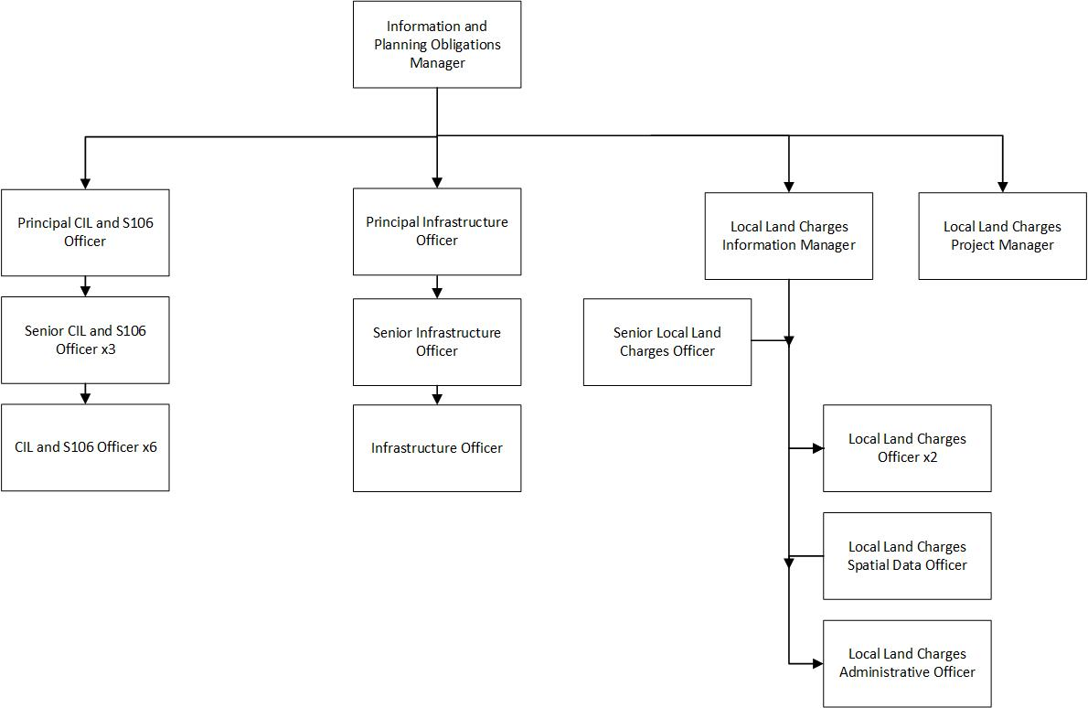

Person Specification

Job Title:  Senior CIL and S106 Officer | Grade:  PO2-PO4
Section:  Spatial Planning | Directorate:  Growth and Place
Responsible to:  Principal CIL and S106 Officer | Responsible for:  CIL and S106 Officers
Post Number/s: | Last Review Date:  November 2019

Our Values
THINK BIGGER
EMBRACE DIFFERENCE
CONNECT BETTER
LEAD BY EXAMPLE
PUT PEOPLE FIRST

Our Values are embedded across Richmond & Wandsworth Better Service Partnership and throughout all roles and responsibilities at all levels of the organisation. Please familiarise yourself with our values as they are an integral part of our recruitment and selection process.

Person Specification Requirements |  |  | Assessed by  A/I/T/C  (see below for explanation)
Knowledge | Essential | Desirable | Assessed
A good knowledge of planning legislation and more detailed up to date knowledge of that relating to S106 Agreements and CIL administration and their application to development. | X |  | A/I/T
Advanced knowledge of Excel and Access and ability to use a wide range of computer software to collate, query, analyse, interpret and present data. | X |  | A/I/T
An understanding of planning and building control and related IT systems. | X |  | A/I/T
Experience | Essential | Desirable | Assessed
Experience of supervising and mentoring staff to deliver workload to required standard, particularly when there are competing deadlines. | X |  | A/I
Experience of coaching staff to meet work demands. |  | X | A/I
Experience in working in development management and/or the management of S106 Agreements and CIL Administration. | X |  | A/I
Experience in working in a high-pressure environment |  | X | A/I/T
Skills | Essential | Desirable | Assessed
Proven information management and numeracy skills and ability to produce and collate accurate information and data reports | X |  | A/I/T
Ability to lead on designated projects with minimum supervision |  | X | A/I
Ability to communicate and liaise effectively, both verbally and in writing, with a range of colleagues and customers. |  | X | A/I/T
Have a methodical approach to work with high levels of accuracy and ability to pay meticulous attention to detail. | X |  | A/I/T
A professional approach, with ability to interpret complex Regulations and make reasoned and consistent judgements. | X |  | A/I
A self-starter with the ability to get to grips with work quickly and independently. | X |  | A/I
Ability to work effectively to meet challenging deadlines and manage competing and changing priorities. | X |  | A/I
Ability to use initiative and identify innovative solutions to everyday challenges, continually striving to improve service delivery. |  | X | A/I/T
Qualifications | Essential | Desirable | Assessed
Membership or working towards membership of an appropriate professional body. |  | X | A/C

A – Application form / CV
I – Interview
T – Test
C - Certificate

