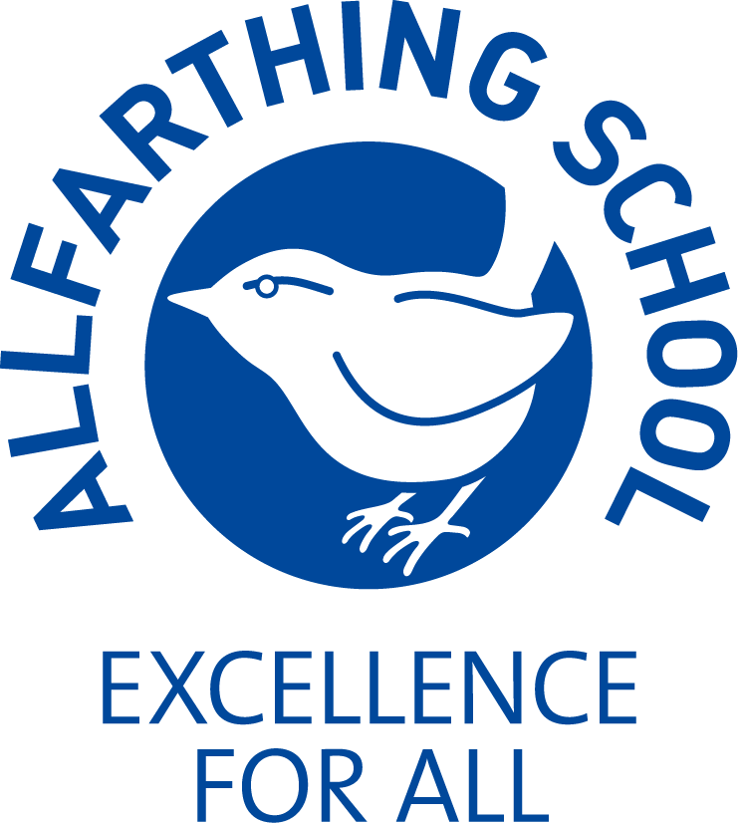
ALLFARTHING PRIMARY SCHOOL
Job description for SENCo

Teachers pay scale (according to experience) + TLR 2.2.
You will be a member of the SLT and accountable to the Head/Deputy Head

MAIN PURPOSE
Exercising professional skills and judgement to ensure that pupils with special educational needs are
Identified, supported and catered for, to best meet their needs with a focus on academic, medical,
emotional and social factors affecting teaching and learning. Promoting awareness and understanding of individual pupil’s requirements. Manage day-to-day provision for the above groups and deploy relevant staff

MAIN RESPONSIBILITIES
Teaching and Learning in relation to SEN. | - To monitor the quality of teaching and learning, including planning for the relevant groups of pupils and share judgements with teachers and support staff as appropriate to inform further improvements  - To support all staff in understanding these pupils’ needs and help to identify and disseminate the most effective teaching methods for them  - To demonstrate, teach and plan alongside teaching and support staff to ensure best practice  - To liaise with other leaders to ensure the delivery of an appropriate, comprehensive, high quality and cost-effective curriculum programme which complements the school’s strategic objectives  - To keep abreast of any new developments in the teaching and assessment of the relevant groups  - To disseminate information and initiatives to all members of staff  - Ensure all pupils with SEN achieve their potential
Curriculum development | - To ensure the curriculum/resources reflect the diverse school community  - Together with other members of the leadership team, to be responsible  for identifying resources and their efficient/effective use  - To be responsible for managing any budgets for your area  - Develop and maintain an up to date provision map of support for relevant groups
Communication | - To liaise with staff to ensure that there is a consistent approach to  teaching and learning for the relevant groups throughout the school  - To liaise with parents, guardians, staff, external agencies and other schools to co-ordinate their contribution, provide maximum support and ensure continuity of provision  - To provide information for parents, guardians and governors so that they have an understanding of school policies and their implementation
Staff development | - To take part in performance review for TAs and other SEN staff  - To identify key CPD needs and lead staff meetings as appropriate  - To provide high quality coaching and mentoring re SEN  - To be responsible for staff induction ensuring that class teachers realise their responsibility towards individuals in the relevant groups
Assessment | - To co-ordinate assessment results and target setting for the above groups together with the Deputy Head  - To ensure that appropriate attainment targets exist for individual pupils in the relevant groups  - To make use of analysis and evaluate performance data in order to improve pupil attainment for the relevant groups  - To ensure that relevant pupils have a personalised education plan where their particular needs are identified through robust assessment.  - To ensure relevant EHCP’s are applied for in an efficient and effective manner  - Raise attainment for SEN pupils.  - Work closely with the Deputy Head on Assessment of SEN pupils
School Success Plan | - To advise the headteacher on the strategic direction and development of all aspects of SEN and to lead development in those areas  - To help to monitor/evaluate the school success plan implementation  - To contribute to relevant aspects of the school’s self evaluation
Pastoral Support | - To help ensure that the school’s pastoral support systems (e.g. circle time, anti bullying) support effective learning
Teaching | - To work closely with teaching/support staff delivering SEN and other group teaching
Additional Duties | - To play a full part in the life of the school community, to support its ethos and to encourage other staff and pupils to follow this example  - To continue your own personal professional development  - To be aware of and comply with policies/procedures related to health/ safety/security/confidentiality/data protection and report all concerns  - To share in leading assemblies  - To assist the designated teacher (DH) for child protection/safeguarding, by being one of the school’s safeguarding leads  - To be fully aware of the principles of safeguarding as they apply to vulnerable adults in relation to this role  - To ensure that you keep your line manager fully informed of any concerns which you have in relation to safeguarding/child protection  - Link person for PATHs and Place2Be  - Undertake other general tasks relevant to the job, as required  - Half-termly meetings with governor responsible for inclusion

Employees will be expected to comply with any reasonable request from the Headteacher to undertake work of a similar level not specified in this job description.

Allfarthing Primary School SENCo PERSON SPECIFICATION

N.B Please address the person specification and not the job description in the statement on your application form. This should not exceed more than two A4 typed sheets of paper.
Attributes | Essential Criteria | Essential | Desirable | How Assessed
Qualifications | - Qualified Teacher Status  - Degree or equivalent  - Evidence of recent relevant professional development  - Willingness to undertake SENCo qualification if not already obtained  - DSL Level 3 or willingness to undertake training | ✓  ✓  ✓  ✓ | ✓ | Application Form
Professional Experience | - Primary Teaching Experience  - Understanding of EYFS  - Involvement with external agencies  - Experience of working with underachieving disadvantaged and SEN pupils  - Experience of successful leadership and management within a school  - Ability to provide professional leadership/management to a staff team and contribute to the work of other teams to secure high quality teaching/ effective use of resources/improved standards of learning & achievement for all pupils across the school | ✓  ✓  ✓  ✓  ✓ | ✓  ✓  ✓ | Application Form  Interview  References
Knowledge and Understanding | - Knowledge of Primary Curriculum  - Knowledge of SEN Code of Practice  - Knowledge of how to stimulate underachieving children  - Understanding of the importance of creativity in the curriculum  - Knowledge of how curriculum can be extended  - Understanding of the importance of partnership with parents  - Understanding of the importance of community links  - Knowledge of relevant legislation, SEN Code of Practice, equal opportunities & disability discrimination legislation & how these apply to pupils with EHCP’s as well as those without  - Knowledge of the range/type of interventions available & ability to apply these appropriately in context of the school’s resources/individual child  - Knowledge of latest local and national SEN developments/ current educational issues & their relationship to inclusion/ behaviour support/education welfare | ✓  ✓  ✓  ✓  ✓  ✓  ✓  ✓  ✓ | ✓ | Application Form  Interview
Skills | - Ability to analyse/prioritise/ meet deadlines  - Ability to communicate clearly both verbally & in writing, with energy and conviction to a wide audience  - Ability to use ICT to support both the curriculum/work organisation  - Ability to work as part of, and contribute to, the whole school team  - Ability to select appropriate resources which ensure high quality teaching & learning, accessible to all pupils  - Ability to assess needs of individuals to inform lesson planning  - Ability to plan appropriately/ motivate all groups of pupils, including the more able  - Ability to use assessment data to report on pupil performance to SLT/Governors  - Excellent time management skills | ✓  ✓  ✓  ✓  ✓  ✓  ✓  ✓  ✓ | ✓ | Application Form  Interview
Personal Qualities | - Commitment to inclusive education/ willingness to respond to needs of individual learners with sensitivity  - Positive & resilient with drive/integrity/ cheerful disposition/sense of humour  - Ambitious & diligent professional who can motivate/inspire others including pupils/teachers/ parents/governors  - Commitment to high standards/equality of opportunity/continuous improvement  - Commitment to safeguarding & promoting welfare of children  - Approachable: able to listen & reflect on the needs of all stakeholders and to work closely with outside agencies to promote children’s development  - Excellent presentation & inter-personal skills | ✓  ✓  ✓  ✓  ✓  ✓  ✓ | ✓  ✓ | Application Form  Interview  References
Continuing Professional Development | - Evidence of personal commitment to professional development | ✓  ✓ |  | Interview

____________________________________________________________________________________________________________

