Job Profile comprising Job Description and Person
Specification
Job Description
Job Title: VAWG Partnership Support Officer | Grade: SO2
Section: Community Safety Service | Directorate: Chief Executives Group
Responsible to following manager:  VAWG Operations Manager | Responsible for following staff:  N/A
Post Number/s: | Last review date: February 2026

Working for the Richmond & Wandsworth Better Service Partnership
We’re Richmond & Wandsworth Better Service Partnership, the shared public service team for Richmond and Wandsworth Councils. Like any local authority, our role is to deliver the agenda of our elected members on behalf of the people who live and work in our part of the world. We deliver key services to our communities including social care, public health, children’s services, housing and regeneration and environmental and community services.
Our joint workforce creates efficiency and resilience by bringing more creativity to the way we work, more objectivity and adaptability too, helping us deliver better services for all our residents.
We’re here to help our communities thrive in a changing world, and to be there for the people who need us most we believe we need to keep adapting. That’s why, at Richmond & Wandsworth Better Service Partnership, you’ll be at the forefront of innovation in local government, and we’ll invest in you and offer you opportunities to grow in a way only our unique organisation can.

Job Purpose:

The VAWG Partnership Support Officer will contribute to the effective partnership delivery of Violence Against Women and Girls (VAWG) priorities across Richmond and Wandsworth by providing key administrative, communications and training coordination functions within the Community Safety Service VAWG team. The role will focus on facilitating effective and efficient ways of working between the VAWG team the wider landscape of VAWG partners.
The post will provide high-quality business administration, liaising with VAWG partners and management staff to coordinate timely inputs into a range of monitoring, reporting and learning processes including updating the needs assessments. The postholder will additionally play a lead role in coordinating the VAWG team training offer and will work closely with VAWG team colleagues and the Communications team to compile and coordinate delivery of an annual VAWG communications plan, The postholder will provide additional ad hoc support across the team where there are needs, which may involve working outside of office hours and sites.

We are looking for someone with an excellent understanding of Violence Against Women and Girls and strong organisational, communication and mobilisation skills that can be applied in a complex multi-agency environment. This post will work across Wandsworth and Richmond.

Specific Duties and Responsibilities:
- To undertake proactive and structured outreach to VAWG partners on behalf of the service, to coordinate timely information gathering for partnership delivery plan monitoring returns, contract management returns, funder reporting, and others as may be needed. With the support of management, identify areas for quality improvement in information gathered and liaise with partners to ensure standards are met.

- To facilitate effective coordination and support high quality partnership working on VAWG, maintain positive working relationships at the operational level with a broad range of partners including Housing, Adult and Children’s Services, commissioned domestic abuse services, Police, voluntary sector organisations, health partners, and others as may be needed. Attend relevant panel or coordination meetings to provide technical inputs and/or administrative/coordination support on behalf of the VAWG team where directed by management.

- To lead on developing and ensuring delivery of an annual VAWG training plan for the service, through identifying training needs of partnership in coordination with VAWG team colleagues, by commissioning trainers, and by undertaking occasional direct training or presentation delivery where appropriate. Coordinate logistics including venue booking, online platform setup, circulation of materials, attendance tracking, and evaluation.

- To lead on consolidating and driving delivery of an annual VAWG communications plan for the service, bringing together communications plans from across the VAWG team. This function includes serving as the operational VAWG team point of contact for the Communications and Design teams, supporting VAWG team colleagues by leading an iterative collaborative process to execute their communications and design vision.

- With the support of management, lead on undertaking or contributing to any relevant needs assessments, surveys, consultations or similar exercises on behalf of the service related to VAWG.

- Coordinate inputs to ensure that VAWG webpages, team calendars and workflow trackers as identified by the Vulnerabilities Manager remain up to date.
- Gather information from colleagues across departments to support the VAWG Manager and Vulnerabilities Manager in preparing responses in FOIRs, SARs, MEs and others as may be required.

Generic Duties and Responsibilities

- To contribute to the continuous improvement of the services of Richmond & Wandsworth Better Service Partnerships.

- To comply with relevant Codes of Practice, including the Code of Conduct and policies concerning data protection, handling complaints and health and safety.

- To adhere to security controls and requirements as mandated by Richmond and Wandsworth procedures and local risk assessments to maintain confidentiality, integrity, availability and legal compliance of information and systems

- To promote equality, diversity, and inclusion, maintaining an awareness of the equality and diversity protocol/policy and working to create and maintain a safe, supportive and welcoming environment where all people are treated with dignity and their identity and culture are valued and respected.

- To understand both Councils’ duties and responsibilities for safeguarding children, young people and adults as they apply to the roles within the Councils.

- The profile is not intended to be an exhaustive list of the duties the post holder will carry out. Other reasonable duties commensurate with the level of the post, including supporting emergency and priority situations, will form part of the role.
Additional Information
Post holder will be expected to work flexibly across the boroughs of Richmond and Wandsworth, with hybrid arrangements including presence at Wandsworth Town Hall and Twickenham Civic Centre where required and work from home provision.

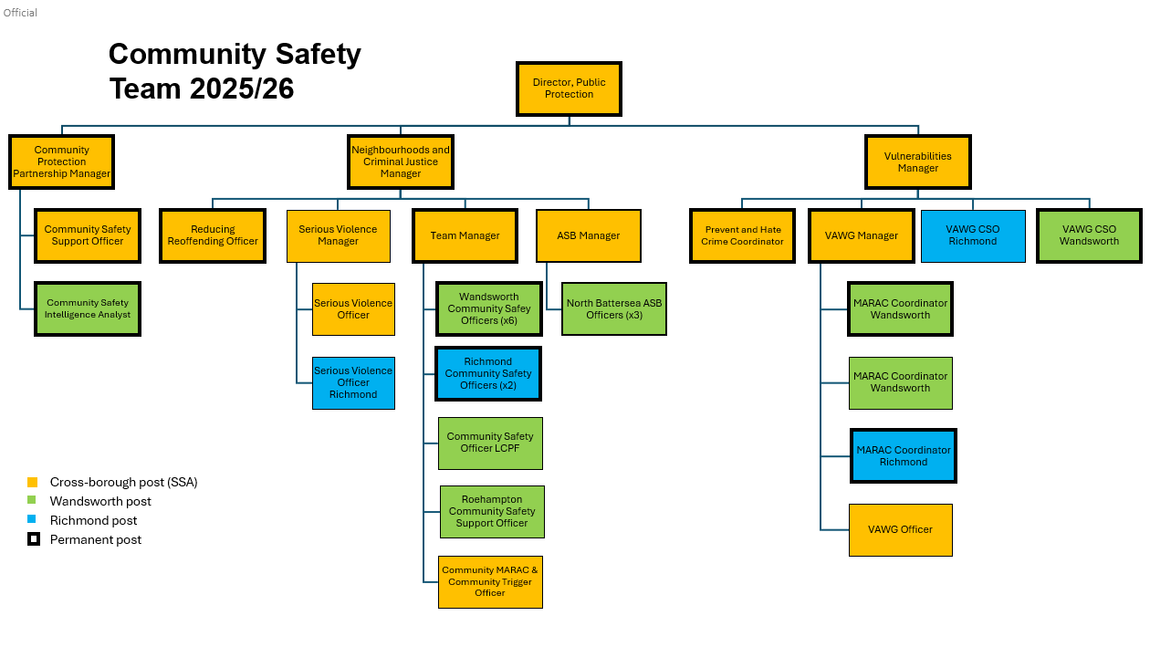

Person Specification

Job Title: VAWG Partnership Support Officer | Grade: SO2
Section: Community Safety Service | Directorate: Chief Executives Group
Responsible to following manager:  Vulnerabilities Manager | Responsible for following staff:  N/A
Post Number/s: | Last review date: February 2026

Our Values
THINK BIGGER
EMBRACE DIFFERENCE
CONNECT BETTER
LEAD BY EXAMPLE
PUT PEOPLE FIRST

Our Values are embedded across Richmond & Wandsworth Better Service Partnership and throughout all roles and responsibilities at all levels of the organisation. Please familiarise yourself with our values as they are an integral part of our recruitment and selection process.

Person Specification Requirements | Assessed by  A /I/ T/ C (see below for explanation)
Knowledge | Essential | Desirable
A comprehensive and demonstrable understanding of tackling Violence Against Women and Girls and the needs of victims. | A/I
A good understanding of national and regional VAWG strategies, data and statutory responsibilities for Local Authorities. |  | A/I
A strong understanding of and commitment to Equality, Diversity and Inclusion, and how these may be promoted within this role. | A/I
Experience | Essential | Desirable
Experience of coordinating complex multi-agency partnership working with both public and voluntary sector stakeholders. | A/I
Experience of delivering presentations, trainings, workshops and briefings to varied audiences. | A/I
Experience participating in safeguarding processes to support VAWG victim-survivors. |  | A/I
Skills | Essential | Desirable
Ability to work both independently and as a member of a team, organising and prioritising a complex workload. | A/I
Excellent written and verbal communication skills, including the ability to mobilise a range of stakeholders. | A/I
Strong business planning and critical thinking skills, with the ability to ensure work is structured to deliver against broader Council or partnership strategies, goals, timeframes and processes. | A/I
ICT literate, including proficient use of the Internet and all mainstream MS programs, with the ability to learn others as required. | A/I
Qualifications | Essential | Desirable
Educated at degree level or an equivalent work-related qualification or equivalence by experience | C/A/I
Evidence of continuing professional development |  | C

A – Application form
I – Interview
T – Test
C - Certificate

