Job Profile comprising Job Description and Person Specification
Job Description

Job Title:  Community Safety Officer | Grade:  PO3
Section:  Community Safety Service | Directorate:  Chief Executives Group
Responsible to following manager:  Community Safety Team Manager | Responsible for following staff:  N/A
Post Number/s:  1 | Last review date: 08/02/2021

Working for the Richmond & Wandsworth Better Service Partnership

We’re Richmond & Wandsworth Better Service Partnership, the shared public service team for Richmond and Wandsworth Councils. Like any local authority, our role is to deliver the agenda of our elected members on behalf of the people who live and work in our part of the world. We deliver key services to our communities including social care, public health, children’s services, housing and regeneration and environmental and community services.

Our joint workforce creates efficiency and resilience by bringing more creativity to the way we work, more objectivity and adaptability too, helping us deliver better services for all our residents.

We’re here to help our communities thrive in a changing world, and to be there for the people who need us most we believe we need to keep adapting. That’s why, at Richmond & Wandsworth Better Service Partnership, you’ll be at the forefront of innovation in local government, and we’ll invest in you and offer you opportunities to grow in a way only our unique organisation can.

Job Purpose

The post-holder will be responsible for a defined geographic area and for building strong relationships with statutory and voluntary sector organisations, communities, and individuals to collectively address persistent and problematic crime and anti-social behaviour. To encourage and develop the involvement of the public through Neighbourhood Watch and business participation groups. Work to deliver priorities and actions in the Community Safety Plan.

Specific Duties and Responsibilities

- Provide leadership and coordination within a defined area to build a network of key individuals, statutory and voluntary sector organisations to reduce crime and anti-social behaviour, build community cohesion and reduce the fear of crime through neighbourhood profiling and the ECINS platform

- To identify and provide leadership on borough crime trends and hot spots by working closely with community groups such as Neighbourhood Watch, Residents’ Associations, business groups and forums to support crime reduction and crime prevention in line with the Mayor’s Office for Policing and Crime (MOPAC) priorities within the Community Safety Plan.

- To identify organisations and/or locations of significant community safety risk and develop key relationships with the relevant management teams. To ensure Emergency Planning and other relevant teams internally and externally are briefed on any relevant issues and to assist in the mitigation of any associated risk.

- To support Neighbourhood Watch Associations in areas identified as crime hotspots or vulnerable to crime.

- Coordinate actions under the Anti-social Behaviour, Crime and Policing Act 2014. To identify best practice in the implementation of ASB tools and powers in line with these priorities including:

- To support the CMARAC process with relevant referral and review materials; to coordinate complex case actions with other risk management panels or processes.

- To identify and develop key relationships and referral pathways with health/mental health teams, social care, drug treatment providers, outreach/triage services and advocacy groups to ensure effective referral and signposting for those who are rough sleeping, street drinking or begging; or who are otherwise deemed vulnerable.

- Collate and present information for review to the Community Trigger Panel.

- To work with Police Teams, Housing, RSLs and other providers to maintain a database of CBO’s, Injunctions and ABCs including positive requirements as required by the Community Safety Manager.

- Represent the Community Safety Service as required at ward and community meetings such as Ward Panels.

- To assist in the development of literature and presentation materials on Community Safety through the communications grid with the support of the Insight and Analytics Team and Communications Team.

- Attend community events and engage with the public to raise awareness of crime issues and provide crime prevention advice.

- To investigate and respond to Member Enquiries and Freedom of Information requests as delegated by the Community Safety Team Manager.

- To take on key responsibilities in key projects as laid down by the Community Safety Team Manager and report back when necessary to the Senior Management Team on progress. This includes developing specialist knowledge, sharing best practice, or running key initiatives across both boroughs.

Generic Duties and Responsibilities

- To contribute to the continuous improvement of the services of Richmond & Wandsworth Better Service Partnerships.

- To comply with relevant Codes of Practice, including the Code of Conduct and policies concerning data protection, handling complaints and health and safety.

- To adhere to security controls and requirements as mandated by Richmond and Wandsworth procedures and local risk assessments to maintain confidentiality, integrity, availability and legal compliance of information and systems

- To promote equality, diversity, and inclusion, maintaining an awareness of the equality and diversity protocol/policy and working to create and maintain a safe, supportive and welcoming environment where all people are treated with dignity and their identity and culture are valued and respected.

- To understand both Councils’ duties and responsibilities for safeguarding children, young people and adults as they apply to the roles within the Councils.

- The profile is not intended to be an exhaustive list of the duties the post holder will carry out. Other reasonable duties commensurate with the level of the post, including supporting emergency and priority situations, will form part of the role.

Team structure

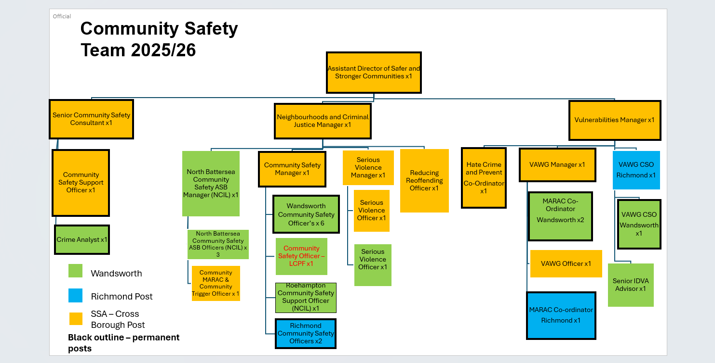

For the current structure please go to The Loop.

Person Specification
Job Title:  Community Safety Officer | Grade:  PO3
Section:  Community Safety Service | Directorate:  Chief Executives Group
Responsible to following manager:  Community Safety Team Manager | Responsible for following staff:  N/A
Post Number/s:  1 | Last review date: February 2021

Our Values
THINK BIGGER
EMBRACE DIFFERENCE
CONNECT BETTER
LEAD BY EXAMPLE
PUT PEOPLE FIRST

Our Values are embedded across Richmond & Wandsworth Better Service Partnership and throughout all roles and responsibilities at all levels of the organisation. Please familiarise yourself with our values as they are an integral part of our recruitment and selection process.

Person Specification Requirements |  |  |  | Assessed by  A/I/T/C  (see below for explanation)
 | Knowledge | Essential | Desirable | Assessed
 | Knowledge of key legislation especially in the Anti-Social Behaviour, Crime and Policing Act 2014 and the Data Protection Act 2018. | x
 | An understanding of how-to problem solve community issues to understand harm and risk. It is desirable to understand the SARA model. | x
 | An understanding of the importance of partnerships in community safety and how these can be developed. | x
 | Experience | Essential | Desirable | Assessed
 | Experience of partnership or multi-agency work in order to achieve shared objectives. | x
 | Experience of working in a community safety related role which involved communicating effectively with the public on all matters involving Community Safety, | x
 | Skills | Essential | Desirable | Assessed
 | Ability to organise and prioritise own workload, within defined requirements for the role. | x
 | Good written and communication in order to deliver reports clearly and concisely. | x
 | Ability to analyse local crime trends and other relevant crime sources. | x
 | Basic knowledge of and ability to use standard IT packages (Microsoft Office and Outlook). Desirable but not essential to use ECINS | x
 | Qualifications | Essential | Desirable | Assessed
 | Degree level or equivalent by experience. | x

A – Application form / CV
I – Interview
T – Test
C - Certificate

