Job Profile comprising Job Description and Person

Specification Job Description

Job Title:  Contracts & Projects Officer | Grade: PO2
Section:  Culture & Leisure | Directorate:  Resident Services
Responsible to following manager:  Contracts & Projects Manager/Parks  Operations Manager | Responsible for following staff:  None
Post Number/s: | Last review date: 10/09/2025

Working for the Richmond & Wandsworth Better Service Partnership

We’re Richmond & Wandsworth Better Service Partnership, the shared public service team for Richmond and Wandsworth Councils. Like any local authority, our role is to deliver the agenda of our elected members on behalf of the people who live and work in our part of the world. We deliver key services to our communities including social care, public health, children’s services, housing and regeneration and environmental and community services.

Our joint workforce creates efficiency and resilience by bringing more creativity to the way we work, more objectivity and adaptability too, helping us deliver better services for all our residents.

We’re here to help our communities thrive in a changing world, and to be there for the people who need us most we believe we need to keep adapting. That’s why, at Richmond & Wandsworth Better Service Partnership, you’ll be at the forefront of innovation in local government, and we’ll invest in you and offer you opportunities to grow in a way only our unique organisation can.

Job Purpose

Support the effective monitoring and management of culture and leisure contracts across Richmond and Wandsworth, leading on specific areas of work as directed, working in partnership to realise positive benefits and outcomes for residents.

Actively contribute to the delivery of high-quality cultural and leisure services through effective contract management and project coordination. The postholder will help ensure that commissioned services, partnerships, and capital projects are delivered on time, within budget, and in alignment with strategic objectives for culture, leisure, and community wellbeing.

Support senior managers to develop, procure, manage and deliver contracts and projects that support both Council’s Corporate Plans and strategic policy objectives.

Specific Duties and Responsibilities

- Monitor and manage contracts with external providers across culture and leisure services (e.g. libraries, museums, sports centres, arts organisations, parks, open spaces, cemeteries).
- Ensure compliance with service level agreements, KPIs, and statutory requirements.
- Lead on contract renewals, variations, and procurement processes in collaboration with legal and procurement teams.
- Undertake industry research, identifying trends and new opportunities (including new technology) to enable services to be planned and improved according to identified need.
- Maintain accurate records and reporting systems for contract performance.
- Support the planning and delivery of capital and service improvement projects within the culture and leisure portfolio.
- Coordinate project timelines, budgets, risk registers, and stakeholder engagement.
- Prepare reports, briefings, and presentations for senior management and elected members.
- Liaise with internal departments and external partners to ensure successful project outcomes.
- Build and maintain effective relationships with service providers, community groups, and cultural organisations.
- Represent the council/organisation at meetings, forums, and events.
- Respond to enquiries and feedback from stakeholders and service users.
- Support in monitoring contract or project budgets, procurement and purchasing of any goods and services in line with the prescribed allocations and contract standing orders.
- Project manage one-off capital / revenue projects as required.
- Attend stakeholder contract management meetings, monitoring visits and receive and review contract performance data.
- Oversee the maintenance and creation of web pages, other information sources and marketing materials as required.
- Lead, develop and support key projects, funding bids or initiatives as required.
- Keep under review and develop the structures, procedures and working methods for which the post holder is responsible to ensure an integrated, effective and efficient approach to the delivery of services.
- Ensure that apprentices are recruited, managed, appraised and developed in line with relevant standards, and that effective arrangements are made for their training and progression.
- Where our suppliers use volunteers, check they are managed.
- Provide and present timely and relevant advice and information to working groups, senior managers and Members and ensure that Managers and Heads of Service are briefed on major and sensitive issues.
- Be fully conversant with relevant statutory provisions and the Council’s constitution, processes and procedures; to develop the full range of managerial and professional skills and knowledge to satisfy the requirements of the post.
- Provide administrative support including logging actions, data analysis, and document preparation.

Generic Duties and Responsibilities

- Contribute to the continuous improvement of the services of Richmond & Wandsworth Better Service Partnerships.

- Comply with relevant Codes of Practice, including the Code of Conduct and policies concerning data protection, handling complaints and health and safety.

- Adhere to security controls and requirements as mandated by Richmond and
Wandsworth procedures and local risk assessments to maintain confidentiality, integrity, availability and legal compliance of information and systems

- Promote equality, diversity, and inclusion, maintaining an awareness of the equality and diversity protocol/policy and working to create and maintain a safe, supportive and welcoming environment where all people are treated with dignity and their identity and culture are valued and respected.

- Understand both Councils’ duties and responsibilities for safeguarding children, young people and adults as they apply to the roles within the Councils.

- The profile is not intended to be an exhaustive list of the duties the post holder will carry out. Other reasonable duties commensurate with the level of the post, including supporting emergency and priority situations, will form part of the role.

Team structure

(Arts, Parks and Events Service

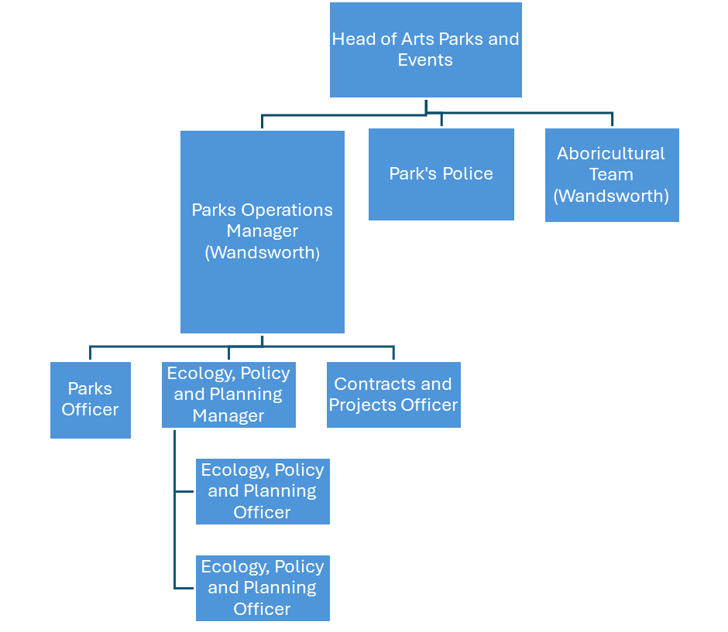

Person Specification

Job Title:  Contracts & Projects Officer | Grade: PO2
Section:  Culture & Leisure | Directorate:  Resident Services
Responsible to following manager:  Parks Operations Manager | Responsible for following staff: None
Post Number/s: | Last review date: 10/09/2025

Our Values
THINK BIGGER
EMBRACE DIFFERENCE
CONNECT BETTER
LEAD BY EXAMPLE
PUT PEOPLE FIRST

Our Values are embedded across Richmond & Wandsworth Better Service Partnership and throughout all roles and responsibilities at all levels of the organisation. Please familiarise yourself with our values as they are an integral part of our recruitment and selection process.

Person Specification Requirements |  |  | Assessed by A/I/T/C (see below for explanation)
Knowledge | Essential | Desirable | Assessed
Knowledge of managing small projects and Project Management techniques and skills | Y |  | A/I
Knowledge of performance management schemes, systems and procedures |  | y | A/I
Experience | Essential | Desirable | Assessed
Reasonable experience of culture, leisure,  sport or recreation working or contract management | Y |  | A/I
Experience in a large public or voluntary sector organisation, probably local government is desirable |  | Y
Experience of analysing data and insight, including financial data is desirable |  | Y | A/I
Experience of using a range of wordprocessing and spreadsheet packages and networked PC’s and of understanding basic web design | Y |  | A/I
Skills | Essential | Desirable | Assessed
An ability to establish and build effective relationships with partner organisations, including the private sector | Y |  | A/I
Good verbal communication skills  Good written communication skills and, in particular, an ability to write clear concise reports | Y |  | A/I
Able to prepare and undertake presentations to a high standard | Y |  | A/I
An ability to work effectively as part of a team | Y |  | A/I
An ability to research, analyse, and interpret and present information and to draw clear conclusions | Y |  | A/I
An ability to plan and prioritise work effectively and meet deadlines | Y |  | A/I
Qualifications | Essential | Desirable | Assessed
A degree and/or a relevant professional qualification | Y |  | A/I/C
Other professional qualifications |  | Y | A/I/C

A – Application form / CV I – Interview T – Test C - Certificate

