Come and join us!
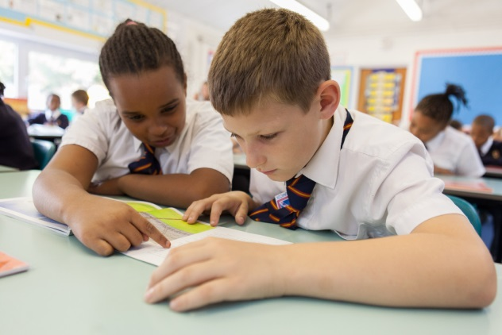


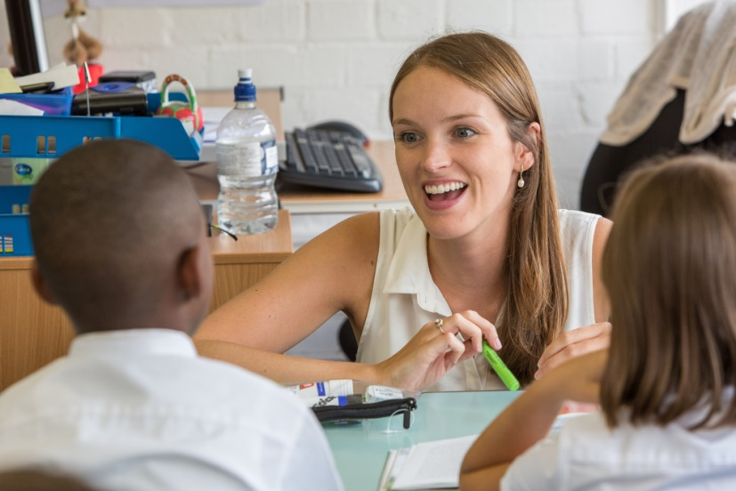

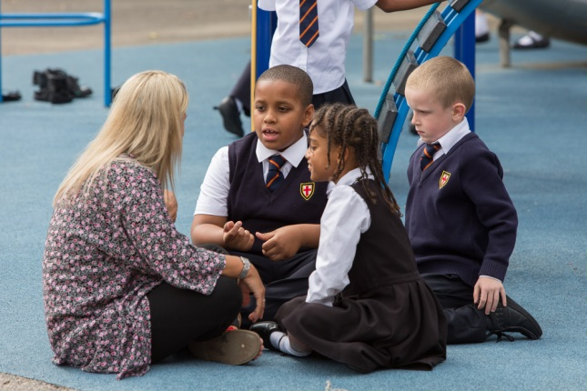
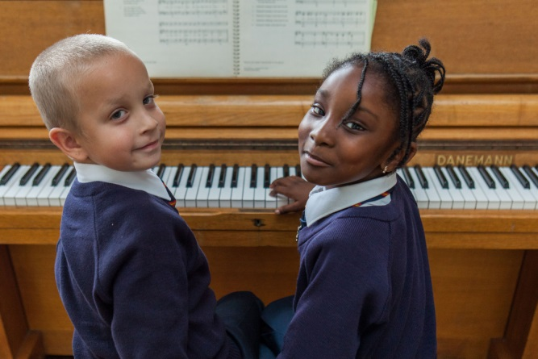


St. George’s is a learning community where everyone can prosper and flourish in God’s wisdom and where each person is known, loved and valued.

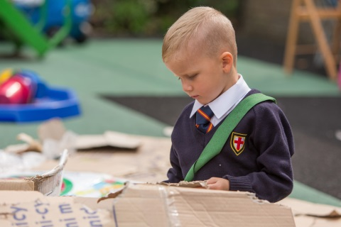
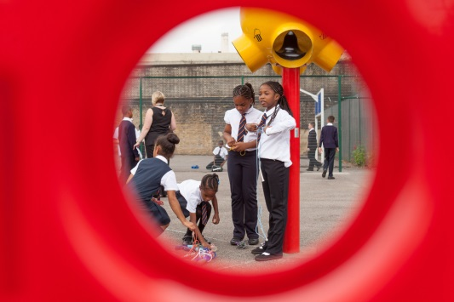

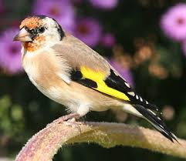
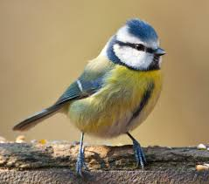
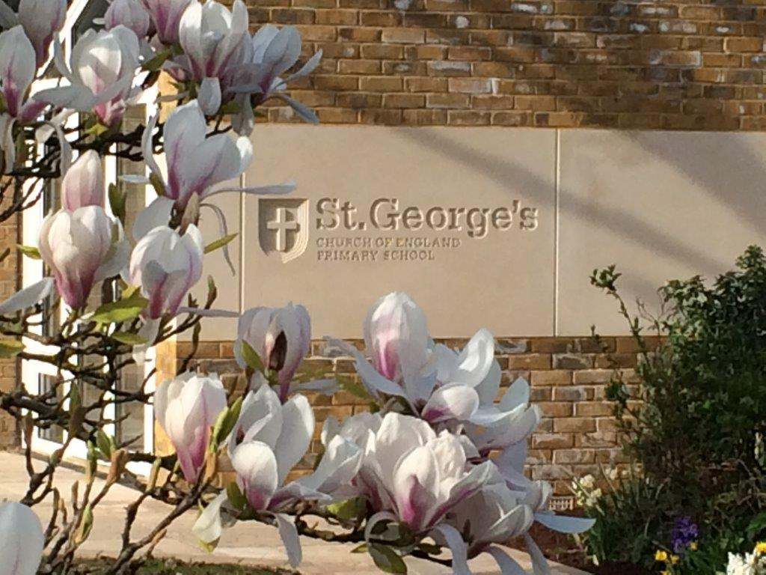
TAKE A PEEP INSIDE!

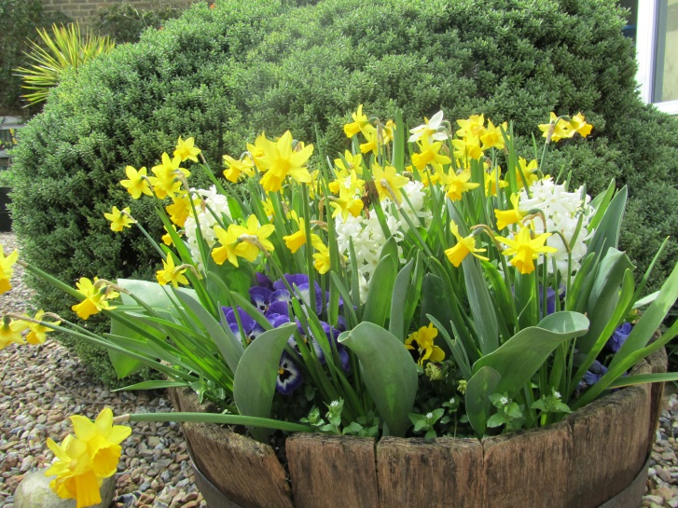
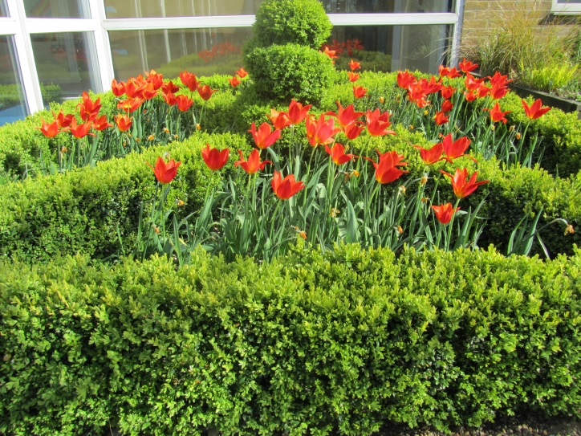

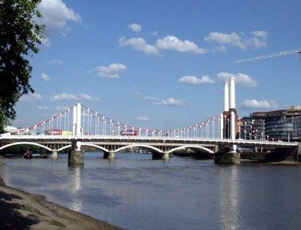

“An oasis of calm in the heart of the city.”

At St. George’s we have beautiful gardens in the heart of South London. We’ve got a well resourced one-storey building with plenty of space, big playgrounds and a car park.

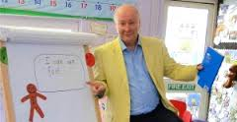
A TALK FOR WRITING TRAINING SCHOOL

We are an accredited T4W training school and work closely with Pie Corbett. He visits St. George’s regularly to spend time developing writing with our staff and children. We run training sessions for teachers across the UK and have had opportunities to work in other schools to improve children’s writing.

What a great job!

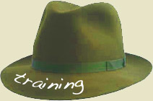
In joining our team, you will have opportunities to work with Pie and the other T4W training schools across the country.
You will also be part of the South
West London Math Hub and working
within a thriving National Support School.
A SOUNDS-WRITE SCHOOL


We are an accredited Sounds-Write training school and work closely with John Walker, the founder and creator of the programme. Teachers from across the UK come to see our phonics teaching.
Every member of our team receives a four-day, high quality phonics training programme.
Sounds-Write is our programme of choice and we have had great success with it across the school. Our Year 1 phonics results have always been 93% or higher!
“It makes teaching reading and spelling a pleasure. Once you understand the code it all becomes simple. We even use it in Year 6.” – St. George’s team member
A FANTASTIC TEAM
We are a small, friendly team. We all work hard and are rewarded for our work. Our Governors provide breakfast and refreshments for us and we always enjoy sharing a meal together during parents’ evenings.
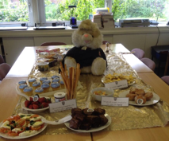


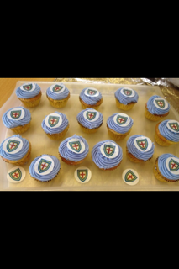

On Fridays we have ‘Friday Goodies’. We all take turns to bring in treats for the staffroom table. Some of us are more competitive than others – it’s like the Great British Bake Off some weeks!

THE BEST WE CAN BE
We truly believe our school is a special place to work.
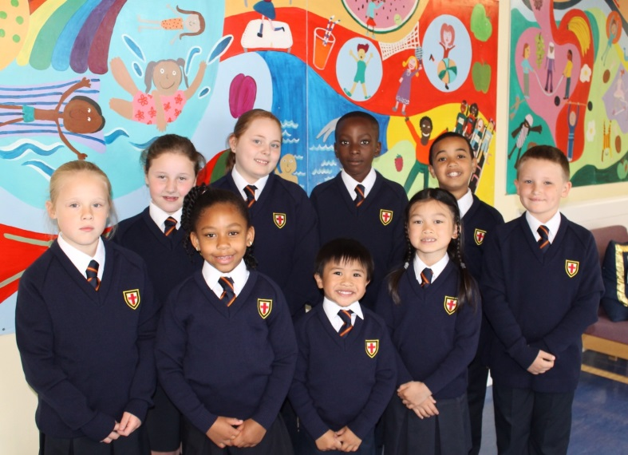
We all strive to be the best that we can be and we believe in developing staff, parents and pupils to achieve their full potential.
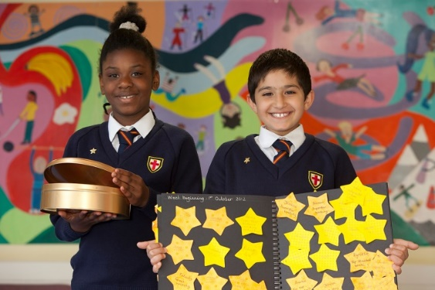
We are proud to be a church school and believe that everyone can prosper and flourish in God’s wisdom. We apply these to our interactions every day and work with dignity and integrity at all times.

We have an outstanding culture of learning and behaviour and impeccably well behaved children. Our ‘Superstar’ reward system makes everyone smile.




Amazing Artwork

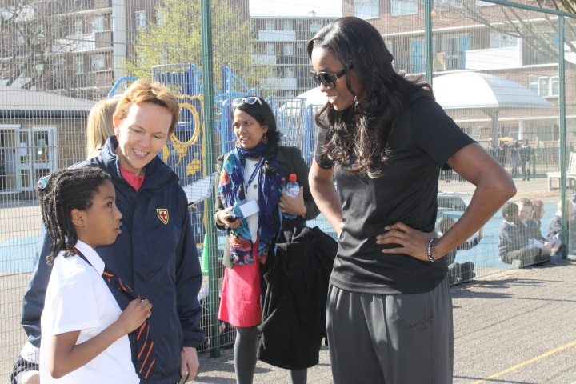

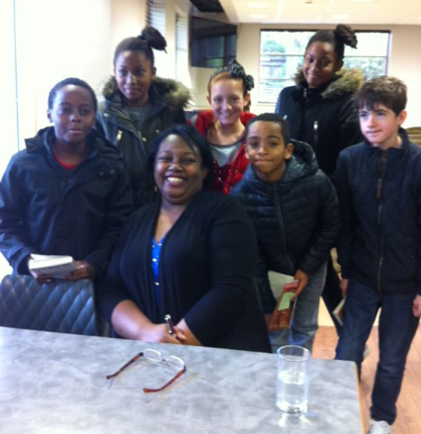
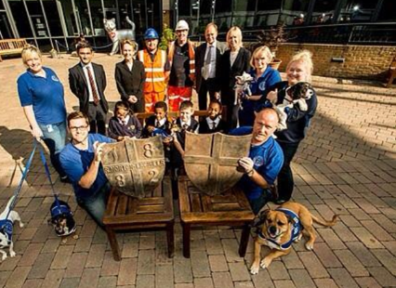
Fabulous Friends

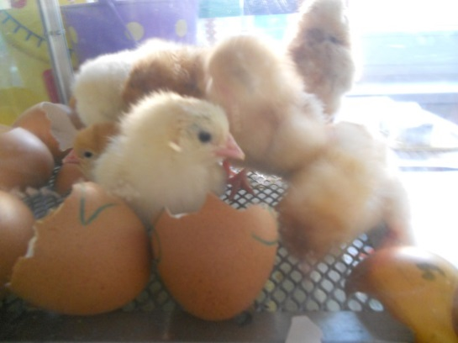
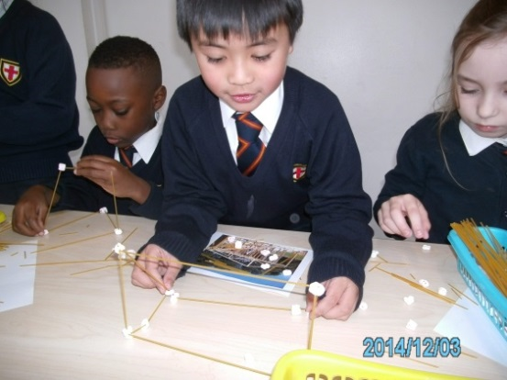


Cracking Curriculum

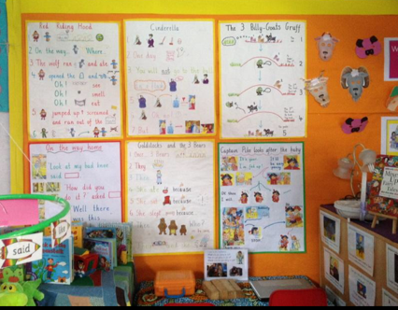
OUTSTANDING ENVIRONMENTS

