Job Profile comprising Job Description and Person Specification
Job Description

Job Title:  Adults Senior Data Analyst | Grade:  PO2
Section:  Adults Performance Team – Assurance & Innovation | Directorate: Adult Social Care & Public Health
Responsible to following manager:  Deputy Adults Performance Manager | Responsible for following staff:  N/A
Post Number/s:  RWA9044 | Last review date:  July 2024

Working for the Richmond & Wandsworth Better Service Partnership

We’re Richmond & Wandsworth Better Service Partnership, the shared public service team for Richmond and Wandsworth Councils. Like any local authority, our role is to deliver the agenda of our elected members on behalf of the people who live and work in our part of the world. We deliver key services to our communities including social care, public health, children’s services, housing and regeneration and environmental and community services.

Our joint workforce creates efficiency and resilience by bringing more creativity to the way we work, more objectivity and adaptability too, helping us deliver better services for all our residents.

We’re here to help our communities thrive in a changing world, and to be there for the people who need us most we believe we need to keep adapting. That’s why, at Richmond & Wandsworth Better Service Partnership, you’ll be at the forefront of innovation in local government, and we’ll invest in you and offer you opportunities to grow in a way only our unique organisation can.

Job Purpose
To support the Adults Performance Team to fulfil the requirements of the statutory adult social care performance management framework and the council’s own performance management framework.

To provide timely, accurate analysis and interpretation of qualitative and quantitative business intelligence necessary for the Directorate to make timely, relevant and strategic decisions for existing and future services.

Specific Duties and Responsibilities

- To lead on producing in-depth analysis, comparisons, and interpretation of highly complex data sets from several information sources to ascertain levels of compliance with national and local performance targets.

- To produce and present benchmarking information that supports the Directorate to understand its performance and evaluate potential risk and options for future action.

- To design, develop and maintain insightful performance management information, and trend data, using visualisation tools that supports operational managers to understand activity and their associated impacts on budgets.

- To be responsible for working collaboratively with managers to make better use of data and insights to support Council, Directorate and partners strategic and operational service delivery decisions and improve service delivery for our residents.

- To lead on producing and analysing national, service user and carer surveys, ensuring returns are accurate and national deadlines for submitting surveys are met.

- To contribute towards producing accurate and timely data submissions to NHS England, Department of Health & Social Care and other government departments to agreed timescales.

- To proactively promote data quality and the use of accurate management information. This will include regularly identifying and assessing data system quality issues and conducting briefings or training sessions as appropriate.

- To provide equalities monitoring, freedom of information requests and ensure compliance with data protection and governance procedures.

- To act as deputy to the Deputy Performance Manager as required and represent the team at internal or external meetings.

- To contribute as required to change programmes within the service.

- To ensure that the services for both Councils are dealt with on an equitable basis to deliver the standards required for each, as agreed annually by the Executives of both Councils.

- To contribute as required to performance review and improvement measures on an ongoing basis, helping to ensure that a customer focus is embedded within the function and innovative and creative solutions are evaluated to securing the highest quality and value for money function.

- Keep abreast of latest thinking, new trends and developments in areas of expertise and implement or act accordingly.

- Work collaboratively with others across the department to contribute in the councils arrangements for preparing and acting upon CQC inspections.

- Lead on short projects in line with changing requirements and priorities of the councils.

Generic Duties and Responsibilities

- To contribute to the continuous improvement of the services of Richmond & Wandsworth Better Service Partnerships.

- To comply with relevant Codes of Practice, including the Code of Conduct and policies concerning data protection, handling complaints and health and safety.

- To adhere to security controls and requirements as mandated by Richmond and Wandsworth procedures and local risk assessments to maintain confidentiality, integrity, availability and legal compliance of information and systems

- To promote equality, diversity, and inclusion, maintaining an awareness of the equality and diversity protocol/policy and working to create and maintain a safe, supportive and welcoming environment where all people are treated with dignity and their identity and culture are valued and respected.

- To understand both Councils’ duties and responsibilities for safeguarding children, young people and adults as they apply to the roles within the Councils.

- The profile is not intended to be an exhaustive list of the duties the post holder will carry out. Other reasonable duties commensurate with the level of the post, including supporting emergency and priority situations, will form part of the role.
Additional Information

Team structure

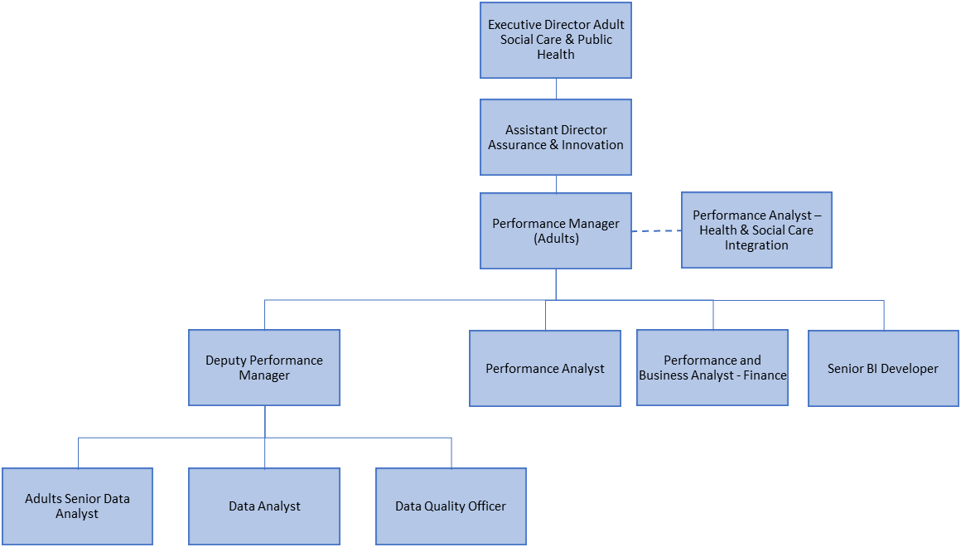

Person Specification

Job Title:  Adults Senior Data Analyst | Grade:  PO2
Section:  Adults Performance Team – Assurance & Innovation | Directorate: Adult Social Care & Public Health
Responsible to following manager:  Deputy Adults Performance Manager | Responsible for following staff:  N/A
Post Number/s:  RWA9044 | Last review date:  July 2024

Our Values
THINK BIGGER
EMBRACE DIFFERENCE
CONNECT BETTER
LEAD BY EXAMPLE
PUT PEOPLE FIRST

Our Values are embedded across Richmond & Wandsworth Better Service Partnership and throughout all roles and responsibilities at all levels of the organisation. Please familiarise yourself with our values as they are an integral part of our recruitment and selection process.

Person Specification Requirements |  |  |  | Assessed by  A/I/T/C  (see below for explanation)
 | Knowledge | Essential | Desirable | Assessed
 | Knowledge and understanding of social care |  | x | A/I
 | Understanding of research and statistical analysis techniques | x |  | A/I
 | Experience | Essential | Desirable | Assessed
 | In using management information systems and the ability to fully understand the interfaces between such systems and local databases. | x |  | A/I
 | In developing and delivering practical, innovative and creative approaches to analysis and insight | x |  | A/I
 | A high level of data literacy used in a business environment, including producing regular performance information for business purposes. | x |  | A/I
 | In working on a variety of large datasets – being experienced in understanding, analysing and interpreting data; spotting and resolving issues and presenting the data in the most suitable format for the audience. | x |  | A/I/T
 | Of using coding tools such as R studio or Python to manipulate and analyse unstructured and structured datasets. | x |  | A/I
 | Skills | Essential | Desirable | Assessed
 | Advanced MS Excel skills including skills in PowerQuery to structure data | x |  | A/T
 | Advanced Power BI Skills – Including defining data relationships, use of DAX and Power Query and ability to develop interactive and engaging dashboards | x |  | A/I/T
 | Intermediate SQL skills - Query data using joins and built-in functions to manipulate data | x |  | A/I/T
 | Strong analytical and numerical skills, including applied knowledge to best practice statistical methods. | x |  | A/I
 | Ability to communicate both orally and in writing to a good standard | x |  | A/I
 | Ability to manage and constantly re-prioritize a varied workloads | x |  | A/I
 | Proactive self-starter with the ability to work as part of a team and independently using own initiative | x |  | A/I
 | Qualifications | Essential | Desirable | Assessed
 | Relevant professional qualification or equivalent practical experience of working in a data analyst role. | x |  | A/I
 | Data Science or Apprenticeship qualification |  | x | A/I

A – Application form / CV
I – Interview
T – Test
C - Certificate

