Job Profile comprising Job Description and Person Specification
Job Description

Job Title:  Principal Accountant | Grade:  PO6
Section:  Financial Management | Directorate:  Resources
Responsible to following manager:  Head of Accountancy | Responsible for following staff:  3.0 Senior Accountants  1.0 Accountancy Officer (indirect)
Post Number/s:  2 | Last review date:  November 2022

Working for the Richmond/Wandsworth Shared Staffing Arrangement

This role is employed under the Shared Staffing Arrangement between Richmond and Wandsworth Borough Councils. The overall purpose of the Shared Staffing Arrangement is to provide the highest quality of service at the lowest attainable cost.

Staff are expected to deliver high quality and responsive services wherever they are based, as well as having the ability to adapt to sometimes differing processes and expectations.

The Shared Staffing Arrangement aims to be at the forefront of innovation in local government and the organisation will invest in the development of its staff and ensure the opportunities for progression that only a large organisation can provide.

Job Purpose

Manages specific aspects of the Councils’ financial policies and procedure rules, best practice reporting requirements, the Statement of Accounts and other areas as set out in the specific duties and responsibilities.

Specific Duties and Responsibilities

Post holders will lead a subsection within Accountancy which holds specialisms in the below work areas (with 3 Senior Accountants as direct reports). Precise split of responsibilities being determined based on the resources and skill sets available and the relative demands of the work areas.

- Capital (programme monitoring, reporting, financing etc) for both boroughs.
- Treasury/investments, banking and cash flow management for Richmond.
- Treasury/investments, banking and cash flow management for Wandsworth.
- Financial Accounting (including the Collection Fund and other projects/ reviews).
- Asset accounting (with linked projects).
- Taxation (VAT etc.).

Principal Accountants will be asked to change the area of specialisation approximately every 2 years to promote multiple skill development.

Aspects that each post is responsible for could include elements of the following, for either or both Councils:

- Assist leading on the preparation of either borough’s Statement of Accounts, ensuring the accuracy and integrity of the accounts.
- Liaise with external auditors and respond to comments and recommendations raised.
- Ensuring that best practice and the appropriate Codes of Practice are utilised.
- Lead on completion of statutory and other returns, producing statistical information and research as required.
- Producing information for the budget setting process where needed.
- Authorising transactions and maintaining accounting records on a daily, weekly and monthly basis throughout the year.
- Providing professional financial advice on all matters relating to the relevant service areas, to a wide range of stakeholders including input into the preparation of strategy documents and future years’ projections.
- Assists the Head of Accountancy in providing a comprehensive corporate finance service.

Ensures that the services for both Councils are dealt with on an equitable basis to deliver the standards required for each, as agreed annually by the Executives of both Councils.

Deputises for the Head of Accountancy as and when required and assists on other groups within the Financial Management Division as directed, to provide flexible response to peak workloads.

Provides motivational management of staff, providing a visible presence within Financial Management and promoting a good working environment with the primary aim of delivering high quality services.

Provides effective management of staff, including recruitment and appropriate application of policies and codes of practice on staffing matters. The post holder will be responsible for implementing a performance management framework for their direct reports to develop and motivate individuals as well as the team, some of whom may be studying for professional examinations.

Generic Duties and Responsibilities

- To contribute to the continuous improvement of the services of the Boroughs of Wandsworth and Richmond.

- To comply with relevant Codes of Practice, including the Code of Conduct and policies concerning data protection and health and safety.

- To adhere to security controls and requirements as mandated by the SSA’s policies, procedures and local risk assessments to maintain confidentiality, integrity, availability and legal compliance of information and systems

- To promote equality, diversity, and inclusion, maintaining an awareness of the equality and diversity protocol/policy and working to create and maintain a safe, supportive and welcoming environment where all people are treated with dignity and their identity and culture are valued and respected.

- To understand both Councils’ duties and responsibilities for safeguarding children, young people and adults as they apply to the role within the council.

- The Shared Staffing Arrangement will keep its structures under continual review and as a result the post holder should expect to carry out any other reasonable duties within the overall function, commensurate with the level of the post.

Team structure

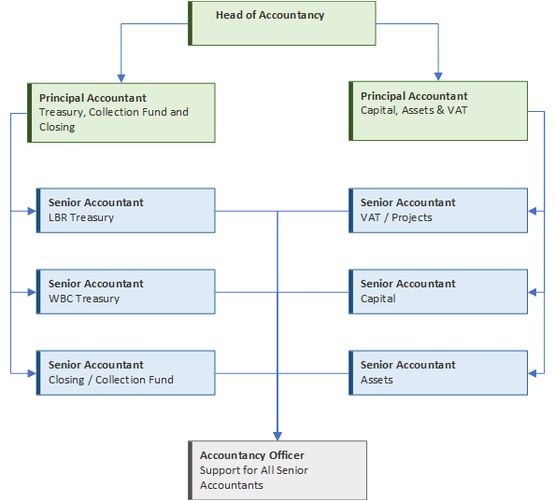

Person Specification

Job Title:  Principal Accountant | Grade:  PO6
Section:  Financial Management | Directorate:  Resources
Responsible to:  Head of Accountancy | Responsible for:  3.0 Senior Accountants  1.0 Accountancy Officer (indirect)
Post Number/s:  2 | Last review date:  November 2022

Our Values and Behaviours

The values and behaviours we seek from our staff draw on the high standards of the two boroughs, and we prize these qualities in particular:

Being open. This means we share our views openly, honestly and in a thoughtful way. We encourage new ideas and ways of doing things. We appreciate and listen to feedback from each other.

Being supportive. This means we drive the success of the organisation by making sure that our colleagues are successful. We encourage others and take account of the challenges they face. We help each other to do our jobs.

Being positive. Being positive and helpful means we keep our goals in mind and look for ways to achieve them. We listen constructively and help others see opportunities and the way forward. We have a ‘can do’ attitude and are continuously looking for ways to help each other improve.

Person Specification Requirements |  |  | Assessed by  A/I/T/C  (see below for explanation)
Knowledge | Essential | Desirable | Assessed
Excellent understanding of legislation, accounting standards and accounting codes of practice governing local authority accounts and financial procedures with the ability to interpret complex issues and apply them. | Y |  | A/I
Experience | Essential | Desirable | Assessed
Experience of a specialism as detailed in the Job Profile. | Y |  | A/I/T
Experience of successfully planning, managing, and reviewing a closing of accounts process or coordinating a budget setting and monitoring process or coordinating and delivering a major project. |  | Y | A/I
Experience of undertaking complex financial calculations including options appraisals and sensitivity analysis. | Y |  | A/I/T
Experience of simplifying complex financial issues and presenting them in a manner that the recipient understands. | Y |  | A/I/T
Experience of designing complex spreadsheets and using them as models for decision making. | Y |  | A/I/T
Skills | Essential | Desirable | Assessed
Proficient IT skills to use spreadsheets, financial systems and other relevant packages for analysis and presentation. | Y |  | A/I/T
Meticulous approach/ working papers for dealing with complex tasks and audit requirements. | Y |  | A/I
Good interpersonal skills to liaise with senior staff and external auditors. | Y |  | A/I
Experience of leading, developing, and motivating staff to improve service delivery. |  | Y | A/I |  | A/I
Proven track record of planning and managing conflicting priorities, multiple demands for service and meeting deadlines. | Y |  | A/I
Qualifications | Essential | Desirable | Assessed
Part/fully qualified CCAB or equivalent or fully qualified AAT/ACT with extensive experience. | Y |  | A/C
A – Application form / CV
I – Interview
T – Test
C - Certificate

