Job Profile comprising Job Description and Person Specification

Job Description

Job Title:  Digital Engagement Support Officer | Grade:  SO2
Section:  Consultation | Directorate:  Resident Engagement
Responsible to following manager:  Catherine Pierce | Responsible for following staff:
Post Number/s: | Last review date:

Working for the Richmond & Wandsworth Better Service Partnership

This role is employed under the Richmond & Wandsworth Better Service Partnership. The overall purpose of Richmond & Wandsworth is to provide the highest quality of service at the lowest attainable cost.

Staff are expected to deliver high quality and responsive services wherever they are based, as well as having the ability to adapt to sometimes differing processes and expectations.

Richmond & Wandsworth Better Service Partnership aims to be at the forefront of innovation in local government and the organisation will invest in the development of its staff and ensure the opportunities for progression that only a large organisation can provide.

Job Purpose

Richmond and Wandsworth Councils are committed to enhancing their insight of and engagement with residents, service users, staff, communities and businesses. Wandsworth Council has also launched a flagship project transforming itself into a Listening Council, placing local people at the heart of it does.

The Digital Engagement Support Officer role supports the delivery of the councils’ digital engagement activities by assisting with the management of our online engagement platforms, helping to build and maintain our public sites and contributing to the creation of engaging digital content. The role also involves supporting data collection and analysis, working closely with officers across both councils on consultation and engagement projects and helping to increase participation and interaction with our residents.

Specific Duties and Responsibilities

- Digital content design

- Create impactful digital content to enhance the Council’s online presence and community interaction
- Help draft and schedule news update posts, ensuring consistency with the Council’s tone of voice
- Support the creation and distribution of questionnaires to gather feedback from residents and stakeholders
- Create and update maps using GIS data as part of the Council’s place-based approach to community engagement
- Ensure all content follows the Council’s brand guidelines
- Help the team monitor the latest trends and best practice in digital engagement

- Communication and engagement

- Help keep the Council’s engagement sites up to date with accessible and engaging content
- Support the team in maintaining relationships with internal stakeholders by attending meetings and creating notes and actions
- Track deadlines and deliverables for assigned tasks
- Act as a point of contact for queries from internal teams, join regular meetings with our software provider and escalate any complex issues as needed
- Help promote engagement with the Council’s activities to a range of audiences in collaboration with colleagues
- Monitor public responses and flag any sensitive or high-interest topics to senior colleagues

- Analytics and performance monitoring

- Assist in collecting and organising data from engagement activities
- Help prepare reports and visual summaries using charts and tables to support decision-making
- Contribute to the creation of ‘You Said We Did’ reports by compiling feedback and outcomes
- Support the team in evaluating engagement activities by gathering feedback and tracking participation
- Help maintain performance tracking spreadsheets and dashboards
- Assist in analysing engagement metrics and identifying patterns or areas for improvement

Generic Duties and Responsibilities

- To contribute to the continuous improvement of the services of Richmond & Wandsworth Better Service Partnerships.

- To comply with relevant Codes of Practice, including the Code of Conduct and policies concerning data protection and health and safety.

- To adhere to security controls and requirements as mandated by Richmond and Wandsworth procedures and local risk assessments to maintain confidentiality, integrity, availability and legal compliance of information and systems

- To promote equality, diversity, and inclusion, maintaining an awareness of the equality and diversity protocol/policy and working to create and maintain a safe, supportive and welcoming environment where all people are treated with dignity and their identity and culture are valued and respected.

- To understand both Councils’ duties and responsibilities for safeguarding children, young people and adults as they apply to the roles within the Councils.

- The profile is not intended to be an exhaustive list of the duties the post holder will carry out. Other reasonable duties commensurate with the level of the post, including supporting emergency and priority situations, will form part of the role.

Team structure

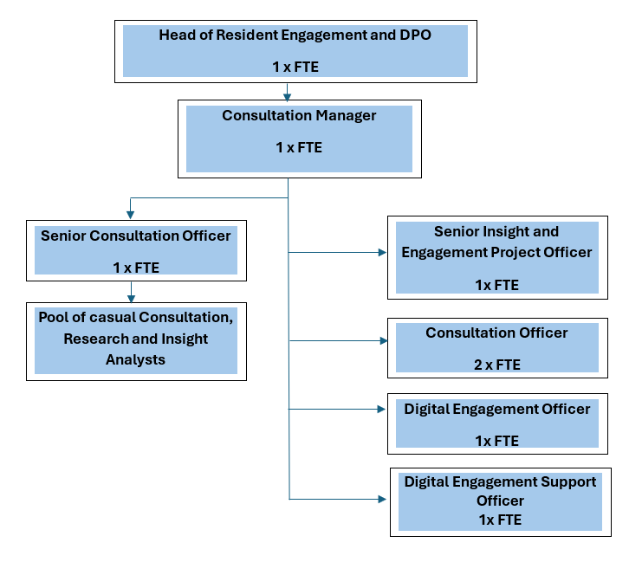
Person Specification

Job Title: Digital Engagement Support Officer | Grade: SO2
Section: Consultation | Directorate: Resident Engagement
Responsible to: Catherine Pierce | Responsible for:
Post Number/s: | Last Review Date:

Our Values
THINK BIGGER
EMBRACE DIFFERENCE
CONNECT BETTER
LEAD BY EXAMPLE
PUT PEOPLE FIRST

Our Values are embedded across Richmond & Wandsworth Better Service Partnership and throughout all roles and responsibilities at all levels of the organisation. Please familiarise yourself with our values as they are an integral part of our recruitment and selection process.

Person Specification Requirements |  |  |  | Assessed by  A/I/T/C  (see below for explanation)
 | Knowledge | Essential | Desirable | Assessed
 | An understanding of effective community engagement principles and digital communication | x |  | A/I
 | An awareness of Richmond and Wandsworth’s communities, or a willingness to learn about local demographics and priorities. | x |  | A/I
 | An understanding of accessibility and inclusion in digital content | x |  | A/I
 | Experience | Essential | Desirable | Assessed
 | Experience in a digital or communications role, including creating and adapting copy and visual assets for digital channels and digital communications (such as e-newsletters or social media) | x |  | A/I
 | Experience working collaboratively with other colleagues, including internal teams or external partners | x |  | A/I
 | Ability to manage projects and deliver outputs within set timelines | x |  | A/I
 | Experience of working in a political environment |  | x | A/I
 | Experience of engaging with diverse or under-represented groups |  | x | A/I
 | Skills | Essential | Desirable | Assessed
 | Strong written and verbal communication skills, with the ability to adapt tone and style for different audiences | x |  | A/I
 | Good interpersonal skills and a collaborative approach to working with others | x |  | A/I
 | Proficiency with some or all of the following: Microsoft Office, Canva, survey platforms, social media scheduling tools, analytics, digital dashboards, online graphic design tools, data visualisation / presentation tools | x |  | A/I
 | A willingness to learn new systems and tools as required | x |  | A/I
 | Ability to organise tasks, manage time effectively and meet deadlines | x |  | A/I
 | Attention to detail and a creative mindset | x |  | A/I
 | Ability to interpret data and contribute to reports or presentations |  | x | A/I
 | Personable team player, able to work both autonomously and collaboratively | x |  | A/I
 | Enthusiastic, proactive, and adaptable to changing priorities | x |  | A/I
 | Qualifications | Essential | Desirable | Assessed
 | Degree or qualification in Communications, Digital Media, Social Research, or a related field |  | x | C
 | Data analysis qualification / certification |  | x | C

A – Application form / CV
I – Interview
T – Test
C - Certificate

