Job Profile comprising Job Description and Person Specification
Job Description

Job Title: Serious Violence Officer | Grade: SO2
Section:  Chief Executive Office | Directorate:  Chief Executives Group
Responsible to following manager:  Serious Violence Manager | Responsible for following staff:  N/A
Post Number/s: 1 | Last review date: December 2024

Working for the Richmond & Wandsworth Better Service Partnership

This role is employed under the Richmond & Wandsworth Better Service Partnership. The overall purpose of Richmond & Wandsworth is to provide the highest quality of service at the lowest attainable cost.

Staff are expected to deliver high quality and responsive services wherever they are based, as well as having the ability to adapt to sometimes differing processes and expectations.

Richmond & Wandsworth Better Service Partnership aims to be at the forefront of innovation in local government and the organisation will invest in the development of its staff and ensure the opportunities for progression that only a large organisation can provide.

Job Purpose
The post-holder will be responsible for strengthening the response to serious violence both within the Community Safety Team and the wider Community Safety Partnership in Richmond and Wandsworth, supported by the Serious Violence Manager.

The Serious Violence Officer will work across the Richmond and Wandsworth services and provide insight and knowledge on issues of serious violence. The post-holder will focus on contextual interventions to ensure spaces and places in the borough remain safe for all residents, particularly those areas which are disproportionately affected by violent crime. Including strengthening referral pathways and partnership working in relation to serious violence.

The post-holder will coordinate projects in Richmond and Wandsworth funded through the Mayor’s Office for Policing and Crime (MOPAC) and the Violence Reduction Unit (VRU). The project work is key to a comprehensive response to serious violence in the boroughs. The post-holder will also have a role in the tracking and management of finances within the serious violence work stream.

Specific Duties and Responsibilities

- Support the Serious Violence Manager in the response to and prevention of serious violence in Richmond and Wandsworth.
- Work in partnership with key agencies to ensure a cohesive and effective response to serious violence across Richmond and Wandsworth.
- Review and maintain Richmond and Wandsworth Violence and Vulnerability Action Plan. Meet with relevant partners to ensure actions are on track for completion by the end of the financial year. Review and revise actions as needed with support of Serious Violence Manager.
- Assist in the administration of the Richmond and Wandsworth Violence Reduction Delivery Group and the Communities Against Violence Forums. Administrate and organise meetings ensuring subsequent meetings run smoothly, agendas and minutes are circulated in a timely manner, and organisations are aware of the objectives and expected outcomes of the board.
- Project management and coordination of the MOPAC & VRU projects in Richmond and Wandsworth. Act as the single point of contact for project leads and provide support around complex cases and issues. Ensure timely and detailed quarterly reports are delivered to VRU. Organise and liaise with projects to respond to Critical Incidents if appropriate.
- Ensure the timely submission of detailed quarterly reports from MOPAC & VRU-funded projects, identifying and addressing any gaps in provision or reporting by escalating issues to the manager.
- Improve and strengthen referral pathways. Work with a variety of agencies to outline and maintain clear referral pathways for victims and perpetrators of violence. Maintain strong relationships with relevant partners including Children’s Services, Police, Probation, Housing, and others to ensure effective development and use of referral pathways.
- Develop and have input into problem solving plans in hotspot locations. Work in partnership with Community Safety Officers and input into multi-agency task and finish groups with the aim of delivering actions to respond to issues and concerns of violence.
- Act as the link officer for the Multi-Agency Risk Vulnerability and Exploitation (MARVE) panels and the Multi-Agency Child Exploitation (MACE) panels in Richmond and Wandsworth.
- Attend community events and conversations to represent the Serious Violence team as necessary. This may require attending evening meetings.
- To take on additional responsibilities as laid out by the Serious Violence Manager.

Generic Duties and Responsibilities

- To contribute to the continuous improvement of the services of Richmond & Wandsworth Better Service Partnerships.

- To comply with relevant Codes of Practice, including the Code of Conduct and policies concerning data protection and health and safety.

- To adhere to security controls and requirements as mandated by Richmond and Wandsworth procedures and local risk assessments to maintain confidentiality, integrity, availability and legal compliance of information and systems

- To promote equality, diversity, and inclusion, maintaining an awareness of the equality and diversity protocol/policy and working to create and maintain a safe, supportive and welcoming environment where all people are treated with dignity and their identity and culture are valued and respected.

- To understand both Councils’ duties and responsibilities for safeguarding children, young people and adults as they apply to the roles within the Councils.

- The profile is not intended to be an exhaustive list of the duties the post holder will carry out. Other reasonable duties commensurate with the level of the post, including supporting emergency and priority situations, will form part of the role.
Additional Information
- Post-holder may be expected to work flexibly across two locations (Wandsworth Town Hall, Richmond Civic Centre) as well as having working from home arrangements.
- Post-holder may need to work evenings and weekends as required to provide a high-quality service and ensure engagement meets the targeted audience.

Team structure
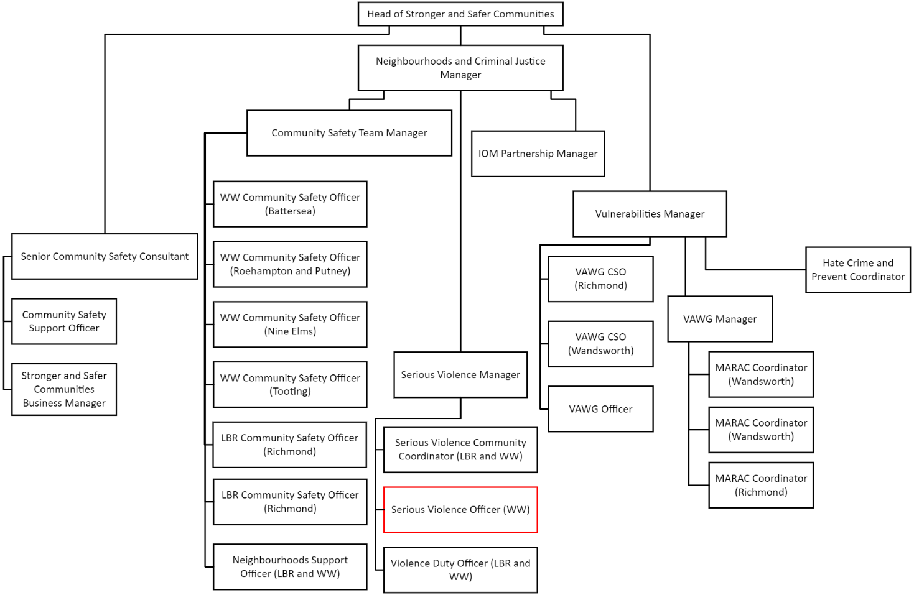

Person Specification

Job Title: Serious Violence Officer | Grade: SO2
Section: Chief Executive Office | Directorate: Chief Executives Group
Responsible to:  Serious Violence Manager | Responsible for:  N/A
Post Number/s: 1 | Last Review Date: December 2024

Our Values
THINK BIGGER
EMBRACE DIFFERENCE
CONNECT BETTER
LEAD BY EXAMPLE
PUT PEOPLE FIRST

Our Values are embedded across Richmond & Wandsworth Better Service Partnership and throughout all roles and responsibilities at all levels of the organisation. Please familiarise yourself with our values as they are an integral part of our recruitment and selection process.

Person Specification Requirements |  |  | Assessed by A/I/T/C (see below for explanation)
Knowledge | Essential | Desirable | Assessed
An understanding of the serious violence crime issues that impact upon communities and of powers available to address these issues. | x |  | A/I
An understanding of multi-agency meetings and their role in responding to and preventing serious violence. | x |  | A/I
An understanding and experience of community led engagement in improving the safety and security of, and improving the levels of public confidence in, localities, and through what means this can be achieved. |  | x | A/I
An understanding of the important of partnerships in community safety and how these can be developed especially through the relevant Community Safety Partnership Boards. |  | x | I
An understanding of referral pathways used for those at risk of exploitation, perpetrating serious violence or victims of serious violence. |  | x | A/I
Experience | Essential | Desirable | Assessed
Experience of partnership or multi-agency work to achieve shared objectives. | x |  | A/I
Experience of engaging and building trusted and effective relationships with other service providers, voluntary and community sector groups, and statutory partner agencies. | x |  | A/I
Experience in communicating effectively and sensitively in oral and written form to a wide range of individuals and organisations. | x |  | A/I
Experience of project management relevant to the role especially experience delivering and overseeing projects. Ensuring that objectives are clearly outlined, communicated and reported on as needed. | x |  | A/I
Experience of using IT and digital tools to support their work. | x |  | A/I
Skills | Essential | Desirable | Assessed
Ability to organise and prioritise own workload, within defined requirements for the role. | x |  | A
Ability to implement and oversee projects relevant to the role. | x |  | A/I
Ability to manage external funding streams and budgets. |  | x | A/I
Proven ability to communicate at all levels both verbally and in writing. Demonstrable experience of writing reports, taking minutes, and project bids. | x |  | A/I
Good communication and interpersonal skills to deliver messages clearly and concisely and develop productive working relationships. | x |  | A/I
Ability to handle confidential or sensitive information, together with an understanding of data protection requirements. | x |  | A/I
Good knowledge of and ability to use standard IT packages (Microsoft Office and Outlook) | x |  | A
Qualifications | Essential | Desirable | Assessed
Any university degree | x

A – Application form/CV
I – Interview
T – Test
C – Certificate

