Job Profile comprising Job Description and Person Specification
Job Description
Job Title:  Violence Against Women and Girls (VAWG) Officer | Grade:  SO2
Section:  Customers and Partnerships | Directorate:  Chief Executives Group
Responsible to following manager:  VAWG Manager | Responsible for following staff:  N/A
Post Number/s: RWE0408 | Last review date: August 2022

Working for the Richmond/Wandsworth Shared Staffing Arrangement

This role is employed under the Shared Staffing Arrangement between Richmond and Wandsworth Councils. The overall purpose of the Shared Staffing Arrangement is to provide the highest quality of service at the lowest attainable cost.

Staff are expected to deliver high quality and responsive services wherever they are based, as well as having the ability to adapt to sometimes differing processes and expectations.

The Shared Staffing Arrangement aims to be at the forefront of innovation in local government and the organisation will invest in the development of its staff and ensure the opportunities for progression that only a large organisation can provide.

Job Purpose
The new Domestic Abuse Act requires multiple changes to the way local authorities and partnerships tackle Domestic Abuse including provision of safe accommodation, raising awareness, protecting victims and children, deterring perpetrators, and strengthening the support for victims of abuse by statutory agencies.
The postholder will work to assist in preparing and implementing the duties and responsibilities of the Domestic Abuse Act and ensuring that Richmond and Wandsworth continue to maintain a strong partnership approach to tackling domestic abuse.

Specific Duties and Responsibilities
- Lead on developing a project plan for Richmond and Wandsworth to fulfil the requirement to cooperate with the Greater London Authority (GLA) in the delivery of the new Domestic Abuse Act duty relating to the provision of support to victims and their children within safe accommodation
- Oversee all work in relation to the Domestic Abuse Act with support from the VAWG manager, Housing, Children’s Services and commissioned providers for advocacy and emergency accommodation to ensure that the council is Domestic Abuse Act ready
- Work in partnership with key stakeholders to ensure awareness of the new duties and compliance with and effective delivery of the new duty requirements
- Builds strong working partnerships across the Housing landscape in Richmond and Wandsworth, including the Local Authority, Housing Associations, Homelessness sector and voluntary sector Domestic Abuse Services
- Oversee all awareness raising and communications in relation to the Domestic Abuse Act duties and responsibilities across the partnership
- Develop and deliver training and briefing sessions to a range of Richmond and Wandsworth practitioners, including Housing on the new duty and how to effectively respond to high-risk victims of VAWG
- To contribute to the VAWG communication strategy to highlight the borough response to tackling VAWG
- Lead on with the support of the VAWG manager any relevant needs assessments to be carried out on a local level with regards to the Domestic Abuse Act duties and responsibilities
- To provide specialist advice, develop action plans, briefing papers, respond to requests for information and enquiries, relative to role

Generic Duties and Responsibilities
- To contribute to the continuous improvement of the services of the Boroughs of Wandsworth and Richmond.
- To comply with relevant Codes of Practice, including the Code of Conduct and policies concerning data protection and health and safety.
- To adhere to security controls and requirements as mandated by the SSA’s policies, procedures and local risk assessments to maintain confidentiality, integrity, availability and legal compliance of information and systems.
- To promote equality, diversity, and inclusion, maintaining an awareness of the equality and diversity protocol/policy and working to create and maintain a safe, supportive and welcoming environment where all people are treated with dignity and their identity and culture are valued and respected.
- To understand both Councils’ duties and responsibilities for safeguarding children, young people and adults as they apply to the role within the council.
- The Shared Staffing Arrangement will keep its structures under continual review and as a result the post holder should expect to carry out any other reasonable duties within the overall function, commensurate with the level of the post.

Additional Information
- Post holder may be expected to work flexibly across two locations (Wandsworth Town Hall and Richmond Civic Centre).

Current team structure
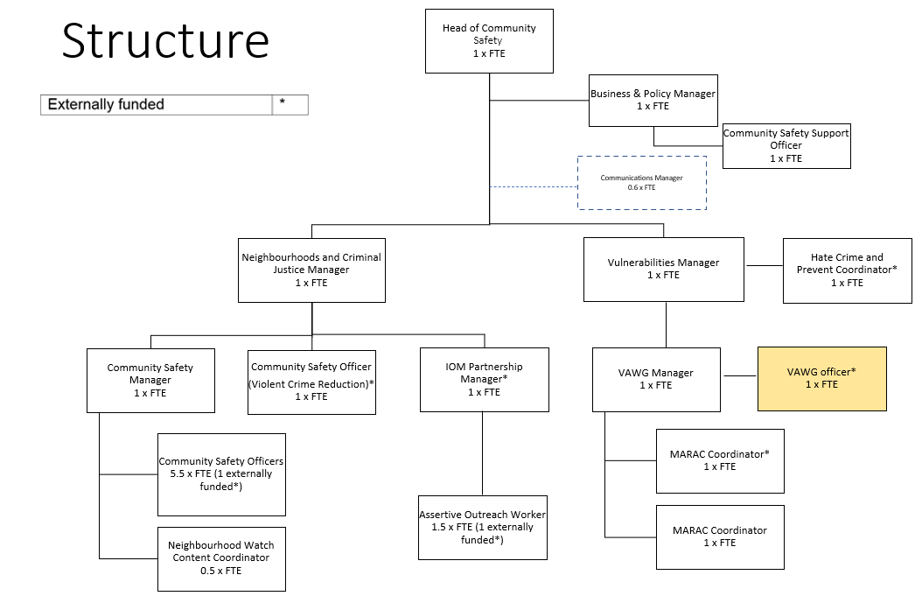
Our Values and Behaviours
The values and behaviours we seek from our staff draw on the high standards of the two boroughs, and we prize these qualities in particular:
- Being open. This means we share our views openly, honestly and in a thoughtful way. We encourage new ideas and ways of doing things. We appreciate and listen to feedback from each other.
- Being supportive. This means we drive the success of the organisation by making sure that our colleagues are successful. We encourage others and take account of the challenges they face. We help each other to do our jobs.
- Being positive. Being positive and helpful means we keep our goals in mind and look for ways to achieve them. We listen constructively and help others see opportunities and the way forward. We have a ‘can do’ attitude and are continuously looking for ways to help each other improve.
Person Specification Requirements | Assessed by A & I/T/C (see below for explanation)
Knowledge
An understanding of relevant legislation including the Domestic Abuse Act 2021, policy and procedure to domestic violence and abuse | A/I
An understanding of how all agencies work within these defined fields | A/I
Knowledge of working within the VAWG and or Community Safety setting | A/I
Knowledge around Housing legislation with regards to Domestic Abuse and VAWG | A/I
Experience
Proven ability of developing successful partnerships, engaging key partners | A/I
Experience in performance reporting | A/I
Experience of working with and negotiating and influencing statutory and voluntary partners at a strategic and operational level | A/I
Skills
Have strong communication and engagement skills, being able to interest and motivate people about population safety and health | A/I
Demonstrate agility and adaptability in mindset and ways of working | A/I
Communicate clearly, confidently and appropriately with colleagues using the best methods of communication for the task | A/I
Ability to produce high quality documents and maintain confidentiality | A/I
Accuracy and attention to detail | A/I
Ability to build effective relationships both internally and externally, showing sensitivity for others’ viewpoints and valuing diversity | A/I
Excellent time management and organisational skills including the ability to work under pressure and meet tight deadlines | A/I
Qualifications
Good standard of general education | A/C
Be able to demonstrate equivalent knowledge and skills through training in a relevant area | A/C

A – Application form
I – Interview
C – Certificate

