Job Profile comprising Job Description and Person Specification
Job Description

Job Title:  Information Governance Manager and DPO | Grade:  MG1
Section:  Resident Engagement | Directorate:  Chief Executive’s Group
Responsible to following manager:  Head of Resident Engagement | Responsible for following staff:  Information and Transparency Manager  Senior Information Governance Officer Records Management and IG Officer
Post Number/s:  1 | Last review date:  September 2025

Working for the Richmond & Wandsworth Better Service Partnership

We’re Richmond & Wandsworth Better Service Partnership, the shared public service team for Richmond and Wandsworth Councils. Like any local authority, our role is to deliver the agenda of our elected members on behalf of the people who live and work in our part of the world. We deliver key services to our communities including social care, public health, children’s services, housing and regeneration and environmental and community services.

Our joint workforce creates efficiency and resilience by bringing more creativity to the way we work, more objectivity and adaptability too, helping us deliver better services for all our residents.

We’re here to help our communities thrive in a changing world, and to be there for the people who need us most we believe we need to keep adapting. That’s why, at Richmond & Wandsworth Better Service Partnership, you’ll be at the forefront of innovation in local government, and we’ll invest in you and offer you opportunities to grow in a way only our unique organisation can.

Job Purpose

- Acting as the strategic lead and responsible for oversight of Information Governance across both Councils. Leading the continued development of the Information Governance Framework and improvement programme, along with all associated policies and processes to ensure compliance in terms of statutory obligations, Information Commissioners Officer (ICO) guidance and best practice.

- To deputise for the Councils’ Data Protection Officer in fulling the statutory role of DPO in meeting the requirements and duties as set out in the Data Protection Act 2018 and UK GDPR.

Specific Duties and Responsibilities

- To build effective working relationships and promote the work of the team across both Councils, with senior managers and elected members to support embedding the policies and procedures within its remit across the day to day activities of both Councils and to show strong political awareness.

- Responsible for keeping the Councils’ policy, procedures and controls in relation to Information Governance under review. Implementing changes where required to ensure efficient and effective compliance with statutory obligations, ICO guidance and best practice.

- Leading the ongoing development, implementation and promotion of the IG improvement agenda and forward plan. Ensuring it reflects changes in statutory obligations, ICO guidance and best practice.

- Act as the key contact point for data subjects, staff, senior managers (including the DPO and SIRO) and for the Information Commissioner’s Office on IG related matters. To have oversight and where appropriate take responsibility for more complex and sensitive cases, ensuring they are dealt with efficiently and within required timescales.

- Responsible for maintaining a forward plan and having oversight of Data Protection Audits to monitor and evaluate processing activities and ensure they comply with statutory requirements and both Councils’ IG policies and procedures. Keeping appropriate senior staff and governance bodies informed of potential risks and mitigating actions (i.e. DPO, SIRO, IGSB).

- To have oversight of Data Protection Impact Assessments and ensuring the IG team provides robust and specialist input and support to services and proactively identifies potential gaps where DPIAs should be carried out. Where required taking responsibility for more complex assessments.

- To ensure effective and efficient policies and procedures are in place for information rights. And ensuring such casework under the data protection legislation is dealt with and responded to within statutory timescales (i.e. FOI’s, SAR’s, data rectification etc).

- To have strategic oversight of the development of new policies, update procedures and internal guidance when necessary in relation to the processing of personal information, including reviewing IG aspects of standard contract templates and data sharing agreements with third parties.

- Where necessary deputising for the DPO

- Liaising with the Information Security team in handling data protection incidents or breaches promptly, where required triaging more high risk, complex and sensitives cases.

- To have oversight of the development and delivery of IG training, and working with Information Security to raise awareness across the BSP of data compliance.

- To have oversight of the reporting, statistical analysis and recommendations on compliance with data protection legislation and training to relevant Council and IG governance arrangements (Cabinet, Committee, Directors Board, IG Strategic Board, Information Governance and Security Forum and related working groups etc).

- To provide effective management of staff within the Information Governance Team Including recruitment, training, development and appropriate application of policies and codes of practice on staffing matters.

- To build and maintain effective strategic and working relationships with key external partners, agencies and networks in relation to Information Governance (e.g. Achieving for Children, NHS, ICB, South London Legal Partnership, Regulatory Services Partnership, Information Governance Forum for London etc)

- To appropriately manage the Information Governance budget in line with both Councils’ policies and practices

Generic Duties and Responsibilities

- To contribute to the continuous improvement of the services of Richmond & Wandsworth Better Service Partnerships.

- To comply with relevant Codes of Practice, including the Code of Conduct and policies concerning data protection, handling complaints and health and safety.

- To adhere to security controls and requirements as mandated by Richmond and Wandsworth procedures and local risk assessments to maintain confidentiality, integrity, availability and legal compliance of information and systems

- To promote equality, diversity, and inclusion, maintaining an awareness of the equality and diversity protocol/policy and working to create and maintain a safe, supportive and welcoming environment where all people are treated with dignity and their identity and culture are valued and respected.

- To understand both Councils’ duties and responsibilities for safeguarding children, young people and adults as they apply to the roles within the Councils.

- The profile is not intended to be an exhaustive list of the duties the post holder will carry out. Other reasonable duties commensurate with the level of the post, including supporting emergency and priority situations, will form part of the role.
Additional Information

Team structure – Resident Engagement Service

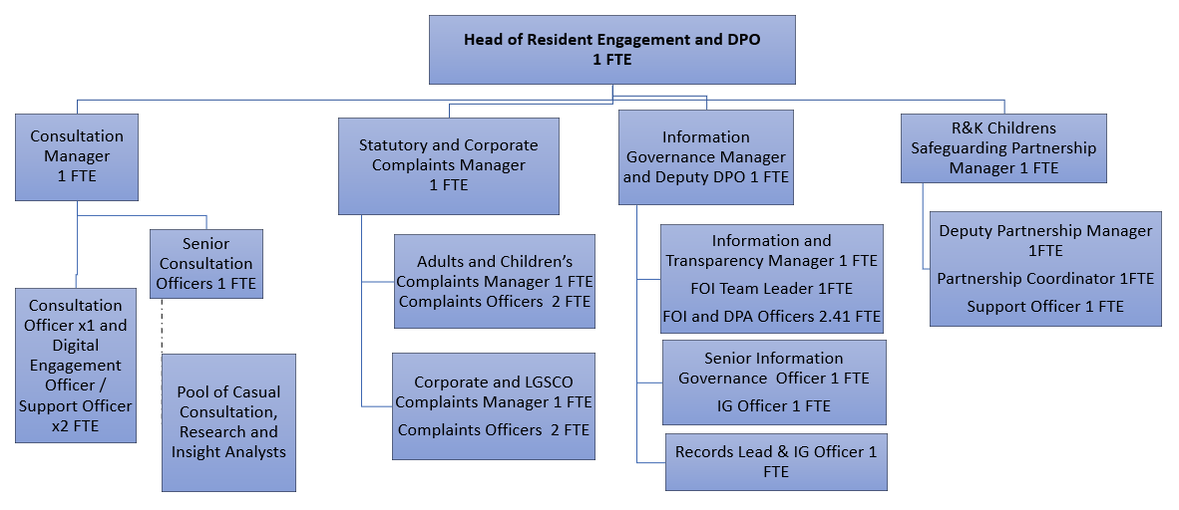

Person Specification

Job Title:  Information Governance Manager and Deputy DPO | Grade:  MG1
Section:  Resident Engagement | Directorate:  Chief Executive’s Group
Responsible to following manager:  Head of Resident Engagement and DPO | Responsible for following staff:  Information and Transparency Manager  Senior Information Governance Officer  Senior Records Management Officer
Post Number/s:  1 | Last review date:  February 2021

Our Values
THINK BIGGER
EMBRACE DIFFERENCE
CONNECT BETTER
LEAD BY EXAMPLE
PUT PEOPLE FIRST

Our Values are embedded across Richmond & Wandsworth Better Service Partnership and throughout all roles and responsibilities at all levels of the organisation. Please familiarise yourself with our values as they are an integral part of our recruitment and selection process.

Person Specification Requirements |  |  |  | Assessed by  A/I/T/C  (see below for explanation)
 | Knowledge | Essential | Desirable | Assessed
 | Expertise and a detailed working knowledge of relevant information governance, data protection and information security legislation, codes of practice and best practice. |  |  | A/I
 | Good working knowledge of data protection, FOI/EIR legislation, Transparency |  |  | A/I
 | Experience | Essential | Desirable | Assessed
 | A proven track record of successfully working with senior officers and elected members across a complex organisation to develop and implement corporate policies, processes and controls in relation to information governance, data protection, records management and information security. |  |  | A/I
 | Experience of successfully dealing with very complex and sensitive information governance, data protection and information security enquires, requests and case work, including handling difficult conversations with data subjects, officers and elected members. Showing strong political awareness. |  |  | A/I
 | Substantial experience of liaising with the Information Commissioner’s Office on complex and sensitive casework and enquires. |  |  | A/I
 | A proven track record in the successful application and management of information compliance issues in a large complex organisation (ideally in the public sector) including ensuring responses to information rights requests from data subjects and providing expertise advice and guidance to senior officers. |  |  | A/I
 | A proven track record in successfully managing a complex organisations requirements and compliance in relation to DPIA’s, DSA and Data Protection Audits. |  |  | A/I

 | Experience |  | Essential |  | Desirable | Assessed
Providing specialist advice, deliver training and provide information to support the successful operation and adherence to records management policy, processes and controls. |  |  |  |  |  | A/I
Practical experience of the application of Records Management best practice within a complex organisation (ideally the public sector) |  |  |  |  |  | A/I
Practical experience of using tools such as Office 365, SharePoint and other IT applications to support information governance, data protection and information security to embed best practice and compliance. |  |  |  |  |  | A/I
A proven track record of successful leading and managing high-performing teams of staff |  |  |  |  |  | A/I
Experience of appropriately managing budgets |  |  |  |  |  | A/I
Skills |  | Essential |  | Desirable |  | Assessed
Ability to think, act and plan strategically |  |  |  |  |  | A/I
Ability to work effectively in a political environment and build positive relationships with senior managers, staff, external partners/agencies and councillors in a way that establishes confidence, credibility and trust |  |  |  |  |  | A/I
Confidently communicate and influence colleagues from all levels of seniority in order to deliver an information governance improvement agenda and all key aspects of the role |  |  |  |  |  | A/I
Substantial experience of working on own initiative with minimal supervision to create innovative solutions; recognising when to escalate matters through the management chain |  |  |  |  |  | A/I
Ability to organise and prioritise own workload, to work under pressure and meet deadlines |  |  |  |  |  | A/I
Excellent oral and written communications skills in order to present the Council’s case effectively and to produce clear guidance and information for different audiences |  |  |  |  |  | A/I
Exceptional team management and leadership skills including the ability to effectively tackle performance issues, motivate, develop and empower staff |  |  |  |  |  | A/I
Qualifications |  | Essential |  | Desirable |  | Assessed
Relevant degree; relevant professional certification / qualification; or evidence of continued study in the areas of information governance, data protection, records management or information security. |  |  |  |  |  | A/I

A – Application form / CV
I – Interview
T – Test
C - Certificate

