Job Profile comprising Job Description and Person
Specification
Job Description

Job Title: | Grade:
FM Helpdesk Administrator | SO1
Section: | Directorate:
Property Services - FM Performance | Housing & Regeneration
Responsible to following manager: | Responsible for following staff:  0
FM Helpdesk Team leader | Responsible for following staff:  0
Post Number/s: | Last review date: August 2022
1 | Last review date: August 2022

Working for the Richmond/Wandsworth Shared Staffing Arrangement

This role is employed under the Shared Staffing Arrangement between Richmond and Wandsworth Councils. The overall purpose of the Shared Staffing Arrangement is to provide the highest quality of service at the lowest attainable cost.

Staff are expected to deliver high quality and responsive services wherever they are based, as well as having the ability to adapt to sometimes differing processes and expectations.

The Shared Staffing Arrangement aims to be at the forefront of innovation in local government and the organisation will invest in the development of its staff and ensure the opportunities for progression that only a large organisation can provide.

Job Purpose

Provides a professional customer focused Helpdesk service to SSA customers, acting as a one stop shop for all FM related enquiries, and by using the Concerto CAFM system to receipt and process email and telephone requests for FM support.

Provide high quality customer service and maintain high levels of customer satisfaction by owning, prioritising, allocating and processing the request for FM support from receipt to completion.

Providing the customer with a Task Reference and regular progress updates until the request / Task has been satisfactorily completed and closed. Update the CAFM system to show Task progress and closure.

Specific Duties and Responsibilities

1. Staff and manage the FM Helpdesk during its hours of operation. Monday to Friday
08.00 – 17.30.

2. Receive and record customer requests verbally, by email and/or telephone in the
Concerto CAFM System.

3. Work closely with FM Helpdesk team leader & CAFM manager to monitor FM service delivery & performance of suppliers & contractors, ensuring jobs are completed within the assigned SLA’s, to high standards of quality, customer service and customer satisfaction.

4. Allocate each request with a CAFM HD Task reference and advise the Customer of the unique reference accordingly using the Concerto system.

5. Review the detail of all jobs received ensuring data accuracy, interrogating the quality of the information, and where necessary by going back to the originator to ensure all the information is correct and valid prior to logging tasks.

6. Understand the requirements ensuring all information is available for each task and allocate accordingly to managers, directly employed FM staff and/or integrated FM contractors / supply chain partners.

7. Monitor and manage progress of each Task against SLA’s or KPI’s including but not limited to Time To Respond (TTR) and Time To Complete (TTC) allocations, working closely with the FM Operations & FM Building Services teams to manage the targets set on concerto for job completion.

8. Regularly update Customers on the Task progress and completion by using concerto and other means of communication.

9. Ensure that HD Tasks in the CAFM system are accurately updated in real-time, and communication with all service providers and stakeholders

10. Responsible for Time to respond and /or Time to complete tasks are monitored daily and contractors and building services members are chased to ensure works are carried out in a timely manner.

11. Provide regular management information reporting to FM Managers as requested.

12. Ensure that all holiday and sickness absence is covered by suitably trained and competent staff, providing support and training as required.

13. Regularly monitor and measure Customer satisfaction levels by conducting pulse surveys of Customers who have used the FM Helpdesk function.

14. Carry out general FM Helpdesk administration duties as and when required.

15. Provide a one stop shop service, for all internal & external stakeholders, ensuring a high level of customer service.

16. Work closely with out of hours call service providers ensuring that tasks & information is logged in a timely manner and correctly allocated, and jobs are followed up accordingly.

17. Support the FM helpdesk team leader in populating and updating the FM Helpdesk manual ensuring information is accurate and relevant.

18. Ensure the information on Concerto is up to date and accurate, highlighting omissions and errors as they are identified, and sourcing the correct information sharing this with the CAFM manager to ensure Concerto is kept up to date.

19. Conduct periodic, systematic, detailed reviews of stakeholder & supplier information stored on Concerto, ensuring its accuracy is constantly reviewed.

Generic Duties and Responsibilities

• To contribute to the continuous improvement of the services of the Boroughs of
Wandsworth and Richmond.

• To comply with relevant Codes of Practice, including the Code of Conduct and policies concerning data protection and health and safety.

• To adhere to security controls and requirements as mandated by the SSA’s policies, procedures and local risk assessments to maintain confidentiality, integrity, availability and legal compliance of information and systems.

• To promote equality, diversity, and inclusion, maintaining an awareness of the equality and diversity protocol/policy and working to create and maintain a safe, supportive and welcoming environment where all people are treated with dignity and their identity and culture are valued and respected.

• To understand both Councils’ duties and responsibilities for safeguarding children, young people and adults as they apply to the role within the council.

• The Shared Staffing Arrangement will keep its structures under continual review and as a result the post holder should expect to carry out any other reasonable duties within the overall function, commensurate with the level of the post.

Additional Information

Manages

N/A
Official

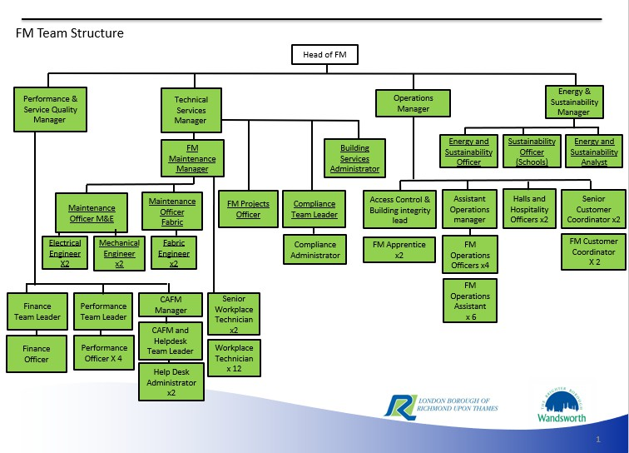

Person Specification

Job Title: | Grade:
FM Helpdesk Administrator | SO1
Section: | Directorate:
Property Services - FM Performance | Housing & Regeneration
Responsible to following manager: | Responsible for following staff:  0
FM Helpdesk team leader | Responsible for following staff:  0
Post Number/s:  1 | Last review date: August 2022

Our Values and Behaviours

The values and behaviours we seek from our staff draw on the high standards of the two boroughs, and we prize these qualities in particular:

Being open. This means we share our views openly, honestly and in a thoughtful way. We encourage new ideas and ways of doing things. We appreciate and listen to feedback from each other.

Being supportive. This means we drive the success of the organisation by making sure that our colleagues are successful. We encourage others and take account of the challenges they face. We help each other to do our jobs.

Being positive. Being positive and helpful means we keep our goals in mind and look for ways to achieve them. We listen constructively and help others see opportunities and the way forward. We have a ‘can do’ attitude and are continuously looking for ways to help each other improve.

Person Specification Requirements | Assessed by  A & I/ T/ C
Knowledge
Good understanding of the Council’s property estate(s) | A & I
CAFM (Concerto) systems an MS Office | A & I
Basic understanding of mechanical and electrical assets / systems | A & I
Experience
Customer Services | A & I
Helpdesk / Call Centre | A & I
Multi-tasking in a fast paced, pressurised working environment | A & I
Skills
Exceptional telephone manner, ability to instil confidence | A & I
Ability to quickly assimilate information and identify specific  resolution requirements. | A & I
The ability to organise and prioritise own workload, to work under  pressure and meet deadlines. | A & I
Qualifications

GCSE educated or equivalent vocational qualification A & I

A = Application form
I = Interview
T = Test
C = Certificate

