Ernest Bevin College
Job Description
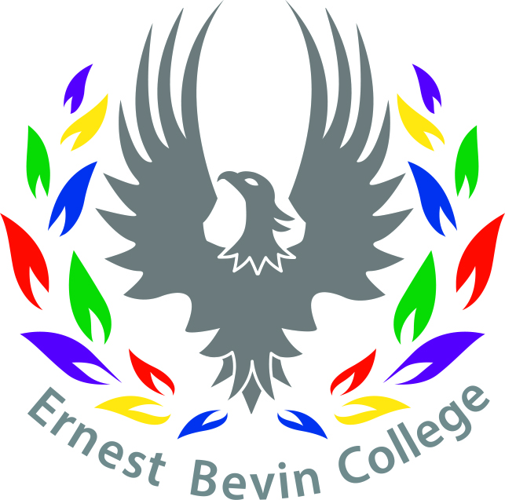
Title: Learning Support Assistant with specialism in EAL | Salary Scale: Scale 1c (£18,995)  36 hours, Term Time Only (39 weeks)
Supported by: Literacy Lead, SEN Department and English Department | Reporting to: Assistant Principal

Personal and Professional Conduct | - Treat students with dignity, build relationships rooted in mutual respect, and at all times observe proper boundaries appropriate to a professional position.  - Have regard to the need to safeguard students’ well-being, in accordance with statutory provisions – in terms of own conduct and taking responsibility to raise any concerns according to college policy.  - To attend training as required.  - Show tolerance of and respect for the rights of others.  - Promote fundamental British values, including democracy, the rule of law, individual liberty and mutual respect, and tolerance of those with different faiths and beliefs.  - Ensure that personal beliefs are not expressed in ways which exploit students’ vulnerability or might lead them to break the law.  - Have a proper and professional regard for the ethos, policies and practice of the college, and maintain high standards in their own presentation, attendance and punctuality.
Strategic Planning | - With support from Literacy Lead, SEN and English teams, plan, monitor and deliver EAL support across the college
Teaching and Learning | - Under the direction of literacy lead, baseline and monitor progress of students on EAL caseload  - Support EAL students in and out of classrooms, in partnership with the class teacher, the SENCO and the English team.  - Plan, deliver and evaluate teaching and learning activities to suit EAL students under the direction of a teacher.  - Support teaching and learning in all areas of the curriculum – this includes break time and lunchtimes (e.g. read and understand planning, communicate feedback with the teacher, have a clear understanding of student’s targets and levels, have a good subject knowledge to support learning; ALWAYS be a positive role model).  - Run EAL intervention sessions.  - Keep records of student EAL progress.  - Prepare and maintain the learning environment to promote the development of language (e.g. preparing resources to help increase engagement).  - Meet with parents / carers and report on progress, establish a good working relationship with families. Maintain records of meetings as directed.  - Assist teachers with advice about specific student’s EAL needs.  - Accompany teaching staff and students on visits and out of school activities as required.  - Record and act upon any concerns about behaviour or progress.  - Attend line management and other meetings as required.  - Assist in the supervision of social interventions – such as a lunch club.
This job description does not direct the particular amount of time to be spent on carrying out the above duties and responsibilities and no part of it may be so construed. This job description is not necessarily a comprehensive definition of the post. It will be reviewed at least once a year and may be subject to modification or amendments at any time after consultation with the post holder. October 2021

Ernest Bevin College

Personal Specification

Title: Learning Support Assistant with specialism in EAL | Salary Scale: Scale 1c (£18,995)  36 hours, Term Time Only (39 weeks
Supported by: Literacy Lead, SEN Department and English Department | Reporting to: Assistant Principal

CRITERIA | ESSENTIAL | DESIRABLE
QUALIFICATIONS |  | - Graduate
KNOWLEDGE AND SKILLS | - Good literacy and numeracy skills.  - Effective use of ICT to support learning and keep records.  - Good organisational skills.  - Some knowledge of the process of education, learning and progression routes for young people.  - Ability to support pupils taking part in a range of educational activities. | - Experience of working with children/students with EAL needs
PERSONAL QUALITIES AND CHARACTERISTICS | - Loyalty and commitment to the college, students, parents and staff of the college.  - Energy, enthusiasm and stamina.  - Flexibility and determination.  - Ability to work under pressure and meet deadlines. Ability to adapt own approaches to meet the needs of EAL, vulnerable and challenging students.  - To be able to establish positive relationships with students, parents, staff and outside agencies.  - Commitment to the principles of equality.  - To have a keen interest in the world of education and a commitment to the future and development of young people.  - Awareness of responsibility towards the safeguarding of students.  - To be able to follow all college procedures and policies.  - To be able to maintain effective records. | - Some experience working in education or with young people.
SPECIFIC TO THE POST | - To be able develop and maintain appropriate contact with the families and carers of students with identified EAL need.  - To demonstrate an interest in the needs and progress of the EAL students, most vulnerable and those with special needs. | - Experience of working with EAL children/ students.

October 2021

