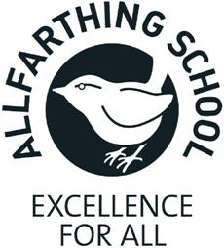
CLASS TEACHER
PERSON SPECIFICATION

QUALIFICATIONS | Qualified teacher status
EXPERIENCE  KNOWLEDGE AND UNDERSTANDING  SKILLS AND  ABILITIES | Relevant teaching experience or NQT
Thorough knowledge and understanding of:
- excellent primary practice
- the requirements of primary curriculum and of how standards
can be raised
- equal opportunities issues and the implementation of equal
opportunities policy
- inclusion and how this impacts on children
- high expectations of pupils’ in terms of educational outcomes
and their behaviour
Candidates will be expected to demonstrate the ability to:
- be a highly effective class teacher, understanding how to bring about exciting and meaningful learning
- raise the standards of pupils’ attainment and secure progress towards their targets
- track progression and organise and implement a range of strategies to ensure a child makes progress
- communicate effectively and accurately in a variety of contexts and at the level necessary for the post
- deal with children with warmth, care and understanding and yet set clear and appropriate boundaries for behaviour
- work with and relate positively to colleagues and parents
- work positively with a wide range of cultural, ethnic and social groups
- work effectively as part of a team
- have excellent ICT skills to support the learning of pupils at the primary level

PERSONAL QUALTIES | Candidates will be expected to demonstrate that:  - s/he is able to relate to relate to staff in a professional and  personable manner  - s/he is highly motivated and committed  - s/he can use own initiative, set realistic goals, work towards  them and monitor progress  - plan, organise and prioritise workload s/he has the desire to  continue learning for themselves

