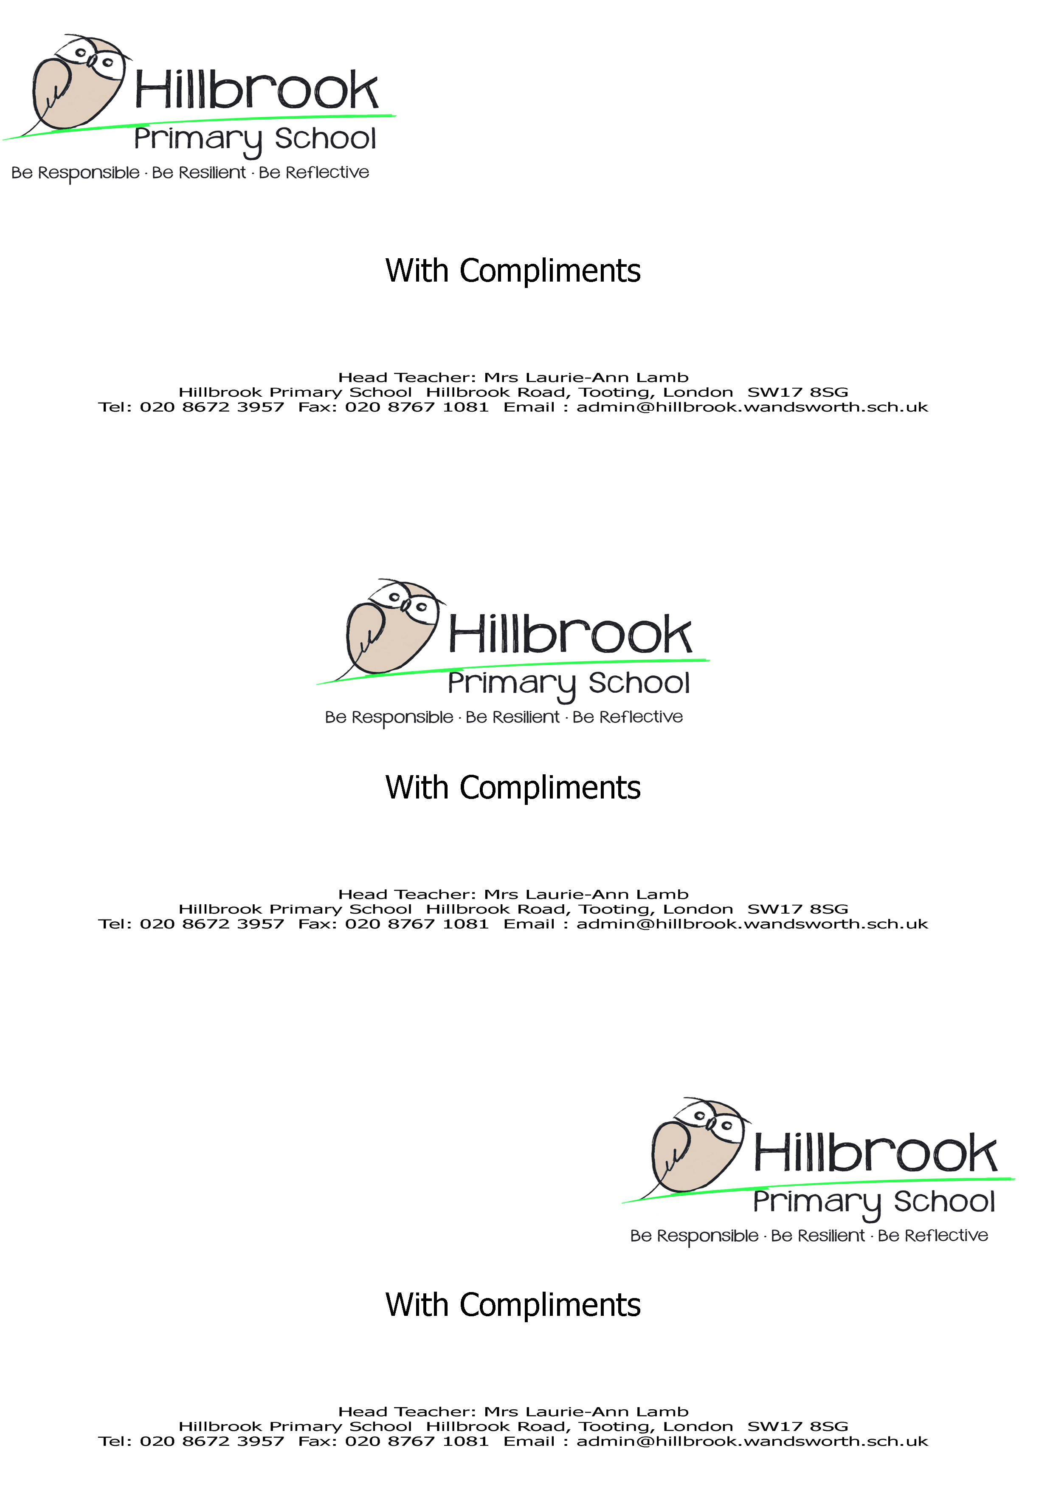

Job Description
Name
Job Title | Teaching Assistant
Relationships/Line Management
Responsible to:
- Class Teacher
- SENco
- Phase Leader
- Deputy head for Inclusion
Responsible for:
- The pupils in your charge
Important relationships:
- Pupils and parents
- Other members of staff
- The Governing Body
- The Parent Teacher Association
Main Purpose of Job
Responsible, under the direction or instruction of the teacher or line manager, to work with individual pupils or small groups supporting access to all areas of learning, including physical care and well-being. Also to provide general support to the teacher in the management of pupils and the classroom (including during PPA cover, class trips and school events).
Meals Supervisor: Under the direction of the Meals Supervisor Leader, work as part of the Lunchtime Team.
Support for Pupils
- Attend to the pupils’ personal needs, including medical procedures following appropriate training;
- Implement related personal programmes such as social, health, physical, hygiene, first aid and welfare matters;
- Supervise and support pupils ensuring their safety and access to learning;
- Establish good relationships with pupils and their parents/carers;
- Be aware of and respond appropriately to individual needs;
- Promote the inclusion and acceptance of all pupils;
- Encourage pupils to interact with others and engage in activities led by the teacher;
- Encourage pupils to act independently as appropriate;
- Supervise and direct pupils in the dining room and play areas;
- Dealing with lunchtime incidents in line with School policies and procedures and referring any issues arising to the Meals Supervisor Leader.
Support for Teacher
- Prepare the classroom as directed for lessons and clear afterwards and assist with the display of pupils work
- Be aware of pupil concerns, progress and achievements and report to the teacher as agreed
- Undertake pupil record keeping as requested
- Support the teacher in managing pupil behaviour, reporting difficulties as appropriate;
- Gather and report information from and to parents or carers as directed.
Support for the Curriculum
- Support pupils to understand and follow instructions;
- Supporting pupils in accessing all areas of the curriculum as appropriate;
- Prepare and maintain equipment and resources as directed by the teacher and assist pupils in their use;
- Monitor and record pupil progress against agreed targets;
- To plan and implement, alongside other professionals, agreed interventions as appropriate.
Standards and Quality Assurance
- Supporting and upholding the aims and the ethos of the school;
- Be aware of and comply with policies and procedures relating to child protection, health, safety and security, confidentiality and data protection, reporting all concerns to an appropriate person;
- Be aware of and support difference and ensure all pupils have equal access to opportunities to learn and develop;
- Appreciate and support the role of other professionals;
- Attend relevant meetings as required;
- Participate in training and other learning activities and performance development as required;
- Assist with the supervision of pupils out of lesson times, including before and after school;
- Accompany teaching staff and pupils on visits, trips and out of school activities as required;
- To be fully aware of and understand the duties and responsibilities arising from the Children’s Act 2004 and Working Together in relation to child protection and safeguarding children and young people as this applies to the worker’s role within the organisation;
- To also be fully aware of the principles of safeguarding as they apply to vulnerable adults in relation to the worker’s role;
- To ensure that the worker’s line manager is made aware and kept fully informed of any concerns which the worker may have in relation to safeguarding and/or child protection.
This job description allocates duties and responsibilities but does not direct the particular amount of time to be spent on carrying them out and no part of it may be so construed.

Person Specification

Post Title: Teaching Assistant/Learning Support Assistant

 | Essential | Desirable
Qualifications
- GCSE qualification, Grade A-C (or equivalent) in English and Maths | ✓
- Willingness to participate in development and training opportunities | ✓
Experience
- Ability to relate well and communicate effectively to children and adults | ✓
- Experience within education setting |  | ✓
Professional Knowledge, Skills and Abilities
- Have a good understanding of classroom roles and responsibilities | ✓
- Ability to use relevant technology e.g. computer, photocopier effectively | ✓
- Good level of oral and written communication skills | ✓
- Be flexible and able to work using own initiative | ✓
- Be able to form and maintain a range of teaching and learning strategies | ✓
- Have the ability to organize activities and games | ✓
- Maintain appropriate professional relationships and boundaries with pupils, parents and other outside agencies | ✓
Work Related Attributes, Qualities, Competencies
- Be patient and understanding | ✓
- Deal with sensitive information in a confidential manner | ✓
- Show a commitment to equal opportunities and safeguarding | ✓
- Willingness to make a full contribution to the environment of the school. | ✓
- To be enthusiastic, energetic, conscientious and committed | ✓

